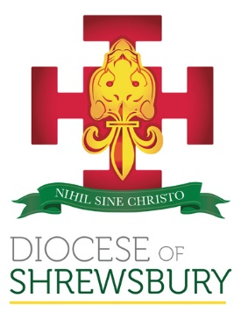
Safeguarding statement

The Diocese of Shrewsbury is committed to safeguarding all those with whom it comes into contact, such as beneficiaries, volunteers and staff. As a charity we follow the leadership of the Catholic Church in England and Wales, which has adopted a common set of national safeguarding standards for the safeguarding and protection of children, and adults who may be vulnerable or at risk.
The standards operate as a coherent whole, which together form an overarching framework within which all church bodies are expected to operate. They represent the expected level of practice that is to be applied by church bodies for the purpose of safeguarding the children and adults with whom the Church has contact.
There are 8 standards which require church bodies to:
- Embed safeguarding in the Church body’s leadership, governance, ministry and culture
- Communicate the Church’s safeguarding message
- Engage with and care for those who report having been harmed
- Effectively manage allegations and concerns
- Manage and support subjects of allegations and concerns (respondents)
- Implement robust human resource management
- Provide and access training and support for safeguarding
- Quality assure compliance to continuously improve practice
Underpinning each standard are criteria which set out the critical elements that contribute to fulfilment of the individual standard, as well as policies within the Diocese which support the operational delivery of these standards. Policies include, but are not limited to:
- Safer recruitment
- Management of concerns and allegations (including mandatory reporting)
- DBS Processing
- Handling of DBS-related Complaints
- Information Security Policy for DBS
The Diocese is also a Regulated Affiliate of Catholic Safeguarding Standards Agency, a voluntary regulator which will test compliance with the standards through its rigorous auditing and assurance processes.

