Andrew

- Andrew was Simon’s brother and was also a fisherman. Jesus told them he would make them ‘fishers of men’
- He had been a follower of John the Baptist.
- He lived with his brother in Capernaum.
- He is said to have been crucified on a X shaped cross.
- Is the patron saint of Scotland and Russia
- This cross became his symbol.
- His feast day is:
November 30th
Simon Peter

- One of Jesus’ favoured apostles.
- He was a fisherman from Bethsaida and lived in Capernaum.
- He was married.
- Jesus gave him a new name – Peter which means rock.
- Recognised Jesus as Messiah but denied knowing him too.
- It is believed he was crucified upside down as he thought he should face a worse death than Jesus.
- His symbol is a pair of keys to show him as the first leader of the new Christian church.
- His feast day is:
June 29th
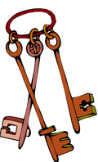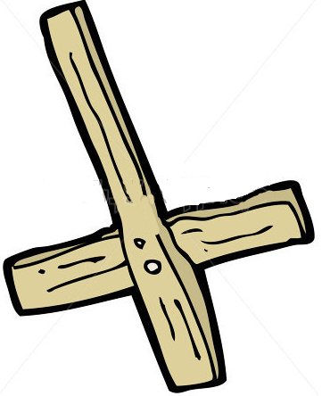
James The Elder

- James the elder, along with his brother John and Peter were the closest to Jesus.
- Jesus nicknamed James and his brother John Boanerges, meaning, ‘Sons of Thunder’.
- His father was a successful fisherman called Zebedee.
- His mother was called Salome and may have been the sister of Mary, Mother of Jesus.
- He was the first of the Apostles to be put to death and the only one whose martyrdom is recorded in the NT.
- He was beheaded.
- His symbols are the staff and wallet of a pilgrim.
- His feast day is:
July 25th

THE 12 APOSTLES

Thaddeus

- Also called Jude or Judas, he is the reputed author of the Letter of St Jude in the NT.
- He is possibly the brother of James the Younger and possibly came from the group of Zealots, like Simon.
- He is said to have travelled to Persia as a missionary.
- His symbol is a sailing boat with a cross mast.
- It is believed that he died a martyr in Persia.
- His feast day is:
October 28th

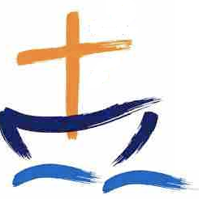
James The Younger

- James the Younger (son of Alphaeus) is said to have preached in Palestine and Egypt.
- His parents and brothers were also followers of Jesus.
- He is said to have been sawn to death, though this is unlikely.
- His symbol is a saw.
- May 1st is the Feast Day of St Philip and St James commemorating the day their relics were brought to Rome, however, this may not have been the same James or Philip.
- His feast day is:
May 3rd

John

- John was a fisherman like his brother James. They were very alike.
- He went with Peter to Samaria to lay hands on the new converts there.
- It is believed he lived and died At Ephesus in his old age.
- Some think John wrote the Gospel himself - others think it was another John.
- His symbols are a chalice with a winged serpent because of a legend about John who was dared to drink a cup of poison. He prayed over the cup and then a snake flew out of it, and he drank the wine.
- His feast day is:
December 27th
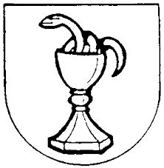

Bartholomew

- Bartholomew’s other name was Nathaniel.
- He was brought to Jesus by Philip.
- He came from Cana in Galilee.
- Tradition states that he was a missionary to Ethiopia, Mesopotamia, Parthia (in modern Iran), Lycaonia (in modern Turkey) and Armenia.
- He is said to have been flayed to death at the command of the Armenian king Astyages.
- His symbols are a Bible and a flaying knife.
- His feast day is:
August 24th
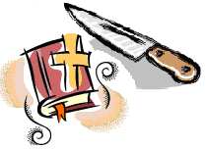

Thomas

- Thomas (in Greek known as Didymos, which means ‘twin’) has his character outlined in John’s Gospel.
- His devotion to Jesus is clearly seen in Jn. 11: 5-16
- He didn’t believe Jesus had risen from the dead until he could touch his wounds.
- From this we get the saying ‘Doubting Thomas’.
- He is said to have preached in Syria, Persia and India.
- Tradition states he was killed with a spear in Chennai.
- His symbol is a spear and carpenter’s square/
- His feast day is:
December 21st
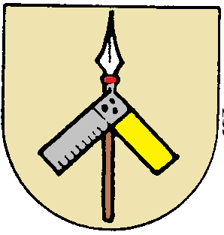
Philip

- Philip was a friend of Andrew and Peter.
- He also came from Bethsaida.
- He is only named once in the Synoptic Gospels but several times in John’s Gospel.
- It is believed that he looked after the food for the Apostles.
- He is said to have preached in Asia Minor.
- He may have died a martyrs’ death but scholars are unsure.
- His symbol is 2 loaves of bread as he participated in the miracle of loaves and fishes (Jn. 6:5-9).
- His feast day is:
May 3rd
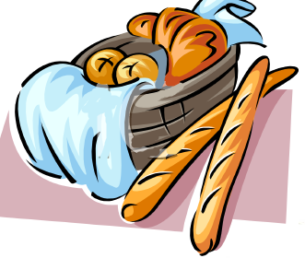

Judas Iscariot

- Judas came from Kerioth, a village in Judea.
- He was the only disciple who was not from Galilee.
- He looked after the money for the Apostles (Jn. 12:6).
- He betrayed Jesus for 30 pieces of silver – the price of a slave!
- According to Matthew’s Gospel he was so upset by what he had done that he hanged himself. In Acts (1:18) it suggests he bought a field with the money, then ‘fell headlong and burst open’.
- His symbol is a yellow shield (yellow signifying a betrayer).

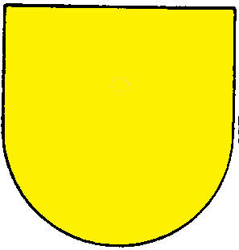
Matthew

- Matthew (also known as Levi in Mark and Luke’s Gospel).
- He was a tax collector in Capernaum when Jesus called him.
- Tradition believes his ministry took him to Ethiopia and Persia and that he may have died a martyr’s death in Ethiopia.
- He is the patron saint of tax collectors and accountants.
- His symbol is money bags.
- His feast day is:
September 21st

Simon

- Simon was a fierce patriot who actively opposed the Romans.
- He was as Zealot – a person who fought against the Romans secretly to free their country.
- He came from Galilee and may have been a fisherman.
- He supposedly preached the gospel in Persia and joined Thaddeus (Jude) in his missionary work.
- Christian Ethiopians believe he was crucified in Samaria. One tradition claims he died peacefully at Edessa. Another that he visited Britain.
- His symbol is a fish on a Bible.
- His feast day is:
October 28th

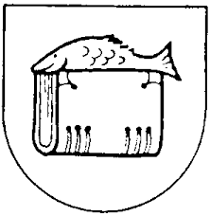

THE 12 APOSTLES

