

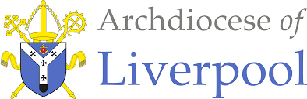

To Know You More Clearly

The Religious Education Directory
EYFS Nursery Scheme of Work
Prophecy & Promise
Education Department

EYFS Nursery Prophecy & Promise
Overview  Prophecy and promise: ‘In many and various ways, God spoke to our ancestors by the  prophets’ (Heb 1:1).  In the Old Testament the prophets speak of God reaching to his people, calling them back into  a relationship with him. In this branch, pupils will explore the Christian understanding of the  teaching of the prophets as they point to the fulfilment of God’s promise in a messiah, Jesus  Christ. They will explore the expectant waiting for the Messiah through the Advent season and  how this speaks to Christians today as they wait for Christ. Pupils will encounter the story of the  nativity of Jesus and the mystery of the incarnation. (when God became man) | Introduction  *Prior Learning – Reminder - The Bible tells us all about God. We have to keep this in a very special place (prayer space/focus, place the book with the title Bible and the ‘Word’ of God) Can you remember where our special book is? Who can remember what the book is called? Remember this book tells us all about God. Would you like to hear a special story about God today?  - Please remember to use a Good News Bible – whilst this is not an accessible read for children, they need to experience what a Bible looks like, and how it is used – just as in other religions in Christianity this is a sacred book and needs to be treated with the utmost respect and care.  - Children will see how you as an adult use the Bible – they may not understand the words but it is our job then to retell the story in as many ways as possible – through retelling, crafts, art, dance etc… etc…  This may be the very first-time children will have heard the story about Mary and Jesus. And possibly their first nativity in a school setting.  Please note that the order of the first sequence has been adapted Hear, Live, Believe & Celebrate | General Guidance  - Please begin with Hear for each sequence.  - The sequences themselves as a whole may be best suited in a different order especially considering the age and stage of the children.  - Also, there may be times when you may wish to teach Believe, Celebrate and Live in a different order following Hear or together to suit the needs of the children.  - The activities within the sequences are suggested and you do not need to cover them all! Just ensure you are covering 10% of your curriculum time each week for Religious Education.
Prophecy and Promise Theme for Nursery:

The focus of this branch is for pupils to develop a continuing understanding of God.

- Creation and Covenant – God shows his love by making a wonderful world for us all to live in.
- Prophecy and Promise – God shows his love by sending his son, Jesus to live with us.

Religious Education within the of Areas of Learning EYFS NURSERY BRANCH 1
Ways of Knowing

You may wish to populate the topic grid to place Religious Education at the heart of learning

TEACHING SEQUENCE EYFS NURSERY BRANCH 2
Mary’s Baby

*Prior Learning – Reminder - The Bible tells us all about God. We have to keep this in a special place (prayer space/focus, place the book with the title Bible and the ‘Word’ of God) Can you remember where our special book is? Who can remember what the book is called? Remember this book tells us all about God. Would you like to hear a special story about God today?
HEAR | LIVE | BELIEVE & CELEBRATE |  |  | WAYS OF KNOWING
Mary was going to have a baby. His name will be Jesus.  Mary’s Baby is based on Luke 1:26-31,38. | God sent Jesus to love us all.  Celebrate Advent, it is a time to get ready for Christmas. | Getting ready for a very special baby. |  | Mary was going to have a special baby called Jesus | UNDERSTAND  What will I see and hear to help me understand?  - The Bible as a special book.  - Begin to hear about Mary.  - Mary was going to have a special baby called Jesus.  - God loves me.  - Jesus loves me.
DISCERN
How will I discover more?
- Beginning to talk about Advent traditions.
RESPOND
What can I do now?
Scripture (HEAR) Good News Translation
Luke 1: 26-31, 38
God sent the angel Gabriel to a town in Galilee named Nazareth. ²⁷ He had a message for a young woman promised in marriage to a man named Joseph, who was a descendant of King David. Her name was Mary. ²⁸ The angel came to her and said, “Peace be with you! The Lord is with you and has greatly blessed you!”
²⁹ Mary was deeply troubled by the angel's message, and she wondered what his words meant. ³⁰ The angel said to her, “Don't be afraid, Mary; God has been gracious to you. ³¹ You will become pregnant and give birth to a son, and you will name him Jesus. ³² He will be great and will be called the Son of the Most High God. He will be a special King. The Lord God will make him a king, as his ancestor David was, ³³ and he will be the king of the descendants of Jacob forever; his kingdom will never end!”
³⁸ “I am the Lord's servant,” said Mary; “may it happen to me as you have said.” Mary said, ‘Yes,’ I will have a baby and call him Jesus. And the angel left her.

HEAR
Teacher notes
Please see the adapted reading above – the word changes are highlighted in yellow. This reading is adapted to suit the age and stage of the children. Please still use the Bible to read from but change the words needed. Place the Bible back in its special place and say to the children that we will tell the story again to learn a bit more about the story.

**Retelling the story
Please be very careful when choosing any other resources from for e.g. from YouTube cartoons as the images and words may lead children to think of the story as magic! The story is known as a ‘mystery’ to Catholics and should be told as it is in the Bible.
Suggested Resources  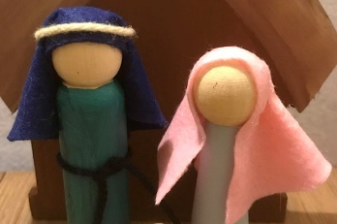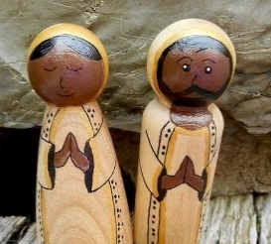  Sing  - The Angel said to Mary – use the video clip of the song from St Anne’s – thank you Sophie – please find in Evidence folder on the SharePoint  Also on Mission Together – Nursery Rhyme Nativity with music – starts at 0:50  https://missiontogether.org.uk/calendar/advent-resources/ |  |  | Learning Activities  - Introducing Mary to the children.  “We are going to hear a story from the Bible about a very special lady called Mary. Mary was very good when she was a little girl. She always did as she was told and was kind and loving to everyone. When she grew up she was going to get married to a man named Joseph. “  Reenact this with play figures and introduce Mary and Joseph – display them on the prayer table/focus so children start to identify them. Explore how they always try to be good for their mums or people who look after them.  See work from Christ the King evidence – thank you Lorna. Please find in Evidence folder on the SharePoint  - Hear the story from the Bible – Luke ( as adapted) directly from the Bible.  - Retell the story of Mary’s baby in your own words using the Golden Box – please consider the advice on resources above in the teacher’s notes. We would advise keeping the story simple and use peg dolls from the Golden Box.  Or/And …  - Retell using images from God’s Story  Continuous Provision  - Role play - Mary’s house and the visit from the Angel Gabriel.  - Small world play – Mary and the Angel Gabriel – use ideas from St Aloysius evidence bank of photographs – thank you Oonagh and staff. Please find in Evidence folder on the SharePoint

LIVE
Teacher Notes

God sent Jesus to love us all.
God loves everyone, Jesus loves everyone – children at this age will learn about God, Jesus and the Holy Spirit through simple readings from the Bible. Christians believe that God, Jesus and the Holy Spirit are One. This is called the Trinity. As children grow this understanding will develop over their school and adult life.

Celebrate Advent, it is a time to get ready for Christmas.

Suggested Resources  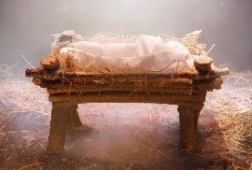  Making the crib ideas – some look a little complicated!  https://littleredwindow.com/cardboard-diy-doll-crib/  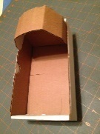https://thesavagedolls.blogspot.com/2015/03/baby-doll-bed-from-cardboard-box.html | Learning Activities  - Explore with the children – What is Love? https://www.bbc.co.uk/cbeebies/watch/whats-the-big-idea-love Share the clip with children. Remind children of all of the wonderful things that God has given to us – explored in Creation and Covenant – share some work as a reminder. God didn’t stop there, he sent his Son Jesus. God loves everyone, Jesus loves everyone. That is why it is so important that we get ready for Jesus.  - God gave me Jesus' song https://www.youtube.com/watch?v=WHUpcJmFbQo  - Make the links between mums/dads/carers/nans etc .. family love & Mary as a mum.  - Preparation of the crib. Preparing the empty crib.  - Make a large crib with the children possibly from junk materials, old laundry basket, old baby crib etc…  - Make and add craft love hearts from scrap fabric pieces to tesselate on a heart shape or make larger hearts so that a group of children can add fabric to the hearts. You may wish to put a layer of cotton wool onto the card, then add the fabric pieces to make it even softer. Use soft materials to prepare for the baby – tissue, felt etc… and talk about how mums etc keep the baby safe, warm and comfortable.  - Place the soft hearts made on the bottom layer of the crib. Find a special place in the classroom for the crib, as the children will be adding to it over the Advent period.  Continuous Provision  - Home corner – family looking after babies.  - Continue - Role play - Mary’s house and the visit from the Angel Gabriel.  - Continue - Small world play – Mary and the Angel Gabriel – use ideas from St Aloysius evidence bank of photographs – thank you Oonagh and staff.

Assess Pupils’…..WAYS OF KNOWING | Informal / Formal Assessment Comments
UNDERSTAND
What will I see and hear to help me understand?
- A reminder of the importance and significance of the Bible.
- Continue to see and hear about the Sign of the Cross
- Who is Mary?
- God shows his love by choosing Mary to be Jesus’ mum.
DISCERN
How will I discover more?
- Mary was going to be a mum.
- Mary was getting ready for her baby to be born.
RESPOND
What can I do now?
- We can learn about getting ready like Mary.

BELIEVE & CELEBRATE
Teachers Notes
- Mary was going to have a special baby called Jesus.
- Getting ready for a very special baby.
- Advent promises
Advent starts on the fourth Sunday before Christmas Day. It marks the start of the Church’s liturgical year. Advent comes from the Latin adventus, meaning ‘arrival’ or ‘coming’. It’s a key time in which we prepare ourselves to celebrate the Lord coming into the world as the incarnate God of love. The liturgical vestments priests wear during the season are purple, matching the candles lit on the Advent Wreath each Sunday of Advent. Purple is a colour typically associated with penance. The exception is the third Sunday – Gaudete Sunday – when priests wear pink vestments – the colour of rejoicing. Advent has a two-fold character: for it is a time of preparation for the Solemnities of Christmas, in which the First Coming of the Son of God to humanity is remembered; and likewise when, by remembrance of this, minds and hearts are led to look forward to Christ’s Second Coming at the end of time. For these two reasons, Advent is a period for devout and expectant delight.
Younger children need to build foundations of learning about Advent by making promises. You may find that making a different promise every day as you open an Advent Calendar might be too overwhelming. A suggestion is to have one promise per week – this way they will be building on the idea of the four candles on the Advent Wreath. In Nursery instead of the Advent Wreath to count the four weeks, children can start to prepare the crib. Small strips of paper/material can be used to add to the crib as promises.

Preparing the manger/crib
is the practice of preparing a soft bedding in the manger for Jesus by using little wisps of straw as tokens of prayers and good works through the season of Advent. This is originally a French custom that quickly spread to other countries. Every night the child is allowed to put in the crib one straw for each act of devotion, good work or sacrifice performed. "Thus the Christ Child, coming on Christmas Day, finds an ample supply of tender straw to keep Him warm and to soften the hardness of the manger's boards" (Francis Weiser, Handbook of Christian Feasts and Customs, 1958).
Suggested Resources  - Word Wall  - School prayers  - Sing Sign of the Cross – John Burland  https://www.youtube.com/watch?v=B_gGERoqhW0  - Sign of the Cross around the World  https://www.youtube.com/watch?v=QwFausSrBuc  Advent Hymn  - We are waiting to welcome Jesus – Bernadette Farrell – repetitive hymn https://www.youtube.com/watch?v=Pl18G23u-t4&list=PLbieJGvfcyVA56DiUnIPvAiR8WiIapz_N&index=18 | Learning Activities  - Continue with the school prayers on focus table and the concept of prayer – a time when we talk to God or think about God inside our heads – we can be silent.  - Continue with the words and actions of the Sign of the Cross. “In the name of the Father and the Son and of the Holy Spirit.” Amen  - Say the school prayer – begin and end with the Sign of the Cross  - Let’s get ready for a very special baby – Introduce a suitable Advent Calendar to the children – many will have one at home, however, please share one that is Christian for the purposes of Religious Education. Counting down of days can be combined with promises. Link the promises to preparing the crib – this can also be linked to the class Collective Worship. Prepare/make strips of paper/felt/material/tissue paper etc with promises so that children can add them to the crib each day in preparation for Preparing the Crib.  Example – translating the four weeks for Nursery children … please adapt the wording and ideas for the four weeks to suit the needs of your class  Waiting for Jesus is hard, it can take a long time. Each week we can try to remember to work hard or listen, share, say how we are feeling, love …Let’s make some promises…  - Work hard or listen (while we are waiting hopefully - Hope)  - Share (while we are peacefully waiting - Peace)  - Say how we are feeling (while we are trying to wait joyfully - Joy)  - Love each other (while we are waiting lovingly - Love)  **Ongoing activity for adding to the crib each day for the promises we have made in Advent  Continuous Provision  - Prayer focus area  - Mirror sign of the Cross  - Home corner – family looking after babies.  - Continue - Role play - Mary’s house and the visit from the Angel Gabriel.  - Continue - Small world play – Mary and the Angel Gabriel – use ideas from St Aloysius evidence bank of photographs – thank you Oonagh and staff.

TEACHING SEQUENCE EYFS NURSERY BRANCH 2
Jesus is born

HEAR | BELIEVE | CELEBRATE |  | LIVE | WAYS OF KNOWING
Jesus was born in Bethlehem. Based on Luke 2:4-7 | Mary had a baby called Jesus | The tradition of the crib  Ongoing  Nativity celebration (see further notes) |  | God sent Jesus to love us all.  Celebrate Advent, it is a time to get ready for Christmas. | UNDERSTAND  What will I see and hear to help me understand?  - Jesus is born.  - Mary, Joseph and Jesus are a special family called the Holy Family.
DISCERN
How will I discover more?
- Jesus is born to love everyone.
- Jesus was born in a manger/stable.
- Look at and talk about pictures/paintings that depict the Holy Family.
- Sharing Advent promises
RESPOND
What can I do now?
- Singing Advent songs and Christmas carols.
- Know that God loves me, Jesus loves me.
- God sent Jesus as a special gift, to love us all.
- Getting ready for Christmas sharing and doing our Advent promises
Scripture (HEAR) Good News Translation
⁴ Joseph went from the town of Nazareth in Galilee to the town of Bethlehem in Judea, the birthplace of King David. Joseph went there because he was a descendant of David. ⁵ He went to register with Mary, who was promised in marriage to him. She was pregnant, ⁶ and while they were in Bethlehem, the time came for her to have her baby. ⁷ She gave birth to her first son, wrapped him in cloths and laid him in a manger—there was no room for them to stay in the inn.
Joseph and Mary went to a town called Bethlehem. They had nowhere to sleep. They stayed in a stable with animals. Mary gave birth to her special baby boy, Jesus. She wrapped him in cloths and laid him in a manger.
HEAR & BELIEVE
Teacher notes
HEAR Jesus was born in Bethlehem. Based on Luke 2:4-7
BELIEVE Mary had a baby called Jesus
Please see the adapted reading above – the word changes are highlighted in yellow. This reading is adapted to suit the age and stage of the children. Please still use the Bible to read from but change the words needed. Place the Bible back in its special place and say to the children that we will tell the story again to learn a bit more about the story.

**Retelling the story
- Please be very careful when choosing any other resources from for e.g. from YouTube cartoons as the images are sometimes unsuitable. Please stick to the simplicity of the story itself.

Were Animals in the Manger on the First Christmas? https://outdoornativitystore.com/blog/manger-scene-animals-history/

Most representations of Jesus’ birth show donkeys, cows, and sheep watching over the Holy Family. Artistic renderings may include animals that are native to the artist’s country. For example, an African artist might include a zebra or a giraffe at the manger scene. But what animals were really there at the manger on the first Christmas? The answer is surprisingly unclear.
In his book Jesus of Nazareth: The Infancy Narratives, Pope Benedict XVI writes, “In the gospels, there is no mention of animals” at the Holy birth. He contends that that references to the ox and the donkey in other parts of the Bible may led Christians to include them in nativity scenes. The donkey is the animal most commonly seen in the Nativity. Many scholars believe Mary rode to Bethlehem on a donkey, and, as a result, many artistic representations show Joseph leading Mary into town as she rides on the back of a donkey. Donkeys were a common mode of transportation for the poor in biblical times. However other historians write that Mary and Joseph may have travelled in a caravan (a line or group of people together) to the census taking. Travelling in large groups was a common practice and was seen as much safer than travelling alone. If that were the case, Mary may have ridden in a basket secured to a camel.
Many nativity scenes also include an ox and/or a cow near the cradle or nestling in the manger. Sources for the presence of these animals go back to the Old Testament Book of Isaiah (“The ox knoweth his owner, and the ass his master’s crib; but Israel doth not know, my people doth not consider” – Isaiah 1:3). Cattle become firmly associated with modern nativity scenes after the publication in the late 19th century of the beloved Christmas carol “Away in a Manger” and its phrase “the cattle were lowing.” Sheep are also included in most manger scenes, typically standing or lying near the shepherds. Some scholars theorize that Jesus was born several of miles outside of Bethlehem near a special shepherds’ watch tower called the Migdal Eder. Therefore, it is certainly possible that shepherds and their sheep visited the manger. Despite his inconclusive research about animals in the manger, Pope Benedict conceded in his book that “No nativity scene will give up its ox and donkey.” In fact, the Vatican itself always includes animals in the nativity scenes it sets up St Peter’s Square each year. Historically accurate or not, creche animals are here to stay. “The striking thing about creches is that they reflect both a common faith and the unique culture of the people who created them,” writes Matthew Powel in his book The Christmas Creche. “The manger scene continues to proclaim that all people are welcome at the stable of Bethlehem.” All people – and animals.
Suggested Resources  - Key words wall  - https://www.youtube.com/watch?v=LgdJyrs1vE8  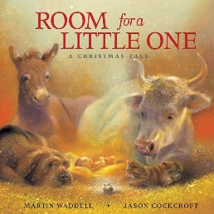 |  |  | Learning Activities  - Hear the story from the Bible – Luke ( as adapted) directly from the Bible.  Or/And …  - Retell using images from God’s Story  - Introducing a new family – the Holy Family - Mary, Joseph and Jesus  - Retell the story using the Golden Box. Talk about the stable – where animals were kept such as sheep or donkeys and how the animals would have eaten from the manger which we now know as a crib.  - Reenact this with play figures Mary, Joseph and Jesus – display them on the prayer table/focus so children start to identify them. Explore links to their own family.  - Include photographs on the focus table of their families. They are just like Jesus in a loving family.  - Story book – Martin Waddell – Room for a Little One – this will support the role play for the Stable  Continuous Provision  - Role play – the stable – Mary, Joseph and Jesus and animals.  - Using small- world figures travelling to Bethlehem/stable  - Outdoor – travelling to Bethlehem

CELEBRATE & LIVE
Teacher Notes:
- The focus on celebrating and living has been brought together to give children a holistic approach of understanding the story.
- CELEBRATE The tradition of the crib
- LIVE God sent Jesus to love us all.

CELEBRATE & LIVE - Advent, it is a time to get ready for Christmas. When the child Jesus was born, his mother Mary laid him in a manger. The manger became his crib. The word “manger” comes from the Latin word manducare which means “to eat.” A manger or crib is a wooden or stone-feeding trough or food box that holds hay for larger farm animals like cattle, horses, and donkeys. Mangers were located wherever livestock were kept, places like stables or caves.
When Mary and Joseph arrived in Bethlehem there was no room for them at the inn, so they were forced to find lodging elsewhere, probably in a cave where animals were staying. When Jesus was born, Mary would not have wanted to lay her infant on the hard, cold, stone floor. Instead, she had to make do with what was available and the manger proved to be a convenient alternative: the hay was soft, the box was up and off the ground, and the sides tall enough to keep her child safely inside.

Jesus was not laid in a manger by accident. It is a major spiritual symbol. Animals go to the manger for physical food, but with Jesus lying on the hay, we can go to the manger for spiritual food. Jesus has an infinite storehouse of nourishment available, and we can approach him any time and never go hungry. Jesus feeds us with his love.

Suggested Resources  Art  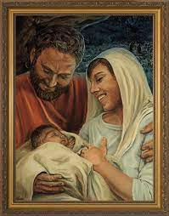  https://nelsongiftswholesale.com/catholic-artwork/nativity-by-jason-jenicke-standard-gold-framed-art/  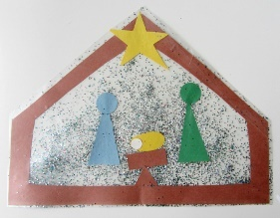  https://www.notimeforflashcards.com/2013/12/nativity-craft-for-kids.html  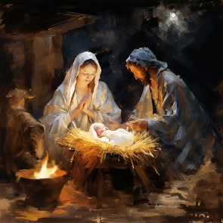  https://www.etsy.com/uk/shop/DesignedByBethWalker?ref=shop-header-name&listing_id=1599021591&from_page=listing  Carol  - Away in a Manger  https://www.youtube.com/watch?v=fRkKHGdjvRA  - Silent Night  https://www.youtube.com/watch?v=kjCOiH-kbs8  - In a Manger Monica Scott (good for reflection music)  https://www.youtube.com/watch?v=fmBVV79j82Y | Learning Activities  - The tradition of the crib – read the teacher’s notes about the French custom of ‘Preparing the Crib’  - Focus on the large crib somewhere central in the classroom. Remind children that we have been adding to the crib  - Work hard or listen (while we are waiting hopefully - Hope)  - Share (while we are peacefully waiting - Peace)  - Say how we are feeling (while we are trying to wait joyfully - Joy)  - Love each other (while we are waiting lovingly - Love)  **Ongoing activity for adding to the crib each day for the promises we have made in Advent  We have added to the crib add a small amount each time we have kept our promises. – until the crib is full and soft in readiness for the baby Jesus. Can you remember what the first things that were placed in the crib… heart – because Jesus has come to love everyone.  - Nearing the end of the term darken the classroom, create a prayerful environment and use battery light candles to process around the manger - sing a carol together. Place a baby doll as Jesus in the manger they have been preparing for all through Advent. Say a prayer together as a class.  - You may wish to invite a Deacon or priest into class to bless the manger and say special prayers and carols together or you may wish to invite parishioners/parents too or your headteacher. This could be your act of worship over the last day/s of the week before the children break up for Christmas.  Art  **When referring to images of the Holy Family – stick to the three people as the shepherds and come later in the following year groups.  - Using the Art images talk about the Holy Family with the children – can they retell the story back to you? Who are the people, where is Jesus? Each of the images are different – which one do they like and can they say why?  - Look at the last image – why do they think this painting has more light around the baby? They may say it is the fire but can they talk about why Baby Jesus ‘shines’ in the painting – leave as an open-ended question for the children to wonder about this (this will build their understanding of Jesus as the light of the world)  - The second image may be something for their Christmas card for home  - Sing Carols (see in resources) whilst gathered around images.  God sent Jesus to love us all. God is love.  - God gave us all a special gift this Christmas – share with children images of God’s love such as animals, stars, sea, mountains, plants, flowers, pictures of themselves, picture of you, etc… God has another gift … Jesus.  - Help children to identify Jesus as God’s special gift sent to love everyone.  - You may wish to include them in the Golden Box or take the children outside and find God’s gifts with a hidden surprise of Jesus at the end of the walk.  - Another idea is to wrap the gifts and play pass the parcel open and identify the gifts that God has given to us

Assess Pupils’…..WAYS OF KNOWING | Informal / Formal Assessment Comments
UNDERSTAND
What will I see and hear to help me understand?

DISCERN
How will I discover more?

RESPOND
What can I do now?

TEACHING SEQUENCE EYFS NURSERY BRANCH 2
Nativity Celebration

HEAR | BELIEVE | CELEBRATE | LIVE | WAYS OF KNOWING
Chosen by the school as part of the Nativity Celebration | Christians retell the story of Jesus’ birth to be reminded that God shows his love by sending his son, Jesus to live with us. | Nativity Celebration  Part of the celebration of the Nativity play/music/drama | Messages through the Nativity Story – God loves us. Jesus was born to show us love.  How can we share our love? | UNDERSTAND  What will I see and hear to help me understand?
DISCERN
How will I discover more?

RESPOND
What can I do now?

Scripture (HEAR) Good News Translation
HEAR BELIEVE CELEBRATE LIVE
Teacher notes
Religious education lessons are not the sum of pupils’ experience in learning about the birth of Jesus in a Catholic primary school. Pupils will experience Advent traditions, participate in nativity plays, see the Christmas crib, and learn Christmas carols with the secular traditions that run alongside the Christmas season. However, in religious education, teachers should focus curriculum time on learning about the revelation of God in Jesus. (this is included throughout this planning)

For Christians, God’s act of emptying himself into our humanity in the incarnation is the foundation of Christian faith and hope for our salvation. While younger children will not yet understand this theologically, they can appreciate it narratively, so the focus is on knowing the story of how Jesus was born. Knowing this will help them connect with the Christmas celebrations in their local community and the Nativity story, whether they share the Christian faith or not. RED Page 82

Therefore, part of the Celebrate area of learning for the children is directly linked to how Jesus’ birth will be celebrated in school. Children may be taking part in a service/play etc… and this should be embraced as retelling the story of Jesus’ birth as part of their overall understanding of God’s love at this time of year in the form of a Nativity Celebration.

Suggested Resources

Christian Nativity Script ideas

- file:///C:/Users/rourke_julie/Downloads/Nursery-Rhyme-Nativity.pdf - Mission Together
- file:///C:/Users/rourke_julie/Downloads/Nursery-Rhyme-Nativity-slides-2%20(1).pdf – Mission Together

- https://www.outoftheark.co.uk/products/nativities/pre-school-nativities/?_gl=1*19yl0ix*_up*MQ..&gclid=EAIaIQobChMIn42owc30iAMV8ZpQBh0u3jozEAAYASAAEgK9__D_BwE

Carols

- https://www.outoftheark.co.uk/out-of-the-ark-essentials-christmas-carols.html Small cost involved to download but use the list to find free resources on the web.

- https://www.classicfm.com/discover-music/occasions/christmas/christmas-carols-for-children/ Free resources including all YouTube songs sung by a variety of singers/choirs.

- Use images/photographs to make a timeline
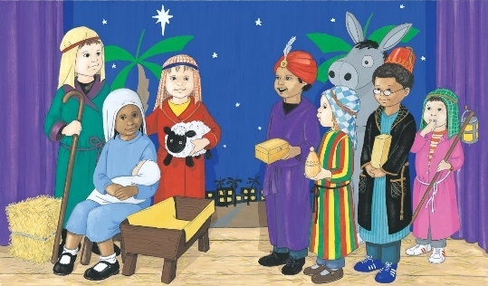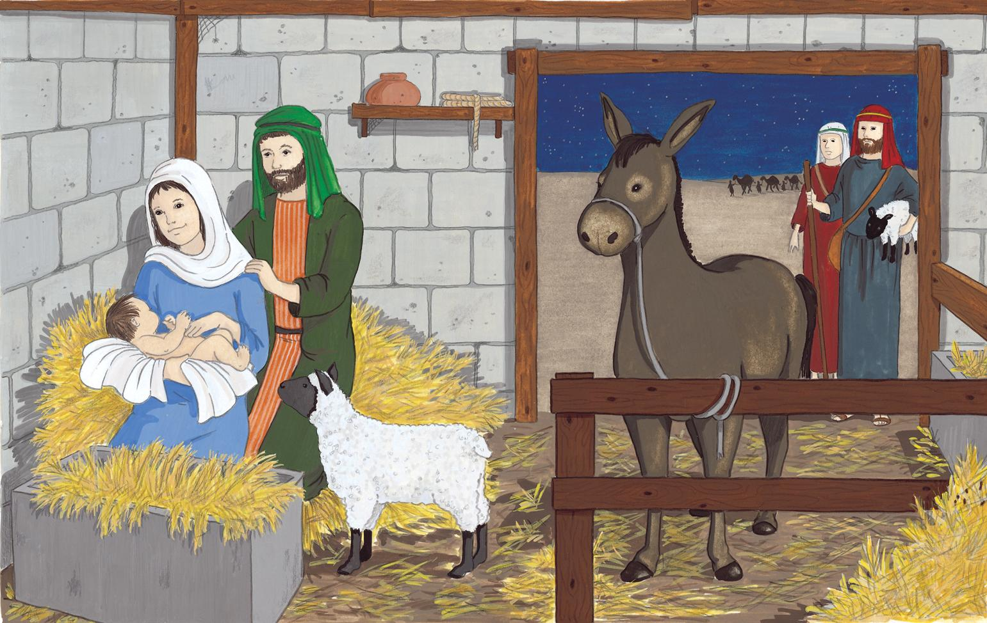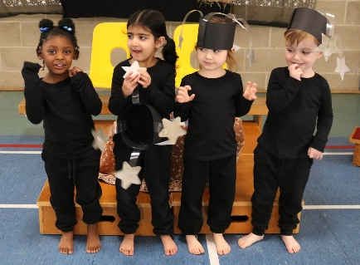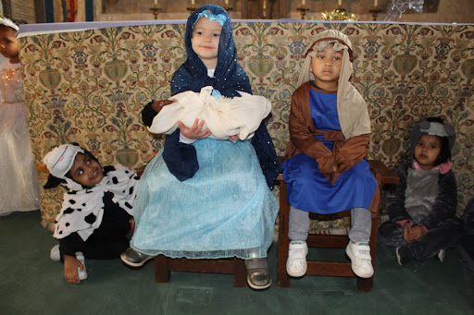

Assess …. WAYS OF KNOWING |  | Informal / Formal Assessment Comments
UNDERSTAND
What will I see and hear to help me understand?
- The Bible as a special book.
- Begin to hear about Mary.
- Mary was going to have a special baby called Jesus.
- God loves me.
- Jesus loves me.
- Jesus is born.
- Mary, Joseph and Jesus are a special family called the Holy Family.
DISCERN
How will I discover more?
- Beginning to talk about Advent traditions.
- How will I discover more?
- Jesus is born to love everyone.
- Jesus was born in a manger/stable.
- Look at and talk about pictures/paintings that depict the Holy Family.
- Sharing Advent promises
RESPOND
What can I do now?
- Singing Advent songs and Christmas carols.
- Know that God loves me, Jesus loves me.
- God sent Jesus as a special gift, to love us all.
- Getting ready for Christmas sharing and doing our Advent promises
Enhancing the Religious Education Curriculum
- Previous Knowledge
- Key Vocabulary
- Timeline
- Equality
- Drama/Role Play
- Poetry
- Catholic Social Teaching
- RSHE
- Parents/ Carers
- Home/school/parish
- Parish Priest
- Parish Deacon
- Parish Catechists
- Governors
- Liturgy
- Sacramental Foundations
- Storytelling
- Liturgical Colour Boxes
- Philosophy
- Inclusion
- Culture
- AWE & WONDER
- Seasons/The Natural World
- Beauty
- Senses
- Music
- Art
- Dance
 | Further Resources  - Come and See  - John Burland  - Look at the back of each God’s & Church’s Story for further questions and ideas  - You Cat for Kids  - USEFUL LINKS  - https://www.sensorytrust.org.uk/  - Music  - https://www.cjmmusic.com/songs/  - https://www.ocp.org/en-us/artists/1092/bernadette-farrell  - https://www.joannewallace.co.uk/  - https://johnburland.net/  - https://www.classicfm.com/  - https://www.onelifemusic.co.uk/  - https://www.ocp.org/en-us/artists/1092/bernadette-farrell#songs  - https://www.kevinmayhew.com/collections/childrens  - Philosophy  - https://www.plato-philosophy.org/philosophy-toolkit/  - https://www.bbc.co.uk/cbeebies/shows/whats-the-big-idea  - file:///C:/Users/Julie/Downloads/GM%20An%20outdoor%20'treasure'%20hunt.pdf  - https://archive.sapere.org.uk/Default.aspx?tabid=289  https://www.catholiceducation.org/en/religion-and-philosophy/philosophy/can-beauty-save-the-world.html |  | Cross-Curricular Links  Please see Religious Education within the of Areas of Learning p.2
Key Words |  |  | Skill/Driver words  Recognise, Retell, Describe  Wonder, Talk about, Ask

RELG: Religious Education Learning Goals across Areas of Learning
Religious Education | Please refer to the Ways of Knowing on the teaching sequence pages…
Personal, Social and Emotional Development | Self-Regulation  - Show an understanding of their own feelings and those of others and begin to regulate their behaviour accordingly.  - Begin to share thoughts about what is fair, unfair, caring and sharing.  - Begin to understand how to show love for others in appropriate ways.  Managing Self  - Aware of the need for rules, know right from wrong and try to behave accordingly.  - Experience and begin to understand that saying sorry and forgiving one another can help them in their friendships.  - Begin to experience how the Sacrament of Reconciliation can help them to say sorry to God.  Building Relationships  - Using the example of Jesus in stories they have heard and read be able to work and play cooperatively and take turns with others.  - Form positive attachments to adults and friendships with peers.  - Show sensitivity to their own and others’ needs and know about similarities and differences between themselves and others.
Communication and Language | - Listen attentively and respond to Bible and religious stories with relevant questions, comments and actions when being read to and during whole-class discussions and small group interactions as well as class and school prayer and liturgy.  - Make comments about what they have heard and ask questions to clarify their understanding.  - Hold conversations when engaged in back-and-forth exchanges with their teachers and peers.  Speaking Children at the expected level of development will:  - Participate in small group, class and one-to-one discussions, offering their own ideas, using recently introduced religious vocabulary.  - Offer explanations for why things might happen, making use of recently introduced key religious vocabulary.  - Express their ideas and feelings about their religious experiences using full sentences with modelling and support from their teacher.
Physical Development | - Use fine and gross motor skills to express feelings, and to recognise and describe events within Bible and religious stories they have heard or read about.  - Capture religious experiences and respond through the use of e.g., dance, role-play arts and crafts.  - Express themselves when responding to songs and hymns they have listened to and learned.
Literacy | Comprehension  - Demonstrate understanding of what has been read to them by retelling Bible and religious stories and using their own words and recently introduced religious vocabulary.  - Anticipate – where appropriate – key events in Bible and religious stories.  - Use and understand recently introduced key religious vocabulary during discussions about Bible and religious stories, or during times of prayer, liturgy and role play.  Word Reading  - Begin to recognise and read key religious words.  - Read aloud their own sentences using key religious words about Bible and religious stories they have heard.  - Read aloud in a group or individually simple phrases/sentences from age-appropriate Scripture.  Writing  - Recognise and begin to spell key religious words.  Write simple phrases and sentences about Bible and religious stories or simple prayers.
Understanding the World | Past and Present  - Talk about the lives and roles of the Parish Priest and people in their local parish.  - Know some similarities and differences between things in the past and now, drawing on their experiences and what has been read about in Bible and religious stories they have heard.  - Begin to understand the past through settings, people and events encountered in Bible and religious stories.  - Recognise key people in the history of the people of God.  People Culture and Communities  - Talk about their immediate environment around them noticing God’s wonderful world.  - Build an understanding that they are part of a parish, school, local and global community.  - Know that they are a child of God. God made them and loves them.  - Recognise experiences of Baptism and being welcomed into the church and parish family.  - Know some similarities and differences between different religious and faith communities in this country and/or their community.  - Know some similarities and differences between life in this country and life in other countries.  - Recognise religious signs and symbols.  The Natural World  - Read Bible and religious stories about how God created the world. Use the descriptions to gain an understanding of the beauty, awe and wonder and seasons of the natural world.  - Talk about the gifts given to people by God that help us to make and build and work.  - Know some similarities and differences between people and places around the world.  Know that they are responsible for looking after their world and experience ways in which they can make a change.
Expressive Art & Design | Creating with materials  • Share their creations and talk about what this represents from their learning.  • Make use of props and materials when role-playing people they have heard about in Bible narratives  and stories.  Being imaginative and expressive  • Recount Bible stories, poems, and prayers.  • In a variety of ways, recount narratives and stories about key figures from the Bible they have read and  heard about with peers and their teacher.  • Sing and perform a range of rhymes, songs, and new and traditional hymns connected to the religious  stories they have read and heard about, and that link to the liturgical year.  • Use songs and hymns to move and dance in time to the music, expressing their feelings in response to  Bible stories and religious experience.

