z


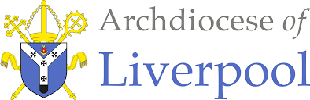

To Know You More Clearly
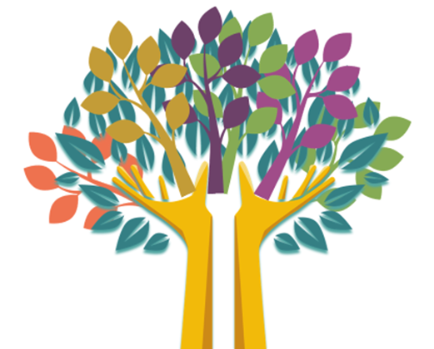
The Religious Education Directory
EYFS Nursery Scheme of Work
Creation & Covenant
Education Department

EYFS Nursery Creation & Covenant
Overview  Creation and covenant: ‘The heavens are telling the glory of God’ (Ps 19:1).  In this branch, pupils will encounter the God who creates and calls a people. | Introduction  Introduction of the Bible to children.  *Prior Learning - Introducing God “This is a very special book; do you want to feel how heavy it is? It is different from our other story books. Why? It is bigger, it has lots of words, not many pictures …This book is called a Bible. Can you say Bible… *The Bible tells us all about God. We have to keep this in a very special place (prayer space/focus, place the book with the title Bible and the ‘word’ God)  *Can you remember where our special book is? Who can remember what the book is called? Remember this book tells us all about God. Would you like to hear a special story about God today? Leading to the Creation story.  - Please remember to use a Good News Bible – whilst this is not an accessible read for children they need to experience what a Bible looks like, and how it is used – just as in other religions in Christianity this is a sacred book and needs to be treated with the utmost respect and care.  - Children will see how you as an adult use the Bible – they may not understand the words but it is our job then to retell the story in as many ways as possible – through retelling, crafts, art, dance etc… etc… | General Guidance  - Planning aims to progress the children in understanding who God is and what we can do as part of God’s wonderful world. Please begin with Hear for each sequence.  - The sequences themselves as a whole may be best suited in a different order especially considering the age and stage of the children.  - Also, there may be times when you may wish to teach Believe, Celebrate and Live in a different order following Hear or together to suit the needs of the children.  - The activities within the sequences are suggested and you do not need to cover them all! Just ensure you are covering 10% of your curriculum time each week for Religious Education.  - The first teaching sequence will be what the Bible is and introducing to some about God.  Prayer & Liturgy opportunities …  through the Sign of the Cross, the Creation story.

Religious Education within the of Areas of Learning EYFS NURSERY BRANCH 1
Ways of Knowing

TEACHING SEQUENCE EYFS NURSERY BRANCH 1

HEAR | BELIEVE | CELEBRATE |  | LIVE | WAYS OF KNOWING
*Prior Learning - Introducing God “This is a very special book; do you want to feel how heavy it is? It is different from our other storybooks. Why? It is bigger, it has lots of words, but not many pictures …This book is called the Bible. Can you say Bible… | The Bible tells us all about God. We have to keep this in a very special place (prayer space/focus, place the book with the title Bible and the ‘word’ God) | Introduce…  The words and actions of the Sign of the Cross:  “In the name of the Father, and of the Son and of the Holy Spirit. Amen” |  | Can you remember where our special book is? Who can remember what the book is called? Remember this book tells us all about God. Would you like to hear a special story about God today? Leading to the Creation story. | UNDERSTAND  What will I see and hear to help me understand?  - Introduction of the Bible to children. Please use the italics as you see fit in class over time and please adapt to suit the needs of the children  - Begin to see, hear about the Sign of the Cross  - Begin to see and hear about the Bible
DISCERN
How will I discover more?

RESPOND
What can I do now?
Scripture (HEAR) Good News Translation
HEAR
Teacher notes
Suggested Resources  - Golden box  - Good News Bible  - Cloth  - Bible stand |  |  | Learning Activities  - Gather the children together whilst playing calm music – Explain to the children that you brought something so precious for them to see that it needs to be kept very safe and handled with great care.  - Show children a golden box or similar. Carefully lift out the Bible “This is a very special book, show a storybook, this very different why?; it is very heavy, would you like to feel it? Demonstrate to the children how to handle with great care – it is precious – explore the word precious (add to a word wall). Pass the Bible around the circle –  - This is called a bible – Can you say Bible? My turn, Bible Our Turn, Bible Your turn, Bible

BELIEVE
Suggested Resources  - Golden box  - Good News Bible  - Cloth  - Bible stand  - Word Wall | Learning Activities  - This Bible tells us all about God, it has lots of stories in it that we are going to listen to together. It is so special that we need to make sure it stays safe – how can we do that? Introduce the children to the focus area and explain that we can come here to pray. Dress the focus table together - Demonstrate putting it on the focus table on the stand – explain that it is ok to look at it but we must handle it with care and it must always live in this special place.  - Add the words Bible and God to the word wall.  Continuous Provision  - Prayer focus area

CELEBRATE
Suggested Resources  - School prayers  - Sing Sign of the Cross – John Burland  https://www.youtube.com/watch?v=B_gGERoqhW0  - Sign of the Cross around the World  https://www.youtube.com/watch?v=QwFausSrBuc | Learning Activities  - Add the school prayers to the focus table and introduce the concept of prayer – a time when we talk to God or think about God inside our heads – we can be silent.  - Introduce the words and actions of the Sign of the Cross. “In the name of the Father and the Son and of the Holy Spirit. Amen  - Say the school prayer – begin and end with the Sign of the Cross  Continuous Provision  - Prayer focus area  - Mirror sign of the Cross

LIVE
Suggested Resources  - Key Vocabulary from Word Wall  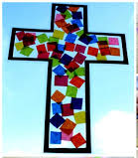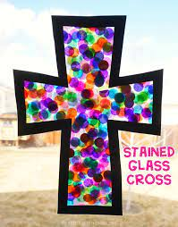  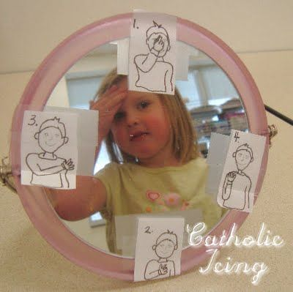 | Learning Activities  - Play calm music as the children gather – Can children recall why we have gathered in this special place? Can you remember where our special book is? Can you remember what it is called? Can you remember what it tells us? Remind them it contains stories about God.  - Put a mirror in the role-play corner so that children may practice making the Sign of the Cross.  - Make crosses using the stained-glass window technique – biscuits with melted sweets.  - Paper crosses for display.  Continuous Provision  - Prayer focus area  - Mirror – Sign of the Cross  - Cross templates craft

Assess Pupils’…..WAYS OF KNOWING | Informal / Formal Assessment Comments
UNDERSTAND
What will I see and hear to help me understand?
- Introduction of the Bible to children. Please use the italics as you see fit in class over time and please adapt to suit the needs of the children
- Begin to see, hear about the Sign of the Cross
- Begin to see and hear about the Bible

TEACHING SEQUENCE EYFS NURSERY BRANCH 1

HEAR | BELIEVE | CELEBRATE |  | LIVE | WAYS OF KNOWING
God made our world.  God made our beautiful world.  God made our wonderful world. | God made the wonderful world. | Give thanks for God’s wonderful world.  ONGOING  The words and actions of the Sign of the Cross:  “In the name of the Father, and of the Son and of the Holy Spirit. Amen” |  | Look after God’s world. | UNDERSTAND  What will I see and hear to help me understand?  - Introduction to the first story about what God did.  - God made our world.  - God made our world – beautiful.  - God made our world – wonderful.  - Ongoing - See and hear about the Sign of the Cross  - Ongoing - See and hear about the Bible
DISCERN
How will I discover more?
- Explore all the good things that make our world beautiful and wonderful.
- The season of Autumn – activities related
RESPOND
What can I do now?
- Share and show how we can say thank you to God for everything he has made for us.
- Share and show how we can look after God’s world.
- Role play – gardener/vet
Scripture (HEAR) Good News Translation
Genesis 1: 31
- *Remind children of the special place where we keep the Bible in class. Remember there are lots of words but you will help them to know and understand more about the stories that are in the Bible.
- You don’t need to read the exact words to the children. Just the experience at this age of picking up the Bible and talking about the stories inside.
- Say to the children, open the Bible to the first story … ‘The Bible’s first story is all about the world that God made. He made the moon and the stars for night-time, the sun for day-time, the seas, the sky, the soil, the grass, the plants, fruit, vegetables, fish, birds, all kinds of animals … so many things! He kept adding more and more beautiful things until he was very happy. He said it was very good.
HEAR
Teacher notes
- Please follow as suggested above. Please adapt to suit the needs of learners in your class.
- The word beautiful is used first as this links to the beauty of God’s world – this is quite a deep question because as adults why do we describe something as beautiful? Is it built into us as humans or taught? By using the word at this stage of learning children come to see and witness the beauty there is all around them.
Suggested Resources  - Good news Bible  - Golden Box  - Globe  - Photos/images of what God made.  - Word wall |  |  | Learning Activities  - Re-tell using golden box and place items in that will represent – perhaps using sensory materials. Voile is good to use for the sea, clouds and let the children feel this.  - Share the story using Golden story box. Pull out a dark cloth to begin with and create a dark space. Shed light on the cloth. Add blue cloth and then patches of artificial grass/green material for land. Then add animal figures.  - Share the word beautiful – add this to the word wall. Exploring the school environment indoors and outdoors Find beautiful items, pictures, images – go exploring – outside and inside – collect things that the children think are beautiful. Can they talk about something beautiful? Perhaps they will talk about mum or nan etc – say that God made them too.  - Make a table for sorting/exploring beautiful things.  - Create a timeline – add The creation story to it. Over time add all of the things that God made that is good.  - Autumn activities  - Go on a walk to the park or other local area to find and spot beautiful things.  Continuous Provision  - Prayer focus area  - Golden Box – sensory items  - Collection of beautiful things to sort  - Autumn crafts/messy table

BELIEVE
Teacher’s Notes
- We have lots of beautiful things all around us. Talk about the display/ images etc created – all of these things are wonderful!
- There are so many beautiful things that we can say they are wonderful!

Suggested Resources  Word Wall | Learning Activities  - Introduce the word ‘wonderful’ to the children. You may wish to follow the suggestion above for collectively calling the beautiful things – wonderful.  - Use real photos from around the world of all different environments and cultures to allow the children to see the beauty of all that God created. Use the word wonderful to describe them all.  - Add the word ‘wonderful’ to the word wall.  - Make a big sentence on the wall – God’s wonderful world. And underneath put all of the beautiful things.  - Make a collage for the banner God’s wonderful world. and children to add to the letters to decorate with tissue paper or other suitable materials.  Continuous Provision  - Prayer focus area  - Golden Box – retell the story  - Autumn

CELEBRATE
Suggested Resources  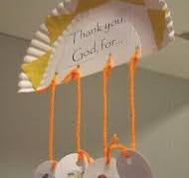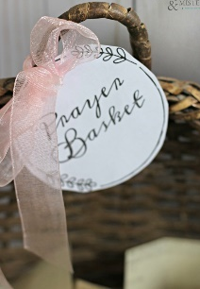 | Learning Activities  - Introduce a prayer thanking God for our wonderful world. Open and conclude with words and actions of the Sign of the Cross.  - Make thank you area/display/crafts – paper plates decorated with things they are thankful for.  - Provide a prayer basket/box for the children to place items/pictures of things they want to thank God for and use this in Collective Worship.

LIVE
Suggested Resources | Learning Activities  - How can we look after God’s world?  Watering Plants  Feeding our pets  Putting our rubbish in the bin  Plant seeds and nurture them – create a class diary – admire the beauty of the flowers.  Tidy our toys away.  - Go on an environmental walk, stop and take time to reflect- admire the beauty of it. Children to take photos with support or notice/ talk about the environment – lie down and look at the sky – admire the beauty of it. Ask children what their favourite thing was they saw – allow the children to write/ mark make or scribe for them.  - Create a book called ‘God’s Wonderful World’ – stick in their photographs and their writing. Did they spot any places where God’s world is not being cared for? Can we do anything to help?  - Create artwork by using recycled items/ junk modelling.  Continuous Provision  - Gardening centre – outdoor  - Vets – indoor  - Further ideas for environmental role play - https://www.educationnaturepark.org.uk/sites/default/files/2023-09/Role%20Play%20Guide.pdf

Assess Pupils’…..WAYS OF KNOWING | Informal / Formal Assessment Comments
UNDERSTAND
What will I see and hear to help me understand?
- Introduction to the first story about what God did.
- God made our world.
- God made our world – beautiful.
- God made our world – wonderful.
- Ongoing - See and hear about the Sign of the Cross
Ongoing - See and hear about the Bible
DISCERN
How will I discover more?
- Explore all the good things that make our world beautiful and wonderful.
- The season of Autumn – activities related
RESPOND
What can I do now?
- Share and show how we can say thank you to God for everything he has made for us.
- Share and show how we can look after God’s world.
- Role play – gardener/vet

TEACHING SEQUENCE EYFS NURSERY BRANCH 1

HEAR | BELIEVE | CELEBRATE |  | LIVE | WAYS OF KNOWING
God made our wonderful world and everything in it.  We can find beautiful things in it. | God made the wonderful world. | Give thanks for God’s wonderful world.  ONGOING  The words and actions of the Sign of the Cross:  “In the name of the Father, and of the Son and of the Holy Spirit. Amen” |  | Look after God’s world. | UNDERSTAND  What will I see and hear to help me understand?  - God made our wonderful world and we can find beautiful things in it.  - We can give thanks to God for our wonderful world.
DISCERN
How will I discover more?
- Autumn activities
- Harvest activities
- Looking after God’s world – gardener/vet
- Environmental role play
RESPOND
What can I do now?
- Practice saying thank you to God for our wonderful world and food we eat
- We can help God to look after everything he made.
Scripture (HEAR) Good News Translation
HEAR
Teacher notes
The belief that God’s world is wonderful – can be revisited as the seasons change – How has our environment changed? In what ways is our world wonderful/beautiful now?
Some children may be aware that humans make some things and we are part of the beautiful things in Gods wonderful world.
Suggested Resources |  |  | Learning Activities  - Re-tell the Scripture using the Golden Box – include items that children have found/explored/gathered – reinforce and deepen the message.  - Create a collective painting with different groups creating different elements of our world – sky, sea, sponge printing animal  Continuous Provision  - As above ongoing

BELIEVE
Suggested Resources  Harvest  - Cauliflowers Fluffy – good images  https://www.youtube.com/watch?v=PukdaXUzgOU  Harvest on the Farm - CBeebies  - https://www.youtube.com/watch?v=5d2Mft72CXg  The Farmer plants the seeds  - https://www.youtube.com/watch?v=cRhGOdqWIIo | Learning Activities  - Take part in or have your own Harvest Festival – this may be done with CAFOD etc in your school.  - Wealth of early years activities for Harvest - https://www.educatall.com/page/419/Harvest-time.html  Continuous Provision  - Ongoing from previous  - Harvest activities

CELEBRATE
Prayer & Hymn  - Bernadette Farrell – Thank you God for the gift of creation  https://www.youtube.com/watch?v=3ydaU34XgxA  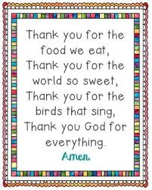  Sung version  https://www.youtube.com/watch?v=06czeWrFex4 | Learning Activities  - Harvest Festival – learn and perform songs – record and share with parents and carers  - Collect food for the local food bank  - Invite parents and carers in to give thanks for the food that grows and harvest.  - Autumn breakfast/stay and pray  - Open and Conclude with words and actions of the sign of the Cross for each prayer  - MacMillan Coffee Morning – CST – HUMAN DIGNITY & COMMON GOOD Thanking God  Continuous Provision  - Additions to the prayer table – thanking God for the food we eat.

LIVE
Suggested Resources  - Tidy by Emily Gravett -https://www.youtube.com/watch?v=rIguZD1y79Y | Learning Activities  - Listen to the story Tidy – what was wrong? How was it fixed? What would you do? Were people looking after God’s world? How?  - Hold a recycling week – CST – STEWARDSHIP  Continuous Provision  - Environmental role play

Assess Pupils’…..WAYS OF KNOWING | Informal / Formal Assessment Comments
UNDERSTAND
What will I see and hear to help me understand?
- God made our wonderful world and we can find beautiful things in it.
- We can give thanks to God for our wonderful world.

DISCERN
How will I discover more?
- Autumn activities
- Harvest activities
- Looking after God’s world – gardener/vet
- Environmental role play
RESPOND
What can I do now?
- Practice saying thank you to God for our wonderful world and food we eat
- We can help God to look after everything he made.

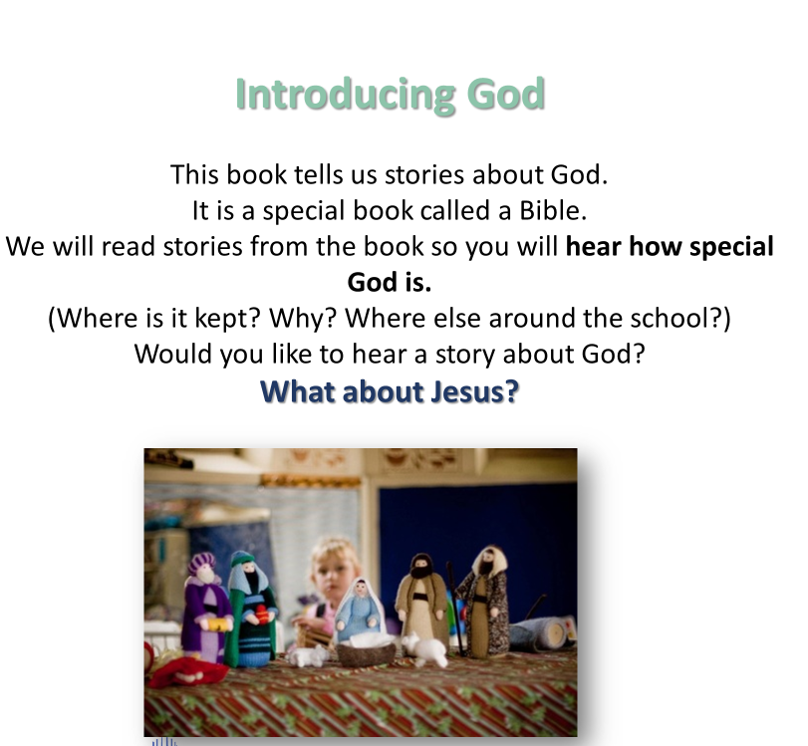
Teachers Notes – Further Understanding
Towards the end of this Branch children will have heard and explored their understanding of God. The next Branch is how as teachers we introduce Jesus.
The concept of young children understanding that God is Jesus and the Holy Spirit is very difficult. It is difficult for adults to understand it. In Christianity we call this the Trinity and can be explained to adults below…
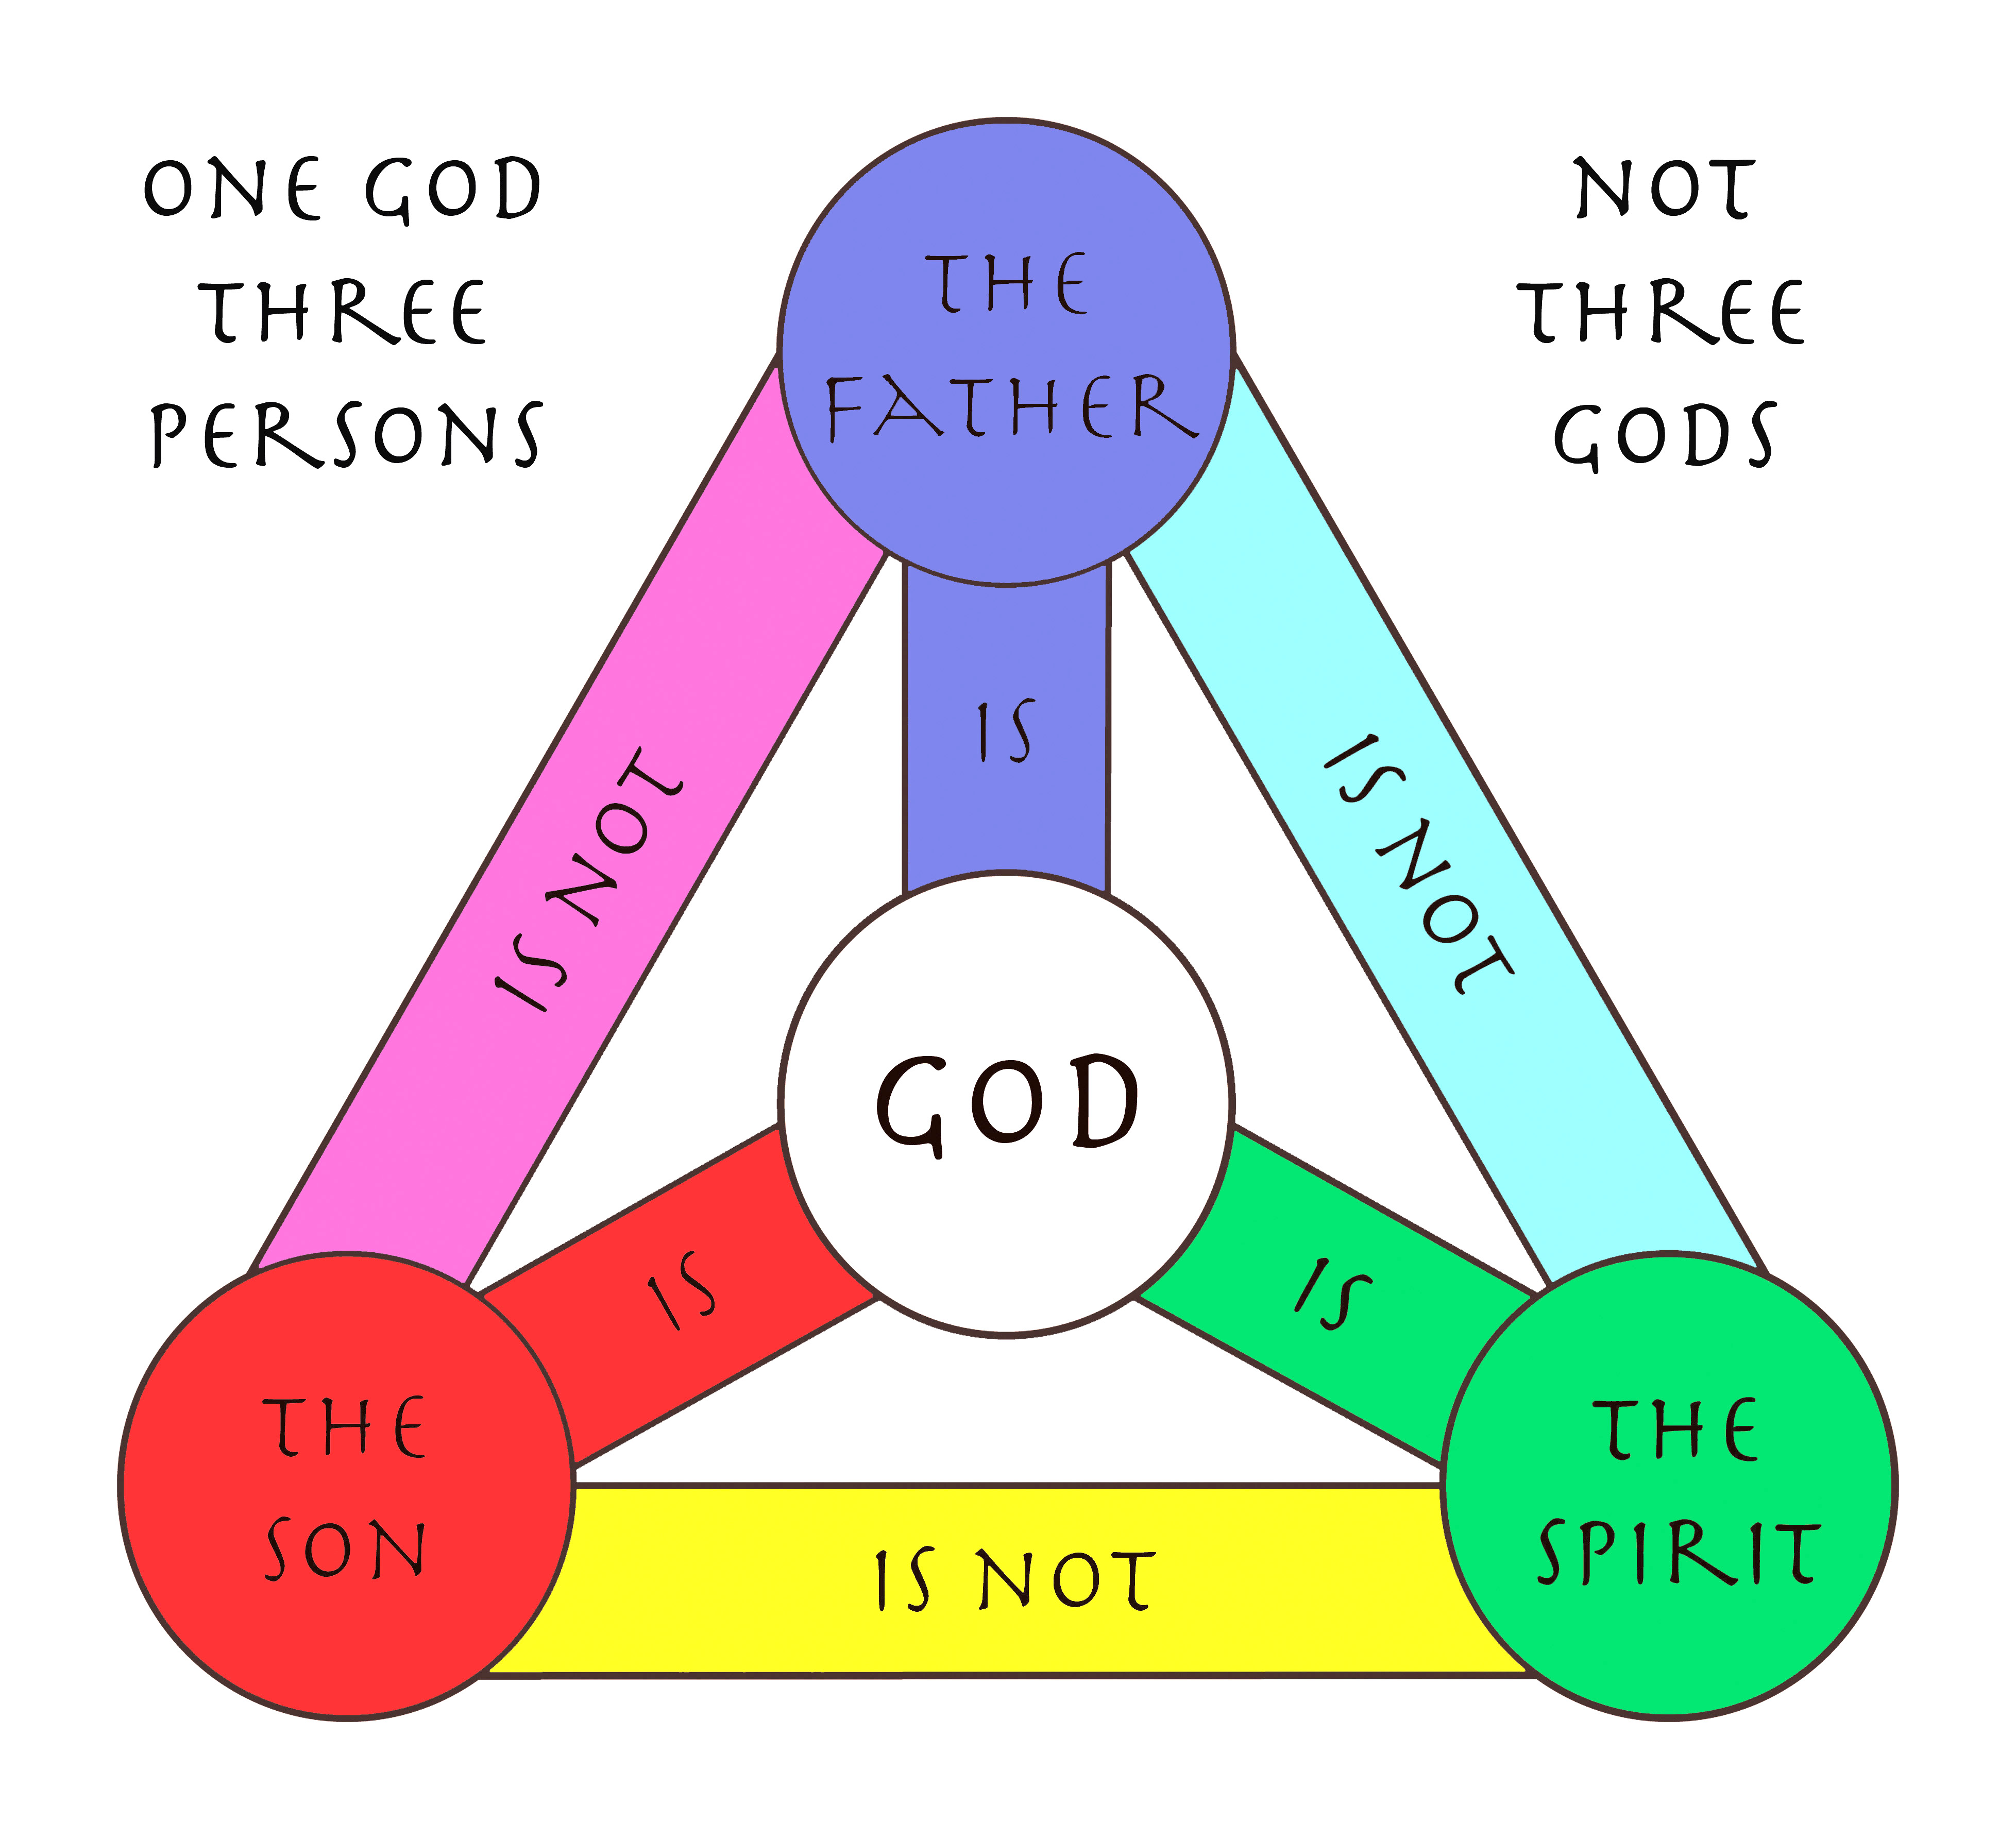
Children will learn them separately and begin to make connections at a later stage of learning.
For now, before the end of the Branch, place the Holy Family – Mary, Joseph and Jesus in a special place in the classroom.
As the next sequence talks about families and humans – and we thank God for them - this may spark questions with the children about this new family they will learn about soon. You may wish to say/or something similar… this is a family that we are going to learn all about soon. There are lots of stories about this family in the Bible.
This enables the child to wonder about and link that there are other stories to hear about from the special book.

TEACHING SEQUENCE EYFS NURSERY BRANCH 1

HEAR | BELIEVE | CELEBRATE |  | LIVE | WAYS OF KNOWING
God made me. | God made me.  God loves me.  God loves everyone. | Give thanks to God for making me.  ONGOING  The words and actions of the Sign of the Cross:  “In the name of the Father, and of the Son and of the Holy Spirit. Amen” |  | Look after me. | UNDERSTAND  What will I see and hear to help me understand?  - God made me.  - God loves me.  - God loves everyone.
DISCERN
How will I discover more?
- God made the wonderful world but he also made me
- I am beautiful
- I am wonderful
- God loves me and everyone I know.
RESPOND
What can I do now?
- Thank you to God for making me.
- Thank you to God for making everyone I know.
- God loves everyone.
- Identifying new places, talking about who has made each thing, meeting new people in the school.
- Identifying people who can help them.

Scripture (HEAR) Good News Translation
HEAR
Teacher notes
Suggested Resources  Hymn  - Bernadette Farrell I am Special  https://www.youtube.com/watch?v=Y5kxasqP-W8  Books  - I love me! By Marvyn Harrison  - Super Duper you! By Sophy Henn |  |  | Learning Activities  - Re-tell the Scripture using the Golden Box – include items they are familiar with but also include peg dolls or similar to share that God made me and you. We are all special because God made us and he loves us very much. God loves everyone.  - Why are you special; children explore their faces using mirrors, children describe one of their features e.g. I am special because I have brown hair etc.  - Use play dough/Clay/Salt dough to create a model of themselves. What colour will you need for your eyes/hair etc?  Continuous Provision  - Golden Box items  - Mirrors – draw faces etc  - Modelling

BELIEVE
Suggested Resources | Learning Activities  - Children use a mirror to explore their unique features and say “God made me” – create a self-portrait and display it with the title ‘God made me and he loves me’  - During circle time- children select a photo and give it to that person saying, “God loves you”. Practitioners to support those children who are not yet ready to articulate.  Continuous Provision  - Mirrors – self-portrait practice

CELEBRATE
Suggested Resources  - The Family Book – Todd Parr  https://www.youtube.com/watch?v=AyVL9bH0guk | Learning Activities  - Listening games – learning each other’s names and those of special people who can help them around school.  - Make name cards to display in class- use to support name writing. Include staff names and photos  - Take or bring in photos of each other – for display. Maybe combine with self-portraits. Use photos and name cards for an outdoor hunt  - Read The Family Book – explore the different families. God loves everyone. Explore Families – who is in your family? Involve families by asking for family photos – create a family tree (display or real)  - Draw pictures of themselves with their family – can you name them?  - Family jigsaws – own family picture laminated and cut up.  - Together write a thank you prayer – thanking God for making us all.  - Thank you prayer for my family.  - Include the Holy Family (see notes above) for children to notice a new family in the classroom.  Continuous Provision  - Small world play – families  - Thank you for …. Writing area

LIVE
Suggested Resources | Learning Activities  - God loves and looks after us all, even when we are happy, sad , angry etc – explore emotions  - Discuss ways in which we can help to look after other people, just like God looks after us. Make a promise  - Create a display with ideas – how will they look after their pet or family member?  - Parents/carers could send in pictures of their child carrying out their promise – celebrate their achievements with a certificate.  Continuous Provision  - Emotions sorting  - Environment  - Doctors role play  - Family role play – home corner

Assess Pupils’…..WAYS OF KNOWING | Informal / Formal Assessment Comments
UNDERSTAND
What will I see and hear to help me understand?
- God made me.
- God loves me.
- God loves everyone.

DISCERN
How will I discover more?
- God made the wonderful world but he also made me
- I am beautiful
- I am wonderful
- God loves me and everyone I know.
RESPOND
What can I do now?
- Thank you to God for making me.
- Thank you to God for making everyone I know.
- God loves everyone.
- Identifying new places, talking about who has made each thing, meeting new people in the school.
- Identifying people who can help them.

Assess …. WAYS OF KNOWING |  | Informal / Formal Assessment Comments
UNDERSTAND
What will I see and hear to help me understand?
- Introduction of the Bible to children. Please use the italics as you see fit in class over time and please adapt to suit the needs of the children
- Begin to see, hear about the Sign of the Cross
- Begin to see and hear about the Bible
- Introduction to the first story about what God did.
- God made our world.
- God made our world – beautiful.
- God made our world – wonderful.
- God made our wonderful world and we can find beautiful things in it.
- We can give thanks to God for our wonderful world.
- God made me.
- God loves me.
- God loves everyone.
DISCERN
How will I discover more?
- Explore all the good things that make our world beautiful and wonderful.
- The season of Autumn – activities related
- Autumn activities
- Harvest activities
- Looking after God’s world – gardener/vet
- Environmental role play
- God made the wonderful world but he also made me
- I am beautiful
- I am wonderful
- God loves me and everyone I know.
RESPOND
What can I do now?
- Share and show how we can say thank you to God for everything he has made for us.
- Share and show how we can look after God’s world.
- Role play – gardener/vet
- Practice saying thank you to God for our wonderful world and food we eat
- We can help God to look after everything he made.Thank you to God for making me.
- Thank you to God for making everyone I know.
- God loves everyone.
- Identifying new places, talking about who has made each thing, meeting new people in the school.
- Identifying people who can help them.
Enhancing the Religious Education Curriculum
- Previous Knowledge
- Key Vocabulary
- Timeline
- Equality
- Drama/Role Play
- Poetry
- Catholic Social Teaching
- RSHE
- Parents/ Carers
- Home/school/parish
- Parish Priest
- Parish Deacon
- Parish Catechists
- Governors
- Liturgy
- Sacramental Foundations
- Storytelling
- Liturgical Colour Boxes
- Philosophy
- Inclusion
- Culture
- AWE & WONDER
- Seasons/The Natural World
- Beauty
- Senses
- Music
- Art
- Dance
 | Further Resources  - Come and See  - John Burland  - Look at the back of each God’s & Church’s Story for further questions and ideas  - You Cat for Kids  - USEFUL LINKS  - https://www.sensorytrust.org.uk/  - Music  - https://www.cjmmusic.com/songs/  - https://www.ocp.org/en-us/artists/1092/bernadette-farrell  - https://www.joannewallace.co.uk/  - https://johnburland.net/  - https://www.classicfm.com/  - https://www.onelifemusic.co.uk/  - https://www.ocp.org/en-us/artists/1092/bernadette-farrell#songs  - https://www.kevinmayhew.com/collections/childrens  - Philosophy  - https://www.plato-philosophy.org/philosophy-toolkit/  - https://www.bbc.co.uk/cbeebies/shows/whats-the-big-idea  - file:///C:/Users/Julie/Downloads/GM%20An%20outdoor%20'treasure'%20hunt.pdf  - https://archive.sapere.org.uk/Default.aspx?tabid=289  https://www.catholiceducation.org/en/religion-and-philosophy/philosophy/can-beauty-save-the-world.html |  | Cross-Curricular Links  Please see Religious Education within the of Areas of Learning p.2
Key Words |  |  | Skill/Driver words  Recognise, Retell, Describe  Wonder, Talk about, Ask

RELG: Religious Education Learning Goals across Areas of Learning
Religious Education | Please refer to the Ways of Knowing on the teaching sequence pages…
Personal, Social and Emotional Development | Self-Regulation  - Show an understanding of their own feelings and those of others and begin to regulate their behaviour accordingly.  - Begin to share thoughts about what is fair, unfair, caring and sharing.  - Begin to understand how to show love for others in appropriate ways.  Managing Self  - Aware of the need for rules, know right from wrong and try to behave accordingly.  - Experience and begin to understand that saying sorry and forgiving one another can help them in their friendships.  - Begin to experience how the Sacrament of Reconciliation can help them to say sorry to God.  Building Relationships  - Using the example of Jesus in stories they have heard and read be able to work and play cooperatively and take turns with others.  - Form positive attachments to adults and friendships with peers.  - Show sensitivity to their own and others’ needs and know about similarities and differences between themselves and others.
Communication and Language | - Listen attentively and respond to Bible and religious stories with relevant questions, comments and actions when being read to and during whole-class discussions and small group interactions as well as class and school prayer and liturgy.  - Make comments about what they have heard and ask questions to clarify their understanding.  - Hold conversations when engaged in back-and-forth exchanges with their teachers and peers.  Speaking Children at the expected level of development will:  - Participate in small group, class and one-to-one discussions, offering their own ideas, using recently introduced religious vocabulary.  - Offer explanations for why things might happen, making use of recently introduced key religious vocabulary.  - Express their ideas and feelings about their religious experiences using full sentences with modelling and support from their teacher.
Physical Development | - Use fine and gross motor skills to express feelings, and to recognise and describe events within Bible and religious stories they have heard or read about.  - Capture religious experiences and respond through the use of e.g., dance, role-play arts and crafts.  - Express themselves when responding to songs and hymns they have listened to and learned.
Literacy | Comprehension  - Demonstrate understanding of what has been read to them by retelling Bible and religious stories and using their own words and recently introduced religious vocabulary.  - Anticipate – where appropriate – key events in Bible and religious stories.  - Use and understand recently introduced key religious vocabulary during discussions about Bible and religious stories, or during times of prayer, liturgy and role play.  Word Reading  - Begin to recognise and read key religious words.  - Read aloud their own sentences using key religious words about Bible and religious stories they have heard.  - Read aloud in a group or individually simple phrases/sentences from age-appropriate Scripture.  Writing  - Recognise and begin to spell key religious words.  Write simple phrases and sentences about Bible and religious stories or simple prayers.
Understanding the World | Past and Present  - Talk about the lives and roles of the Parish Priest and people in their local parish.  - Know some similarities and differences between things in the past and now, drawing on their experiences and what has been read about in Bible and religious stories they have heard.  - Begin to understand the past through settings, people and events encountered in Bible and religious stories.  - Recognise key people in the history of the people of God.  People Culture and Communities  - Talk about their immediate environment around them noticing God’s wonderful world.  - Build an understanding that they are part of a parish, school, local and global community.  - Know that they are a child of God. God made them and loves them.  - Recognise experiences of Baptism and being welcomed into the church and parish family.  - Know some similarities and differences between different religious and faith communities in this country and/or their community.  - Know some similarities and differences between life in this country and life in other countries.  - Recognise religious signs and symbols.  The Natural World  - Read Bible and religious stories about how God created the world. Use the descriptions to gain an understanding of the beauty, awe and wonder and seasons of the natural world.  - Talk about the gifts given to people by God that help us to make and build and work.  - Know some similarities and differences between people and places around the world.  Know that they are responsible for looking after their world and experience ways in which they can make a change.
Expressive Art & Design | Creating with materials  • Share their creations and talk about what this represents from their learning.  • Make use of props and materials when role-playing people they have heard about in Bible narratives  and stories.  Being imaginative and expressive  • Recount Bible stories, poems, and prayers.  • In a variety of ways, recount narratives and stories about key figures from the Bible they have read and  heard about with peers and their teacher.  • Sing and perform a range of rhymes, songs, and new and traditional hymns connected to the religious  stories they have read and heard about, and that link to the liturgical year.  • Use songs and hymns to move and dance in time to the music, expressing their feelings in response to  Bible stories and religious experience.

