Print in colour to see the RED outcomes for your Year Level

Abraham: from Ur to the Promised Land
Content Area: Covenant
Know the Noah story, focusing on Noah and God’s promise to all living creatures in the sign of the rainbow. (C&C 1.4) – NOT NECESSARY FOR YEAR 1
Be familiar with the story of Abraham. (C&C 2.4)

Talk about the covenant God made with Abram. (C&C 2.5)

Retell the story of the birth of Moses and be able to talk about how he led the Israelites to freedom. (C&C 2.6)
Retell the story of Abraham, (Gen 11 – 24) ensuring it is accurate in sequence, detail, and shows an understanding of the term ‘covenant’.
(C&C 3.4)

Show some understanding of the historical context of Abraham (and Joseph) and the cultural and religious context out of which he/they were called. (C&C 3.5)

Show some understanding of how decisions of Abraham (and Joseph) were informed by their faith, hope and love in God. (C&C 3.6)

Recognise that God’s covenant with Abraham is the foundation of the faith of people of the Old and New testaments: Judaism and Christianity. (C&C 3.7)
Give an overview of the story of Exodus, focusing on the final plague – the Passover. (C&C 4.5)

Describe moments in Moses’ leadership: reluctance, courage, obedience, trust, fidelity (faithfulness) (C&C 4.6)

Describe the role of the women, especially Miriam (Moses’ sister) and Jochebed (Moses’ mother) in saving Moses. (C&C 4.7)
Revisit and summarise the covenants with Noah (Gen 6:1-9:17), Abraham (Gen 15 and 17), and the Israelites (Ex 19) (C&C 5.3)

Correctly use developing specialist vocabulary to describe what a covenant is, recognizing that God made several covenants throughout history. eg Noah, Abraham, Moses. (C&C 5.4)

Explain the notion of covenant with reference to climate change. (C&C 5.5)
Retell the Moses story, focusing on the two key events of the call and the covenant (the burning bush – Ex 3:1-15); the Sinai covenant and the ten commandments. (Ex 19:3-8, 20:1-17) (C&C 6.4)
Show an understanding of a passage of Old Testament scripture that shows the importance of women in salvation history, recognizing authorial intention and historical context. (C&C 6.5)
Show an understanding of one of the following Old Testament scripture passages that show the importance of women in salvation history. (Miriam Ex 18-22, 2:1-10) (C&C 6.6)
Use theological language to explain what is meant by describing the women of the Old Testament as ‘true protagonists of salvation history’. (C&C 6.7)

Adapted from NRSV

Instructions:
Read the whole event from start to finish.

Resources suitable for teaching the whole passage are included in or at the back of this resource:
- A ‘fill the gaps’ map (See KIP website)
- Dialogue boxes, interspersed with narration, to role play some sections
- A geographical place map (at the end of the resource)
- Sequencing card example for pupils to illustrate using the 10 subsection titles (at the end of the resource)

Think literacy; you are basically reading a book.

Remember, God is definitely on the Israelites side and will appear to do anything to help and save them. This makes God’s actions more aggressive or violent than we might feel comfortable with. We need to be careful not to lose sight of the nature of the text, written from the winners perspective and their determination to show that ‘their God’ was better and stronger and more powerful than any evil the people could encounter.

Summary of whole story in table below.

Part 1: Abram and Sarai
Abram moves to Canaan: stops at Haran
Abram makes a covenant with God
God repeats the covenant; Abram becomes Abraham
Isaac is born
Isaac finds a wife
Abraham and Sarai die
Part 2: Isaac and Rebekah
Esau and Jacob
Jacob becomes Israel
Part 3: The Israelites in Egypt
Joseph is sold into Egypt
The Israelites come to Egypt

PART 1: Abram and Sarai

Notes: Sons were important as they carried the inheritance of their fathers and the family line so the lack of mention of daughters reflects their lesser importance in a strongly Patriarchal society. An irony, as Judaism as a faith tradition is passed through mothers!

Names mean something, so pay attention to them!
- Abraham: Means ‘father lifted up’ or ‘father exalted’
- Sarah: princess, noble woman
- Jacob: the twin born second. Means ‘he grabs the heel’
- Israel: ‘one who struggles with God’ or ‘turns the head of God.’

If a person changes their character, they change their name!

Don’t try and make the ages of the characters work – this hyperbole! It’s another way to show that God can do anything!

Narrator/Storyteller:

Abram moves to Canaan (Gen 11)

This is the account of Abraham’s family. Terah was the father of 3 sons: Abram, Nahor and Haran. The name of Abram’s wife was Sarai. Now Sarai was childless, meaning she had no children.
Terah took his son Abram and Sarai and his nephew Lot (the son of Haran), and together they set out from their home county of Ur of the Chaldeans towards Canaan. On the way to Canaan they came to Haran, and they settled there. While they were there, Abram’s father, Terah, died.
One day God called to Abraham.
The Lord: Leave your country, your relatives and your father’s home and go to a land that I am going to show you. I will make you into a great nation, and I will bless you; I will make your name great, and you will be a blessing
I will bless those who bless you, and whoever curses you I will curse, and all peoples on earth will be blessed through you.
Narrator/Storyteller:
So, Abram went again, just as the Lord had told him. Abram was seventy-five years old when he set out from Haran. ⁵ He took his wife Sarai, his nephew Lot, all the possessions they had accumulated and the people they had acquired in Harran, and they set out for the land of Canaan, and, in time, they arrived there. The Lord appeared to Abram and said:

The Lord: To your offspring I will give this land.”
So Abram built an altar to the Lord who had appeared to him.
(Pause)
Now there was a famine in the land, and so Abram and his family went to Egypt, including his nephew Lot, to live there for a while. After the famine was over, Abram left Egypt with his wife and everything he had, and Lot went with him. Abram had become very wealthy in livestock and in silver and gold.
They came to Bethel, but the land could not support them all and Abram and Lot began to quarrel.
Abram: Let’s not have any quarrelling between you and me. Let’s part company. If you go to the left, I’ll go to the right; if you go to the right, I’ll go to the left.
So, Lot chose for himself the whole plain of the Jordan and set out toward the east, and Abram went toward the west to live near the great trees of Mamre at Hebron, where he pitched his tents and built an altar to the Lord.

Abram makes a covenant with God (Gen 15)
Narrator/storyteller:
One day, while Abram was living there, the Lord came to him in a vision:
The Lord: Do not be afraid, Abram. I am your shield, your very great reward.”
Abram: Sovereign Lord, what can you give me since I still have no children, and so the one who will inherit my estate will be a servant in my household!
The Lord: This man will not be your heir, but a son who is your own flesh and blood will be your heir.” Come outside. Look up at the sky and count the stars—if indeed you can count them. This is how many offspring you shall have.
Abram: How will I know this will happen?
The Lord: Bring me a sacrifice of a heifer, a goat and a ram, each three years old, along with a dove and a young pigeon.

Narrator/storyteller:
And so, Abram did just that – and sealed the covenant with the sacrifice to the Lord. (Pause)

God repeats the covenant; Abram becomes Abraham: (Gen 17)
Abram and Sarai waited for a long time – but still they had no sons. Then one day when Abram was ninety-nine years old, the Lord appeared to him again.
The Lord: I am God Almighty; walk before me faithfully and be blameless. Then I will make my covenant between me and you and will greatly increase your numbers.”
Abram fell facedown on the ground.
The Lord: This is my covenant with you: You will be the father of many nations. No longer will you be called Abram; your name will be Abraham, for I have made you a father of many nations. I will make you very fruitful; I will make nations of you, and kings will come from you. I will establish my covenant as an everlasting covenant between me and you and your descendants after you for the generations to come, to be your God and the God of your descendants after you. The whole land of Canaan, where you now reside as a foreigner, I will give as an everlasting possession to you and your descendants after you; and I will be their God.”
The Lord: As for you, you must keep my covenant, you and your descendants after you for the generations to come. This is my covenant with you and your descendants after you, the covenant you are to keep. As for Sarai your wife, you are no longer to call her Sarai; her name will be Sarah. I will bless her and will surely give you a son by her. I will bless her so that she will be the mother of nations; kings of peoples will come from her.”
Abraham laughed and said: Will a son be born to a man a hundred years old? Will Sarah bear a child at the age of ninety?
The Lord: Your wife Sarah will bear you a son, and you will call him Isaac. I will establish my covenant with him as an everlasting covenant for his descendants after him. But my covenant I will establish with Isaac, whom Sarah will bear to you by this time next year.
Isaac is born (Gen 21)
Narrator/Storyteller:
So, Abraham and Sarah waited for a year…and finally…Sarah became pregnant and bore a son to Abraham in his old age, at the very time God had promised him. Abraham gave the name Isaac to the son Sarah bore him. Abraham was a hundred years old when his son Isaac was born to him. Sarah said:
Sarah: God has brought me laughter, and everyone who hears about this will laugh with me. Who would have said to Abraham that Sarah would nurse children? Yet I have borne him a son in his old age.

YEAR 2 STOP HERE

Isaac finds a wife (Gen 24)
Isaac grew into a man. Abraham was now very old. One day Abraham told his senior servant in his household, to go back to Ur to find a wife for his son, Isaac. The servant left, taking with him ten of his master’s camels loaded with all kinds of good things from his master.
The servant prayed that God would help him and that he would be successful for his master. Before he had finished praying, Rebekah came out with her jar on her shoulder, to collect water from a well.
Rebekah had a brother named Laban, and he hurried out to the man at the well and said:
Laban: Why are you standing out here? I have prepared the house and a place for the camels.
So Abraham’s servant went home with them and explained that his master had sent him to find a wife for his son. Laban answered, “We can tell that this is from the Lord; we can say nothing to you one way or the other. Here is Rebekah; take her and go, and let her become the wife of Isaac, your master’s son, as the Lord has directed.”
So, they sent their sister Rebekah on her way, along with her nurse and Abraham’s servant and his men.
Now Isaac was out in the field meditating one evening and as he looked up, he saw camels approaching. Rebekah also looked up and saw Isaac. She got down from her camel and asked the servant who the man in the field was.
The servant answered that it was Isaac. So, she took her veil and covered herself. Then the servant told Isaac all he had done. Isaac brought Rebekah into the tent of his mother Sarah, and he married Rebekah.

Abraham and Sarah die
Narrator/storyteller:
Sarah lived to be a hundred and twenty-seven years old. She died at Hebron in the land of Canaan, and Abraham mourned for Sarah and wept over her.
And Abraham? Well, he lived until he was a hundred and seventy-five years. Then Abraham breathed his last and died at a good old age, an old man and full of years; and he was gathered to his people.

PART 2: Isaac and Rebekah

Esau and Jacob (Gen 25)
Narrator/storyteller:
Isaac was 40 years old when he married Rebekah. Because Rebekah had no children Isaac prayed to the Lord and God answered his prayers, and Rebekah became pregnant with twins!
When the time came for her to give birth, she gave birth to two boys. The first to come out was red, and his whole body was like a hairy garment; so, they named him Esau. After this, his brother came out, with his hand grasping at his brothers’ heel; so, he was named Jacob.

The boys grew up, and Esau became a skilful hunter, a man of the open country, while Jacob was content to stay at home among the tents. Isaac, who had a taste for wild game, loved Esau, but Rebekah loved Jacob.

In the ancient world, it was customary for a father to give his blessing to his first-born son before he died. One day when Isaac was very old he called for Esau.

Isaac: Esau, my son.
Esau: Here I am.
Isaac: I am now an old man and don’t know the day of my death. Prepare me the kind of tasty food I like and bring it to me to eat, so that I may give you my blessing before I die.

Now Rebekah was listening as Isaac spoke to his son Esau. She recognised that it was Jacob who was the better leader among the two boys, and so she called to Jacob and arranged for him to take Esau’s place at his father’s side.
She dressed Jacob in Esau’s clothes and sent him to his father. When Isaac caught the smell of his clothes, he blessed Jacob and said:

Isaac: Ah, the smell of my son is like the smell of a field that the Lord has blessed. May God give you heaven’s dew and earth’s richness—an abundance of grain and new wine. May nations serve you and peoples bow down to you. Be lord over your brothers and may the sons of your mother bow down to you. May those who curse you be cursed and those who bless you be blessed.

Narrator/storyteller:
After Isaac finished blessing him his brother Esau came in from hunting. He was angry at what Rebekah and Jacob had done. And so, Esau held a grudge against Jacob because of the blessing his father had given him.

Jacob becomes Israel (Gen 32)
Narrator/storyteller:
For many years the brothers lived apart from each other. One day, Jacob and his family left his land to visit his brother Esau. He was frightened as he thought Esau would still be angry with him. Jacob prayed:

Jacob: O God of my father Abraham, God of my father Isaac, Lord, you who said to me, ‘Go back to your country and your relatives, and I will make you prosper,’ I am unworthy of all the kindness and faithfulness you have shown your servant. Save me, I pray, from the hand of my brother Esau, for I am afraid he will come and attack me, and also the mothers with their children. But you have said, ‘I will surely make you prosper and will make your descendants like the sand of the sea, which cannot be counted.’

That night Jacob wrestled with a man – a stranger he did not know. As they fought the man asked Jacob his name, and Jacob answered ‘Jacob’. The man then said:

Your name will no longer be Jacob, but now it will be Israel, because you have struggled with God and with humans and have overcome.

In the morning, Jacob went to meet Esau, and when the two brothers saw each other, they embraced and wept with joy.

(Pause)
True to God’s promise to Abraham that he would be the father of a great nation, Jacob (now Israel) formed a family of 12 sons.
The sons of Israel were ……Reuben, Simeon, Levi, Judah, Issachar and Zebulun. Joseph and Benjamin, Dan and Naphtali, Gad and Asher.

These were the Israelites – the great nation that God had promised to Abraham in the covenant

PART 3: The Israelites in Egypt

Joseph is sold into Egypt (Gen 37)
Narrator/storyteller:
Among all of Israel’s sons, Joseph was his favourite. His father had a beautiful coat made for him.
Joseph was a dreamer and one day he had a dream. He called to his brothers to tell them about it.

Joseph: Listen to this dream I had: We were binding sheaves of grain out in the field when suddenly my sheaf rose and stood upright, while your sheaves gathered around mine and bowed down to it.
A brother: What does this mean? Do you intend to reign over us? Will you actually rule us?
Narrator/storyteller:
And they hated him all the more because of his dream and what he had said. One day when the brothers were out in the field Joseph came to work with them.

A brother: Here comes that dreamer! Come now, let’s kill him and throw him into one of these wells and tell our father that a ferocious animal devoured him. Then we’ll see what comes of his dreams.”
Reuben: No, let’s not take his life. Don’t shed any blood. Throw him into this cistern here in the wilderness, but don’t lay a hand on him.

Narrator/storyteller:
So, when Joseph came to his brothers, they stripped him of the beautiful robe he was wearing and they took him and threw him into the well. As they sat down to eat their meal, the brothers saw a caravan of merchants with camels loaded with spices, balm and myrrh, on their way to Egypt.

Judah: What do we gain if we kill our brother and cover up our actions? Come, let’s sell him to these merchants and not lay our hands on him at all – they can take him to Egypt with them.

Narrator/storyteller:
So, when the merchants came by, his brothers pulled Joseph up out of the well and sold him for twenty shekels of silver to the merchants, who took him to Egypt.

(Pause)
Two full years passed, and Joseph was living in Egypt.
One day the Egyptian Pharaoh had a dream. The Pharoah was standing by the Nile, when out of the river there came up seven sleek, fat cows. But after them came seven other cows, ugly and skinny. In the morning his mind was troubled, so he sent for all the magicians and wise men of Egypt. Pharaoh told them his dreams, but no one could interpret them for him.
Then one of his officers remembered that a young Israelite had interpreted his dream and so they got Joseph and took him to Pharoah.

Pharaoh: What does this dream mean?
Joseph: The seven good cows are seven years, and the seven lean, ugly cows are seven years of famine.
Pharaoh: I hereby put you in charge of the whole land of Egypt.

Narrator/storyteller:
The Pharaoh took his signet ring from his finger and put it on Joseph’s finger. He dressed him in robes of fine linen and put a gold chain around his neck. He had him ride in a chariot as his second-in-command and people shouted before him, “Make way!”

During the seven years of plenty the land produced an abundance of food. Joseph collected all the food produced and stored it in the cities. Eventually the seven years of abundance in Egypt came to an end, and the seven years of famine began, just as Joseph had said it would. When Egypt began to feel the famine, the people cried to Pharaoh for food. Then Pharaoh told all the Egyptians to go to Joseph and to do what he told them to do. And so, Joseph opened all the storehouses he had filled and sold grain to the Egyptians.

The famine was everywhere and soon the Israelites, the family of Israel and Joseph’s own 11 brothers, were hungry.

The Israelites come to Egypt (Gen 37-46)

Narrator/storyteller:
Israel learned that there was grain in Egypt. He gathered his sons and said:

Israel: Why do you just keep looking at each other? I have heard that there is grain in Egypt. Go down there and buy some for us, so that we may live and not die.

As soon as Joseph saw his brothers, he recognized them, but he pretended to be a stranger and spoke harshly to them.

Joseph: Where do you come from?
Brothers: From the land of Canaan. We have come to buy food.
Joseph: I think you are spies! Come to see where our land is not protected!
Brothers: No, we are not. We are only here to buy food. Our father lives in Canaan with our younger brother; one brother has died.
Joseph: You may take some grain. But you must leave one of your brothers here in prison in trust, and bring back your youngest brother, Benjamin.

Narrator/storyteller:
When the brothers got back home their father Israel was devastated, and he refused to let them take Benjamin.

Again, the Israelites needed food and Israel wanted the brothers to go to Egypt to buy more. But the brothers knew they could not go unless Benjamin was with them. So, they took Benjamin and packed gifts for Joseph –still not knowing it was him!

When Joseph saw them, they presented to him the gifts they had brought with them, and they bowed down before him to the ground. He asked them how they all were, and how their father was. Then he looked at Benjamin – his mother’s youngest son – and was so deeply moved that he wept.
When he could hold it no longer Joseph asked that everyone except his brothers leave and he said to his brothers:

Joseph: I am Joseph! Is my father still living?

But his brothers were not able to answer him, because they were terrified at his presence.

In the days that followed the whole Israelites family – Israel and his sons, their wives, his grandsons and granddaughters, his livestock and possessions – all of it – moved to Egypt to be with Joseph. And at Beersheba, on the way, God spoke to Israel in a vision and said:

The Lord: Israel, Israel!
Israel: Here I am.
The Lord: I am God, the God of your father. Do not be afraid to go down to Egypt, for I will make you into a great nation there. I will go down to Egypt with you, and I will surely bring you back again.

So, Israel and all his offspring went to Egypt, and there they lived until……TO BE CONTINUED!

Resources to establish knowledge of the whole narrative:

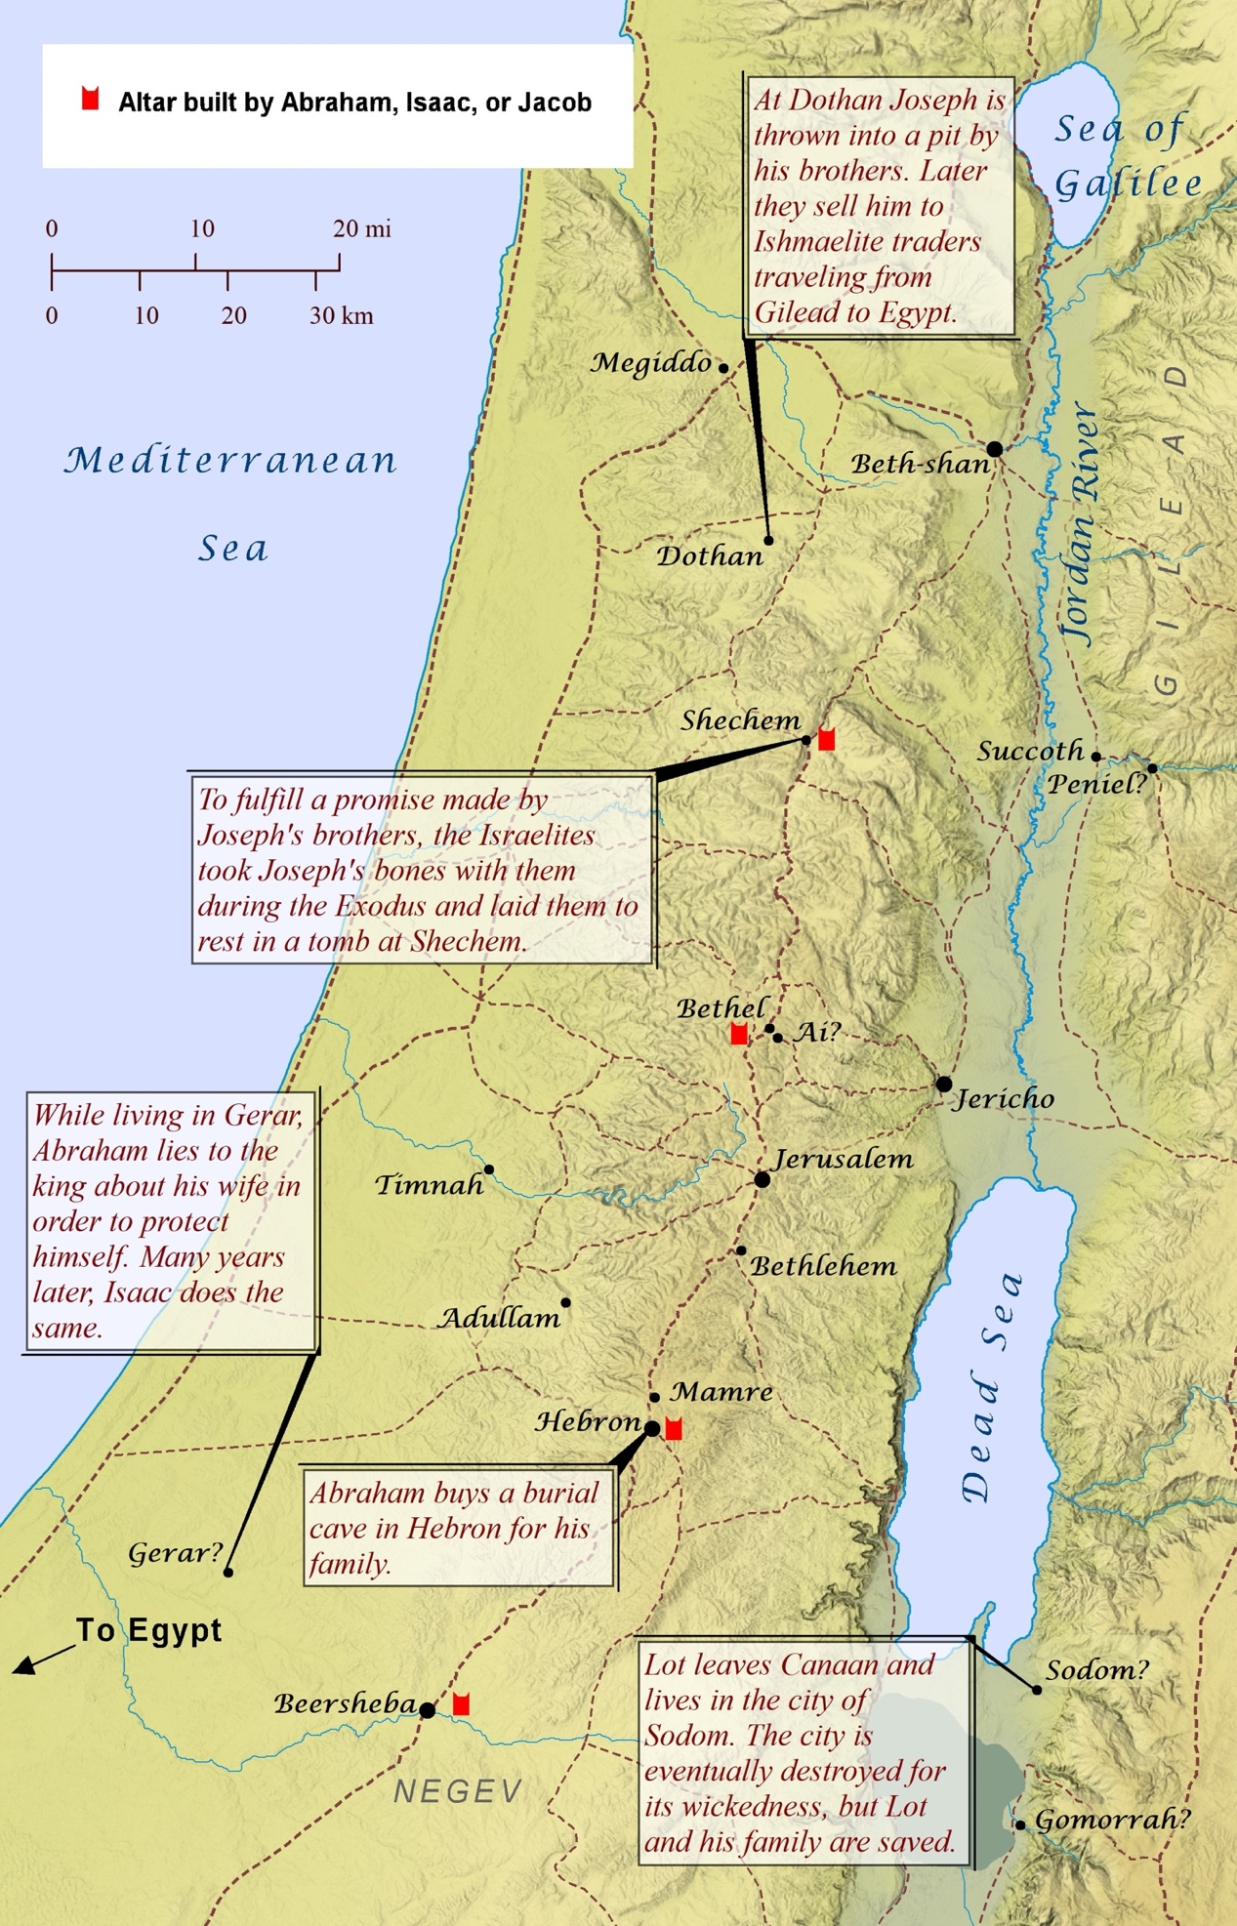

Make a really simple page (or sequencing strips) to tell the narrative – decorate it with a symbol to visually represent the content.


Abram moves to Canaan

Symbols to decorate each section

Sub section | Possible symbol
Abram moves to Canaan |  bag (swag) on a stick
Abram makes a covenant with God |   Heart Hand shake -
God repeats the covenant; Abram becomes Abraham | Abraham and Sarah – name badges
Isaac is born | 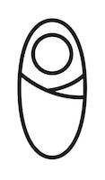swaddled baby
Isaac finds a wife | 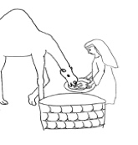 Rebecca at well
Abraham and Sarai die | Burial plots – maybe two

Esau and Jacob |  Rebekah pregnant with twins
Jacob becomes Israel | Acrostic Jacob/Israel – shared ‘a’

Joseph is sold into Egypt |  Coins
The Israelites come to Egypt | Multiple Abraham swags  (above) – showing lots of people moving.

