
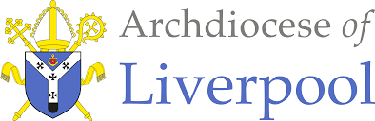

Religious Education Scheme of Work
Nursery
Dialogue and Encounter
To Know You More Clearly
Year Nursery Branch 6 Dialogue & Encounter
Overview  ‘For “In him we live and move and have our being”’ (Acts 17:28).  In this branch, pupils will learn how Christians work together with people of different religious convictions and all people of goodwill towards the common good, respecting the dignity of all humanity.  They will also encounter other pathways of belief drawing on the teaching of the Church about intercultural dialogue.  P.62 RED  Themes  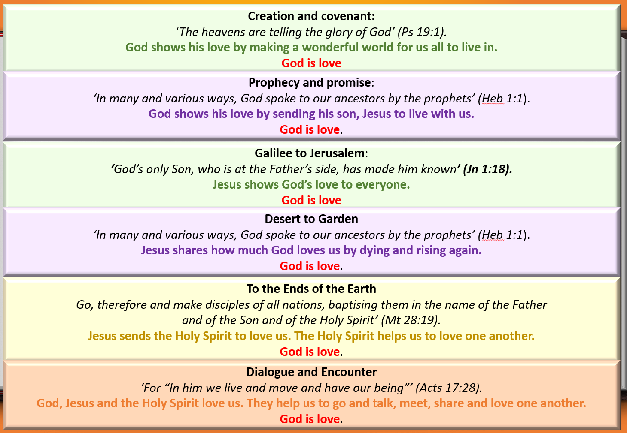  Prior Learning – Reminder - The Bible tells us all about God. We have to keep this in a very special place (prayer space/focus, place the book with the title Bible and the ‘Word’ of God) Can you remember where our special book is? Who can remember what the book is called? Remember this book tells us all about God. Would you like to hear a special story about God today?  - Please remember to use a Good News Bible – whilst this is not an accessible read for children, they need to experience what a Bible looks like, and how it is used – just as in other religions in Christianity this is a sacred book and needs to be treated with the utmost respect and care.  - Children will see how you as an adult use the Bible – they may not understand the words but it is our job then to retell the story in as many ways as possible – through retelling, crafts, art, dance etc… etc…  General Guidance  - Please begin with the Scripture story told from the Good News Bible at the beginning of each teaching sequence.  - Please try to follow the sequences as they appear in the planning. This will allow for timelines and links to be made. However, in some circumstances, they may be best suited in a different order especially considering the age and stage of the children.  - Also, there may be times when you may wish to teach Believe, Celebrate and Live in a different order following Hear or together to suit the needs of the children.  - The activities within the sequences are suggested and you do not need to cover them all! Please ensure you cover 10% of your curriculum time each week for Religious Education.  Introduction for Dialogue and Encounter  In the Early Years curriculum, the first principles of dialogue are laid out to understand how to listen when others speak, develop attitudes of respect, and embrace similarities and differences.  Many children will begin to encounter Christianity for the first time. They will learn about some of the religious and secular times that are part of British cultural life, for example, the importance of Diwali in some Dharmic traditions or Remembrance Day. Developing these behaviours and understandings forms part of good Early Years provision. These opportunities will happen across the year, not only in the summer term alongside a broad sensory curriculum where children learn about the music, food, smells, tastes, and types of clothing worn to enrich their understanding of different religious and cultural traditions.  Teachers should also use visitors to the school (where possible), create spaces for children to talk about their beliefs and religious practices with each other, and begin to understand what it means to be a good neighbour. Children should have opportunities to speak about their experiences and understandings of religion and spirituality in a local context as part of the community they encounter each day.  Throughout their time in Early Years, children should experience diverse representations of Christianity to appreciate that it is a global faith. In learning about Jesus, children could begin to understand that Jesus lived in the past in a place called Nazareth in Palestine. Children should begin to understand that Jesus would have looked and dressed like everyone else in Palestine at that time and would have had brown skin and dark hair. Re-imagined historical images from the time of Jesus (e.g., Nazareth Village website) could help deepen this appreciation. In the same way that children learn respect for Christianity, through respectful sitting during prayer and liturgy, careful handling of religious artefacts, and thoughtful learning, they should foster attitudes of respect for other people’s spiritual and cultural traditions.  The first religion they study beyond Catholicism will be Judaism because Jesus was born and lived his earthly life as a part of the Jewish community and Hebrew scriptures are an integral part of Christian beliefs.  Branch 6 …  - Offers the chance to revisit and develop children’s learning.  - Some of the opportunities are more suited to different times of the year and will be added to an overview yearly plan.  - Some of the opportunities can be taught and experienced throughout the year and in this branch.  Please see the table below…  Liturgical Events  Other useful dates |  |  |  | Notes
  Throughout the year | DIALOGUE | ENCOUNTER
  Throughout the year | - Key National events … see calendar e.g. Remembrance Day  - Diverse representations of Global Christianity  - Hindu religion – Divali festival– November/December  - Invite visitors from the Hindu religion.  - Judaism – Jesus was part of a Jewish community and read Hebrew Scriptures. He was brought up as a Jew.  - Where Jesus lived – Palestine Nazareth Village Website – how he looked, dressed, brown skin, dark hair.  - Explore a range of pictures of Jesus from a non-European tradition.  Children Volunteering at Nazareth Village - YouTube  Nazareth Village: A look at how Jesus grew up and what inspired His parables | World (youtube.com)  Enjoying a Biblical Meal in Nazareth Village (youtube.com)  Bible Trek - Bible Society  - Visitors – good neighbour, understanding religions and faiths in the community where they live and go to school.  - Invite someone into the class from the local area or a school community member to talk about their local (faith) community and why it matters to them.  Reception Various cultures celebrate Jesus’ birthday in different ways – Dialogue and Encounter | Develop opportunities to engage children in a broad sensory curriculum about the music, food, smells, tastes, and specific clothing worn, to enrich understanding of different cultural traditions.  Handling of religious artefacts, thoughtful learning, respect for other’s spiritual and cultural traditions.
  May | June
  29 The Ascension of the Lord | 8 Pentecost
   | 9 Mary Mother of the Church
   | 15 The Most Holy Trinity
   | 22 The Most Holy Body and Blood of Christ
   | 27 The Most Sacred Heart of Jesus
   | 29 Ss Peter and Paul Apostles
  June | July
  Religious/cultural | Religious/cultural
  2-3 – Shavuot * Judaism | 6 – Ashura * Islam
  5-9 – Hajj * Islam | 10 – Asalha Puja (Dharma day) Buddhist
  6 – Waqf al Arafa * Islam | 19 – Guru Har Krishan Jayanti Sikh
  7-10 – Eid al-Adha * Islam | Awareness and events
  12 – Guru Hargobind Jayanti Sikh | 18 – Nelson Mandela international day
  15 – Eid al-Ghadir * Islam | 18 Jul-17 Aug – South Asian heritage month
  26 – Islamic New Year * Islam
  Awareness and events
  14 – Global wellness day
  15 – Father’s Day
  15-21 – Refugee week
  20 – World refugee day
  21 – Summer solstice
  23-27 – School diversity week
 |  |  |  | Key Words
Enhancing the Religious Education Curriculum
Please find below a list of possible ways to engage learners…
- Previous Knowledge
- Key Vocabulary
- Timeline
- Equality
- Drama/Role Play
- Poetry
- Catholic Social Teaching
- RSHE
- Parents/ Carers
- Home/school/parish
- Parish Priest
- Parish Deacon
- Parish Catechists
- Governors
- Liturgy
- Sacramental Foundations
- Liturgical Colour Boxes
- Philosophy
- Inclusion
- Culture
- Awe and wonder
- Seasons/The Natural World
- Beauty
- Senses
- Music
- Art
- Dance
- Storytelling
Cross Curriculum Links

The aim of Religious Education in the Early Years is for it to be taught as far as possible at the heart of the curriculum. The Branch itself can lead all learning.
Please find below the diagram of how RE is central and links to other areas of learning.

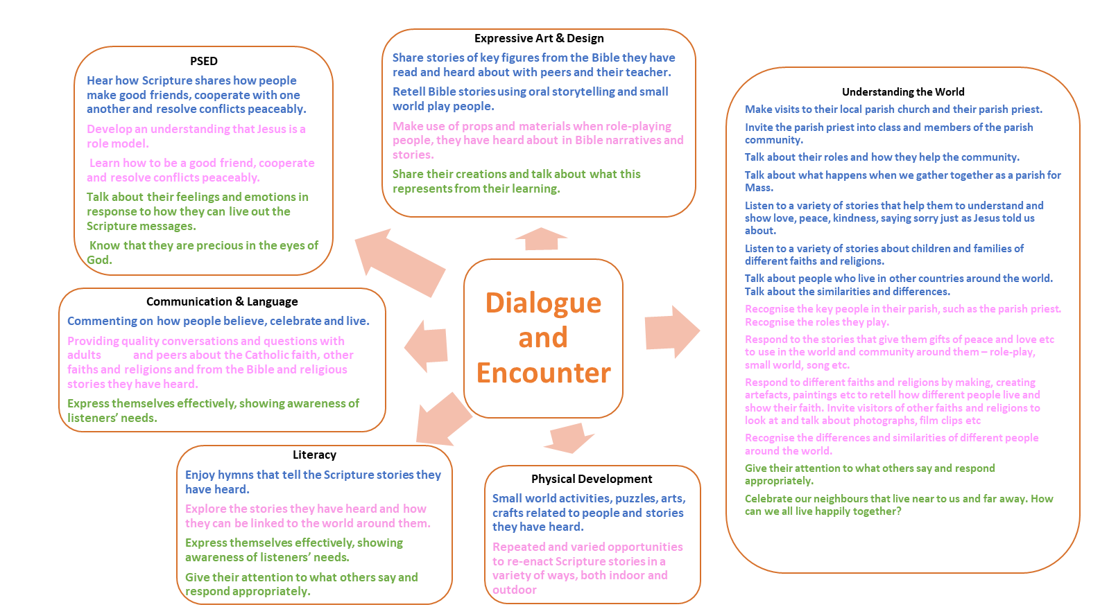
EXEMPLAR - Religious Education within the of Areas of Learning Branch 6 EYFS Reception Summer 2

Planning Overview
Ways of Knowing – Skills
In the ways of knowing table below, we describe the aim of each way of knowing, the skills that are required to develop them, the driver words that indicate progress through them, and generic progression indicators in the ways of knowing for each age-phase.
The skills below will help children to achieve their expected outcomes. Within each activity, use these skills to inform and help guide their skill progression.
UNDERSTAND |  | DISCERN | RESPOND
Skills | In this way of knowing, pupils will  deepen their understanding by  developing the skills to:  • Remember and apply the meanings of key texts, beliefs, and concepts.  • Provide explanations by making links between religious texts, beliefs, and  practices.  • Interpret and analyse the meaning of texts, practices, and rituals and  their historical and cultural  connections. | In this way of knowing, pupils will increase in wisdom, through dialogue with others, by  developing the skills to:  • Think creatively and critically, testing ideas by imagining other possibilities.  • Compare different interpretations of religious  expression, different ways of celebrating rites, and different ways of life, explaining differences within and between religions and  worldviews.  • Critically evaluate differences to arrive at wise judgements about what is true, what is good, and what is beautiful. | In this way of knowing, you will invite pupils to respond personally and with integrity by developing the skills to:  • Reflect on the meaning of what they have learned for their own lives.  • Dialogue with others to understand themselves and others better.  • Imagine how their own lives and the future of the communities to which  they belong could be transformed by what they have learned.
Driver words and phrases Ages 3-5 | Recognise  - Name  - Remember  - Recall  - Label  - Identify  - Match  - Sort  - Begin to recognise religious words and phrases of religious life and practice.  - Begin to recognise simple connections between sources, beliefs, worship and life.  - Begin to recognise texts, beliefs, rites, ways of life. | . ‘What if?’  - Ask ‘what if?’ questions  - Say what they wonder about and suggesting answers  Imagining how they and others are feeling.  - Recognising similarities and differences.  - Point out what is the same and what is different.  - Expressing a point of view or a preference.  - Listening to different viewpoints.  - Supporting a preference with reasons. | Talk about  - Talk about their own feelings and experiences.  - Begin to make links between their own feelings and the Scripture they have heard.  - Begin to make links between their behaviour or way of life and the Scripture they have heard.

Sequences | NURSERY  DIALOGUE | NURSERY  ENCOUNTER | RECEPTION  DIALOGUE | RECEPTION  ENCOUNTER
First Teaching Sequence | Talk about – Jesus is my friend.  Jesus has lots of friends all over the world. |  | Talk about – Jesus is my friend.  Jesus has lots of friends all over the world. John 15:15. Introduce and talk about saints.
Second Teaching Sequence | Friends of Jesus: Hear a simple life of St Peter and St Paul, friends of Jesus | Celebration of SS Peter & Paul Feast Day – this may be a whole school experience linked to the children who have made their First Sacramental Reconciliation and Eucharist. | Friends of Jesus: Hear a simple life of St Peter and St Paul, friends of Jesus (linking to their feast day). | Celebration of SS Peter & Paul Feast Day – this may be a whole school experience linked to the children who have made their First Sacramental Reconciliation and Eucharist.
Third Teaching Sequence | Who are our neighbours? | Invite the parish priest into class to share a story about Jesus being a good friend. | Visitors – good neighbours, understanding religions and faiths in the community where they live and go to school. Focus on Catholicism | Invite someone in from the local parish to talk about their Faith and why it matters to them to be a friend of Jesus.
Fourth Teaching Sequence | Visitors – good neighbours, understanding religions and faiths in the community where they live and go to school. | Invite someone into the class from the local area or a school community member to talk about their local (faith) community and why it matters to them. | Visitors – good neighbours, understanding religions and faiths in the community where they live and go to school. | Invite someone into the class from the local area or a school community member to talk about their local (faith) community and why it matters to them.

Expected Outcomes
UNDERSTAND What will I see and hear to help me understand?  - Jesus is my friend, and he has friends all over the world.  - Hear and retell a simple story about friends of Jesus called Peter and Paul  - Share the good news, Jesus loves everyone.  - Who are our neighbours?  - Neighbours help us to understand about the people and places around our school.  - Listen to visitors/neighbours from other faiths or religions.  - Neighbours help us to understand about the people and places around our school. | DISCERN How will I discover more?  - Talk about how people feel when they hear Jesus loves everyone.  - Talk about our home, school and parish families  - Discover more about our neighbours who live near our school family. | RESPOND What can I do now?

Sequence 1
Scripture (Hear) – Good News Translation

DIALOGUE
Teachers’ Notes:

Talk about – Jesus is my friend.
Jesus has lots of friends all over the world.

Activities:
- Remind children about Jesus' friends. Who do they remember?
- Golden box of Jesus friends they have heard about.
- Decorate peg dolls/faces on lolly sticks etc to represent themselves. Place them into the Golden Box with the other friends of Jesus. Explore this with the children. We are all friends of Jesus.
- Pupil responses to being a friend of Jesus.
- Share that Jesus has friends all over the world. Place faces on the globe/floor map to represent friends of Jesus.
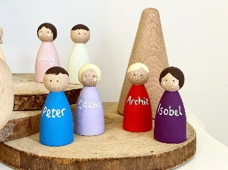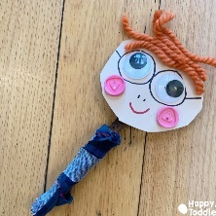
Ways of Knowing (Expected Outcomes)
UNDERSTAND What will I see and hear to help me understand?
- Jesus is my friend and he has friends all over the world.

Sequence 2
Scripture (Hear) – Good News Translation
DIALOGUE
Teachers’ Notes:
Friends of Jesus: Hear a simple life of St Peter and St Paul, friends of Jesus

The stories of Saints Peter and Paul can contain lots of detail, especially if you google them to share videos or facts with the children. Some of the stories are too descriptive and it will be enough for early years children to know that …
Jesus had some friends called Peter and Paul. They wanted to tell everyone about their friend Jesus. They made special journeys to tell everyone about Jesus. They said, “Jesus loves everyone.”
Activities:
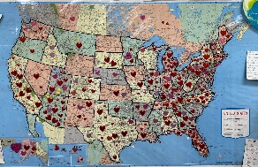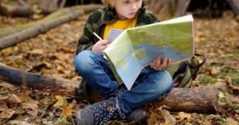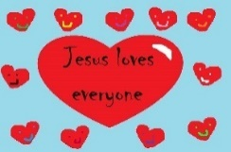

- Retell the simple story of Peter and Paul using the Golden Box.
- Draw a heart or decorate Jesus loves everyone to take on a journey.
- Roleplay going on a journey across the world to tell the good news – Jesus loves everyone. Small world play with boats, peg people, boats traveling to places to attach the good news of Jesus.
- Outdoor journey/adventure/explorer with signs to countries/ or suitable to the age of the children – go forward, turn this way, etc.…take messages with them to leave in places to share the good news.
- When children have collected or sent good news of Jesus, talk about the reactions of others, how do they think the messages made them feel?
- Sing – He’s Got the Whole World in His Hands – add in verses – He’s got …Jesus’ friends, everybody here, Peter & Paul etc… https://www.youtube.com/watch?v=srRB1ss_SVc

 Continuous Provision

Explorers! Role-play outside and hunt for hidden messages – Jesus loves everyone!
Travelling using various transport to tell about the Good News of Jesus
ENCOUNTER
Teachers’ Notes:
There may be an opportunity for a celebration or a Mass to mark the Feast Day of Saints Peter & Paul. Introduce this by noting that Peter and Paul were friends of Jesus.
Activities:
Ways of Knowing (Expected Outcomes)
UNDERSTAND What will I see and hear to help me understand?
- Hear and retell a simple story about friends of Jesus called Peter and Paul
- Share the good news, Jesus loves everyone.
DISCERN How will I discover more?
- Talk about how people feel when they hear Jesus loves everyone.

Sequence 3
Scripture (Hear) – Good News Translation
DIALOGUE & ENCOUNTER
Teachers’ Notes:

Who are our neighbours?
Invite the parish priest into class to share a story about Jesus being a good friend.

Slide 7 Pages 12-13
The Church family comes together to celebrate. The parish church is a principal focus for the life of the Catholic community. The Eucharist is the expression, celebration and deepening of communion with Christ and in Christ with one another. It helps to remember that our English name ‘Mass’ comes from the final, encouraging command ‘Go in peace to love and serve the Lord’. (In Latin, Ite missa est.)
Activities:

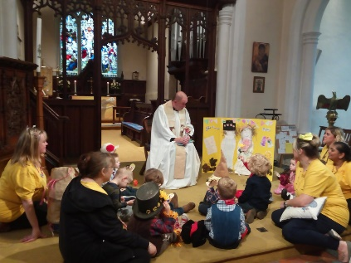

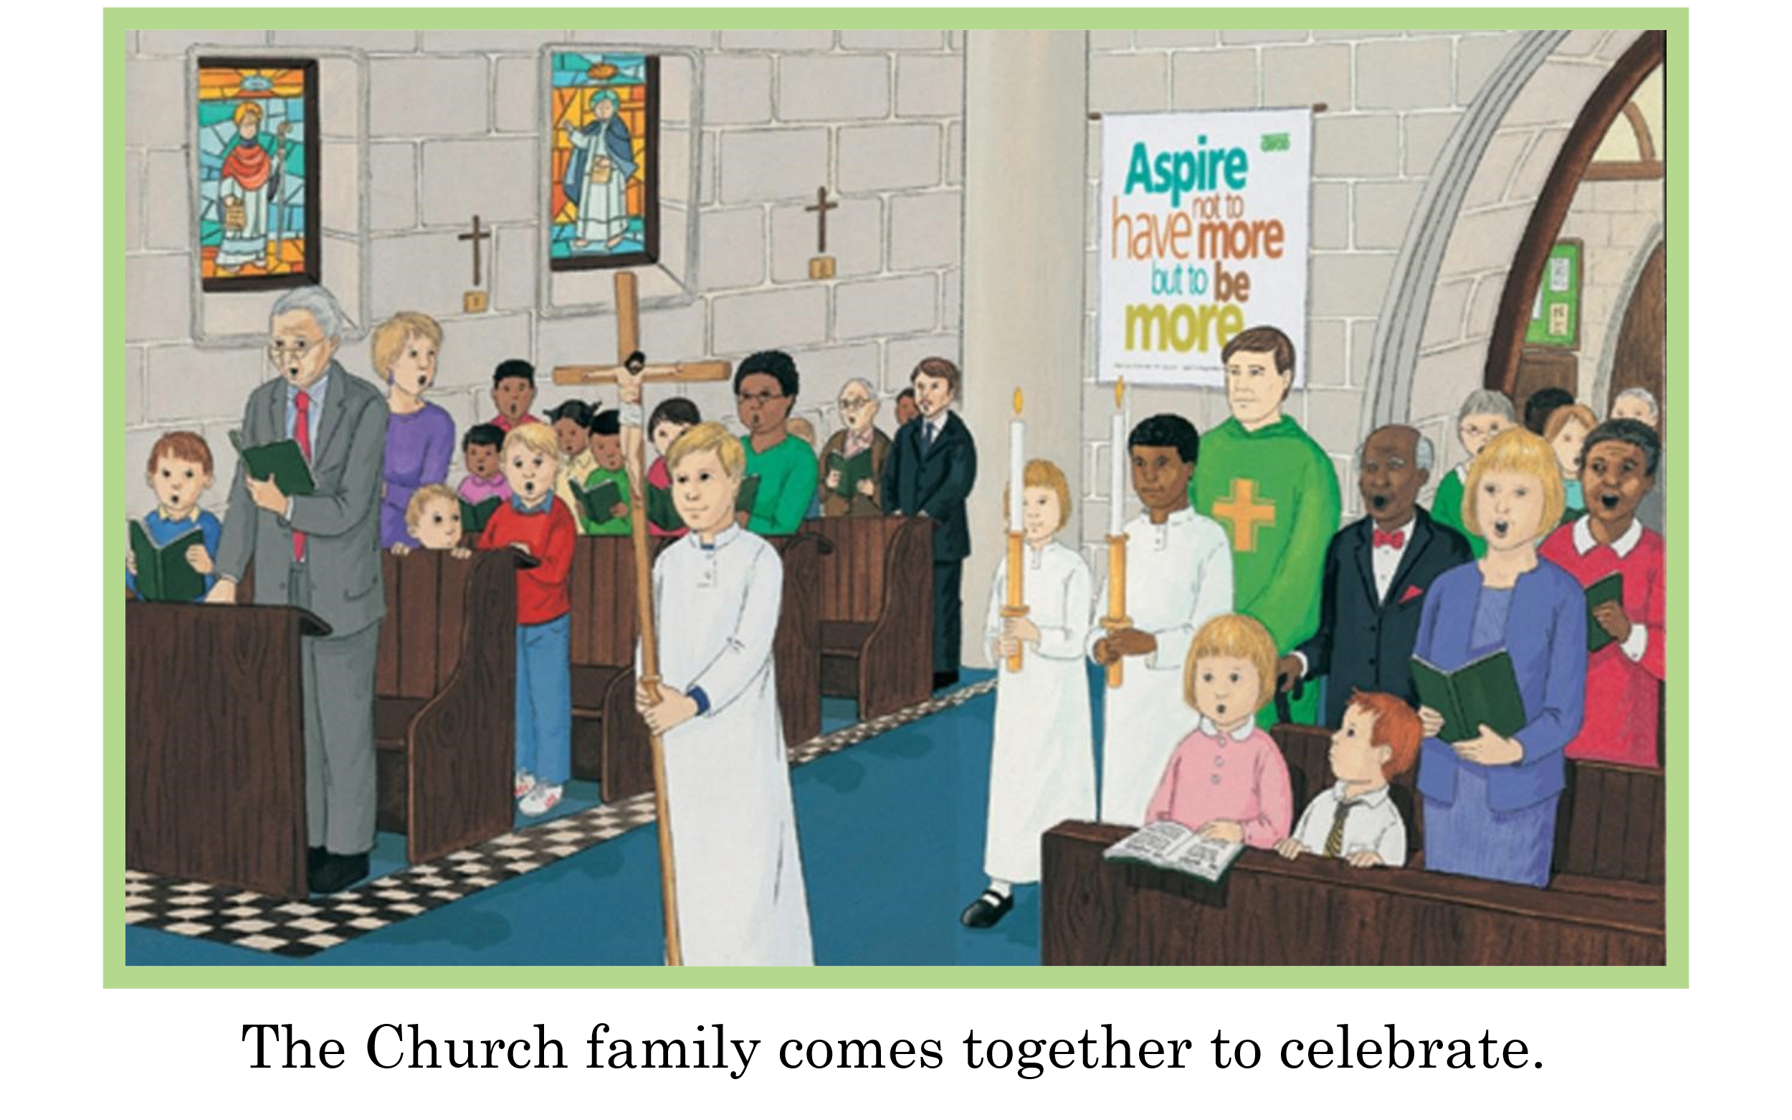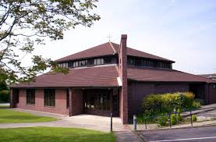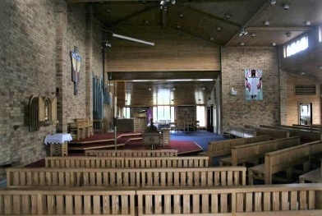

- Talk about what a Church is. Share God’s Story 1 page 12-13. Talk about your local Church.
- Share a photograph of your Church. Talk about who goes there – because they are friends of Jesus.
- Invite the parish priest into class to share a story about Jesus and talk about what he does in the Church. Or you may wish to visit Church.
- We celebrate when we go to Church. We sing and we pray. We are a Church family.
- Invite children to draw and place themselves on a large floor/wall display of the inside of church. You might wish to invite parents and children for a visit to the Church if feasible.

Ways of Knowing (Expected Outcomes)
UNDERSTAND What will I see and hear to help me understand?
- Who are our neighbours?
- Neighbours help us to understand about the people and places around our school.
DISCERN How will I discover more?
- Talk about our home, school and parish families

Sequence 4
Scripture (Hear) – Good News Translation
DIALOGUE
Teachers’ Notes:
Visitors – good neighbours, understanding religions and faiths in the community where they live and go to school.

Activities:
Focus on other faiths and religions within their school community.
Diverse representations of Global Christianity (there may be opportunities in this area however, this will be included also throughout the year)

- The resources for Nursery are available (originally from CAFOD’s Universal Topic in Come and See) https://cafod.org.uk/education/primary-teaching-resources/eyfs-re-resources

ENCOUNTER
Teachers’ Notes:

Invite someone into the class from the local area or a school community member to talk about their local (faith) community and why it matters to them.

There may be opportunities to develop sensory activities… however, if this is not possible here there will be further opportunities throughout the year…
Develop opportunities to engage children in a broad sensory curriculum about the music, food, smells, tastes, and specific clothing worn, to enrich understanding of different religions and cultural traditions.
Handling of religious artefacts, thoughtful learning and respect for others’ spiritual and cultural traditions. Invite someone into the class from the local area or a school community member to talk about their local (faith) community and why it matters to them.

*This area will be dependent on your local community and members of your school family. You may have children, families, neighbours who are of a different faith or religion.
*It is important to note that at this young age, children need to be made aware that other families all over our country and world pray different prayers, sing different hymns and believe in different things. This makes our country and our world an exciting place to be in because we can share and learn about one another.

Activities:
Sing :
- The More We Get Together - Kids Songs - Children's Songs - Nursery Rhyme - by The Learning Station (youtube.com)

- Talk to the children about sharing where we live with lots of different people who pray, sing, and believe different things. We are going to find out what some people do.
- Sharing with families/parents from our community
- Sharing about families in our local area
OR/AND
- Remind children of activities they have done this year about their families and may have shared how they pray, sing, and food they might eat on special occasions.

You may wish to share BBC - Search results for celebrating our world a clip from CBeebies – that is suitable for your children to remember events or to find out more about the families that live in the school community.

Ways of Knowing (Expected Outcomes)
UNDERSTAND What will I see and hear to help me understand?
- Listen to visitors/neighbours from other faiths or religions.
- Neighbours help us to understand about the people and places around our school.
DISCERN How will I discover more?
- Discover more about our neighbours who live near our school family.

