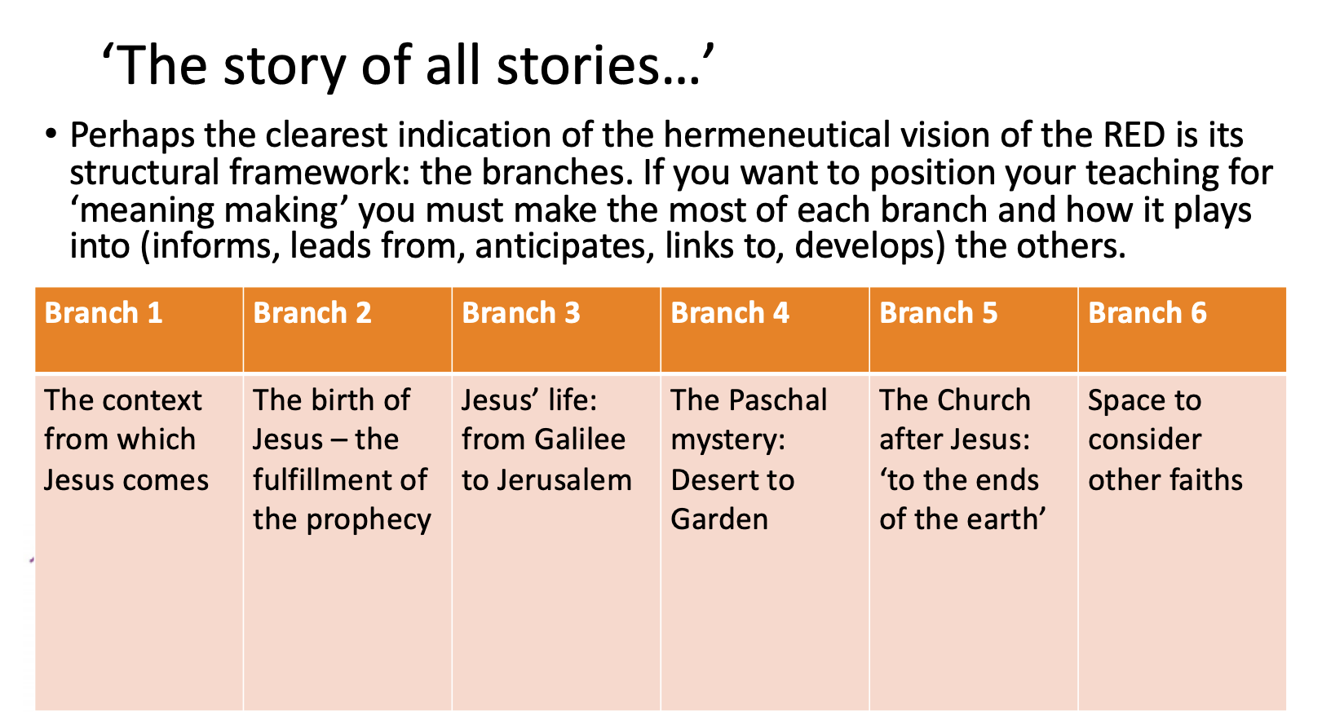

- Branch 1 and 5 ‘bookend’ the life of Jesus
- Judaism to Christianity - The shoot of the tree of Jesse
- No Eucharist without Passover
- Apostles, disciples
- Mark’s Gospel design

