PHASE 1 Texts

(Year 1) Luke 4: 14-21

Children’s Lectionary

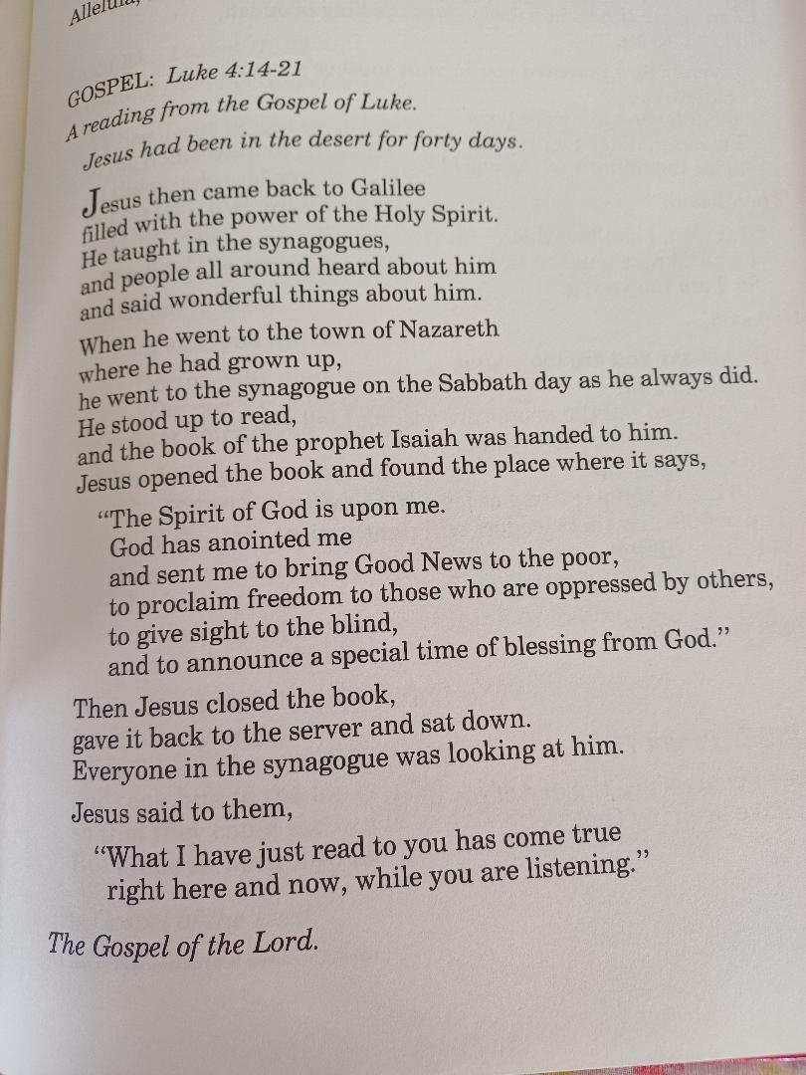

Year 2: Luke 15:1-20 (15:4-7)

