Branch 1. Moses: from Egypt to the Promised Land. Visio Divina images.

Some examples of artwork about parts of the story that were highlighted in the outcome statements. There are many online images – this is a selection.
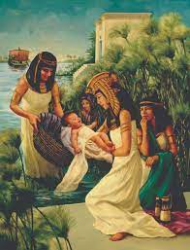
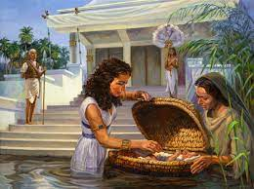

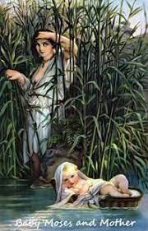
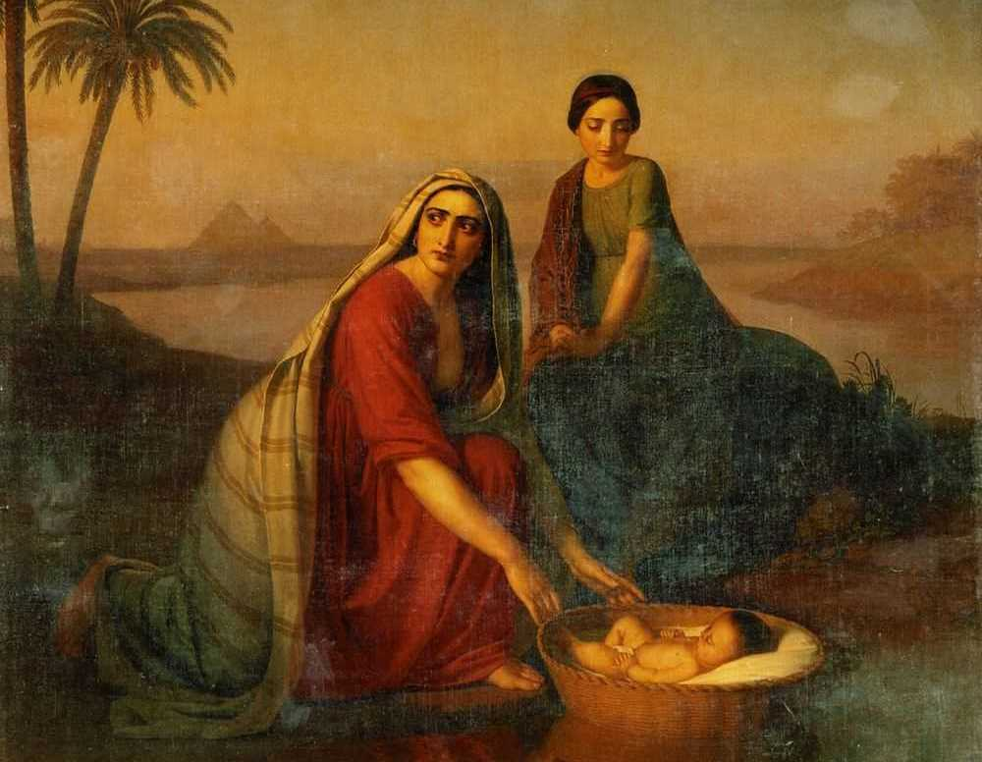

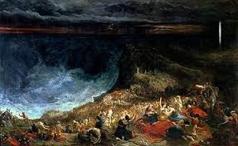
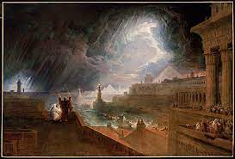

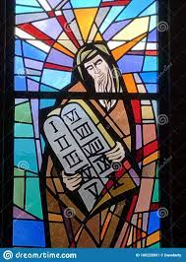

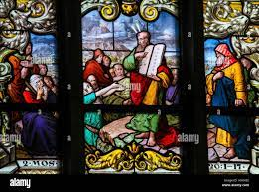

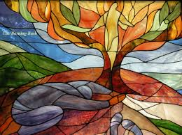
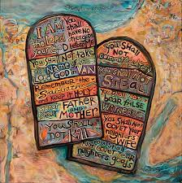

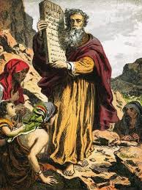

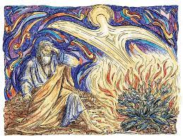

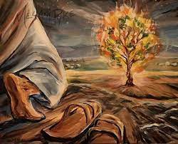

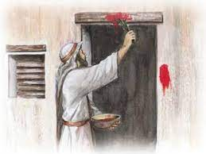
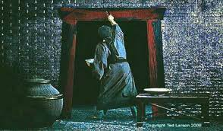

All pupils: Try the prayer Visio Divina – Lectio Divina but with an image instead of words. Its sometimes called, ‘praying with your eyes.’

• Choose your image. There are plenty about the Moses story; a selection that pick up key moments of his life are on the KIP website. Choose 1 and make a copy for each pupil.
• Set the room for prayer or meditation, or go to a sacred space, chapel prayer room etc.

1. Sit pupils in a circle with the image in front of them on the floor. Use quiet music to settle pupils. When ready….
2. Make the sign of the cross.
3. Ask pupils to pick up their image and hold it. Invite them to look carefully at it, and to think about it for one minute.

4. Say… as you sit a look at your picture, think about (they don’t answer you!) …
- The people in the picture, who is in this picture?
- What is happening?
- Where does it come in the whole story of Moses?
Pause….

- What do you notice about the characters?
- What feelings do you think the artist is showing in the character?
- How you would have felt being there?
- What might you have said?
Pause….

- Does this picture remind you of anytime in your life?
- Does this picture remind you of someone else?

5. Now sit in silence and invite God to speak to you in your heart…
- Are you drawn to one part of this picture?
- What is God saying to you as you look?
- Does this picture teach you something?
- Does it invite you to live a bit differently?

6. Say a quiet silent prayer…
- Ask God to help you, or someone else who needs your prayer,

7. Say quietly together, the Lord’s prayer, and make the sign of the cross

