



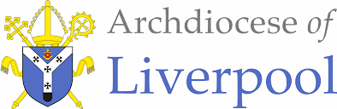

To Know You More Clearly
The Religious Education Directory
Nursery Scheme of Work
Branch 3 - Galilee to Jerusalem
Education Department

Nursery Branch 3 – Galilee to Jerusalem
Introduction  The overarching theme for Nursery and Reception is God is Love.  Themes  Galilee to Jerusalem Theme for Nursery: The focus of this branch is for pupils to develop a developing understanding of Jesus.  - Creation and Covenant – God shows his love by making a wonderful world for us all to live in.  - Prophecy and Promise – God shows his love by sending his son, Jesus to live with us.  - Galilee to Jerusalem – Jesus shows his love for us.  Galilee to Jerusalem  - The Feast of the Epiphany (Matt 2:1-12) will fall at the beginning of this branch, (January 6th)  - The visit of the Magi will be experienced in EYFS and then covered in detail in Year Three.  Prior Learning – Reminder - The Bible tells us all about God. We have to keep this in a very special place (prayer space/focus, place the book with the title Bible and the ‘Word’ of God) Can you remember where our special book is? Who can remember what the book is called? Remember this book tells us all about God. Would you like to hear a special story about God today?  - Please remember to use a Good News Bible – whilst this is not an accessible read for children, they need to experience what a Bible looks like, and how it is used – just as in other religions in Christianity this is a sacred book and needs to be treated with the utmost respect and care.  - Children will see how you as an adult use the Bible – they may not understand the words but it is our job then to retell the story in as many ways as possible – through retelling, crafts, art, dance etc… etc…  General Guidance  - Please begin with the Scripture story told from the Good News Bible at the beginning of each teaching sequence.  - Please try to follow the sequences as they appear in the planning. This will allow for timelines and links to be made. However, in some circumstances, they may be best suited in a different order especially considering the age and stage of the children.  - Also, there may be times when you may wish to teach Believe, Celebrate and Live in a different order following Hear or together to suit the needs of the children.  - The activities within the sequences are suggested and you do not need to cover them all! Just ensure you are covering 10% of your curriculum time each week for Religious Education. | Skill/Driver words  Recognise, Retell, Describe, Wonder, Talk about, Ask, begin to make links and connections, begin to give reasons  Key Words  Enhancing the Religious Education Curriculum  Please find below a list of possible ways to engage learners…  - Previous Knowledge  - Key Vocabulary  - Timeline  - Equality  - Drama/Role Play  - Poetry  - Catholic Social Teaching  - RSHE  - Parents/ Carers  - Home/school/parish  - Parish Priest  - Parish Deacon  - Parish Catechists  - Governors  - Liturgy  - Sacramental Foundations  - Storytelling  - Liturgical Colour Boxes  - Philosophy  - Inclusion  - Culture  - Awe and wonder  - Seasons/The Natural World  - Beauty  - Senses  - Music  - Art  - Dance  Cross-Curricular Links  The aim of Religious Education in the Early Years is for it to be taught as far as possible at the heart of the curriculum. The Branch itself can lead all learning.  Please find below the diagram of how RE is central and links to other areas of learning.

Religious Education within the of Areas of Learning EYFS NURSERY BRANCH 1
Ways of Knowing

Planning Overview Nursery/Reception
*When planning for Nursery or and Reception – look over both sets of plans. Please adjust to suit your own settings.
EYFS Galilee to Jerusalem – Nursery |  |  |  |  | EYFS Galilee to Jerusalem – Reception
Sequences over 5/6 weeks | HEAR | BELIEVE | CELEBRATE | LIVE | HEAR | BELIEVE | CELEBRATE | LIVE
First sequence of lessons | The visit of  the Magi  Matthew 2:1-2, 10-11  Please note the edited Scripture version for Nursery. | The Magi visited Jesus with gifts.  Jesus is God’s son and came for everyone.  Jesus’ birth is celebrated at Christmas. | The Feast of the Epiphany will fall at the beginning of this branch, (January 6th)  The Church prays The Glory Be as a response to the coming of Jesus |  | Matthew 2:1-2, 10-11 Please note the edited Scripture version for Reception. | The Magi visited Jesus with gifts.  Jesus is God’s son and came for everyone.  Jesus’ birth is celebrated at Christmas. | The Feast of the Epiphany will fall at the beginning of this branch, (January 6th)  The Church prays The Glory Be as a response to the coming of Jesus
Second sequence of lessons | Luke 2:40  Jesus grows up in a loving family.  *Please note that this is an addition to the Scripture listed in the RED. | Christians believe that Jesus grew up in a loving family.  Jesus, Joseph and Mary were known as the Holy Family. |  |  | Luke 2:40  Jesus grows up in a loving family.  *Please note that this is an addition to the Scripture listed in the RED. | Christians believe that Jesus grew up in a loving family.  Jesus, Joseph and Mary were known as the Holy Family.
Third sequence of lessons | Jesus blesses the little children.  Mk 10:13-16 | Jesus came to show God’s love and welcomes everyone. | The Church prays The Glory Be as a response to the coming of Jesus | Show love to everyone like Jesus. | Jesus blesses the little children.  Mk 10:13-16 | Jesus came to show God’s love and welcomes everyone. | The Church prays The Glory Be as a response to the coming of Jesus | We welcome and show love to everyone in our words and actions as Jesus does.
Fourth sequence of lessons | *Please note there is no fourth teaching sequence for Nursery |  |  |  | Feeding of five thousand  Jn 6:1-14 | Jesus takes care of everyone. | The Church prays The Glory Be as a response to the coming of Jesus | We are called to help the poor and hungry. CST You need food, water, a house, your school, a good doctor and a job for the grown-up who takes care of you. So does everybody else on the whole Earth. But many people do not have these things. Jesus wants us to take extra care of these people. An Option for the Poor and Vulnerable

FIRST TEACHING SEQUENCE
NURSERY BRANCH 3
The visit of the Magi
HEAR & BELIEVE | CELEBRATE | WAYS OF KNOWING
- The Wise Men visit Jesus.  - Matthew 2:1-2, 10-11 Please note the edited Scripture version for Nursery.  - The Magi visited Jesus with gifts.  - Jesus is God’s son and came for everyone.  - Jesus’ birth is celebrated at Christmas.  - Hear about/take part in The Feast of the Epiphany | The Church prays The Glory Be as a response to the coming of Jesus | UNDERSTAND  What will I see and hear to help me understand?  - The Bible as a special book.  - Remember that Mary had a special baby called Jesus.  - Hear about the Wise men who visited Jesus.  - Listen to/talk about The Feast of the Epiphany as a whole school/class/year group  - God loves me.  - Jesus loves me  - Listen to and talk about The Glory Be prayer.
DISCERN
How will I discover more? What can I do now?
- Wondering about the Magi
- Recognising and retelling the story of the Magi in different ways
Scripture (HEAR) Good News Translation
Jesus was born in the town of Bethlehem in Judea, during the time when Herod was king. Soon afterwards, some men who studied the stars came from the East to Jerusalem 2 and asked, “Where is the baby born to be the king of the Jews? We saw his star when it came up in the east, and we have come to worship him.”
10 When they saw the star, how happy they were, what joy was theirs! It went ahead of them until it stopped over the place where the child was. 11 They went into the house, and when they saw the child with his mother Mary, they knelt down and worshipped him. They brought out their gifts of gold, frankincense, and myrrh, and presented them to him.
HEAR
Teacher Notes – The Magi
The Bible story of the Three Wise Men, from the gospel of Matthew, is also known as the biblical Magi or the Three Kings. This Bible story regards a group of scholars who travelled from another country to visit Jesus after his birth, bearing gifts of gold, frankincense, and myrrh. They were probably astrologers more than Kings.
As directed by King Herod, they went on their way, and the star they had seen in the East went before them until it stopped over the area where the child lay. Upon arriving at the house, they observed the child with his mother, Mary, and they kneeled down and worshipped him. Then they opened their treasures and presented him with gold, frankincense, and myrrh gifts. They were then miraculously warned in a dream not to return to Herod, as he planned to kill Jesus to preserve his authority and returned to their home by an alternative route.
Names & Characteristics of the Three Wise Men
Accounts have been told about the Three Wise Men, and they have been given names. This is how they are sometimes portrayed although we can only assume there were three Kings as the Bible refers to three gifts only – we can only guess that there were three. What we also don’t know are where they were kings – various resources name a variety of places…
Gaspar (or Caspar) wears a green cloak and a gold crown with green jewels. He is the King of Sheba. Gaspar represents the Frankincense brought to Jesus.
Melchior has long white hair and a white beard and wears a gold cloak. He is the King of Arabia. Melchior represents the Gold brought to Jesus.
Balthazar has a black beard and wears a purple cloak. He is the King of Tarse and Egypt. Balthazar represents the gift of Myrrh that was brought to Jesus.
Meaning of the Gifts for Jesus
When the Wise Men discovered Jesus and Mary, they would have been residing in a modest house in Bethlehem because, by this time, Jesus would have been aged between one and two. The story however, seems to always be depicted as the three men visiting a baby. Their gifts seem somewhat unusual to give to a baby. However, Christians consider that they had the following purposes and meanings:
Gold: is affiliated with Kings, and Christians believe that Jesus is the King of Kings.
Frankincense: is used in liturgical worship in traditional Churches and represents that people would worship and praise Jesus.
Myrrh: is a fragrance that is embedded on dead bodies to make them smell pleasant and represents that Jesus would endure persecution resulting in his death.

Background and celebration of The Feast of the Epiphany – 6th January

“Epiphany” means “manifestation.” It comes from Greek roots that mean "to show, to display" (phainein) and "on, to" (epi-). An epiphany is thus a time when something is shown, displayed, or manifested to an audience.
For Christians, this feast day is part of the liturgical calendar and will be celebrated in Mass on the nearest Sunday to the date. It will be marked in some way in a Catholic school, usually by a gathering, prayers, hymns, etc., and will certainly form part of the whole school’s prayers and liturgy. Traditionally, the hymn ‘We Three Kings’ is sung. However, for younger children, the words are quite difficult, but as children hear this each year, they will come to recognise its tune and words.
The Epiphany reminds Christians of how special Jesus is and that we should spend our lives seeking Him, just like the Magi did. Jesus is the light for everyone; if we follow Him, we will never go astray. At the end of the hymn, We Three Kings the line Star of wonder, star of night, star with royal beauty bright – westward leading, still proceeding, guide us to the perfect light. For children in their Early years, a focus on the star is a good focus – the star, the light leads us to God/Jesus. It called the shepherds and the kings – the rich and the poor because Jesus welcomes and loves everyone.
Continuous Provision  - Build outdoor spaces using cardboard boxes for the wise men to visit Jesus.  - Use building materials – logo/wood etc to make the wise men/camels  - Imaginative play – dressing as the Magi  - Outdoor provision - The three kings travelling – finding a star up high outside  - Using sand to depict the desert use small world figures to retell the story  Craft ideas  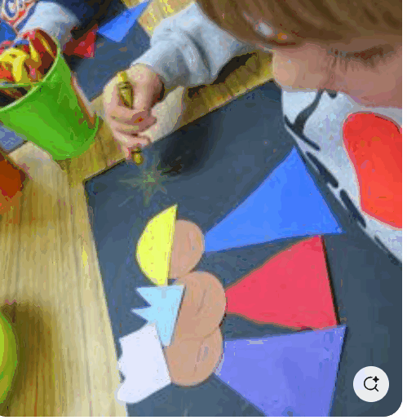  https://uk.pinterest.com/pin/291115563416528173/  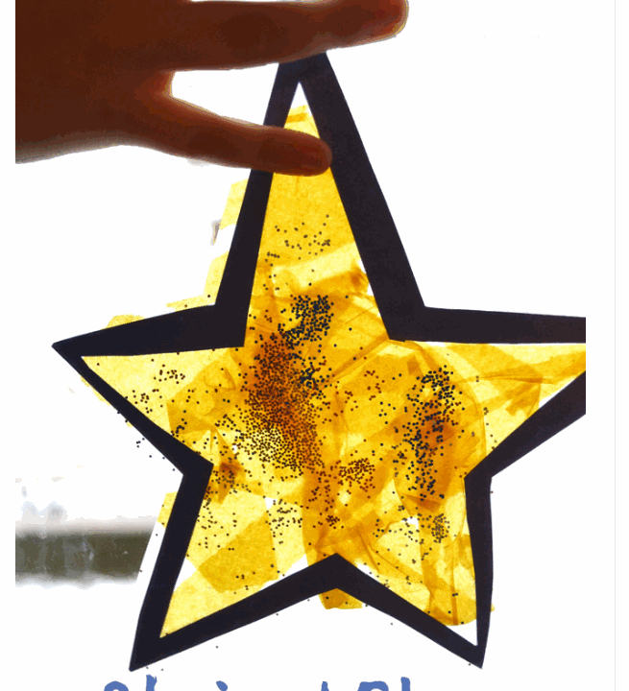  Stained glass suncatcher  https://uk.pinterest.com/pin/291115563416528117/  https://uk.pinterest.com/pocketpreschool/  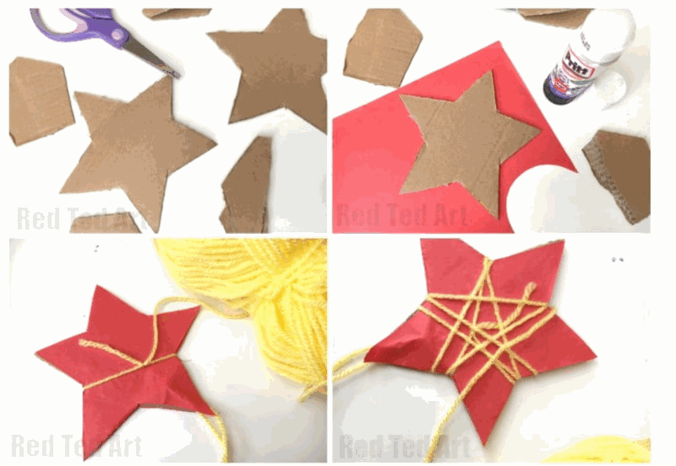  Wrap wool around a star shape – to create the star the wise men were following  https://www.redtedart.com/yarn-wrapped-stars/  Drama/Role Play  - We’re going on a Star Hunt (may need some adaptation) https://www.amazon.co.uk/gp/product/B0CQGHBXQ9/ref=ox_sc_act_image_1?smid=A3P5ROKL5A1OLE&psc=1 |  |  | Learning activities/Objectives  What will I see and hear to help me understand?  Recognise - name, remember, recall, label, identify, match, sort  - Read directly from the Good News Bible, and then place in your special area of class. In this area keep the nativity scene and baby Jesus.  - We have talked about God who made our wonderful world.  - Can we remember what happened to Mary and Joseph?  - Talk about the events from the last topic – use previous work/pictures etc to identify.  - This wasn’t the end of the story. After the shepherds visited the baby Jesus some wise men called Magi came to see him.  - Identify who the Magi were and that they had travelled a long way.  - Focus on the baby – Jesus – what is very special about Jesus? Talk about God’s love and Jesus' love for us.  - Retell/Golden Box – revise and extend the story to the Wise Men visiting.  - Use a timeline to revisit from Creation – Prophecy & Promise and add the Wise Men. Add the Magi or use peg people to the prayer table next to Jesus and the Bible.  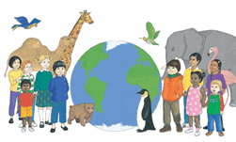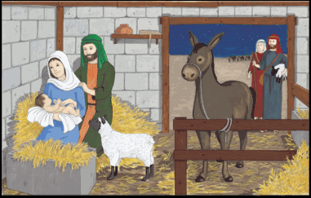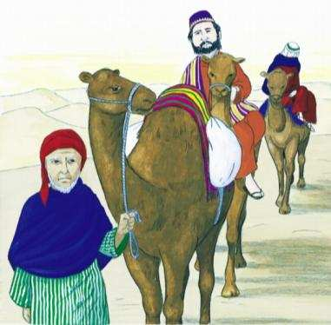  - In the first week back from Christmas the children may take part or witness The Feast of the Epiphany in school this may be as part of a whole school or year group liturgical gathering. You may wish to do this in class. Please read the teacher’s background notes. For young children focus on the star the Magi were following. The star of wonder – because they didn’t know what they were going to find, they were wondering about it as they travelled.  Some ideas of how to celebrate the feast might be to…  - Bake/eat star-shaped biscuits  - Star-shaped snacks/sandwiches  - Make and wear a crown like the kings/Magi for the day  - Use role play as the three kings to follow a star  Learning activities/Objectives  How will I discover more?  What can I do now?  What if? Wonder about? Awe and Wonder, Imagining, similarities, differences, views, preferences, identify, names, experiences, creative and artistic expression  Art/Craft  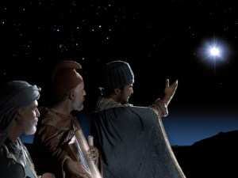  https://breadforbeggars.com/2019/01/what-was-the-magis-star/  - What do you wonder about the Magi/the wise men and the star?  - Use the image above with the three kings to talk about what they can see. What do they think the wise men are saying to one another?  - Talk about the journey that they were making gifts/what might they bring to baby Jesus today. Use this as an opportunity to write their own names on a piece of card to place next to baby Jesus – say they are giving their names or words such as love, share, give etc… to Jesus who loves them all. The words could then be used in Collective Worship/Celebration of the Word.  Music & Movement  - The BBC has some KS1 clips for dance – Finding Jesus and depicts the journey of the three Kings – it may need some adaptation to its length but is a good way to role-play the Wise men's journey.  https://www.bbc.co.uk/teach/school-radio/articles/zvdpwty  Music & Roleplay  - https://www.youtube.com/watch?v=47SidY4VRnE Watch and sing the actions of children from St Luke’s CE, Formby.  Journey Role Play Ideas  - Children to dress as the Magi, wearing crowns, clocks and crowns  - Finding the star – journey in space you have available to find the hidden star  - Follow a path/map in the outdoor provision and talk about what they have experienced in the desert – imagine seeing the star in the sky – follow the instructions turn around, go ahead, sit down, sleep, eat food etc…  - Use the ideas below to create the journey with sounds and movement
We’re Going on a Star Hunt adapted from - THE BABY HUNT (with thanks to Michael Rosen)  *Instead of a drum beat you could use a triangle/twinkle sound for the star  (Drum beat)  "We're going on a star hunt, we're going to see a special one….  What a beautiful night! We're not scared! (drums stop)  Uh oh... Grass... long wavy grass...  We can't go over it, we can't go under it, we've got to go through it! Swishy swashy swishy swashy....  (Drum beat)  We're going on a star hunt.... (drums stop)  Uh oh a river... a deep cold river...  We can't go over it, we can't go under it, we've got to go through it! Swim! Splash, splash….. splash, spalsh  (Drum beat)  We're going on a star hunt... (drums stop)  Uh oh mud, thick oozy mud!  We can't go over it, we can't go under it, we've got to go through it! Squelch squelch squelch squelch...(Drum beat) |  |  | We're going on a star hunt... (drums stop)  Uh oh a sand storm, a swirling whirling sand storm!  We can't go over it, we can't go under it, we've got to go through it! Hoooo Whoooo Hooooo Whooooo...  (Drum beat)  We're going on a star hunt... (drums stop)  Oooooo! ……a warm dark stable...  We can't go over it, we can’t go under it, we'll have to go through it! tip toe tip toe  What's that?! Two big eyes, one little round nose, one smiley mouth.... Wow, it’s the baby!  Wow it's the baby.... quick! Let’s give him our gifts  We have to tell everyone...  Back through the stable....tip toe tiptoe  Back through the sand storm... hooo whoooo hooo whoooo  Back through the mud... squelch squelch squelch squelch  Back through the river... splash splash… splash splash  Back through the grass... swishy swashy swishy swashy  Hooray everyone!!! We found the baby!

CELEBRATE
Teacher Notes

Glory be to the Father, and to the Son, and to the Holy Spirit,
as it was in the beginning, is now, and ever shall be, world without end. Amen.

The Glory Be prayer is a traditional prayer of the Catholic faith. For children in Early Years, they will only need to experience the prayer being said out loud and not to be learnt by rote! The key message of the prayer for children of this age are the words ‘Glory Be’ – which is a sign of praise, a thank you to God for sending his Son. Our theme this year concentrates on building the knowledge that God loves everyone. God is love.

Background
- The Glory Be Prayer is a simple but powerful prayer that is widely used by Catholics around the world.
- Glorifies the Holy Trinity – God the Father, Son, and Holy Spirit – and acknowledges their power and majesty.
- Although it is a short prayer, the Glory Be has deep meaning and significance that can help Christians deepen their faith and connection with God.
- End of each decade of the Rosary, during the Liturgy of the Hours, and during other Catholic liturgical celebrations.
- Commonly used as a way to begin and end personal prayers, to give thanks for blessings, and to ask for guidance and protection from God.
- The phrase “world without end” in the Glory Be prayer emphasizes the idea that God’s power and love will endure forever.
The children will have experienced The Sign of the Cross and can use their actions for this prayer too. It is important not to get too detailed on Father, Son and Holy Spirit – so far the children have only learnt about God and now Jesus. The actions and experience of prayer is enough at this age and stage of learning.

*Please be mindful of the use of the word Father (God) – a well-known difference between Islam’s god and Christianity’s God is that Islam’s god is never described or known as "Father", but in both Christianity and Judaism, God is known as Father.

Suggested Resources | Learning activities/Objectives  What will I see and hear to help me understand?  Recognise - name, remember, recall, label, identify, match, sort  - Please read the teacher's notes about the Glory Be prayer before teaching.  - We are very happy that Jesus has been born, shepherds, angels and wise men were all so happy to see him. We can say Glory be for all of this happy and good news.  - There is a prayer for GLORY – Glory be to the Father etc..  - Introduce children to The Glory Be prayer by reading it to them and by using this clip to say together https://www.youtube.com/watch?v=8Pywcp-hBcw  - Say the prayer to children.  - Use the words Glory Be in prayer and liturgy – giving praise to God/Jesus – by simply saying after a prayer – “Glory be to God/Jesus.”

Assess Pupils’…WAYS OF KNOWING | Informal / Formal Assessment Comments
UNDERSTAND
What will I see and hear to help me understand?
- The Bible as a special book.
- Remember that Mary had a special baby called Jesus.
- Hear about the Wise men who visited Jesus.
- Listen to/talk about The Feast of the Epiphany as a whole school/class/year group
- God loves me.
- Jesus loves me
- Listen to and talk about The Glory Be prayer.
DISCERN
How will I discover more? What can I do now?
- Wondering about the Magi
- Recognising and retelling the story of the Magi in different ways

SECOND TEACHING SEQUENCE
NURSERY BRANCH 3

Jesus grows up in a loving family
HEAR & BELIEVE |  | WAYS OF KNOWING
Luke 2:40  Jesus grows up in a loving family.  *Please note that this is an addition to the Scripture listed in the RED. | - Christians believe that Jesus grew up in a loving family.  - Jesus, Joseph and Mary were known as the Holy Family.
  UNDERSTAND
  What will I see and hear to help me understand?
  - Talk about Jesus, Mary and Joseph as the Holy Family
  - Talk about and hear about Jesus as a boy
  DISCERN
  How will I discover more? What can I do now?
  - Wonder about the Holy Family and what they did together
  - Talk about similarities and differences between their own family and the Holy Family
Scripture (HEAR) Good News Translation
Luke 2:40
³⁹ When Joseph and Mary had done everything required by the Law of the Lord, they returned to Galilee to their own town of Nazareth. ⁴⁰ And the child grew and became strong; he was filled with wisdom, and the grace of God was on him.

Teacher Notes
*Please note that this is an addition to the Scripture listed in the RED.

Jesus as a child In Year 1 the children will hear about Jesus as a child in the temple. In between the stories of His birth, the shepherds and Kings who came to visit, there are no stories of how Jesus grew as a child. This is hard for children and even adults to understand and we are left wondering about what his younger years were like. By helping children to fill those gaps, they will be able to make links between their own younger years growing up in their own family along with how Jesus grew in his family.
Jesus’ childhood home was in Nazareth, a city of Galilee (Matthew 2:19-23; Luke 2:39). We hear in Luke’s Gospel … Luke 2:40 ³⁹ When Joseph and Mary had done everything required by the Law of the Lord, they returned to Galilee to their own town of Nazareth. ⁴⁰ And the child grew and became strong; he was filled with wisdom, and the grace of God was on him.

Jesus’ family life Jesus grew up in a bustling, growing family. Matthew’s Gospel does give reference to brothers and sisters and Jesus was the oldest of possibly seven children. Matthew 13:55-56 ⁵⁵ Isn't he the carpenter's son? Isn't Mary his mother, and aren't James, Joseph, Simon, and Judas his brothers? ⁵⁶ Aren't all his sisters living here?
Joseph was a carpenter (verse 55). This occupation is generally understood to be someone who works with wood yet it can also mean carpenter or even builder in a time when most people’s houses were made of mud brick. This occupation would require skill, patience and hard work—all traits Jesus would have observed during His childhood. As the oldest son in the household, it seems probable that Jesus would have been trained and employed as a carpenter.

Jesus was raised in a religious home Jesus was raised in the Jewish faith, Mary and Joseph raised Him in a religious home, celebrating the Jewish religious festivals. Luke’s Gospel states that Jesus’ family made annual pilgrimages to Jerusalem for the feast of Passover and Days of Unleavened Bread (Luke 2:41-42). https://lifehopeandtruth.com/god/who-is-jesus/jesus-childhood/
Suggested Resources  Ideas for images of the Holy Family  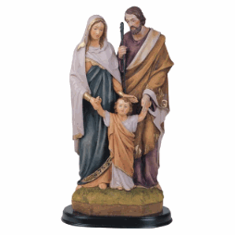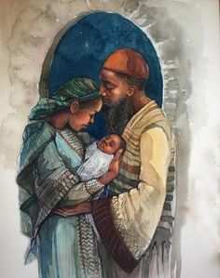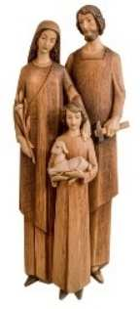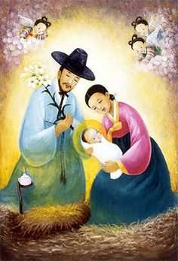  https://uk.pinterest.com/elminthebreeze/jesus-around-the-world/  Hymns/Songs  Sing together The Holy Family by John Burland  Continuous Provision  - Role play Jesus at home in Nazareth – please find below some ideas…  P.S. I’m not suggesting you make the house with mud or stone!  Teacher’s notes - ideas for role play please adapt/choose to suit the age range and ability of the children  - https://blog.adw.org/2014/07/what-were-typical-homes-like-in-jesus-time/attachment/070114/  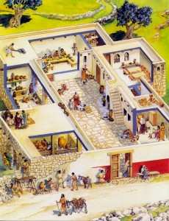  https://dailylifeinthetimeofjesus.weebly.com/daily-life-at-the-time-of-jesus.html  - Houses were made of clay bricks or stones held together with mud and straw and had dirt floors.  - The average family lived in one-room, two-level dwellings with living quarters separated from and raised above the animal stalls. Jewish extended families often lived together.  - The poor lived in one-room houses built of mud brick on a stone foundation. External steps led up to the flat roof which provided storage space and somewhere to sit.  - Inside the house a raised platform at one end of the room provided quarters for eating and sleeping. The lower level was used mainly as a stable.  - Some items in the house included a table, a spinning wheel, wooden bowls, an olive oil lamp.  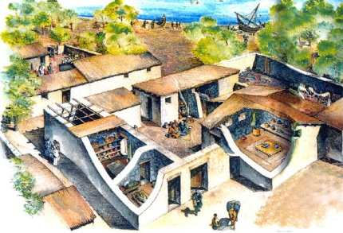  - Men’s jobs were typically farmers, craftsmen, or fishermen  - Women learned cooking and household duties.  - The more fortunate would have been taught a trade by their father—Joseph would have taught Jesus.  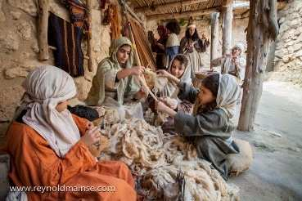  - The range of food was much more limited than it is today.  - Seasonal vegetables (e.g. beans, onions, lentils, leeks, cucumbers), flavoured with herbs and salt, and bread (made from wheat or barley flour) provided the basis of a staple diet.  - There would also have been fruit (though not the citrus fruits for which Palestine is known today), together with nuts, honey and cheese.  - Fish were plentiful, especially around Galilee, and could be preserved by drying and salting.  - Wooden cooking utensils  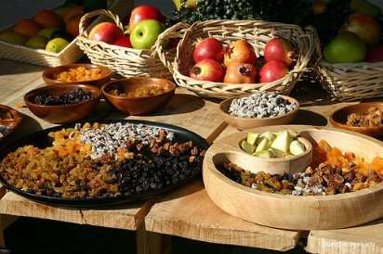  - Clothing was much simpler. Most garments were made from wool, though linen was also used  - Both men and women would normally wear an ankle-length tunic next to the skin, often held at the waist by a belt (which could also be used as a purse). A cloak could be worn over this, especially at night or if the weather was cool during the day.  - If shoes were worn at all, they would generally have been leather (or perhaps wooden) sandals.  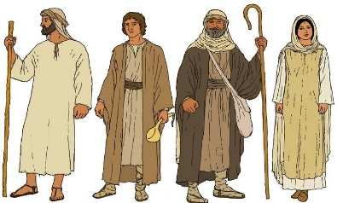  - The languages spoken were: Aramaic, the common, daily language, Hebrew, the language used for prayer and Greek, the language of the land – perhaps some of your children/families can speak or have experienced these languages.  - Daily activities may have sometimes included - Feasting, singing, story-telling and dancing all had their place as recreational activities.  - Games, both indoor and outdoor, were also popular. Archaeologists have discovered a few gaming boards with playing pieces. |  |  | Learning activities/Objectives  What will I see and hear to help me understand?  Recognise - name, remember, recall, label, identify, match, sort  Recognise and retell Jesus growing up in loving family.  Recognise Jesus, Joseph and Mary are known as the Holy Family.  - Talk to the children who is in the Holy Family – think about why they think it is such a special name – The Holy Family?  - Read directly from the Good News Bible, and then place in your special area of class. Place an image/picture/statue of the Holy Family.  - Retell/Golden Box – revise and extend the story to after the Wise Men had left. Retell the story of the Holy Family’s return to Nazareth. Use sand and reenact using peg people to travel to the home where Jesus grew up. You might wish to use a small cardboard box as His house would have had a flat roof.  - Talk about the things that Jesus may have done growing up. His dad worked with wood and was a carpenter. He might have helped his mum Mary to grow things and cook. The family will have prayed together – use the images below.  - Recognise Jesus’ life as a child.  - Use the images to sort as Jesus grew.  - Ask children to bring in photographs of them helping the family at home and or in school. If children pray at home and or in school. Playing with friends or family at home/school.  - Scribe for the children to compare what they do and what Jesus was doing in the pictures.  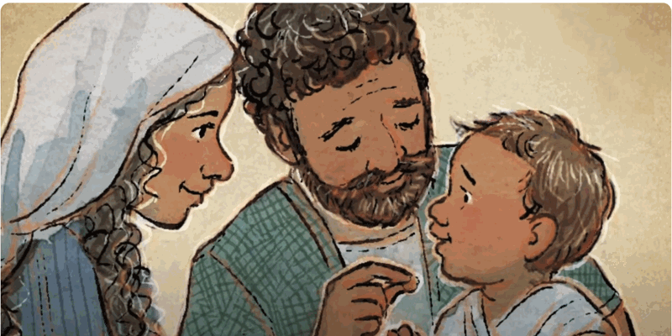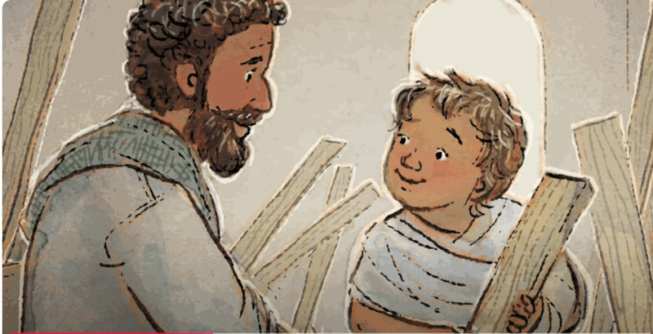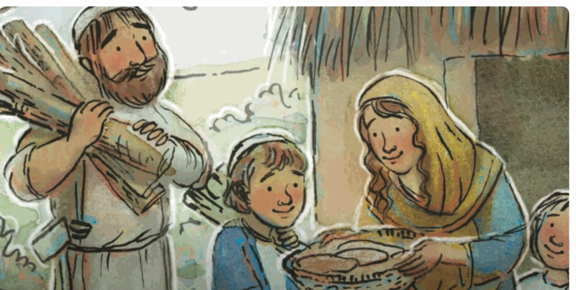  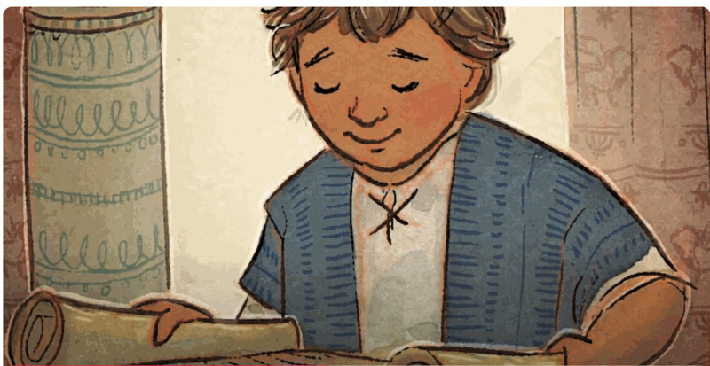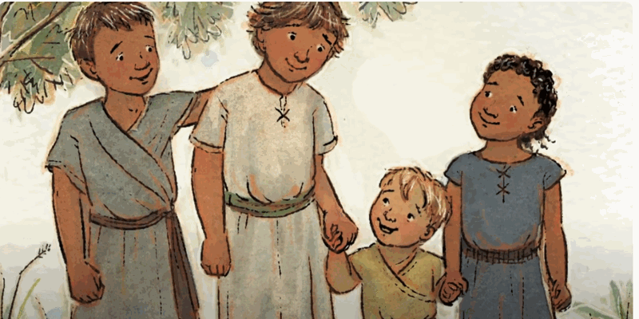  *Please note the images used are clips from an online story. The whole story would not be suitable for children in our schools, therefore please just use the images provided.  Learning activities/Objectives  How will I discover more?  What can I do now?  What if? Wonder about? Awe and Wonder, Imagining, similarities, differences, views, preferences, identify, names, experiences, creative and artistic expression  - Role playing the life of Jesus when he was a boy.  - Talk about and wonder about Jesus as a child.  - What questions/thoughts and ideas do they have about Jesus as a boy  - Say that we can’t answer all the questions, but we can find clues through pictures and images from Nazareth today.  - Talk about their role play and what they imagined Jesus was doing

Assess Pupils’…WAYS OF KNOWING | Informal / Formal Assessment Comments
UNDERSTAND
What will I see and hear to help me understand?
- Talk about Jesus, Mary and Joseph as the Holy Family
- Talk about and hear about Jesus as a boy
DISCERN
How will I discover more? What can I do now?
- Wonder about the Holy Family and what they did together
- Talk about similarities and differences between their own family and the Holy Family

THIRD TEACHING SEQUENCE
NURSERY BRANCH 3
Jesus blesses the little children
HEAR & BELIEVE |  | CELEBRATE & LIVE |  |  | WAYS OF KNOWING
Jesus blesses the little children.  Mark 10:13-16 | Jesus came to show God’s love and welcomes everyone. | The Church prays The Glory Be as a response to the coming of Jesus |  | We welcome and show love to everyone in our words and actions as Jesus does. | UNDERSTAND  What will I see and hear to help me understand?  - Hear about Jesus as a man blessing the little children.  - Jesus welcomes everyone.  - Continue to hear the Glory Be prayer in thanks and praise to God and Jesus.  - We can be like Jesus and welcome everyone.
DISCERN
How will I discover more? What can I do now?
- Use the words Glory be as a way to praise and give thanks to Jesus.
RESPOND
What can I do now?
- We can use our actions and words as Jesus has shown us.
Scripture (HEAR) – Good News Translation
Jesus Blesses Little Children
Some people brought children to Jesus for him to place his hands on them, but the disciples scolded the people. ¹When Jesus noticed this, he was angry and said to his disciples, “Let the children come to me, and do not stop them, because the Kingdom of God belongs to such as these. I assure you that whoever does not receive the Kingdom of God like a child will never enter it.” Then he took the children in his arms, placed his hands on each of them, and blessed them.
HEAR and BELIEVE
Teacher Notes
*In this teaching sequence we now jump to when Jesus is older. Make this clear to the children on a timeline.
At the time of Jesus, having children blessed by a Rabbi was a long-held tradition from when Jacob blessed his grandsons by laying hands on them (Gen 48:14-16). At the time it was the fathers who had the responsibility for the spiritual development of the children (Deut 6:4-7, Eph 6:4) It is most probable that it was the fathers who were bringing the children to Jesus as the spiritual heads of the household.
Children (those under the age of 12) were seen as weak and powerless and of lesser importance, hence the disciples trying to stop the children from being brought to Jesus to be blessed.
The story of Jesus blessing the children sits as part of a suite of teachings about welcoming God and being faithful to what God is asking and greatness (Mk 9:33- 10:31). and is sandwiched between two predictions of Jesus’ death. It is written in a narrative structure, with a beginning and a middle, together with a problem resolved in the end.
We find Jesus and the disciples in a house in the region of Judea beyond the Jordan (Mk 10:1). Jesus had finished an encounter with some Pharisees (Mk 10:2) and a debriefing with his disciples, (Mk 10:10).
As you begin the text it gives the reader the impression that there were a considerable number of people bringing their children forward to be blessed. This may have annoyed the disciples who were still perhaps talking with Jesus. They spoke sternly to the people bringing the children but Jesus became “indignant” and told the disciples that if they wanted to enter the Kingdom (to be with God) they would have to be open to the embrace of the Lord just as the little children the fathers were bringing to be blessed were open (Mk 10:15). He then takes them in his arms and blesses them.
The idea of Jesus taking them in his arms would suggest that the children presented were around 5 or 6 years of age highlighting their powerlessness and need for protection (Mk 10:16). Jesus also challenges the idea of people being too self-reliant and in the gesture of embrace and blessing he highlights the need to be like a child who has complete trust in a parent to love and care for them as they cannot care for themselves independently. They are not self-reliant and need to be cared for as they are vulnerable and powerless.
Inviting the indignant disciples challenges their view of themselves as those with status: here Jesus commends those among the most vulnerable…this would not have been an easy message for the 12 to take on.
Continuous Provision  and adult-guided |  |  | Learning activities/Objectives  What will I see and hear to help me understand?  Recognise - name, remember, recall, label, identify, match, sort  Recognise and retell the story of Jesus blessing the little children.  Recognise that Jesus blesses the children because he wants to show God’s love.  Recognise that Jesus wants to show love and welcome everyone.  - Remember the stories the children have heard – The Magi visiting baby Jesus, Jesus as a boy. Make it clear to the children that in this story Jesus has grown up into a man. Indicate this with the use of a timeline using some of the images from both stories. You may wish to make this a more permanent fixture in the classroom – adding to it each time a new story happens.  - Retell the story of Jesus blessing the children. You may wish to use role play to reenact what Jesus and the disciples were saying.  - You may wish to use the images for children to add what is being said by Jesus and the children.  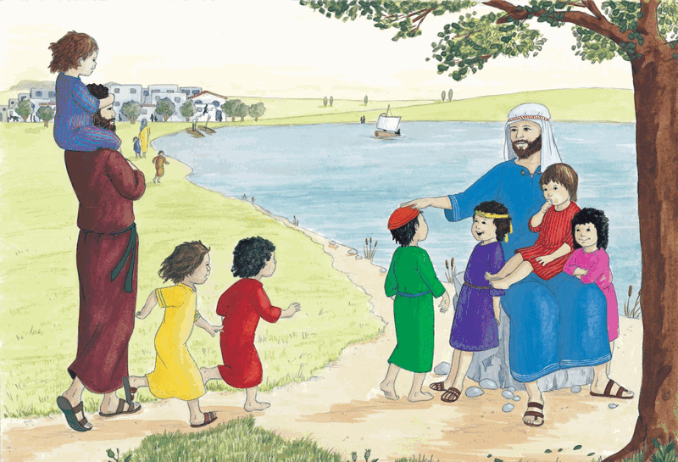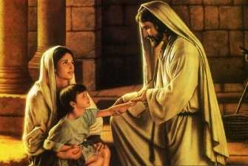  - The image from God’s story pp.30-31 can be used to further understanding  - What do you see?  - What are the children doing?  - What are the people doing?  - What is Jesus doing?  - Would you like to be there too? Why?  - What did the people want Jesus to do?  - Why was Jesus cross?  - What did Jesus say?  - What did he do?  - What does the story tell you about Jesus?  - Place items in the Golden Box for children to use as small-world figures to retell the story.  - Read and retell the story using Never Too Little by Steph Williams (The Good Book Company) https://www.youtube.com/watch?app=desktop&v=Z9K08o1URnU  **Thank you to one of our fabulous teachers who recommended these books for Early Years – more can be found at The Good Book Company  https://www.thegoodbook.co.uk/authors/steph-williams  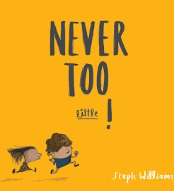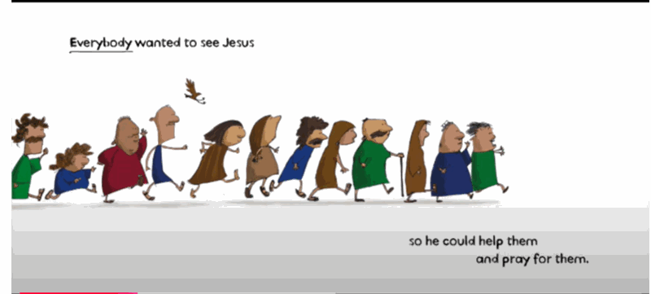  Art/Craft  - Jesus had a very important job to do and this story shows how much love He had to share. He wants to welcome everyone and tell everyone about God’s love.  - To demonstrate Jesus' love for everyone and how he welcomed little children make a large poster/display etc with Jesus in the centre. Find a suitable way to represent the children - this might be their own family photograph, handprints etc…  - Use the title Jesus welcomes all children/”Bless you.” or something similar.
CELEBRATE & LIVE
The Church prays The Glory Be as a response to the coming of Jesus

- Please follow the guidelines from the Teacher’s Notes in the first teaching sequence. In this sequence pick up again The Glory Be Prayer where children can use the prayer as praise and thanks.

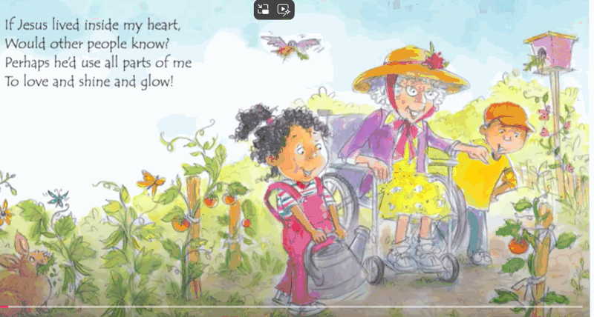  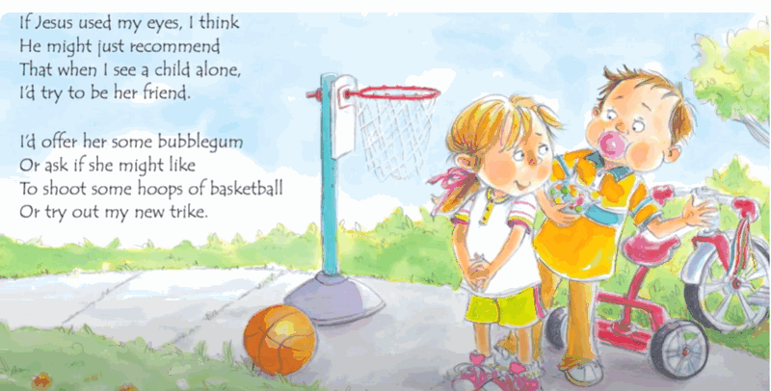  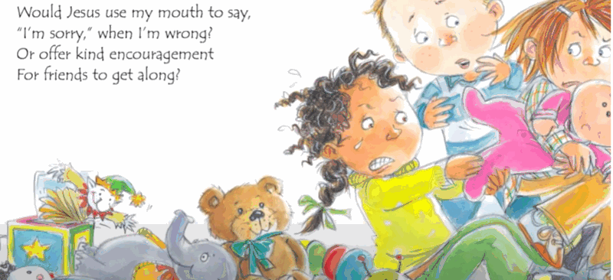  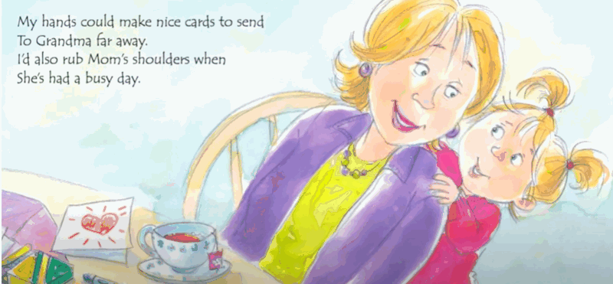  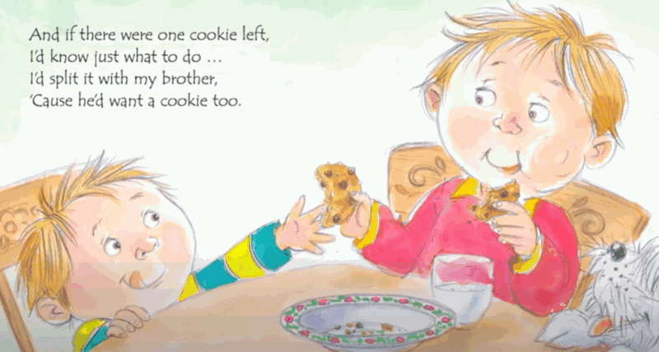  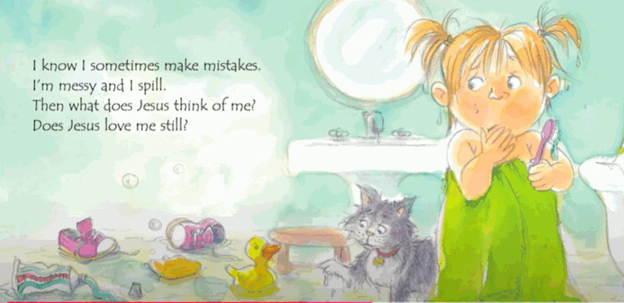  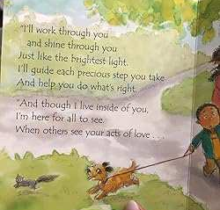  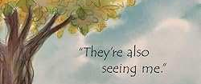 |  |  | Learning activities/Objectives  What will I see and hear to help me understand?  Recognise - name, remember, recall, label, identify, match, sort  Recall and recognise the Glory Be prayer  - Say the prayer and watch the clip to remind children of the Glory be prayer.  - When reflecting on the children’s work over the Branch – say the prayer in thanks to God and Jesus – Children will begin to know that the prayer is being said in thanks, led by the teacher.  - If children can… ask them to repeat the simple sentence … Glory be to God/Jesus at the end of their daily prayers or during prayer and liturgy times.  Learning activities/Objectives  How will I discover more?  What can I do now?  What if? Wonder about? Awe and Wonder, Imagining, similarities, differences, views, preferences, identify, names, experiences, creative and artistic expression  Learning Activities/Objectives  What can I do now?  Talk about - feelings and experiences. Begin to make links from Scripture …feelings, behaviour, life, live.  How can I be more like Jesus (Catholic Social Teaching)  - Sing You’ve gotta love like Jesus did – John Burland – https://www.youtube.com/watch?v=3v-tr4NQmKA  - Read and share If Jesus Lived Inside My Heart https://www.youtube.com/watch?v=6ip9ioFtDUM  - Use the story and some of the images (you may wish to use just one or two)to share and talk about what might happen if we act like Jesus - it is like He is in our hearts. He was kind and loving to the little children. How can we be more like Jesus? How can we be kind and loving?  - The images have been taken from the online story and some from google images – I have picked a selection but you may wish to focus on one or two. You also may wish to buy the book and use the images from the book. If Jesus Lived Inside My Heart By Jill Roman Lord · 2000  Ideas to use from the storybook  - Retelling a page from the story  - Scribe children’s responses to questions about being like Jesus  - We know Jesus is kind because blessed all of the children – how can I be kind?  - Remove the text and ask children to say what is happening and compare to a kind and loving Jesus  - Share how they have been kind/loving just like the story  - Ask children to go a kind thing at home and take a photograph or talk about it in school  *The acts of loving and kindness are small steps in Catholic Social Teaching

Assess Pupils’…WAYS OF KNOWING | Informal / Formal Assessment Comments
UNDERSTAND
What will I see and hear to help me understand?
- Hear about Jesus as a man blessing the little children.
- Jesus welcomes everyone.
- Continue to hear the Glory Be prayer in thanks and praise to God and Jesus.
- We can be like Jesus and welcome everyone.
DISCERN
How will I discover more? What can I do now?
- Use the words Glory be as a way to praise and give thanks to Jesus
RESPOND
What can I do now?
- We can use our actions and words as Jesus has shown us.

