
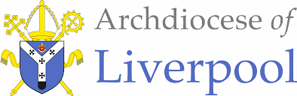

To Know You More Clearly
Religious Education Scheme of Work
EYFS Nursery
To the ends of the Earth

EYFS Nursery Branch 5 - To The Ends of the Earth
- Overview  The overarching theme for Nursery and Reception is God is Love.  To the ends of the Earth:  ‘Go, therefore and make disciples of all nations baptising them in the name of the Father and of the Son and of the Holy Spirit’ (Matthew 28:19) In this branch, in an age appropriate way, pupils will study the events that flowed from the Resurrection and Ascension in the coming of the Holy Spirit and the work of the apostles and early Church. They will also learn about the Catholic Church today as the apostolic Church and how its liturgy and structures flow from the early Church.  Themes  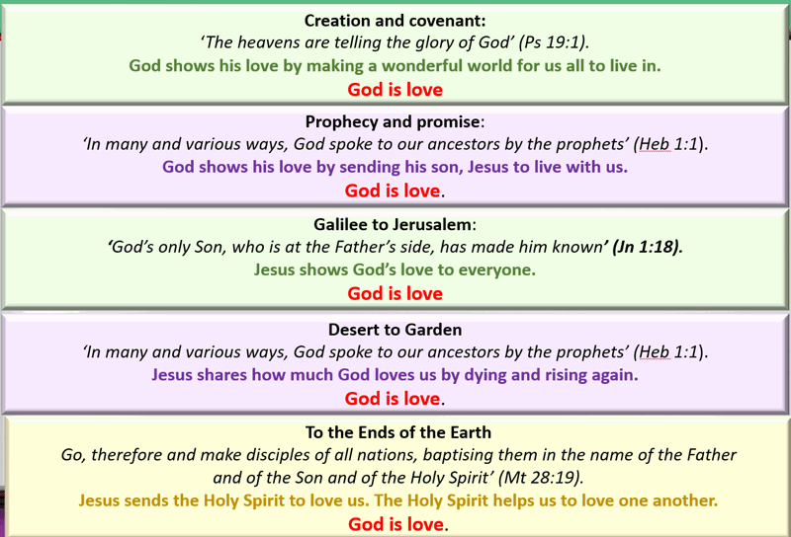  Prior Learning – Reminder - The Bible tells us all about God. We must keep this in a very special place (prayer space/focus, place the book with the title Bible and the ‘Word’ of God) Can you remember where our special book is? Who can remember what the book is called? Remember this book tells us all about God. Would you like to hear a special story about God today?  - Please remember to use a Good News Bible – whilst this is not an accessible read for children, they need to experience what a Bible looks like, and how it is used – just as in other religions, in Christianity this is a sacred book and needs to be treated with the utmost respect and care.  - Children will see how you as an adult use the Bible – they may not understand the words but it is our job then to retell the story in as many ways as possible – through retelling, crafts, art, dance etc… etc…  General Guidance  - Please begin with the Scripture story told from the Good News Bible at the beginning of each teaching sequence.  - Please try to follow the sequences as they appear in the planning. This will allow for timelines and links to be made. However, in some circumstances, they may be best suited in a different order especially considering the age and stage of the children.  - Also, there may be times when you may wish to teach Believe, Celebrate and Live in a different order following Hear or together to suit the needs of the children.  - The activities within the sequences are suggested and you do not need to cover them all! Please ensure you cover 10% of your curriculum time each week for Religious Education.  Liturgical Events  April  Sunday 27 2nd Sunday of Easter  Monday 28 St George, Martyr, Patron of England;  May  Thursday 29 The Ascension of the Lord  June  Sunday 8 Pentecost  Other useful dates |  |  |  | Notes
 |  |  |  | Key Words
Enhancing the Religious Education Curriculum
Please find below a list of possible ways to engage learners…
- Previous Knowledge
- Key Vocabulary
- Timeline
- Equality
- Drama/Role Play
- Poetry
- Catholic Social Teaching
- RSHE
- Parents/ Carers
- Home/school/parish
- Parish Priest
- Parish Deacon
- Parish Catechists
- Governors
- Liturgy
- Sacramental Foundations
- Liturgical Colour Boxes
- Philosophy
- Inclusion
- Culture
- Awe and wonder
- Seasons/The Natural World
- Beauty
- Senses
- Music
- Art
- Dance
- Storytelling
Cross Curriculum Links

The aim of Religious Education in the Early Years is for it to be taught as far as possible at the heart of the curriculum. The Branch itself can lead all learning.
Please find below the diagram of how RE is central and links to other areas of learning.

Assessment Overview
Ways of Knowing – Skills
In the ways of knowing table below…we describe the aim of each way of knowing - the skills that are required to develop them - the driver words that indicate progress through them - and generic progression indicators in the ways of knowing for each age-phase. The skills below will help children to achieve their expected outcomes. Within each activity, use these skills to inform and help guide skill progression.

UNDERSTAND What will I see and hear to help me understand? See |  | DISCERN How will I discover more?  Judge | RESPOND What can I do now?  Act
Skills | Activities will help pupils to see, hear and understand  help pupils to be able to understand deeply  - the meaning of sacred texts,  - religious beliefs,  - sacred rites  - lives of individuals and communities who are shaped by these texts, beliefs, and rites.  deepen their understanding by developing the skills to:  - Remember and apply the meanings of key texts, beliefs, and concepts.  - Provide explanations by making links between religious texts, beliefs, and practices.  - Interpret and analyse the meaning of texts, practices, and rituals and their historical and cultural connections. | Activities will… help pupils to discover more be able to judge wisely in response to …  - different interpretations of the meaning,  - significance,  - implications of texts,  - beliefs,  - rites,  - ways of life  arrive at justified conclusions about…  - what is true,  - what is good,  - what is beautiful.  Increase in wisdom, through  - dialogue with others  developing the skills to:  - Think creatively  - Think critically  - testing ideas by imagining other possibilities.  Compare different interpretations of  - religious expression  - celebrating rites  - different ways of life  - explaining differences within and between religions and worldviews.  Critically evaluate differences to arrive at  wise judgements about what is  - true  - good  - beautiful. | Activities will help pupils to ask what they can do now and how to act because of what they have understood and discovered further to…  - give a personal response  - reflect on what they have understood and discovered further  - reflect on what their learning means in their own lives  - dialogue with others to understand themselves more  - dialogue with others to understand others more  - imagine how their lives could be changed or transformed by what they have learned  - imagine how the lives of their community can be changed or transformed by what they have learned  - imagine how their lives and their community could be improved and transformed in the future
 | Ages 3-5
Driver words and phrases | Recognise  - Name  - Remember  - Recall  - Label  - Identify  - Match  - Sort  - Begin to recognise religious words and phrases of religious life and practice.  - Begin to recognise simple connections between sources, beliefs, worship and life  - Begin to recognise texts, beliefs, rites, ways of life. | ‘What if?’  - Ask ‘what if?’ questions,  - say what they wonder about and suggesting answers,  - imagining how they and others are feeling.  - Recognising similarities and differences.  - Point out what is the same and what is different.  - Expressing a point of view or a preference.  - Listening to different viewpoints.  - Supporting a preference with reasons. | Talk about  - Talk about their own feelings and experiences.  - Begin to make links between their own feelings and the Scripture they have heard.  - Begin to make links between their behaviour or way of life and the Scripture they have heard.

Planning / sequence overview
Understand What will I see and hear to help me understand?  - Jesus went back to his Father.  - Jesus gave his friends a special gift called the Holy Spirit.  - The Holy Spirit is our friend.  - Jesus sent the Holy Spirit to help me.  - The Holy Spirit looks after me.  - The parish church is a special place where we meet our friends.  - We sing and say prayers in the parish church.  - Friends gather together at church on Sunday. | Discern How will I discover more? | Respond What can I do now?
EYFS To the Ends of the Earth – Nursery |  |  |  |  | EYFS To the Ends of the Earth – Reception
Sequences | HEAR | BELIEVE | CELEBRATE | LIVE | HEAR | BELIEVE | CELEBRATE | LIVE
First Teaching Sequence | Jesus went back to his Father. Jesus gave a special gift to his friends  Acts 1: 3-4, 8-9  *Adapted |  |  |  | Story of  Pentecost (Simple  Telling)  Acts1:3-4  Jesus promises a special gift. |  | Alleluia!  Praise God  *Please note this is a new addition to the RED
Second Teaching Sequence | Acts 2:1-4  The Coming of the Holy Spirit.  *Adapted | He sent a special friend, the Holy Spirit, to look after us. | The Holy Spirit is our friend.  The Holy Spirit looks after us. |  | Acts 1: 8-9 Jesus goes back to his Father
Third Teaching Sequence |  |  | The parish church is a special place where we meet our friends. We sing and say prayers. | The parish church.  We gather with friends at church, especially on Sunday. | Acts 2:1-4  The Coming of the  Holy Spirit | Coming of the  Holy Spirit at  Pentecost | Pentecost is a special celebration in the Church. | The parish church and the parish family meet there to celebrate.
Fourth Teaching Sequence |  |  |  |  | The early Christian community (Acts  2:42-47 | The Good  News of  Jesus lived out by the early Christian community. | Sunday is a special day for the Church to celebrate | CST Jesus knows that people can be happy with families and friends. He tells us that we can let these important people help us. He asks us to help them too. We need each other. We Are  Called to Live as Family and  Community  CST All people are God’s children. That makes us brothers and  sisters. We are connected to each  other. It is as if  everyone in the world held hands! We can be very different from each other, but we are still one family—God’s family. Solidarity
Sequence 1 - Nursery
Jesus gave a special gift to his friends
Scripture (Hear) – Good News Translation
Jesus went back to his Father. Jesus gave a special gift to his friends ***This reading has been adjusted to suit the age and stage of the children in Nursery. It refers to parts of Acts 1:3-4 and 8-9 Please use the bible as normal but use the words below in blue to the children.

The original bible reading: ³ For forty days after his death he appeared to them many times in ways that proved beyond doubt that he was alive. They saw him, and he talked with them about the Kingdom of God. ⁴ And when they came together,^{[a]} he gave them this order: “Do not leave Jerusalem, but wait for the gift I told you about, the gift my Father promised.
⁸ But when the Holy Spirit comes upon you, you will be filled with power, and you will be witnesses for me in Jerusalem, in all of Judea and Samaria, and to the ends of the earth.” ⁹ After saying this, he was taken up to heaven as they watched him, and a cloud hid him from their sight.

Please use the adapted version below…
Read as:
Jesus was alive and he appeared to his friends many times. They saw him and he talked with them. When they were all together Jesus gave them an order, “I am sending you a gift. The gift is the Holy Spirit. It will give you power. Jesus then left and went back to his father in heaven.
HEAR
Teachers Notes: Jesus went back to his Father. Jesus gave a special gift to his friends
Background The Acts of the Apostles…
is the name given to Luke’s second book. It continues the story of Jesus. It tells how the gospel (‘good news’) of Jesus was spread in the early Church. Luke begins with the story of Jesus’ return to his Father, the Ascension, and the coming of the Holy Spirit at Pentecost.
The friends of Jesus had found it hard to understand that Jesus had risen from the dead. Today, Christians know this as the mystery of God. Not something magical but a way to understand how special, how significant Jesus was. He fulfilled what the prophets in the Old Testament had said.
Jesus made a huge impression and offered a way of life that inspired his followers, and they wanted to live just as he had told them and how he had shown them.
**Be careful with explaining the story to young children - it is best advised not to explain by comparing their loved ones who have died to Jesus as they may wonder why their own loved ones didn’t do as Jesus did. It is enough to retell the story from Scripture as it is and leave the mystery of God with them.
For us as adults we can begin to relate by remembering our loved ones who have died. They often leave such special memories and gifts that we can treasure that may help us carry on with our lives.
Words to notice.
- There isn’t a great announcement of a gift to the friends of Jesus instead He says – when the Holy Spirit comes. The Holy Spirit is Jesus’ gift to the friends.
- The gift of the Holy Spirit - this is a difficult concept for adults and children. Christians believe that the Holy Spirit is a person – part of the Trinity – Father, Son and Holy Spirit are the same. (see notes below in Believe) Children (and many adults too) struggle with this understanding. For children of this age, we keep them as three people. The gift is a spiritual gift which gives Christians a power to fulfil their lives. Every single believer who has placed their trust in God has one—even very young children. This is great news for a child to feel special and valued; giving them a clear life purpose, unique talent, and a way to measure up against their peers while helping others around them, as they use their Holy Spirit’s gift to benefit from and use their power to do good, just as Jesus had shown them. Young children will associate the gift as someone who is helping them to be good, strong etc. Some may describe the Holy Spirit as a friend that will be their friend. Some may even say it is a feeling inside that makes them happy, good, have power to help others)
- Power – at this stage explain the power of the Holy Spirit as simple as possible. The Holy spirit gives us gifts to use such as wisdom and understanding – the children will hear about this as they progress in their learning. For now, the power that is given through the Holy Spirit is for good – it helps us to be powerful and strong in caring for one another, helping, working etc…
- Went back to his Father in heaven. After Jesus had gone back to his Father in heaven: The New Testament accounts of the Ascension (when Jesus returns to his Father) express in picture language the belief of the early Jewish Christian community that God’s dwelling place was above the heavens.
*For young children it is sufficient that they understand that Jesus went back to his Father. In God’s Story 2 and God’s Story 3 further details of the symbolic language are introduced.
HEAR
Learning Activities: Understand, what will I see and hear
Recognise Name Remember Recall Label Identify Match Sort
Jesus went back to his Father.
- Read and share the Scripture story from the Good News Bible. Explain to the children that we will find out more about what this means.
- Prior Learning - remind children of the signs and symbols of Easter - white, growth, Easter Garden, Easter eggs, new life.
- Talk about the events of Good Friday and Easter Sunday, what can they remember, what did they hear about?
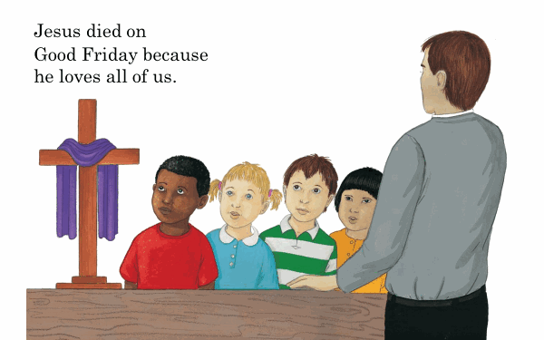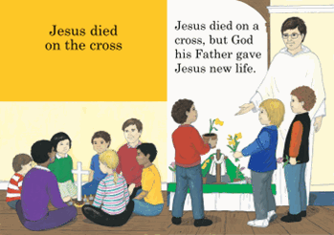
- Gather around the Easter Garden/Cross – make sure there is a white a drape. With the children, recall the Good News of Easter for the friends of Jesus. Prior learning – Golden Box or previous work – you may wish to add signs/symbols for reminders to the Golden Box
- Retell the new Scripture they have heard in your own words.
- Use the Golden Box to recreate the story.
- Using a timeline remember the special things Jesus had done. What can the children remember? You may wish to use some of the children’s work or other pictures to help the children with the timeline.
Use the timeline in small groups to order/sort and talk about.
You may wish for the children to draw/paint their own timeline. Use previous work from Advent/ Spring 1 or 2 branches or photographs to prompt discussion.
Jesus was a baby.
Jesus was a little boy….

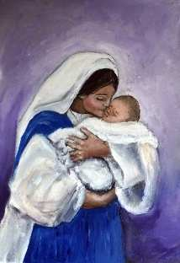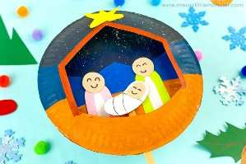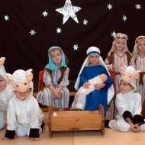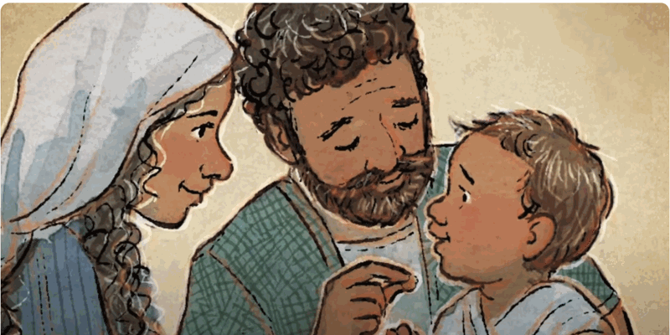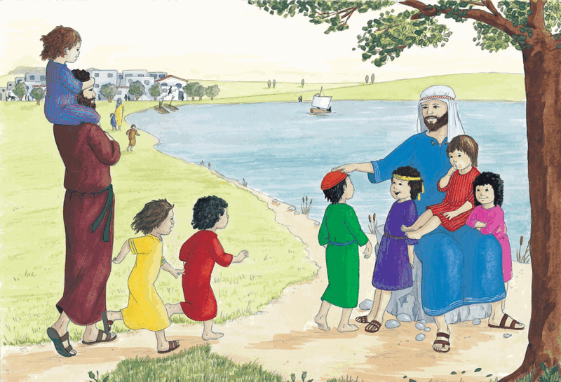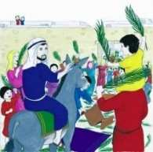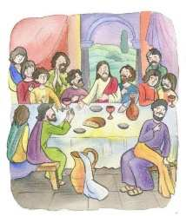

Continuous Provision

- Golden Box for retell
- Timeline sorting/ordering/writing table
- Role play Jesus with his friends – fishing together and enjoying a meal together

“Jesus was alive and he appeared to his friends many times. They saw him and he talked with them.”

- We remember that Jesus was alive! He rose again and we celebrate this at Easter. His friends were very happy, and they talked together many times.
- Talk about the three images below -
- The friends were shocked to see Jesus alive! The friends were happy because he was alive.
- The friends talked to Jesus. They prayed together. They ate food together.
- Jesus went back to his Father in heaven. Jesus left them with a special gift.
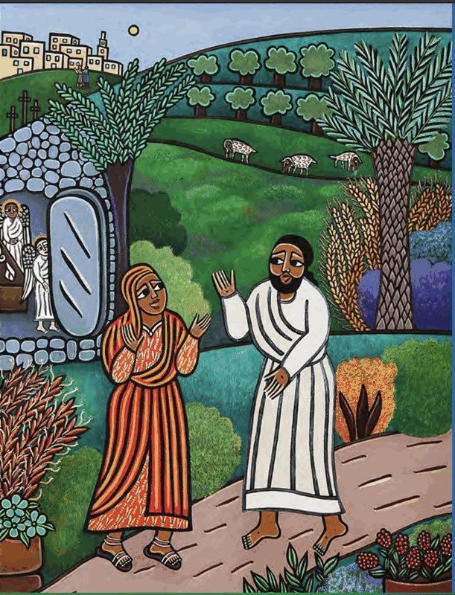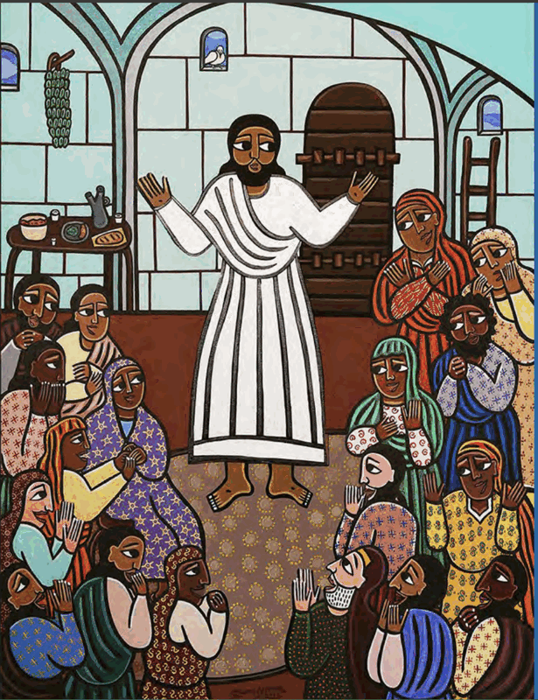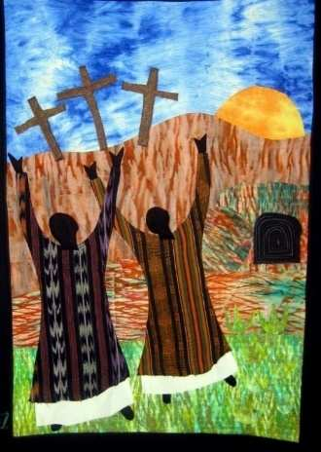

1st and 2nd image - part of a series https://futurechurch.org/wp-content/uploads/2024/07/Stations-Slides-for-Web.pdf
3rd image –-https://bameanglican.wordpress.com/2019/04/21/easter-and-art-from-around-the-world/

- Role play area - Jesus meeting his friends again and sharing food together.

The gift is the Holy Spirit. It will give you power.
Jesus went back to his Father in heaven.
He gave his friends a gift called the Holy Spirit.
The Holy Spirit helps us.
The Holy Spirit gives us power.

- Using large speech bubbles ask the children what they think the Holy Spirit is? Perhaps use the images above to express their feelings about what is happening … Jesus said I will give you a gift etc… I think the gift will help us…
What are they wondering about?
If Jesus has given the gift, do they think it will be a good gift? Why?
Scribe for the children or draw pictures to say what they think/feel the Holy Spirit is?
(Young children will associate the gift as someone who is helping them to be good, strong etc. Some may describe the Holy Spirit as a friend that will be their friend. Some may even say it is a feeling inside that makes them happy, good, have power to help others)

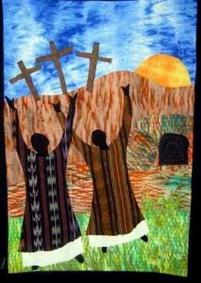

Continuous Provision

- Golden Box for retell
- Using the three images to talk about with friends – use play people to represent the actions in the pictures to retell.
- Role play – Jesus meeting his friends again.
HEAR Ways of Knowing (Expected Outcomes)
- Jesus went back to his Father.
- Jesus gave a special gift to his friends.

Sequence 2
The Coming of the Holy Spirit
Scripture (Hear) – Good News Translation
Acts 2:1-4
The Coming of the Holy Spirit. Please read from the adapted version.

2 When the day of Pentecost came, all the believers were gathered together in one place. ² Suddenly there was a noise from the sky which sounded like a strong wind blowing, and it filled the whole house where they were sitting. ³ Then they saw what looked like tongues of fire which spread out and touched each person there. ⁴ They were all filled with the Holy Spirit and began to talk in other languages, as the Spirit enabled them to speak.

Please read …
Jesus’ friends gathered together to wait for a special gift from Jesus called the Holy Spirit. Suddenly there was a noise from the sky which sounded like a strong wind blowing, and it filled the whole house where they were sitting. They were all filled with the Holy Spirit.
HEAR
Teachers’ Notes:

- The thought of being without Jesus frightened the disciples. In a Gospel account of the Last Supper Jesus reassures them and promises to send a new Helper to be with them. All through the ages Christians have relied on this promise.
- The frightened disciples gathered together behind closed doors. The picture language of the account tells of wind a symbol of the transforming power and love of the Holy Spirit. The frightened disciples are powered to burst out of the room and to tell the good news of Jesus.
- It is difficult at this age for children to understand the abstract concept of the Holy Spirit. We use images such as air and wind to help us explain the power of the Holy Spirit. The effects of these elements are what we want the children to explore and thereby deepen their understanding.
- *Other symbols of the Holy Spirit such as fire will be used in Year 1
- *At this age the children may hear about Pentecost especially if it forms part of their family/school practice. It is enough for children to experience the event rather than make a formal teaching point which will be picked up from Reception.

Explaining this to the children
- The Holy Spirit feels like the wind. He makes us feel alive and awake and ready to do the job that Jesus wanted his friends to do – tell the good news about Jesus.
- When we feel awake, alive and ready we have the power to go and tell everyone about Jesus and the good things he said and did. Jesus knows that His friends have an important job to do so this is one way the Holy Spirit gives this power to help them carry out this role.
- Today, Christians are also tasked with this job. They feel the power of the Holy Spirit in their lives, the gift he has given us enables them to go out and do good things for everyone – just as Jesus did.
HEAR
Learning Activities: Understand, what will I see and hear
Recognise Name Remember Recall Label Identify Match Sort
The Coming of the Holy Spirit
- Read and share the Scripture story from the Good News Bible. Explain to the children that we will find out more about what this means.
- Retell the story using the Golden Box.
- Retell and use a fan with streamers attached, blow this towards the children to show the effects of wind and to demonstrate how the disciples may have felt.
- Retell the story using God’s Story 1 Pages 36-39
Talk about
What do you see?
What do you think is happening?
How do you think the friends are feeling? (Notice the changing emotions: from sad, worried, frightened - to happy and joyful.)
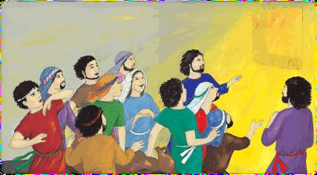

- Retell using the words from God’s Story …
After Jesus had gone back to his father in heaven* his friends were sad. They missed him. They felt lonely and afraid without him.
On Pentecost day they were all together in the house. Suddenly they began to feel different. Joy and happiness filled their hearts. It was wonderful. They knew that Jesus had kept his promise to send a new friend, the Holy Spirit. (based on Acts 2:1-4)

How does the wind make us feel? (Please see the teachers’ notes)
- Explore with the children the effects of wind in relation to the Holy Spirit. (this may be an opportunity to use this work as cross curricular)
EYFS Links:
- Understanding the World: Observing wind’s effect on objects.
- Physical Development: Developing coordination through running and crafting

Exploring the power of wind.
The friends of Jesus couldn’t see the Holy Spirit. But … they felt the wind, they heard the wind, they saw what the wind did.
- Can we see the Holy Spirit around us today?
- Do you think we can feel the Holy Spirit? Can we hear the Holy Spirit? Can we see what the Holy Spirit does? Let’s find out …

Read, share and talk about
- The Windy Day by Anna Milbourne– Usborne Books https://www.youtube.com/watch?v=Ij1qXn_dDLQ
- Talk about the effect the wind had throughout the book. Use images to talk more about what is happening in the pictures.
- The story reminds me of what happened to Jesus’ friends – they felt the wind blow all around them – they felt awake, and alive!

In the Reception planning there is a list of activities about wind. You may also have your own activities. Choose with your colleagues which activities will be suitable for each foundation stage.

- Wind chimes watch and listen to a wind chime. Talk about how the wind enables music to be made.
- Fly a kite Experiment with a range of flying kites and see which work best. Ensure there is plenty of space and no overhead wires or power lines!
- Experiment with windsocks, windmills and streamers. Make windsocks – from socks and compare these with other ideas from children, e.g. pillowcases, streamers, etc. for determining the most effective material and shape. Create long streamers and find out which is the longest that can fly horizontally in the wind.
- Storm damage The power of wind can be felt on gusty days. Observe wind blowing through different trees and how the different species cope. Look at how birds fly in the wind. Gulls are particularly good at wind surfing.
- Cloud racing Look at the clouds moving and see if they are all moving the same way. Does the height of the cloud affect the speed at which it moves? Look for cloud shadows on the ground on sunny days. Try to run as fast as a cloud shadow.
- Discover the wind direction Hold up a wet finger and feel which way the wind is blowing. Move slowly around to find the direction where the wind is blowing in your face. Look at clues in nature. For example, which way are flowers or grasses bending? Hold up a thin streamer or piece of ribbon and see which way it is flying.
- Seed scattering and leaf catching Many plants rely on wind to scatter their seeds. Blow on a dandelion clock and watch the seeds float away on their own ‘parachutes.’ Sycamore, maple and ash seeds have wings. Compare how these seeds spin and fall to the ground. If you have a portable fan, it is possible to set up an experiment to investigate how effectively different seeds can be scattered in the wind.
- Wind-blown messages Set up a thin washing line or nylon fishing line so that it faces the wind. Attach paper clips to small sheets of cardboard – you will need to push them through the cardboard. Then attach the paper clip to the line. Watch the wind blow the cardboard along the line. You can now write and send messages to friends this way!
- Explore eddies and shelter Find the most sheltered spot outside. How do you know it is the most sheltered place? Go to the windiest part of your playground. Each child can release a feather and investigate where it ends up on a windy day. Does this match up with where litter usually gathers? On windy days see if you can find places where wind eddies and tunnels exist in your grounds.
- Run with and against the wind Try running against the wind. Compare how this feels to running with the wind behind you. What happens if you hold a big piece of cardboard or create wings with your jacket. Hold up different types of material but of the same size. Why do they feel different when held up to the wind? Which is the easiest to hold and why?
- Ball Find a straight line outside or draw one with a piece of chalk on a smooth level piece of ground. Roll a ping pong ball along the line and see what happens on a windy day – compare to doing the same activity inside. Experiment with directions and see what happens when the ball is rolled into the wind, or away from the wind or when the wind hits it from the side. Try rolling different balls and see which one rolls best along the line on a windy day. Throw a ball into the air on a windy day and see what happens. Hold a ball throwing competition with the wind behind you as you throw and then compare this to when you throw a ball into the wind. Again, different balls may react differently in the wind.
- Play with the wind Create a sailing boat from natural materials. Make a toy parachute from a square of plastic or a cotton handkerchief. Throw the parachute into the air and watch what happens. Compare the experience of doing this on windy and calm days.
- Blow bubbles and watch them as they float away. On a windy day, is it possible for the wind to blow a bubble? Can you do this just by moving the wand?
- Wind Tunnels: Use a fan to blow lightweight objects like feathers, scarves, or tissue paper. Let children experiment with how different items move.
https://creativestarlearning.co.uk/early-years-outdoors/10-ideas-for-windy-days/

- Let us look again at the picture we saw that shared what happened to Jesus’ friends when they felt the Holy Spirit – like the wind

- Ask the children about Jesus’ friends now after finding out more about the wind – (can they talk about how the disciples were feeling in more detail – such as they felt it all whooshing around them, or they shivered, or it woke them up! Etc.)
- Scribe the words that the children respond with- perhaps with speech bubbles – what are they saying or feeling.

Continuous Provision

- Golden Box for retell
- Emotions/writing table
- Role play the room where the disciples were waiting for the Holy Spirit. Did they eat together. Comfort each other? Where they excited about the Holy Spirit? What happened when the wind blew strongly on them? How did they feel?
- Outdoor play – pinwheels, wind chimes etc… choose activities planned together with Foundation 2 – Reception class

HEAR Ways of Knowing (Expected Outcomes)
- The Holy Spirit comes to Jesus’ friends
Believe & Celebrate
Jesus sent a special friend, the Holy Spirit, to look after us.
The Holy Spirit is our friend.
The Holy Spirit looks after us.
Teacher’s Notes

*At this age the children may hear about Pentecost especially if it forms part of their family/school practice. It is enough for children to experience the event rather than make a formal teaching point which will be picked up from Reception.

The words written in red highlight the focus for Nursery children.

For your own subject knowledge …
Pentecost holds great significance for Catholics for several reasons:
- The Gift of the Holy Spirit: Pentecost is a reminder of the promise Jesus made to send the Holy Spirit to guide and empower his disciples. The Holy Spirit strengthens believers in their faith and helps them to live as followers of Christ.
- Unity in Diversity: The story of Pentecost emphasises the unity of believers from different backgrounds and languages. It reminds Catholics of the universal nature of the Church and the call to embrace diversity while working together for the common good.
- Missionary Zeal: After receiving the Holy Spirit at Pentecost, the apostles boldly proclaimed the message of Jesus Christ, leading to the spread of Christianity throughout the world. Pentecost challenges Catholics to share their faith with others and participate in the Church's mission of evangelization.
https://www.catholic.org/news/hf/faith/story.php?id=87077

How do Catholics Prepare for Pentecost?
Preparing for Pentecost can deepen one's spiritual experience of the feast day. Here are some simple ways Catholics can prepare:
- Prayer: Set aside time for prayer, asking the Holy Spirit to fill your heart and guide you in your faith journey.
- Reflection: Reflect on the role of the Holy Spirit in your life and consider areas where you may need His guidance and strength.
- Acts of Charity: Practice acts of kindness and charity, following the example of Jesus Christ and demonstrating love to others.
- Reconciliation: Receive the sacrament of reconciliation (confession) to cleanse your heart and renew your commitment to following Christ.

Learning Activities: Understand, what will I see and hear
Recognise Name Remember Recall Label Identify Match Sort
Jesus sent a special friend, the Holy Spirit, to look after us.
The Holy Spirit is our friend.
The Holy Spirit looks after us.

- Jesus gave us the Holy Spirit to be our friend. We might feel sad that Jesus has gone back to be with God, his Father.
- Jesus looked after us. The Holy Spirit will look after us.
- Jesus showed us how to help one another. The Holy Spirit gives us power – just like the wind - to help one another.

Let’s find out how the Holy Spirit takes care of us. How he gives us power to help one another…

- The Holy Spirit knows how special we are so he wants us to use our special gifts more – he will help us use them.
- Using images such as the ones below. In groups, talk about what they can do best – children may wish to share their gifts in photographs taken when they have used their special gifts, in person in class and/or they may just wish to share how they tidy, share games etc.. – perhaps take photographs of the children sharing, playing, etc..
- Make a display in class The Holy Spirit gives me the power to share my gifts … or similar words.
- Ask the children why they think it is important to use their gifts to help others? We can share, we can teach other how to…

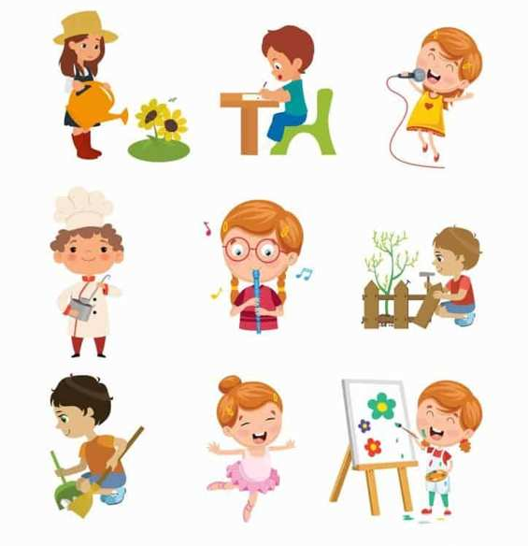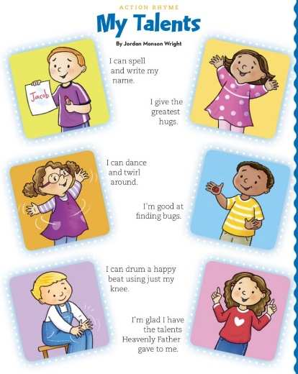

Hymns to celebrate the Holy Spirit/sharing their gifts with others.

- Go out! Go out! In Jesus name, Tell the world His story, By the way you live and work, By the Love you show. This is an old hymn that I unfortunately don’t have the tune to share with you (if anyone has this, please let me know)
- Love is something if you give it away …https://www.bbc.co.uk/teach/school-radio/articles/zk63239 … along the theme of spreading love, just like Jesus did.
- And along the same theme Happiness is something if you give it away …https://www.youtube.com/watch?v=mhqIaKamRik
- Mike Stanley – I’ve Got that Joy of the Holy Spirit Sign video clip and lyrics - https://www.youtube.com/watch?v=iUJv4q4sr_4
- John Burland – The Holy Spirit https://www.youtube.com/watch?v=qXIU-QyVtmY

Prayer & Reflection

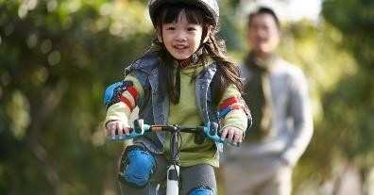
- Use images from the work completed above… of riding bikes, helping at home, tidying up – doing good things.
- Ask and lead children to understand how the Holy Spirit helps. The Holy Spirit gives us the power and strength to …
- Complete the sentence/prayer. Let the children choose words/images to make a prayer of their own.

The Holy Spirit gives me the power to ………………………………….
The Holy Spirit gives me the power to tell everyone about Jesus.
The Holy Spirit gives me the power to be like Jesus.

Prayer and Liturgy – The Holy Spirit - please use the preparation above to use in dedicated Prayer and Liturgy time.

HEAR Ways of Knowing (Expected Outcomes)
- Jesus sent the Holy Spirit to help us
- The Holy Spirit is our friend.
- The Holy Spirit looks after me.

Sequence 3
The parish church is a special place where we meet our friends. We sing and say prayers.
We gather with friends at church, especially on Sunday.
CELEBRATE & LIVE
The parish church.
The parish church is a special place where we meet our friends. We sing and say prayers.
We gather with friends at church, especially on Sunday.

Teachers’ Notes:
Background

The disciples and followers of Jesus shared their belongings with one another. They would sell their property and possessions, and distribute the money among all, according to what each one needed. Day after day, they met as a group in the Temple, and they had their meals together in their homes, eating with glad and humble hearts, praising God, and enjoying the goodwill of all the people. And every day the Lord added to their group those who were being saved. (Acts 2:42-47)

Once the disciples knew they had the support of the Holy Spirit, they felt able to go out and tell everyone about the good things Jesus had done. This was the early life of the Christian church. One of Jesus’ followers, Peter, tells people, “Each one of you must turn away from your sins and be baptized in the name of Jesus Christ, so that your sins will be forgiven; and you will receive God's gift, the Holy Spirit. For God's promise was made to you and your children, and to all who are far away—all whom the Lord our God calls to himself.” After this speech, 3,000 people were baptised into the faith. After this event, we are shown into the life of the first Christians. (Acts 2:42-47)
This closeness and bond – the community were supportive and close to one another. This kind of heart-to-heart fellowship takes time, which is why the Christians devoted themselves to it. They devoted their time to loving one another. The Good News of Jesus was being truly lived out by the early Christian Community.
This is what Christians try and aspire to do today in our parish community and schools.
Therefore… The parish church is a special place where we meet our friends. We sing and say prayers.
We gather with friends at church, especially on Sunday. Just like the early followers of Jesus did.

- The Sunday celebration of the Lord’s Day and his Eucharist (Holy Communion) is at the heart of the Christian Church’s life.
- In the Catechism (the rules for Catholics) it states … On Sundays and other holydays of obligation, the faithful are obliged to participate in the Mass. They are also to abstain from such work or business that would inhibit the worship to be given to God, the joy proper to the Lord’s Day, or the due relaxation of mind and body.
- The obligation of participating in the Mass is satisfied by one who assists at Mass where-ever it is celebrated in a Catholic rite, either on the holyday itself or on the evening of the previous day
https://www.liturgyoffice.org.uk/Calendar/Info/Holydays-Background.pdf
CELEBRATE & LIVE
Learning Activities: Understand, what will I see and hear
Recognise Name Remember Recall Label Identify Match Sort
The parish church is a special place where we meet our friends. We sing and say prayers.
We gather with friends at church, especially on Sunday.
- Retell what the followers of Jesus did using the Golden Box. Demonstrate fellowship using peg people – eating, sharing stories etc…
- Demonstrate what being together means by making a circle and interlocking arms and perhaps singing rhymes together.
What does it feel like when we are doing things together? Why?
Talk about what they do at home with family and friends when they are together. It makes me feel safe. I feel happy. I can share and talk with my friends etc…
- Remind children that they are being just like the friends of Jesus - working together often in circle time, story time, prayer, meals, snacks, sharing etc…

Role play area
- The friends of Jesus living together, talking together, singing together, eating together. Writing area to share good news. You may wish to provide this area outside with a cover – the friends could then deliver good news messages they have written to other children/classes.
- The good news they share – this may sat first be focused on their own news at first and then encouraged to share news about Jesus. To support this, place small images from Sequence 1 pictures to prompt good news of Jesus.

Continuous Provision

- Golden Box for retell – play people – fellowship
- Home area Friends of Jesus with writing area- helping one another, sharing stories about Jesus, cooking together, sharing meals.

The parish church is a special place where we meet our friends.
- Share with the children – I belong images below. Ask the children to share photos or paintings, etc, of their own family/ a class photo/a photo of the school building/ photo of your parish church and parish priest.
- Sort the photographs into different groups and then put them together—for example, use large hoops.
- Focus on the parish family—have the children place their own photographs/class into the parish family area—and say to the children, "We all belong together in our parish family."

I belong to my family. | I belong to my school family. | I belong to my parish family.
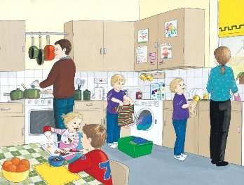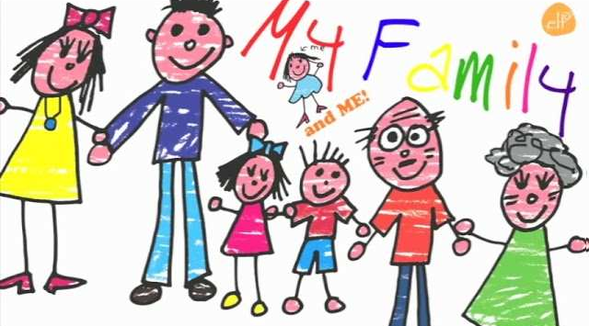 | 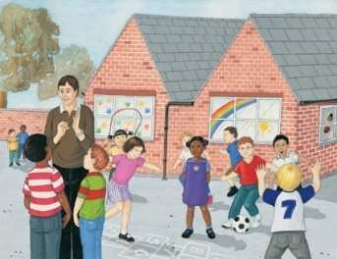 | 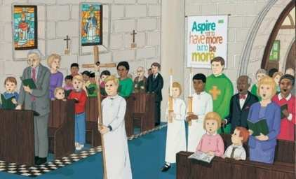  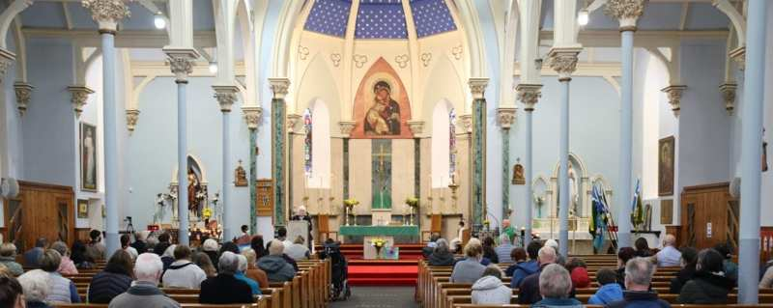

This is our parish family …
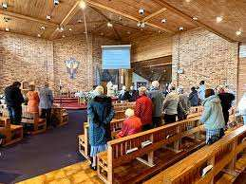

We go to the parish church with our friends. We sing and say prayers.
- Try to use this as an opportunity to visit your local parish church. (Unless you have made a recent visit) Try to have the parish priest or a parishioner greet the children and welcome them into church. Take photographs to share back at school.
- Some children may go to this church at the weekend/Baptism etc… – ask them to share any stories they have. Some staff/governors might be parishioners – ask them to come into class to tell them about the parish and share photographs.
- This traditional finger game and rhyming activity can help children remember how important as it is to have a church building, it is the people inside who make the Church a special place to be. The words of the rhyme are underneath.
‘Here is the Church and here is the steeple. Open it wide and see all the people.’ https://www.youtube.com/watch?v=H80a9OaEq2M (This link shares the rhyme and hand movements if you are not familiar with this. It is a little twee, but you may wish to watch it and teach it to the children yourself )

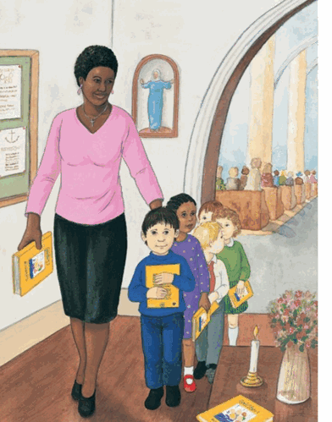

- Whilst in church, read a simple recent reading from the Good News Bible, sing a hymn together and say a simple prayer. Use a hymn that is familiar to the children (see hymns above or similar). Use a simple prayer – join hands –

In the name of the Father and of the Son and of the Holy Spirit.
Dear Jesus, thank you for sending the Holy Spirit to look after me.
In the name of the Father and of the Son and of the Holy Spirit. Amen.

- Celebrate their visit to church by sharing a biscuit and drink afterwards – either in Church or back at school. This will give the children the idea of parish community joining together in prayer and in sharing food – just as the friends of Jesus did in the early church.
Continuous Provision
- Set up a role play church area with welcomers, battery candles, sing together in groups and say a prayer

We gather with friends at church, especially on Sunday. (Cross-curricular links to the Days of the Week)
Talk about …
- Share the word Sunday with the children – share what you and other staff might have done on Sunday? Can the children recall what they did?
- Do they remember their visit to church – recall this event. Sometimes Sundays can be busy because we have so much to do. Today, Jesus’ friends know that Sundays are a blessing; it is a special day to go to Church and join in Mass with their friends and pray to God. They also try to have a rest. (Please note that Catholics may also go to Mass on a Saturday evening instead of a Sunday.)
- Invite a member of staff or yourself to talk about going to Church on Sunday – they may be able to share a hymn/photograph of what they did.
- Sunday, Monday, Tuesday etc…days of the week, focus on Sunday being a special day for some people to go to Church and rest.
- Church craft – using a simple open envelope, place people inside ‘the church’, make this part of group discussion with the children about what they know about their parish church and what they can remember from their visit.

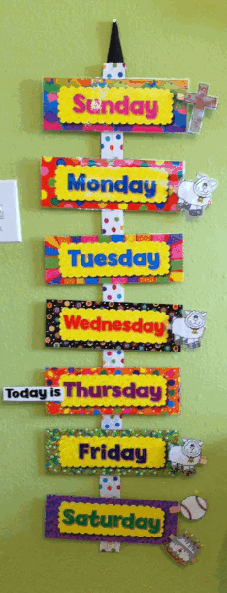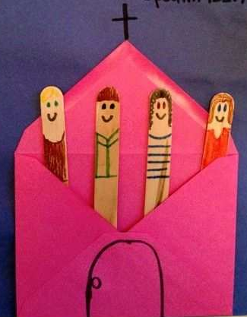

Ways of Knowing (Expected Outcomes)
- The parish church is a special place where we meet our friends.
- We sing and say prayers in the parish church.
- Friends gather together at church on Sunday.

