



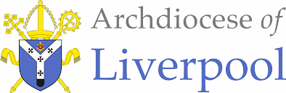

To Know You More Clearly
The Religious Education Directory
Nursery Scheme of Work
Branch 4 – Desert to Garden
Education Department

Nursery Branch 4 – Desert to Garden
Introduction  The overarching theme for Nursery and Reception is God is Love.  Themes  Desert to Garden Theme for Nursery: This branch focuses on helping pupils develop an understanding of Jesus.  - Creation and Covenant – God shows his love by making a wonderful world for us all to live in.  - Prophecy and Promise – God shows his love by sending his son, Jesus to live with us.  - Galilee to Jerusalem – Jesus shows his love for us.  - Desert to Garden – Jesus shows his love for us.  Prior Learning – Reminder - The Bible tells us all about God. We have to keep this in a very special place (prayer space/focus, place the book with the title Bible and the ‘Word’ of God) Can you remember where our special book is? Who can remember what the book is called? Remember this book tells us all about God. Would you like to hear a special story about God today?  - Please remember to use a Good News Bible – whilst this is not an accessible read for children, they need to experience what a Bible looks like, and how it is used – just as in other religions in Christianity this is a sacred book and needs to be treated with the utmost respect and care.  - Children will see how you as an adult use the Bible – they may not understand the words but it is our job then to retell the story in as many ways as possible – through retelling, crafts, art, dance etc… etc…  General Guidance  - Please begin with the Scripture story told from the Good News Bible at the beginning of each teaching sequence.  - Please try to follow the sequences as they appear in the planning. This will allow for timelines and links to be made. However, in some circumstances, they may be best suited in a different order especially considering the age and stage of the children.  - Also, there may be times when you may wish to teach Believe, Celebrate and Live in a different order following Hear or together to suit the needs of the children.  - The activities within the sequences are suggested and you do not need to cover them all! Just ensure you are covering 10% of your curriculum time each week for Religious Education.  Liturgical Events  March  Wednesday 5 Ash Wednesday  Sunday 9 1st Sunday of Lent  Sunday 16 2nd Sunday of Lent  Sunday 23 3rd Sunday of Lent  Sunday 30 4th Sunday of Lent  April  Sunday 6 5th Sunday of Lent  Sunday 13 Palm Sunday of the Passion of the Lord  Thursday 17 Maundy Thursday  Friday 18 Good Friday  Saturday 19 Holy Saturday  Sunday 20 Easter Sunday Vigil | Day  Other useful dates  March 2025  1- 30 March - Ramadan (Islam)  11 March - Mother’s Day | Skill/Driver words  Recognise, Retell, Describe, Wonder, Talk about, Ask, begin to make links and connections, begin to give reasons  Key Words  Enhancing the Religious Education Curriculum  Please find below a list of possible ways to engage learners…  - Previous Knowledge  - Key Vocabulary  - Timeline  - Equality  - Drama/Role Play  - Poetry  - Catholic Social Teaching  - RSHE  - Parents/ Carers  - Home/school/parish  - Parish Priest  - Parish Deacon  - Parish Catechists  - Governors  - Liturgy  - Sacramental Foundations  - Storytelling  - Liturgical Colour Boxes  - Philosophy  - Inclusion  - Culture  - Awe and wonder  - Seasons/The Natural World  - Beauty  - Senses  - Music  - Art  - Dance  Cross-Curricular Links  The aim of Religious Education in the Early Years is for it to be taught as far as possible at the heart of the curriculum. The Branch itself can lead all learning.  Please find below the diagram of how RE is central and links to other areas of learning.

Religious Education within the of Areas of Learning EYFS NURSERY BRANCH 4
Ways of Knowing

Planning Overview Nursery/Reception
EYFS Desert to Garden– Nursery |  |  |  |  | EYFS Desert to Garden– Reception
Sequences | HEAR | BELIEVE | CELEBRATE | LIVE | HEAR | BELIEVE | CELEBRATE | LIVE
First Teaching Sequence | Love God and love everyone  (Taken from Great Commandment reading) …  Lent is a time to care for others. | Caring for others in Lent. | Simple signs of Lent – colour purple, ashes | Care for others. | The Great Commandment.  Lk10:25-28  A commandment!  Jesus tells the story of loving one another. Loving your neighbour as you love yourself. | Listen to and talk about the season of Lent.  Simple Religious symbols in Lent | The Church uses Purple and Ashes as signs of Lent.  We learn the importance of saying sorry and being sorry. | Trying to help others by what we do in Lent.  Please note the CST activities and shown throughout and marked with CST  CST Rights and Responsibilities  Every single person on earth needs these things: food, water, work, clothes, a home, a school, and a doctor.Some people have what they need, but many people don’t.  Jesus wants the people who already have what they need to help these others. Jesus wants us to take care of this.
Second Teaching Sequence | Holy Week events - leading to Jesus dying on the Cross | People sang Hosanna.  Jesus shared a meal with his friends. | Simple signs of Lent – colour purple, palms, sharing bread | Christians share signs and symbols | A simplified version of key events of Holy Week  Palm Sunday  Please note the chosen Scripture is not referenced in the RED | Continuing to remember Lent.  Simple Religious symbols in Lent  Palm waving  Hosanna! | Representations of Holy Week …  Palms | Various cultures celebrate Lent in different ways.  Palm Sunday customs around the world.
Third Teaching Sequence | Jesus died on a cross.  It is a sad time.  Jesus was given new life by God his Father.  Jesus rose and everyone celebrates. | Jesus died on a cross.  Jesus rose and we celebrate. | Simple signs of Easter – colour white, growth, Easter Garden | Christians share signs and symbols - garden growth, Easter eggs, new life. | A simplified version of key events of Holy Week  The Last Supper  Please note the chosen Scripture is not referenced in the RED | Continuing to remember Lent.  Simple Religious symbols in Lent  The Last Supper – sharing bread and wine – the body and blood of Jesus | Representations of Holy Week …  The Last Supper | Various cultures celebrate Lent in different ways.  The Last Supper traditions – Hot Cross Buns
Fourth Teaching Sequence |  |  |  |  | A simplified version of key events of Holy Week  Good Friday & Easter Sunday  Please note the chosen Scripture is not referenced in the RED – Please follow the guidance below | Simple Religious symbols in Lent and Easter  Good Friday & Easter Sunday | Representations of Holy Week …  Good Friday & Easter Sunday | Various cultures celebrate Easter in different ways.  Polish Easter Baskets

FIRST TEACHING SEQUENCE
NURSERY BRANCH 4
Jesus’ New Rule
HEAR | BELIEVE & LIVE |  | CELEBRATE | WAYS OF KNOWING
The Great Commandment.  Lk10:25-28  A commandment!  Love God and love everyone. | Caring for others in Lent  Care for others. |  | Simple signs of Lent – colour purple, ashes | UNDERSTAND  What will I see and hear to help me understand?  - Jesus tells us a rule - to love one another  - Lent is a time to get ready for Easter  - Lent is a time to grow more like Jesus.  - Lent is a time to care for others.  - Recognise some of the signs and symbols of Lent – purple, seeds, growing, ashes
 |  |  | Simple signs of Lent – colour purple, ashes | DISCERN  How will I discover more? What can I do now?  - Lent is a time to share and show love like Jesus
 |  |  | Simple signs of Lent – colour purple, ashes | RESPOND  What can I do now?  - Experience how to show love to my friends and family just like Jesus tells us to do.
Scripture (HEAR) Good News Translation

Luke 10:25-28 “‘Love the Lord your God with all your heart, with all your soul, with all your strength, and with all your mind’; and ‘Love your neighbour as you love yourself.’”

HEAR
Teacher Notes
This reading is known as a commandment – a rule to live by directly from Jesus.
Continuous Provision  - Retelling some of the words of Jesus from the Golden Box  - Use the words in the writing area  - Decorate a large version of the words for display/focus  - Home corner – helping one another to do the jobs – caring for one another in their family  - Decorating love hearts  - Mother’s Day activities |  | Learning activities/Objectives  What will I see and hear to help me understand?  Recognise - name, remember, recall, label, identify, match, sort  - Jesus tells us a rule - to love one another  - Read the Scripture as it is written from the Bible and place the Scripture back into its special place in the classroom.  - Retell the story with the children to help them to understand what the words mean to them by using a variety of activities from the ideas below.  - Retell using the Golden box by placing cards/words – simple symbol – a heart. Share with the children Jesus tells us to love God – can they remember that God is Jesus’ father? Jesus is sharing with us what God would like us to do.  Use the words – perhaps you would like to use them in Prayer and Liturgy as a reminder for the children. The children may want to use the words in the writing area or decorate for the focus/display area. Please use a more simple version below or similar words.  I love God in my heart.  I love God in my mind.  I love God with all my strength.    I love my family and my friends like Jesus.  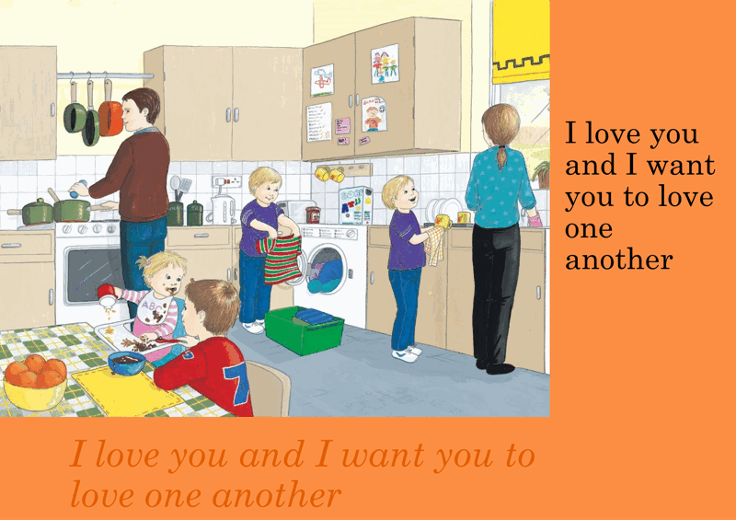  - Using God’s Story One - Slide 17 pp.32-33  Talk about/Identify  What do you see? What room is this? What is the same in your house? What is different? What are the people doing? Why?  How do they feel? Do you do these things at home? How do you feel?  What was Jesus’ new rule?  What would happen if his friends kept this rule?  What would happen if everyone kept this rule?  How do you think people feel when they keep this rule?  How do you think they feel when they don’t keep it?  Learning activities/Objectives  How will I discover more?  What can I do now?  What if? Wonder about? Awe and Wonder, Imagining, similarities, differences, views, preferences, identify, names, experiences, creative and artistic expression  - Lent is a time to share and show love like Jesus  Wonder about Love…  - “How do you know when someone loves you?” Take turns sharing how each of you likes to be loved such as hugging, having someone’s help, or enjoying a game together.  - How can we love God’s world?  - How can we show our love at home?  - How can we show love to our friends?  - Make and decorate a big “Love Heart.”  - Learn a sign that means “I love you.”  - Make a card for someone you love. (Mother’s Day)  Songs  - You’ve Got a Friend in me – Toy Story https://www.youtube.com/watch?v=EYb2QfjKe_4  - Makaton UK https://www.youtube.com/watch?v=kKYiGdgHiO8&list=PLjT4XhijakZgCm8nJhf9adEsARLXS83Ho&index=29  - Put a Little Love in Your Heart – sung by children https://www.youtube.com/watch?v=VNySTUKOlWU  - Love, Love, Love – The Beatles – sung and signed by children https://www.youtube.com/watch?v=cOmIY23hV-4  - Love, Love, Love – The Beatles/Beat Bugs https://www.youtube.com/watch?v=WFFFgROJ1nQ  Hymns  - Love is Something if you give it away – Kevin Mayhew https://www.youtube.com/watch?v=1Zx5iSExD9I  Use actions/signs for Love  Learning Activities/Objectives  What can I do now?  Talk about - feelings and experiences. Begin to make links from Scripture …feelings, behaviour, life, live.  - Experience how to show love to my friends and family just like Jesus tells us to do.  Mother’s Day Cards  - As part of CST Mother’s Day is celebrated on 11th March 2025 perhaps you would like to focus on the theme of love.  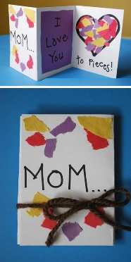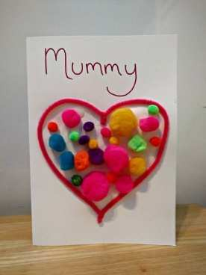  Some further ideas - https://blossomeducational.com/blog/mothers-day-activities-for-eyfs/  - Heart Collage for Mum  Provide heart-shaped paper cut-outs and materials like tissue paper, stickers, and glitter. Children can create a colourful heart collage to give to their mums as a keepsake.  Expressive Arts and Design  Creating with Materials:  Designing collages allows for creative exploration.  Being Imaginative and Expressive:  The activity encourages personal expression.  Physical Development  Fine Motor Skills:  Handling small materials improves hand coordination.  Mother’s Day Song or Poem  Use the song ideas above for children to learn with signing. They can perform it during circle time or record it to send home as a surprise. You might wish to ivite parents into a prayer session and finish with their love song for mums and/or family members.  Communication and Language  Listening, Attention and Understanding:  Learning a song or poem builds listening skills.  Speaking:  Performing the song or poem develops confidence and language skills.  Expressive Arts and Design  Being Imaginative and Expressive:  Singing or reciting a poem fosters creativity and self-expression.

BELIEVE & LIVE
Caring for others in Lent
Care for others.

Teacher’s Notes – for subject knowledge
- Lent is an Old English word for spring. In almost all other languages, Lent’s name is a derivative of the Latin term quadragesima or “the forty days.”
- Lent lasts for 40 days and ends at Easter. Christians are preparing for Easter during Lent. Easter is the most important time for the Christian Church.
- The season of Lent begins on Ash Wednesday and continues until Holy Thursday
- There are 3 spiritual practices of Lent: prayer, fasting and almsgiving (donating money, fundraising, acts of charity)
- In Lent, Christians remember that Jesus went into the desert for 40 days and fasted in the wilderness and so Christians try to do the same – perhaps by giving up something they really enjoy like chocolate, biscuits or by doing extra acts of kindness.
- The Lenten journey of sacrifice unites Christians with Jesus

Shrove Tuesday/Pancake Day

1) Shrove Tuesday is a Christian festival celebrated in many countries across the globe. During Lent, Christians give up luxuries to remember when Jesus went into the desert for 40 days to fast and pray.
2) The exact date of Shrove Tuesday changes from year to year. But one thing stays the same — it’s always 47 days before Easter Sunday. And yes, you guessed it, it’s always on a Tuesday!
3) The name comes from the old word ‘shriving’, which means to listen to someone’s sins and forgive them. In Anglo-Saxon England, Christians would go to church on Shrove Tuesday to confess their sins and clean their soul. In other words, they would be ‘shriven’.
4) In the United Kingdom, Ireland, Australia and Canada, Shrove Tuesday has another name… Pancake Day! Traditionally during Lent, Christians would give up rich, tasty foods such as butter, eggs, sugar and fat (some Christians continue to do so, in fact). Shrove Tuesday was the last chance to eat them – and what better way to do so than with a delicious pancake!
5) Today, people continue to whisk up these yummy treats on Shrove Tuesday — and they add all kinds of tasty toppings, too, such as fruit, honey, chocolate and ice cream! But check this out; pancakes aren’t only for eating during this fab festival — people race with them, too!
6) Pancake races are a super-fun Shrove Tuesday tradition. In this mad-cap activity, people race each other whilst tossing a pancake in a pan. Today, pancake races are often organised to raise money for charity and help those in need.
7) The tradition of the pancake race is a story goes that it originated way back in 1445, in the town of Olney in Buckinghamshire, England. A woman was so busy making pancakes that she lost track of time. When she heard the church bells ringing for the Shrove Tuesday mass, she ran as fast as she could to make it and arrived still carrying her pancake in the pan!
8) Pancakes have become such a popular Shrove Tuesday tradition that on this day, a whopping 52 million eggs are used in the UK alone! That’s 22 million more than your average day.

Continuous Provision  - Spring craft, growing activities  - Garden Centre role play  - Gardening role play  - Signs of Spring plants, animals  - Looking after young animals and what they are called – puppies, foals, lambs etc…  - Minibeast exploring  - Home corner – imaginative play - making pancakes with the family  - Sensory Spring activities/trays/walks etc…  - Spring picture books  - Handprints/drawing around our hands  - Sorting signs and symbols of Spring from Autumn etc… | Learning activities/Objectives  What will I see and hear to help me understand? Recognise - name, remember, recall, label, identify, match, sort  - Lent is a time to get ready for Easter  - Lent is a time to grow more like Jesus  - Lent is a time to care for others.  - Recognise some of the signs and symbols of Lent – seeds, growing  - Spring – this is an ideal time for children to use cross-curricular Spring activities. Spring is the season for growing and we welcome new life. It is also the time of Lent. Lent is a time when we are getting ready to celebrate Easter.  - Set up a Spring focus table with the children that fits in with other Spring activities in your curriculum.  - Introduce children to the season of Spring using crafts, gardening, planting, chicks etc…  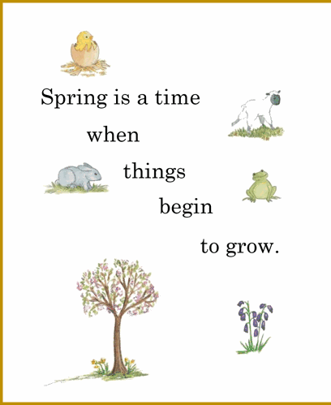  - Using Church’s Story 1 - Slide 20 Pages 38  Spring is a time when things begin to grow.  Talk about what helps plants, animals to grow - connect to the picture  Lent is a time when we grow more like Jesus.  What kind of things could we do to grow more like Jesus?  Remind children of this part of the prayer.  - Ask children to draw their family/friends underneath the words and talk about them. You may wish to send this home for families to add their photographs to it for a display and talking point in school.  I love my family and my friends like Jesus.  Learning activities/Objectives  How will I discover more?  What can I do now?  What if? Wonder about? Awe and Wonder, Imagining, similarities, differences, views, preferences, identify, names, experiences, creative and artistic expression  - Lent is a time to share and show love like Jesus  Making our Lenten promises  - In Lent we try to be more like Jesus.  - Lent is a time we are waiting for Easter.  - Talk together about the images from Church’s Story 1  - You might wish to share a story book you know about kindness, caring, sharing etc. A recent new book can be bought from https://www.thegoodbook.co.uk/what-are-hands-for-board-book  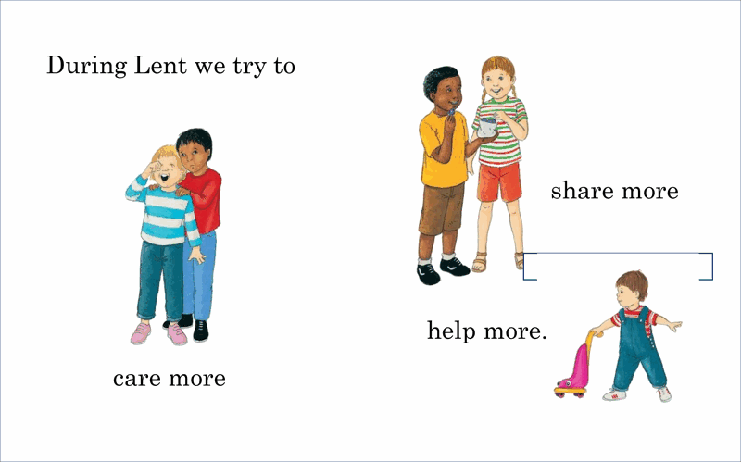  - Let’s make some promises in Lent – please see some ideas below …  - Using kind hands to help children keep their promises in Lent  - Invite children to make handprints and make their promise to share, care, help etc. At the end of week/day ask children to display their hands and talk about their act of kind hands.  - Making hands are for …….  - Using promises as in Church’s story  - I can love my family and friends  - I can care more.  - I can share more.  - I can help more.  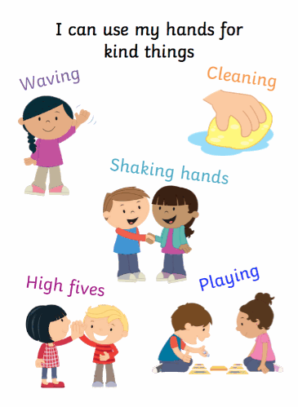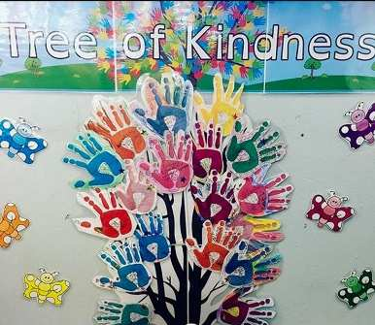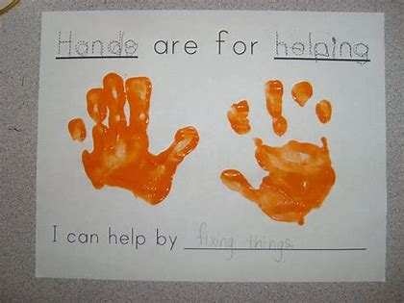  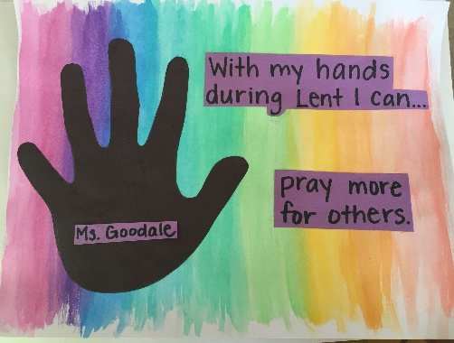  This activity is an ongoing Easter Garden that you may wish to start planting now for the effects of new life at the end of Lent. Please see Teaching Sequence Three.  - A lovely way to celebrate the good news and to share the new life of Easter Sunday and combine this with the season of Spring. This is a great whole class activity that you may wish to start planting at the beginning of Lent and the children can see the growth and new life over the weeks leading to Easter.  Learning Activities/Objectives  What can I do now?  Talk about - feelings and experiences. Begin to make links from Scripture …feelings, behaviour, life, live.  - The day before Lent begins (Ash Wednesday) is usually called Pancake Day or Shrove Tuesday. Many people all over the world celebrate this day. Please see the teacher’s notes. Perhaps you would like to make some pancakes with the children…  https://www.bbc.co.uk/cbeebies/makes/pancake-recipe  https://childrens-binary.files.bbci.co.uk/childrens-binarystore/cbeebies/cbeebies-pancake-recipe-card.pdf  Allergy-free pancakes - https://blog.earlyyearsresources.co.uk/2018/02/allergy-free-pancake-recipe/  Animal pancakes - https://blog.earlyyearsresources.co.uk/2020/02/healthy-animal-pancake-recipes-for-kids/  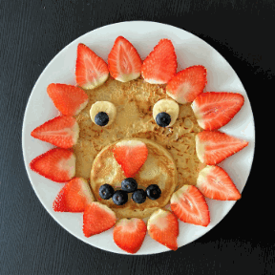

CELEBRATE
Simple signs of Lent – ashes, colour purple

Teacher Notes –

Why do Catholics have ashes on their foreheads on Ash Wednesday?
- Catholics begin the season of Lent on Ash Wednesday where they receive ashes on their foreheads to remind them of their mortality and call to repentance.
- Ashes are from burning the palms from last year’s Palm Sunday service
- When receiving the ashes, the priest makes the Sign of the Cross on each person’s forehead and says words such as: Remember that you are dust and to dust you will return, or in school the priest may say something simpler for the children to understand.

Why is the colour purple used in Lent?
- Purple is the colour of Lent as it symbolises royalty of Christ as King of all Kings and repentance.
- Before Jesus was crucified, he was dressed in a purple robe and a crown of thorns was placed on his head (see Mark 15:17). The purple colour is deliberate as Jesus was accused of declaring himself "king of the Jews." The inscription "INRI" often seen above Jesus on crucifixes, means "Jesus Christ, King of the Jews" in Latin.
- Purple dye was a precious commodity and it was painstakingly manufactured. Because of the laborious process to extract purple dye, purple cloth was expensive and worn by royalty and nobility, often the only people who could afford to purchase it. Kings and emperors would dress entirely in purple to emphasize their wealth and power. Therefore, dressing Christ in a purple robe was a symbolic act, even if intended to disrespect him.
- When we see the purple color, we are reminded that we too have disrespected Christ though our sins, and we are called to repent (say sorry) and ask forgiveness.

Continuous Provision  - Arranging a focus/area for Lent – using the signs and symbols of Spring, purple, ashes, growing | Learning activities/Objectives  What will I see and hear to help me understand?  Recognise - name, remember, recall, label, identify, match, sort  - Recognise some of the signs and symbols of Lent – purple, ashes  - Ash Wednesday is the beginning of Lent. There will usually be a liturgical service in school where children and adults will be marked by ashes on the forehead. In 2025 Ash Wednesday will be on Wednesday 5th March. Ash Wednesday marks the beginning of Lent. We make the sign of the cross with ashes to show that we want to grow more like Jesus.  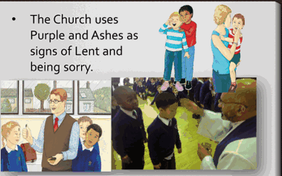  - Using images from Ash Wednesday service and from Church’s Story 2 – talk about what will happen when Ashes are crossed on our heads. It will remind us about Jesus and his rule to love everyone. Remind the children about Jesus’ rule. You might wish to use this prayer once ashes have been placed or in prayer and liturgy.  I love God in my heart.  I love God in my mind.  I love God with all my strength.  I love my family and my friends like Jesus.  - Focus table for the children with the use of colour purple. Explain this colour in simple terms for the children. The colour purple reminds us that we are in Lent and getting ready for Easter.

Assess Pupils’…WAYS OF KNOWING | Informal / Formal Assessment Comments
UNDERSTAND
What will I see and hear to help me understand?
- Jesus tells us a rule - to love one another
- Lent is a time to get ready for Easter
- Lent is a time to grow more like Jesus.
- Lent is a time to care for others.
- Recognise some of the signs and symbols of Lent – purple, seeds, growing, ashes
DISCERN
How will I discover more? What can I do now?
- Lent is a time to share and show love like Jesus
RESPOND
What can I do now?
- Experience how to show love to my friends and family just like Jesus tells us to do.

SECOND TEACHING SEQUENCE
NURSERY BRANCH 4
Palm Sunday and Maundy Thursday
HEAR & BELIEVE & CELEBRATE & LIVE |  |  |  |  | WAYS OF KNOWING
Holy Week events - leading to Jesus dying on the Cross | People sang Hosanna.  Jesus shared a meal with his friends. | Simple signs of Lent – colour purple, palms, sharing bread |  | Christians share signs and symbols | UNDERSTAND  What will I see and hear to help me understand?  - Holy Week is a special week before Easter Sunday.  - People loved Jesus and shouted Hosanna and waved palms when Jesus came to see them.  - Jesus shared a special meal with His friends.
DISCERN
How will I discover more? What can I do now?
- Christians wave palms to remember Jesus on Palm Sunday.
- People waved palms and sang Hosanna to Jesus because he cared and helped others.
- Show love to one another by sharing a meal with friends
RESPOND
How will I find out more?
- Talk about the loving, caring feelings of the people waving the palms.
- Talk about special times when we share our food with others.
Scripture (HEAR) Good News Translation
Please note there are two short readings in this teaching sequence.
Matthew 21:8-9 Good News Translation

Palm Sunday
⁸ A large crowd of people spread their cloaks on the road while others cut branches from the trees and spread them on the road. ⁹ The crowds walking in front of Jesus and those walking behind began to shout, “Praise to David's Son! God bless him who comes in the name of the Lord! Praise be to God!” Some people shouted “Hosanna!”

HEAR, BELIEVE, CELEBRATE & LIVE
Teacher Notes

For children in Nursery simple events leading to Jesus’ death will help them to understand the story in context.

- Holy Week is a special week before Easter Sunday.
- People loved Jesus and shouted Hosanna and waved palms when Jesus came to see them.
- Christians wave palms to remember Jesus on Palm Sunday.
- People waved palms and sang Hosanna to Jesus because he cared and helped others.
- Talk about the loving, caring feelings of the people waving the palms.

Palm Sunday
- Some people shouted Hosanna as Jesus rode on a donkey past them. They loved Jesus. Hosanna means Save us! This was because they had seen how Jesus cared and helped others. This reading is also known and celebrated in the Church as Palm Sunday (Sunday 13th April 2025) The Palms are blessed by the priest before the Palm Sunday Mass. Six hundred years before the Palm Sunday event, a prophet named Zechariah stated that a king would come into Jerusalem riding on a donkey. The crowds celebrated Jesus’ arrival into Jerusalem. They laid down their coats, waved palm branches and declared him to be their king, who would free them from the Roman occupation and restore Israel. However, Jesus, riding on a donkey, had come for a different kind of fight – not with the Romans, but with sin and death. He would conquer not by force, but by sacrifice and love. This short 2 minute clip from the Bible Society website is good to use for subject knowledge and perhaps share with staff - https://www.biblesociety.org.uk/resources/bible-trek/jesus-enters-jerusalem-bible-trek-easter-series-01
Continuous Provision  Palm Sunday  - Golden Box – small world play with peg people, donkey, cloaks and branches  - Making palms to decorate the outdoor play area for reenacting Jesus coming on a donkey – children may wish to dress as the disciples (and you may find the donkey headdress that you may have used previously in Advent!)  - Ribbon weaving  - Cutting palm leaves |  |  | Learning activities/Objectives  What will I see and hear to help me understand?  Recognise - name, remember, recall, label, identify, match, sort  • Holy Week is a special week before Easter Sunday.  • People loved Jesus and shouted Hosanna and waved palms when Jesus came to see them.  Palm Sunday  - Share with the children that Holy Week is a very special time before Easter. The first story tells us about Palm Sunday. Christians go to Church and wave palms to celebrate how much they love Jesus – just as we can hear in the story.  - Retell the story from Scripture in a variety of ways and by using the Golden Box to reenact the events.  - Using God’s Story 2 image (see below) retell the Scripture Story using these words or similar…  Lots of people loved Jesus. He rode on a donkey into the town. People spread their cloaks on the road.  Some cut branches and waved them. The people were all shouting,  “Hosanna! Praise God!”  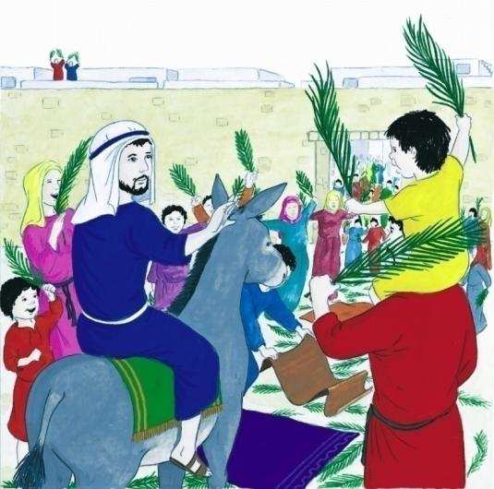  Hymns  - The traditional version of Sing Hosanna – generally used in UK schools- traditionally children make palms and wave them when they sing Hosanna! https://www.youtube.com/watch?v=yno7LNhiL_E  Making Palms  - https://www.bakerross.co.uk/craft-ideas/kids/palm-sunday-handprint-palm/  - https://www.livewellplaytogether.com/palm-sunday-crafts-palm-leaf-craft-two-ways/  - Decorating the word, Hosanna!  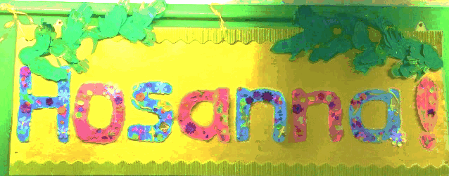  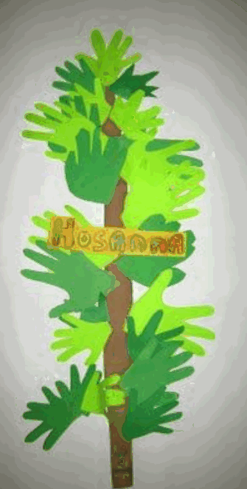  https://uk.pinterest.com/pin/365213851010688338/  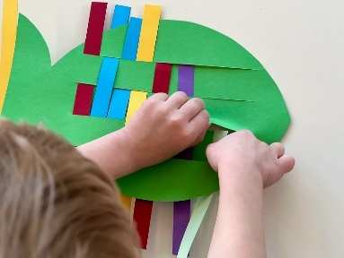 Ribbon weaving https://www.howwemontessori.com/.a/6a0147e1d4f40f970b02a308e14aef200c-pi  (It is actually a fish – with the tail cut off – looks just like a palm! )  Discovering more - Palm Sunday  - Christians wave palms to remember Jesus on Palm Sunday.  - People waved palms and sang Hosanna to Jesus because he cared and helped others.  - Re-enact the story together or in groups – sing Hosanna and wave palms they have made. Schools usually hold a special Holy Week liturgy, and the children may be able to take part in this with the whole school.  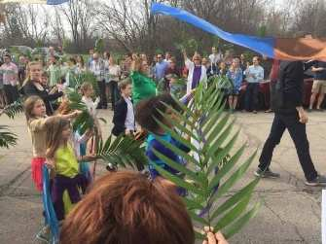  Talk about the loving, caring feelings of the people waving the palms.  - Wonder about why people waved and shouted Hosanna! What were the people celebrating?

Scripture (HEAR) Good News Translation
Please note there are two short readings in this teaching sequence.
Luke 22:19-20 Good News Translation

Maundy Thursday

Then he took a piece of bread, gave thanks to God, broke it, and gave it to them, saying, “This is my body, which is given for you. Do this in memory of me.”
HEAR, BELIEVE, CELEBRATE & LIVE
Teacher Notes
• Holy Week is a special week before Easter Sunday.
• Jesus shared a special meal with His friends.
• Show love to one another by sharing a meal with friends
• Talk about special times when we share our food with others.

For children in Nursery simple events leading to Jesus’ death will help them to understand the story in context.

Maundy Thursday Jesus shared a special meal with his friends. This is also known as The Last Supper.
Story Overview:
After the events of Palm Sunday, Jesus knew his popularity was great. There were, however, some who did not like or agree with him and thought that he was acting against the law. Jesus knew he was going to die so he called his friends together for one last meal.

On the night before He was crucified, Jesus celebrated one last Passover meal with His disciples. Remember that Jesus was a Jew and traditionally ate the meal annually to celebrate God’s deliverance from Egyptian rule. On this particular night, Jesus used elements of the meal to institute a new remembrance, bread to remember His body and wine to remember His blood. From this time forward, the followers of Jesus would celebrate God’s deliverance from sin through Jesus.

Background Study:
This would not be the first Passover meal for Jesus and his disciples. It was an extremely important event; these men would have celebrated it yearly since they were children. This time was different, however. Jesus knew this was the last time He and the disciples would be together to celebrate before He was crucified and then returned to heaven after the resurrection.
The setting of the meal is bittersweet. On one hand, Jesus was excited to eat this last meal with the men who were close to Him. On the other, one of the men, Judas, had already secretly met with the Pharisees and decided to betray Jesus. Jesus knew this, but the other disciples did not.
There was a strict schedule for the Passover feast. The Passover lamb was sacrificed at a specific time on the fourteenth day of the first month on the Jewish calendar. In this case, it was on Thursday of Passion Week. We will later learn that Jesus was crucified on Friday.
It seems Jesus had planned and had already made some arrangements for where the celebration would take place. He sent Peter and John ahead to meet a man who would show them to a large upstairs room where they would eat together. Preparations would involve gathering the key traditional food items that were familiar to all Jews.

Unleavened bread: Flat bread made without yeast. Originally this was eaten during the Passover because the Jews left Egypt so quickly that the bread did not have time to rise. The unleavened bread was to be eaten at specific times during the meal.
Lamb: Killed at sundown and roasted. The blood of the lamb was to be given to the priest to pour on the altar. They were to eat the whole lamb during the meal.
Bitter herbs: These were eaten to remind the Jews of the bitter times in Egypt.
Wine: This was to be drunk at four specific times during the Passover meal.
God’s story began long before the New Testament. Much of what Jesus said and did relates to what God planned and did in the Old Testament. Adults and children alike need to see the Bible as one beautifully connected story. It is in the reading of this history that the full meaning of the purpose of Jesus becomes clear.

The first Passover had been celebrated hundreds and hundreds of years earlier on the last night that the Jews were captive in Egypt (Exodus 12). The Jews who followed God’s instructions and placed lamb’s blood on their doorposts were able to celebrate the meal safely inside their homes while the Angel of Death passed over them. Jews continued to celebrate the Passover as a reminder of God’s salvation (rescue from Egyptian slavery). Jews continue to celebrate it today.

Everything that is known about the history of God’s people and the celebration of Passover brings fuller meaning to what Jesus did during this meal. At communion people receive Jesus in Holy Communion. The sacrament of the Eucharist brings us closer to Jesus and to one another. The sacrament of the Eucharist is a sacrament that people receive often. The Church believes that Jesus is truly present because of what he said. His words about the bread and wine are Jesus saying to us ‘This is my living presence, this is myself, it is me’. Catholics believe that the bread is Jesus’ body
The importance of The Last Supper In a Catholic school as well as creating the foundations for the Sacrament of Reconciliation, we are also preparing children for the Sacrament of Eucharist. Whether the children will make these Sacraments with the local parish or not, as teachers in a Catholic school, we take opportunities through Religious Education to help children find out and discover more about these Sacraments.
Any child or adult making their Sacrament of Eucharist will be supported by their parish. This Sacrament is also known as First Holy Communion or First Eucharist. The Church family gathers together to share in the Sacrament of the Eucharist. Eucharist means thanksgiving. With Christ the Church comes to give thanks to God. The Eucharist remembers and celebrates the life, death, and resurrection of Jesus.
Children in Early Years settings will be building the foundations for understating what Catholic’s believe about the bread and wine at Mass. The sharing of food and drink is a great opportunity to role play what happens at Mass, to know that sharing a meal together is a happy time when we come together and share with friends/family – at home, in school, at sack time etc…
Building in time for children to share simple food such as biscuits, cakes etc and some juice at opportunities after Prayer and Liturgy help children to see that sharing food and drink after prayers brings a bond of togetherness and community – just as the parish is a community.
Continuous Provision  Maundy Thursday  - Golden Box – small world play – Jesus and his friends, small table etc…  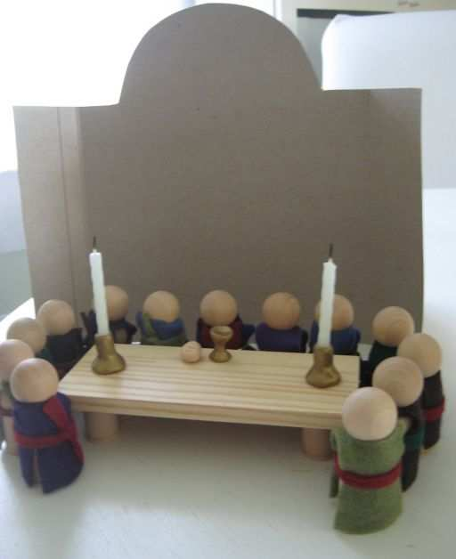  - Sharing meals together in the Home Corner  - Rules for sharing  - Role play and dressing as friends of Jesus and as Jesus | Learning activities/Objectives  What will I see and hear to help me understand?  Recognise - name, remember, recall, label, identify, match, sort  - Holy Week is a special week before Easter Sunday.  - Jesus shared a special meal with His friends.  Maundy Thursday  - Remind the children that we are in a special week before Easter Sunday. This story tells us all about Jesus sharing a very special meal with his friends.  - Retell the story from Scripture and then in a variety of ways and by using the Golden Box, reenact the events.  - Using God’s Story 2 image (see below) retell the Scripture Story using these words or similar…  The night before he died, Jesus and his friends went to celebrate a special meal together.  Jesus took some bread blessed it, broke it and shared it out among his friends.  Jesus said, “Do this in memory of me.”  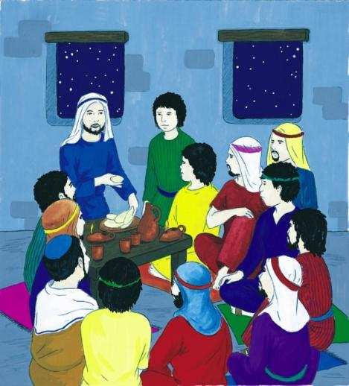  Discovering more  - Show love to one another by sharing a meal with friends  Maundy Thursday  - Retell the story together or in groups – share some bread and juice – pass it around and reenact the story of Jesus' meal with his friends.  - Ask the children questions such as –  - Why do you think Jesus shared the bread with his friends?  - Have you shared food at home with your family? Talk about meals together at home and in school  - He said ‘Do this in memory of me –we can remember Jesus when we share, care for one another.  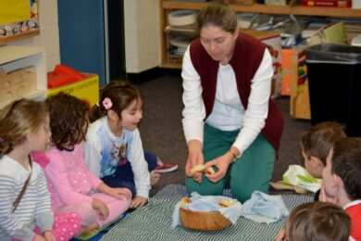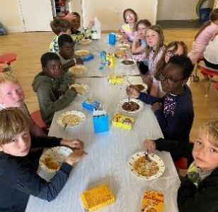  Hymns  https://www.bing.com/videos/riverview/relatedvideo?q=do+this+john+burland &&mid=00F1C3520D5919EEEA2600F1C3520D5919EEEA26&mcid=7F9E3297207F4E43A3A5353156BB0EDA&FORM=VCGVRP  - Do this in Memory of Me – repetitive chorus throughout for children to hear and sing the important words Jesus shared at the Last Supper  Talk about special times when we share our food with others.  Maundy Thursday  - Using photographs of the children gathered sharing bread and juice/lunchtime/snack time – write/scribe using emotions How do they feel when sharing with friends? How did the friends of Jesus feel? Etc…  - Using a simple image of the Last Supper, talk about and wonder about what it would have been like to be with Jesus sharing a meal  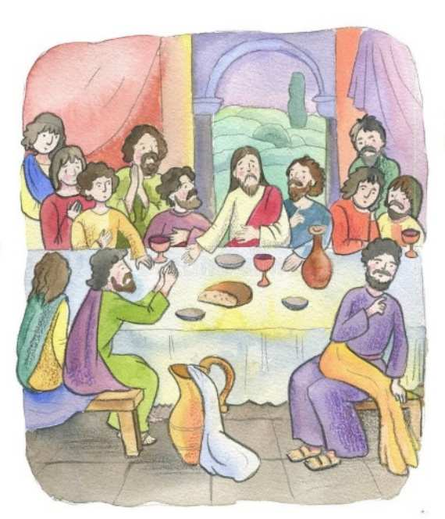  - Who are the friends listening to? What do you think Jesus is saying to them? Do they look happy? Do you think something will happen after the meal?  - Ask the children to try and notice things in the painting – who can they see? What is behind them? Look at the faces – what do you think they are thinking? Who is in the middle – allow children to come to their own conclusions about the painting and perhaps some are ready to say which one they like and say why.

Assess Pupils’…WAYS OF KNOWING | Informal / Formal Assessment Comments
UNDERSTAND
What will I see and hear to help me understand?
- Holy Week is a special week before Easter Sunday.
- People loved Jesus and shouted Hosanna and waved palms when Jesus came to see them.
- Jesus shared a special meal with His friends.
DISCERN
How will I discover more? What can I do now?
- Christians wave palms to remember Jesus on Palm Sunday.
- People waved palms and sang Hosanna to Jesus because he cared and helped others.
- Show love to one another by sharing a meal with friends
RESPOND
How will I find out more?
- Talk about the loving, caring feelings of the people waving the palms.
- Talk about special times when we share our food with others.

THIRD TEACHING SEQUENCE
NURSERY BRANCH 4
Good Friday and Easter Sunday
HEAR, BELIEVE, CELEBRATE & LIVE |  |  |  |  | WAYS OF KNOWING
Jesus died on a cross.  It is a sad time.  Jesus was given new life by God his Father.  Jesus rose and everyone celebrates. | Jesus died on a cross.  Jesus rose and we celebrate. |  | Simple signs of Easter – colour white, growth, Easter Garden | Christians share signs and symbols - garden growth, Easter eggs, new life. | UNDERSTAND  What will I see and hear to help me understand?  - Holy Week is a special week before Easter Sunday.  - In Holy Week Christians hear about Good Friday.  - Signs and symbols of Good Friday – purple, hot cross buns  - Easter Sunday is celebrated at the end of Lent  - Signs and symbols of Easter - white, growth, Easter Garden, Easter eggs, new life.
DISCERN
How will I discover more? What can I do now?
- Talk about and respond to the events of Holy Week
- Talk about and wonder about the events of Holy Week
Scripture (HEAR) Good News Translation

Jesus died on the cross. But this was not the end of the story!

Please use the images from God’s Story 1 instead of Scripture and retell the story of Good Friday and Easter Sunday. Please follow the instructions in Teacher’s Notes to share the symbols of Good Friday and Easter with children and the images from God’s Story.

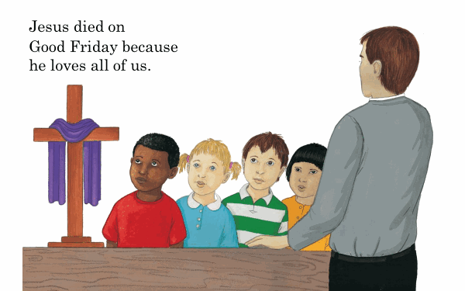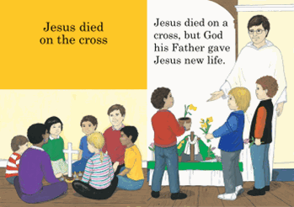
What do you see?

Where is the cross?
What do you think the children are doing?

It was a sad time. Jesus died on a cross on Good Friday.

(Show children a cross in classroom)

Good Friday is a special day. It is a sad day because people remember Jesus who had died.
BUT It is a good day because people remember how much Jesus loved us all.
The cross is special because it helps us to remember Jesus’ great love.

Remind and help children to learn to make the sign of the cross.

That wasn’t the end of the story because God his Father gave Jesus new life.

What do you see? (Easter garden, cross, flowers, empty tomb)
What are the children doing?
What is the priest wearing? (white vestments - white is the Church’s Easter colour.
What do you think the people are doing?

Easter Sunday is a happy day. The priest wears white vestments. White is the special Easter colour. Some churches have an Easter garden to help people remember that Jesus died and was buried, but God his Father gave him new life. Spring flowers are a symbol of new life. Easter is the Church’s celebration of new life for Jesus and for everyone.

HEAR, BELIEVE, CELEBRATE & LIVE
Teacher Notes
- Holy Week is a special week before Easter Sunday.
- In Holy Week Christians hear about Good Friday.
- Signs and symbols of Good Friday – purple, hot cross buns
- Easter Sunday is celebrated at the end of Lent
- Signs and symbols of Easter - white, growth, Easter Garden, Easter eggs, new life.
- Talk about and respond to the events of Holy Week
- Talk about and wonder about the events of Holy Week

It is important for teachers to read the notes below and not to focus on the death of Jesus but the new life of Jesus. It is important to tell the stories Good Friday and Easter Sunday together.

God’s Story 1 Notes
It is enough for young children to know that Good Friday celebrates the day on which Jesus died.
By placing a cross in a place of honour, with growing plants or flowers and lights, we may begin to lead young children to recognise the cross as special, to be honoured with love and respect.
They will begin to have a sense of death and life and ‘life through death’. The focus here is on how younger children can participate in the celebration of Good Friday and Easter Sunday. The Easter Garden (p.35) is a symbol for them of the Easter events.
Good Friday is a special day. It is a sad day because people remember that Jesus died on the cross.
It is a good day because people remember how much Jesus loved us all.
The cross is special because it helps us to remember Jesus’ great love.



From a purple cloth to a white cloth - The colour reflects the season, so that for instance in Advent purple is used, a colour of royalty because we are preparing to welcome the coming of a king. Purple is used again in Lent because it also symbolises suffering and pain.
At Christmas and Easter, the colour changes to white or gold, both bright optimistic colours for festivals, times for joy and celebration. Between the festivals green cloths symbolise all living things, renewal and promise of new life. And finally, red is the colour of fire, used in churches to celebrate Pentecost and saints’ days.

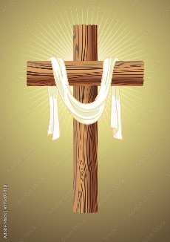

Easter Sunday is a happy day. The priest wears white vestments. White is the special Easter colour. Some churches have an Easter Garden to help people remember that Jesus died and was buried, but God his Father gave him new life.
Spring flowers are a symbol of new life. Easter is the Church’s celebration of new life for Jesus and for everyone.

The Last Supper/Good Friday – Hot Cross Buns

Buns with crosses on have been around for a very long time. In pagan times they were made in celebration of spring and the goddess of dawn, Eostre, with the cross symbolising the 4 phases of the moon. Then, according to English folklore a monk in St Alban’s, Thomas Rocliffe, developed a recipe for Alban buns which he distributed to the poor on Good Friday. The buns were said to have ‘become holy’ and in 1592 Queen Elizabeth 1 decreed they must be baked at no other time than on Good Friday or Christmas or for funerals! The first recorded reference to them, however, was in the early 1700’s with the words to this hot cross buns song: ‘Good Friday comes this month, the old woman runs, with one a penny, two a penny, hot cross buns!’ Tradition has it that if you hung a bun from the rafters in your kitchen it would not go mouldy all year. Supposedly it would enhance friendships, prevent fires and if taken on a voyage it would stop that ship from being wrecked! Brother Thomas Rocliffe, a 14th century monk at St Albans Abbey made buns to feed the poor on Good Friday.
In Ireland, the UK and as far abroad as New Zealand, Australia, Canada and India, Hot Cross Buns are eaten every Good Friday the day after the Last Supper to remember his last meal and his death on the cross in Christian communities.
They are symbolic of this significant day in the Christian faith when Jesus was crucified.
Each bun is decorated with a cross made from flour paste, which represents the cross on which Christ died.
The spices in hot cross buns are said to represent the spices that were used to embalm Christ after his death.
There is a song/verse which reminds Christians of Jesus and what happened on Good Friday.
Flour for the bread at Our Lord’s Last Meal,
Sultana’s for the wine,
A Cross to tell of his Holy Death,
Spices prepared for His tomb.

For children at this age it is enough for them to take part in the tradition of Hot Cross Buns in Holy Week – eaten on Good Friday. You may wish for them to sing the traditional Hot Cross Buns Rhyme too.

Continuous Provision  - Golden Box – small world play and reenact the story of Good Friday and Easter Sunday  - Sort pictures from the Easter Fix images.  - Use small world items/symbols from the Golden Box to organize the four events they have heard from Holy Week - signs and symbols – purple, Lenten prayers, ashes, palms (branches) Children to identify Easter – White, cross, flowers, garden, eggs, lambs, chicks etc which bring New Life just as Jesus did.  - Spring Crafts  - Easter Cards  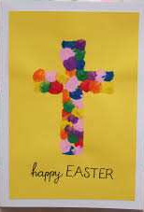  Fingerprints  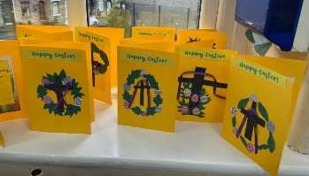  https://leesfieldprimary.co.uk/curriculum/religious_education/religious_education_gallery.html  - Tissue flowers  - Tissue to add to the large cross for display |  | Learning activities/Objectives  What will I see and hear to help me understand?  Recognise - name, remember, recall, label, identify, match, sort  - Holy Week is a special week before Easter Sunday.  - In Holy Week Christians hear about Good Friday.  - Signs and symbols of Good Friday – purple, hot cross buns  - Easter Sunday is celebrated at the end of Lent  - Signs and symbols of Easter - white, growth, Easter Garden, Easter eggs, new life.  - Remind the children that Holy Week is special week. We have heard two stories – Palm Sunday and The Last Supper – show on a timeline. The next two stories we will hear are about Good Friday and Easter Sunday.  - Please follow the words given above from God’s Story and instructions for Good Friday and Easter Sunday.  - Retell the story using the focus table as shown in the images above.  - You may wish to retell using these items from the Golden Box and let children use them for their small world play later.  - Retell the story using the Easter Fix children’s story https://www.youtube.com/watch?v=Mvmow7vvvmI  - Sequencing/sorting/retell/sentences using the slides on the PPT or PDF images – see SharePoint for resources.  The Easter Fix by Steph Williams    Can be bought also from - https://www.eden.co.uk/shop/search.php?products%5Bquery%5D=the%20easter%20fix  Hymns  John Burland https://johnburland.net/videos/new-life/ hymn with lyrics and movement  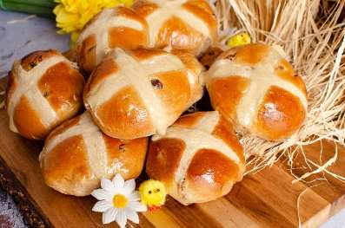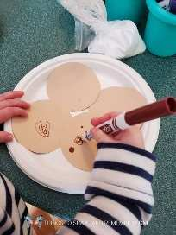  - Hot Cross Buns – look at the shape of the cross on top of the bun. This reminds us that Jesus was going to die on a cross. People make them every year to remember Jesus. Have you seen some in the shops/home?  - You might wish to make Hot Cross Buns – easy recipe (see SharePoint for recipe suggestion) or decorate some sweet ready-made buns with an icing cross.  - Hot Cross Bun crafts – paper plate painted brown, colour or stick on paper for currants and make a white cross on top.  Easter  - Remind children of what happened after Jesus died. He rose again and his father gave him new life. Spring reminds us of new life too.  - Focus/prayer table – update with colour of white  - This was a very happy time and it is celebrated in church on Easter Sunday.  - How can we celebrate Jesus’ new life …  Decorating crosses for new life  - You may wish to decorate the focus table or outside the classroom.  - Make a large class cross for children to choose a Spring colour add their fingerprints to the cross.  - Make individual crosses with bright Spring colours they have chosen with finger painting.  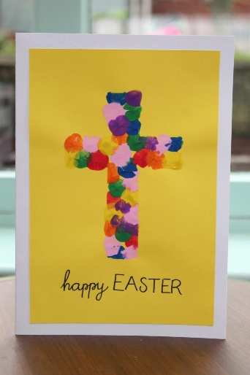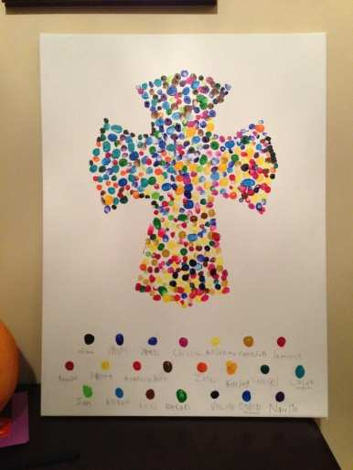  Easter Garden  - A lovely way to celebrate the good news and to share the new life of Easter Sunday and combine this with the season of Spring. This is a great whole class activity that you may wish to start planting at the beginning of Lent (see Teaching Sequence One) and the children can see the growth and new life over the weeks leading to Easter.  - You might wish to send this idea home for children to make with their families  - As the garden is made in class or brought from home ask the children to retell the story – what have they included? Do they know why? What are they wondering about?  - Use the Easter Garden tutorial and you may wish to pause at certain times for children to make the garden however, this can also be used for teacher subject knowledge. The downloaded version is on the SharePoint but you can download also from here https://request.org.uk/resource/restart/2017/02/23/make-an-easter-garden/  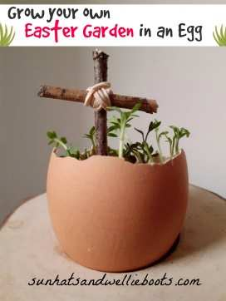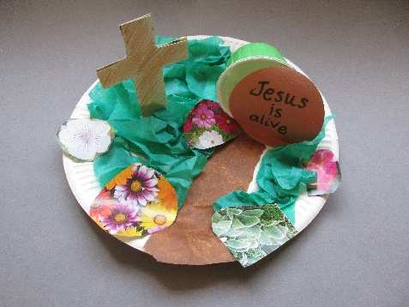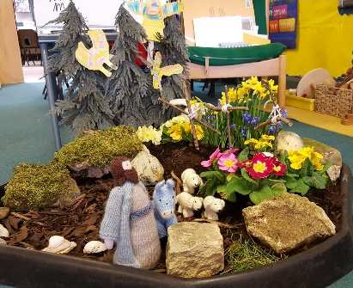  - Growing Cress in egg shell - https://www.sunhatsandwellieboots.com/2021/03/grow-your-own-easter-garden-in-egg.html  Learning activities/Objectives  How will I discover more?  What can I do now?  What if? Wonder about? Awe and Wonder, Imagining, similarities, differences, views, preferences, identify, names, experiences, creative and artistic expression  • Talk about and respond to the events of Holy Week  • Talk about and wonder about the events of Holy Week  Timeline  - Using images - recognise the events of Holy Week – how they happen in order. Talk about and remember with the children – talk about the feelings of people involved and Jesus throughout the week. How do they feel about the events? You may have other events throughout this branch such as growing chicks, growing flowers, planting, Easter eggs – etc – use all of this to celebrate new life.  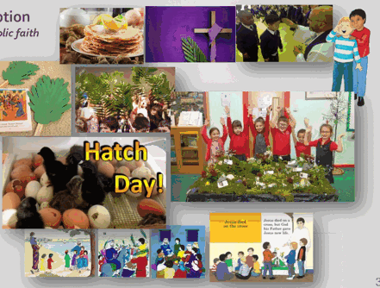

Assess Pupils’…WAYS OF KNOWING | Informal / Formal Assessment Comments
UNDERSTAND
What will I see and hear to help me understand?
- Holy Week is a special week before Easter Sunday.
- In Holy Week Christians hear about Good Friday.
- Signs and symbols of Good Friday – purple, hot cross buns
- Easter Sunday is celebrated at the end of Lent
- Signs and symbols of Easter - white, growth, Easter Garden, Easter eggs, new life.
DISCERN
How will I discover more? What can I do now?
- Talk about and respond to the events of Holy Week
- Talk about and wonder about the events of Holy Week

