- DESCRIPTION:
  - Fior Di Latte is a semi-soft cheese made fresh from pasteurized cow’s milk.
  - The product is made into 1 pound log-shaped pieces called Filoncino.
  - (20) Twenty pieces are packed per pail.
- BRAND NAME: Liuzzi Cheese
- PRIVATE LABEL: No
- PHYSICAL SPECIFICATIONS:
  - Foreign Matter: None visible
  - Net Weight: 20 Lb each pail
- ORGANILEPTIC CHARACTERISTICS:
  - Color: White
- CHEMICAL SPECIFICATIONS:
  - Moisture 58 +/- 4%
  - Butterfat 22 +/- 4%
  - pH 5.8 +/- 2%
- MICROBIOLOGICAL SPECIFICATIONS:
  - Coliform <100/g
  - Mold / Yeast <100/g
  - Aerobic <100,000
- INGREDIENT STATEMENT:
Pasteurized Whole Milk, Pasteurized Cream, Starter, Vegetable Rennet and Salt. CONTAINS: MILK

- NUTRITION INFORMATION:
  - Nutrition Information
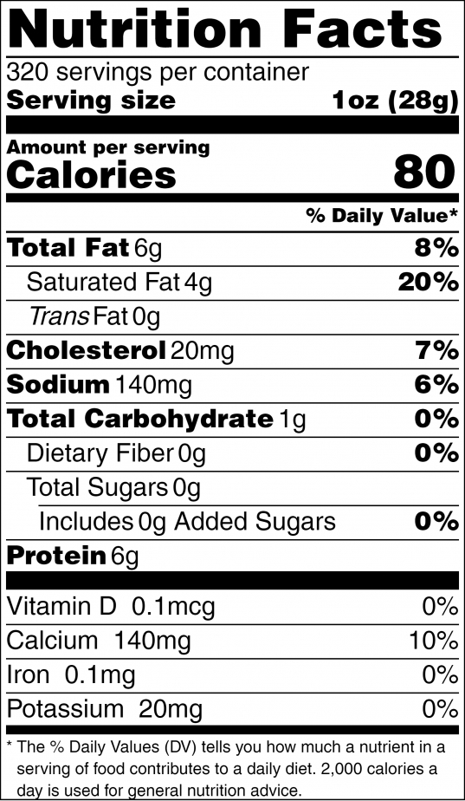
  - Allergens: Contains Milk
  - Country of Origin: USA
- UPC / GTIN:
  - UPC: 816115011479
  - GTIN: 00816115011479
- SHELF LIFE:
  - 32 days from date of packaging
- STORAGE REQUIREMENTS:
  - Product must be stored 33-38°
- SHIPPING REQUIREMENTS:
  - Carriers used to transport product shall be maintained at 33-38°
  - Trailers shall be clean, dry and free of foreign material and objectionable odors.
- CASE PACK INFORMATION:
  - Pail Dimensions: Height – 12”, Diameter – 11.625”
  - Gross Weight: 45 lbs.
- PALLET INFORMATION:
  - 36 pails per pallet
  - 12 pails/layer//3 layers/pallet
  - Wooden pallets
  - Pallets stretch wrapped

