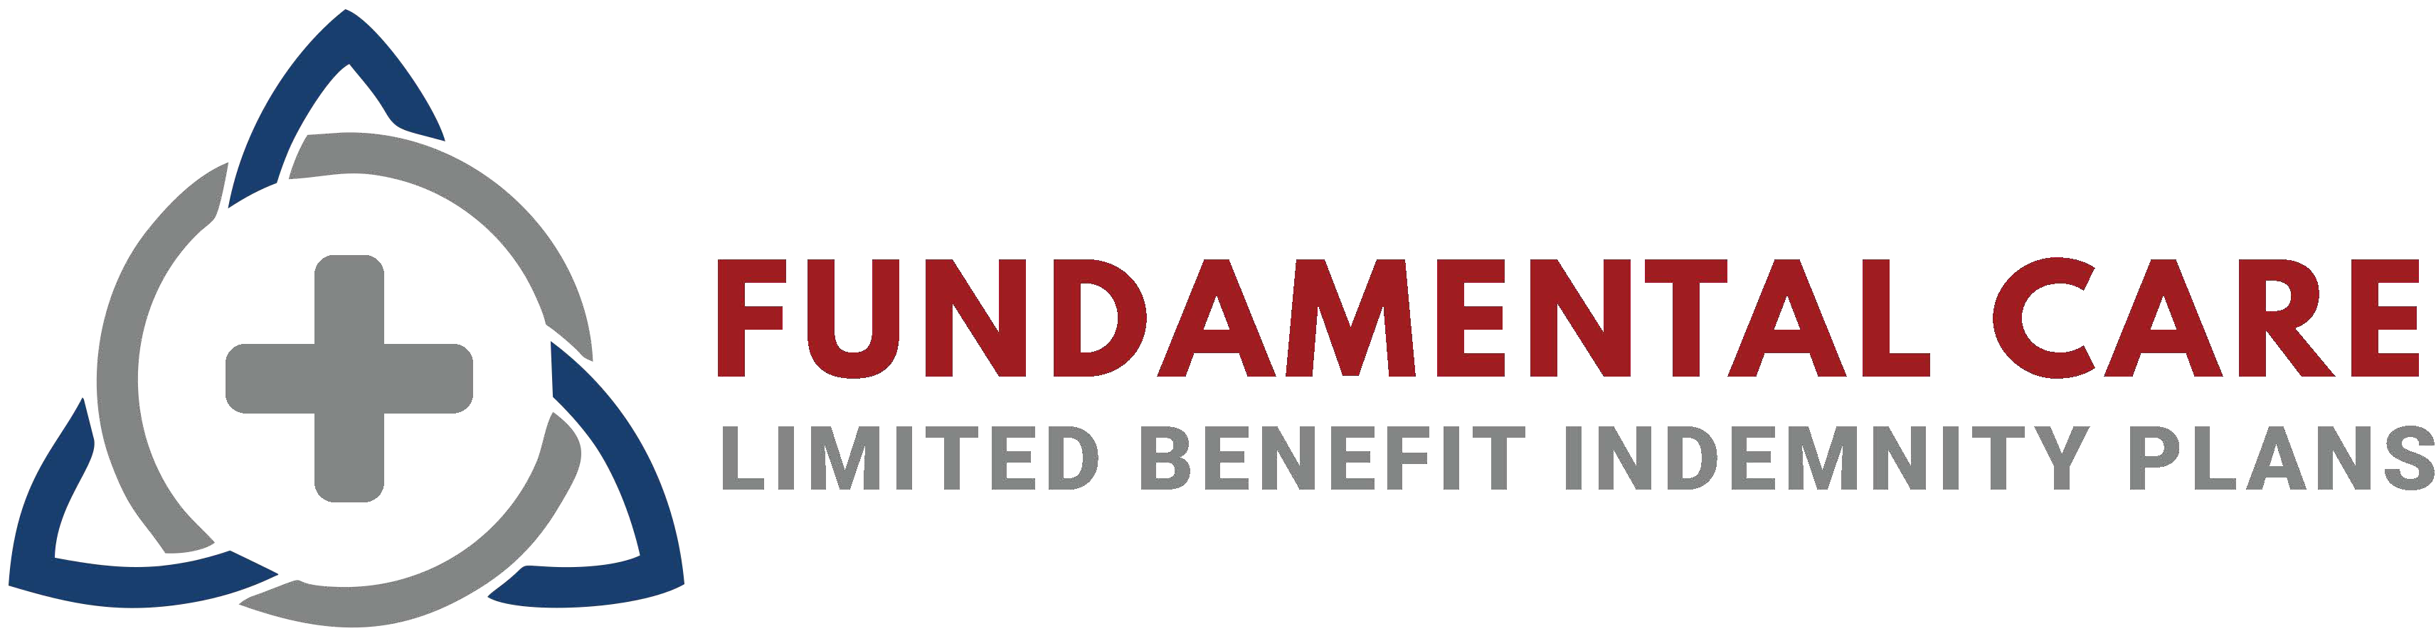
Enhanced Plan Benefits

Physician and Hospital PPO Network

First Health is a national PPO network, with wide-ranging access in both urban and rural areas. Although employees are free to use any provider they choose, when they access services covered under the GLI plan, from a provider who participates in the First Health preferred provider network, they may be eligible for discounts off the total that is due for the service. This could reduce the amount owed after the full insurance benefit has been paid.

Provider Look Up:
800.226.5116 or visit: www.firsthealthlbp.com/fhlbpfi

Pharmacy Network and Prescription Discounts

The Drexi Pharmacy Benefit Administration (PBA) benefits included with this plan members access to savings on a wide variety of prescription drugs. The Drexi nationwide pharmacy network includes all major chains, retailers, grocers, and independents. Employees can use the information on their ID cards to get prescriptions filled at any participating pharmacy.

Pharmacy Help Desk:
Call: 1-844-728-3479 or visit the link listed on your ID Card


For the MEC plan, members have access to Rx Assist by Medalist Rx, which provides ACA preventive drugs, including birth control, at $0 Copay. For other prescriptions, the RxAssist plan can save you between 60-95% off the average wholesale price for your generic medications and can save you between 13-17% off the average wholesale price for your brand medications. Nationwide pharmacy network includes all major chains, retailers, grocers, and independents.

Telemedicine
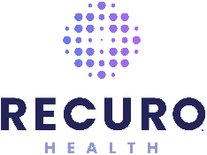
Recuro Health provides 24/7/365 access to board certified doctors and pediatricians.

- 24/7 access to consult with a licensed physician by phone or video
- $0 consult fee and unlimited visits for all urgent and primary care visits
- Physicians can write prescriptions when applicable
- Link: www.recurohealth.com

Phone Number: 1-855-6RECURO

Employee Assistance Plan and Counseling
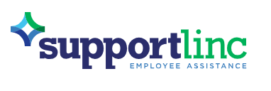
The comprehensive Employee Assistance Plan (EAP) is provided by CuraLinc. Their SupportLinc program is staffed by professional, licensed counselors available to members by phone 24/7/365 at no cost. Provides up to three (3) face-to-face counseling sessions per presenting issue for a wide array of personal and work-related concerns at no cost.

1-888-881-5462
www.supportlinc.com

Username: coterie


Health Services Hub
Access all of your Enhanced Benefits listed above through a single member portal!

www.healthserviceshub.com
Login with your Member ID
Passcode: benefits18

Fundamental Care contracts with third-parties to offer these noninsurance services. The fees for these products are combined with Globe Life insurance premiums. These third-party services are not offered or underwritten by Globe Life.

