Product Planning Template

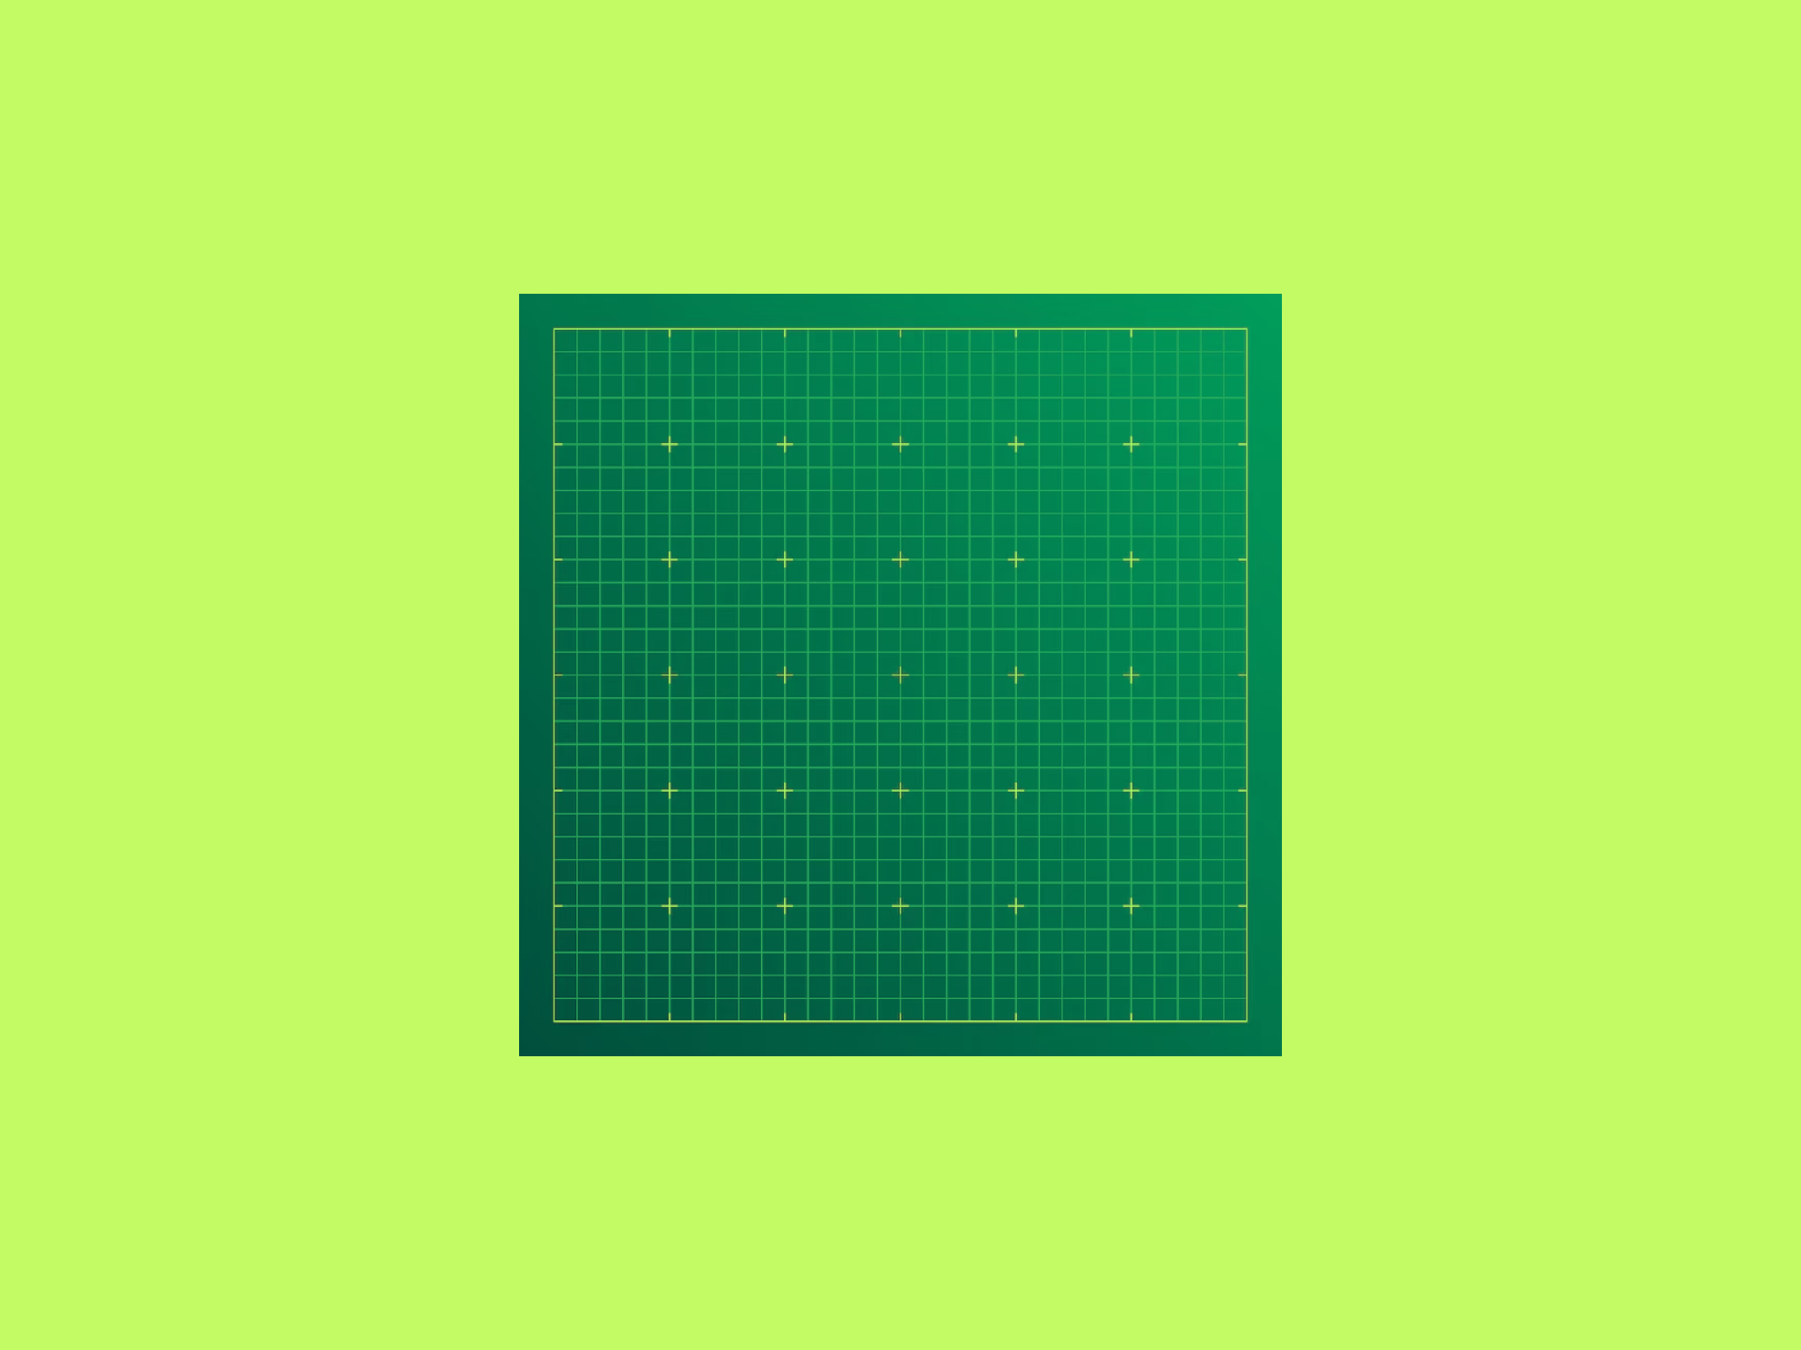

Building a new hardware product is one of the most ambitious things a company can do.
There's a moment early in every program — when the idea is still on a whiteboard, when anything seems possible — that's genuinely exciting. A new form factor. A better user experience. Technology that didn't exist five years ago, now small enough to hold in your hand. That moment is worth protecting.
But hardware is unforgiving.
Unlike software, you can't push a patch to fix a mechanical design. A wrong assumption about power architecture, a missed certification requirement, a tooling decision made too early — these are the things that turn a nine-month program into an eighteen-month one. The teams that consistently ship great products aren't lucky. They're disciplined. They ask the right questions before committing to tooling, align on requirements before writing a line of firmware, and treat the development process as a series of deliberate gates rather than a race to the finish.
Working with an ODM shortens that learning curve.
An experienced ODM partner brings a process that has already absorbed the hard lessons — in platform selection, certification, supply chain, and manufacturing. You get to skip the expensive mistakes and spend your energy on what actually differentiates your product.
This document is your starting point.
Complete Steps 1, 2, and 3 to capture your requirements, then submit — we'll come back with a full technical and commercial proposal within a week. At the back, you'll find a plain-English overview of the development process and answers to the questions we hear most often.

Step 1 | Contact Information
Step 2 | Product Brief
Step 3 | Technical Requirements
Submit | Email your completed document to Mobiwire
NPI Process | Reference overview of the development stages
FAQs | Frequently Asked Questions

Step 1: Contact Information
Company Name *
Company Address *
About Your Company
2-3 sentences: what does your company do, and who are your customers?
Point of Contact *
Title *
Email Address *
Contact Details *  Please include area code. | Mobile:  WhatsApp:  WeChat:

Step 2: Product Brief
Tell us about what you're building. Don't worry if you don't have all the answers yet — that's what the first call is for.
Project Name *
Short internal name, e.g. 7 inch Medical Bedside Tablet
Product Description *
Describe the product and its primary function in one sentence.
Core Use Cases *  What are the 2-3 main things users will do with this product? | 1.  2.  3.
Target Customer / User *
Who is the end user? Describe their environment and any needs we should design around.
Unique Selling Points
What needs to be true about this product for it to win in your market?
Product History *
Is this new, a next generation, or a supply chain retool? If iterating, please describe the existing product.
Reference / Competitor Products
Any comparable products on the market we should evaluate?
Customer IP / Existing Design
Do you have existing hardware, schematics, a reference design, or proprietary technology you are bringing to this project?
Integration Requirements
Does this product need to connect to or integrate with any existing systems, software, or hardware?
Volume & Lifecycle * | 1st Year Forecast:  Annual Forecast:  Product Lifecycle (years):  Comments:
Target Timeline *  Target dates. See Appendix A for stage definitions. | Receive Proposal:  Start Development:  Engineering Samples:  Marketing Samples:  Certification Samples:  Mass Production:  Other Key Dates:
Non-Recurring Engineering / Unit Cost / Minimum Order Quantity *  What are your targets or expectations for these commercial issues?Let us know of any specific constraints or budgets that you know about. | Target NRE:  Target Unit Cost:  Target MOQ:  Comments:
Risks or Concerns
Any constraints or hard requirements we should know from the start?
Priority Ranking *  Rank 1st, 2nd, 3rd. | Cost:  Performance:  Time to Market:

Step 3: Technical Requirements
Get as specific as you can here. The more detail you share, the more quickly and more accurately we can put together a proposal that meets your needs. Write N/A if a feature is not required, or ‘Don’t know’ if unsure.

Item | Minimum Requirement | Comments
Hardware
CPU / SoC
State your requirement, or write ‘Open to recommendation’ – Mobiwire will propose a platform based on your spec.
Memory – RAM
Memory – ROM
Display
Size, resolution, touch type, display type (LCD/OLED), brightness if known
Cellular
2G / 3G / 4G / 5G / Cat-M / NB-IoT / None
Camera
Front / Rear / Other – resolution and any special requirements
Bluetooth
Wi-Fi
802.11 standard, bands required
NFC
I/O and Interfaces
e.g. USB-C, USB-A, UART, I2C, SPI, PCIe, GPIO, Ethernet, RS232, audio jack, HDMI, PoE
Biometrics
Fingerprint, facial recognition, iris, other
Other Peripherals
Sensors, scanners, printers, or special hardware not listed above
Battery
Capacity (mAh), cell chemistry, number of cells if known
Power
Power Source
Battery only / wired / tethered / both – describe
Input Voltage / Power Budget
e.g. 5V USB-C, 12-32V DC input, 10W tethered
Charging Method
USB-C, wireless (Qi), proprietary, none
Mechanical
Industrial Design
Aesthetic direction, CMF preferences, any brand guidelines
Physical Dimensions
Target or maximum dimensions (mm or inches)
Weight
Target or maximum weight
Physical Connectors
SIM tray, SD card, USB ports, custom connectors – placement or constraints
Buttons
Required buttons and their functions
IP Rating
e.g. IP54, IP67, IPX8, or N/A
Environmental and Durability
Operating Temperature
Min / max operating range, e.g. -20 to +60 degrees C
Storage Temperature
Min / max, if different from operating
Humidity / Weatherproofing
Any specific requirements
Shock and Vibration
Drop test height, applicable standards (MIL-STD-810, IEC 60068), or application context
Other Environmental
UV exposure, chemical resistance, ESD, flammability, or other durability requirements
Software
Operating System
Android version, Linux, RTOS, or other
GMS / Google Services
Required / not required / don’t know
MDM / Enterprise Enrollment
e.g. Android Enterprise Zero Touch, Samsung Knox, custom MDM, N/A
Pre-loaded Applications
List any apps that must be pre-installed or restricted
Custom UI / Launcher
Custom UI, kiosk mode, or launcher requirements
Other Software Requirements
APIs, SDKs, middleware, or software the device must support
Certification
Certifications Required
e.g. FCC (USA), CE (Europe), PTCRB / GCF (carrier), PCI PTS (payment), FDA (medical), IATF 16949 (automotive), DO-160G (aerospace)
Target Countries / Regions
List all countries and regions where you plan to sell
Other
Packaging
Retail box, plain box, bulk, specific requirements
Accessories
Charger, cable, spare battery, case, stylus, etc.
Other Requirements
Anything not captured above

Done? You’re in good shape.

Email this document to your Mobiwire contact, or send it to contact@mobiwire.com
We’ll review your requirements and come back with a full technical and commercial proposal — typically within a week.

NPI Process
The eight stages below describe what working with Mobiwire looks like from first call to mass production. Your program manager will confirm specific milestone dates based on your product's complexity and certification requirements.
Stage | What Happens
1 Tell Us About Your Product | A 30-minute call where you share your product vision, target market, and technical requirements. We confirm fit and recommend the right engagement model.
2 Get Proposal | Within a week, you receive a full technical and commercial proposal: product specification, project schedule, BOM cost estimate, NRE investment, and unit pricing.
3 Project Kickoff | Your NRE deposit confirms the project. We assign a dedicated program manager and lock in your hardware, software, mechanical, and quality leads along with a detailed schedule.
4 Layout and Tooling Review | Schematic, PCB layout, and mechanical design are finalized and reviewed. Tooling is launched for all mechanical components -- the last gate before physical samples are built.
5 Engineering Verification | First complete samples arrive with tooled parts. Hardware, RF, audio, and software are tuned and verified. Issues are identified and resolved before qualification begins.
6 Design Verification | The product passes full qualification testing -- performance, reliability, and environmental. Certifications (FCC, CE, carrier approvals) are obtained and the design is locked.
7 Production Verification | A production pilot run verifies that factory processes, test fixtures, and the assembly line produce to specification at volume. Your purchase order triggers materials procurement for mass production.
8 Mass Production | Components are in stock, the line is qualified, and your order ships.

Frequently Asked Questions
What is the difference between ODM, JDM, and EMS?
ODM (Original Design Manufacturing) is Mobiwire's most common model: Mobiwire designs and manufactures the product to your specifications, and you bring it to market under your brand. JDM (Joint Development Manufacturing) is a collaborative model where your team takes an active design role alongside Mobiwire's engineers. EMS (Electronics Manufacturing Services) is manufacturing-only: you provide a finished design and Mobiwire handles sourcing, production, and quality control.
How long does development take?
A product built on an existing Mobiwire platform can reach production readiness in as little as four months. Products requiring new tooling, bespoke hardware, or third-party certification -- FCC, CE, PCI PTS, EMV -- typically take nine to twelve months or longer. Certification timelines are the most variable and often determine the critical path.
What is your MOQ?
MOQs depend on product category. Consumer devices typically run 3,000 to 10,000 units; aerospace and specialized hardware can be as low as 100 units. For startups and low-volume programs, lower MOQs are available with fixed production overhead quoted separately.
Do you work with startups?
Yes. Pay-as-you-go arrangements can reduce upfront capital requirements, and program structure is flexible for organizations without dedicated supply chain or regulatory functions. Early-stage partners get access to the same engineering, manufacturing, and certification resources as Mobiwire's largest customers.
How is intellectual property handled?
IP ownership is defined in the commercial agreement before work begins, and Mobiwire operates under NDA throughout. You retain ownership of proprietary software and design elements you bring to the program. Mobiwire's platform IP is licensed to you for use in the program. Mobiwire has never brought a customer product to a competing customer.
What certifications can you support?
Mobiwire has 30 years of certification experience. Connectivity: FCC, CE, PTCRB, AT&T / T-Mobile / Verizon carrier acceptance. Payment: PCI PTS and EMV L1 & L2. Industrial and rugged: IP ratings and environmental standards. Medical: FDA 510(k) support. Automotive: IATF 16949. Aerospace: DO-160G. Specify which certifications your product requires in Step 3.
Where do you manufacture?
Mobiwire manufactures in China and Romania. The China facility is ISO 9001 certified with the most diverse capabilities and highest throughput. The Romania facility serves European and North American aerospace and defense customers for whom supply chain proximity or security matters.
Do you provide engineering services?
Yes. Engineering is a core part of the ODM offering, covering hardware design, firmware development, industrial design, and certification. Integrating engineering and manufacturing under one roof means design iterations are validated on the production line, tooling decisions account for manufacturing constraints from the start, and there are no handoffs between vendors. Mobiwire does not generally offer standalone engineering without an associated manufacturing program.
Can I customize an existing Mobiwire platform?
Yes. Hardware customization typically covers branding, color and materials, camera configuration, battery capacity, and accessories. Software customization covers Android launcher, application pre-loading, OTA update management, and firmware configuration. Custom tooling and bespoke industrial design are available for partners who need a fully differentiated form factor.

