
OFFICE OF RESEARCH AND SPONSORED PROGRAMS

Grant Forward
User Guide



Contents
Introduction 1
Establishing an Account 2
Search for Funding Opportunities 6
Search Options 6
Search Results 15
Saved Searches 24
Favorite List 28
Profiles 30
Create Own Profile 31
Create a Profile for Someone Else 39
Claiming a Profile 42
Editing A Profile 44
Delete a Profile 47
Privacy Options 48
Recommendations 48
User Account Page 51
Account 53
Subscription Status 54
Notification Settings 54
Invitations 55
Sponsor Directory 55

Introduction
Cazoodle, Inc. manages the Grant Forward database (link on the Office of Research website under Finding Funding, link: http://www.uno.edu/orsp/FundingOpportunities/). The database includes federal and private funding opportunities as well as a few from state agencies throughout the country. Grant Forward offers different options for researchers to seek new opportunities:
- Multiple choices to search for funding opportunities
- Email alerts based on entered search criteria
- Favorite list to be able to track upcoming deadlines
- List of recommended opportunities on the home page once logged in
Since Grant Forward is a subscription service paid by the Office of Research, users must either be on campus and using a computer with a UNO IP address or establish an account in Grant Forward that is linked to UNO. With an account, users can log in anywhere to search for funding opportunities or to view the links in email alerts.
The rest of this document will provide guidance on establishing an account, performing searches, establishing an email alert, and creating/managing profiles. The Grant Forward website also has links to training documents.

Establishing an Account
Users are not required to create an account if they are using a computer on the UNO campus; the user is authenticated based on the computer’s UNO IP address. However, if a user would like to perform a search from a non-UNO computer (or view links provided in an email alert), the user must log in with a valid UNO email address and the account must be linked to UNO. Accounts are also necessary if the user would like to save searches, save opportunities as a favorite, or set up an automatic email alert.
To create an account, click “Sign Up” on the main Grant Forward page (upper right corner or middle of screen):
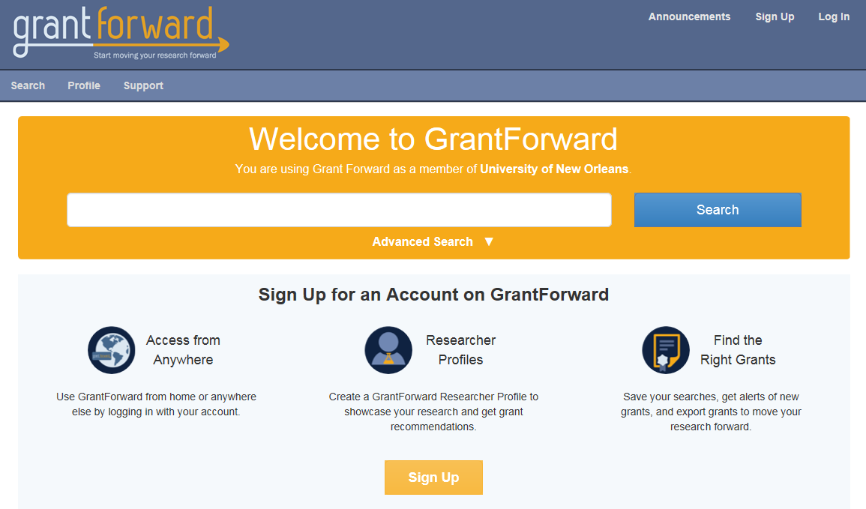
On the account screen, the default tab is the Institutional Account tab. Since the Office of Research pays for a subscription, all UNO employees and students can create an institutional account. Enter a UNO email address (once a UNO email address is entered, UNO is entered as the Institution Name), name and password in the fields provided; then click on Create my Account:
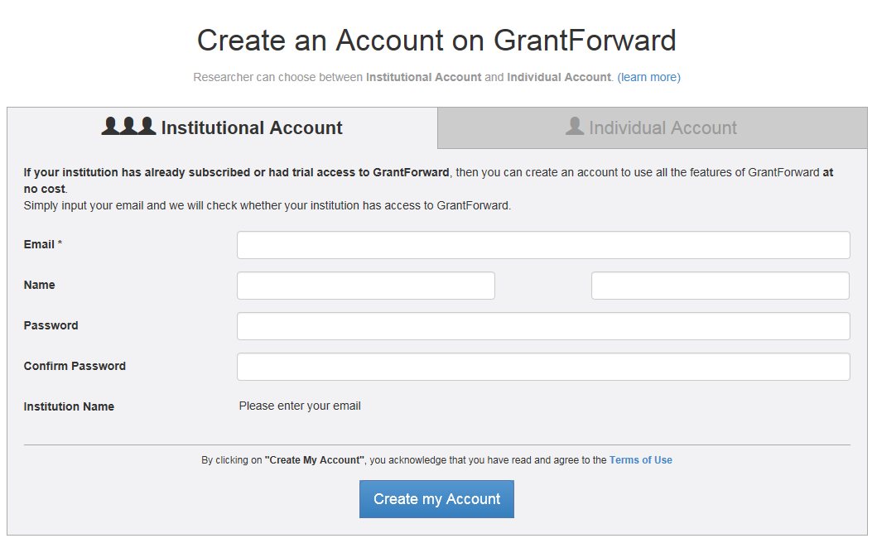
Once this is done, an email will be sent to the entered email address; the email contains a confirmation link. The user must click on this link to confirm the account creation. If this is not done, the user will not be able to use the account. If an email is not received (may take a few minutes to receive), check your spam/junk email box; if the email is not there, contact Grant Forward through the link on their website for assistance.
If the individual already has an account but has changed institutions, the institution can be changed. After logging into Grant Forward (there is a “Log In” link in the upper right hand corner of the main Grant Forward page), click on “Hi,” in upper right-hand corner and then “Account”:
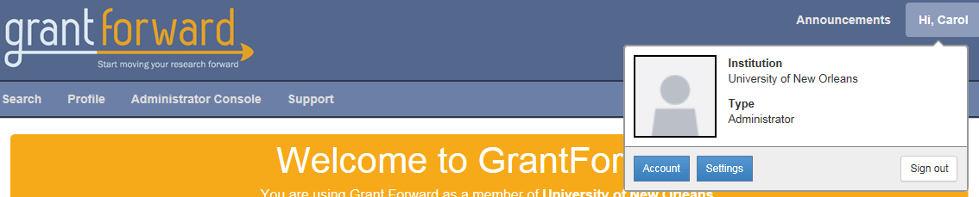
Click the “Update Linking” button in the Institution Linking box:
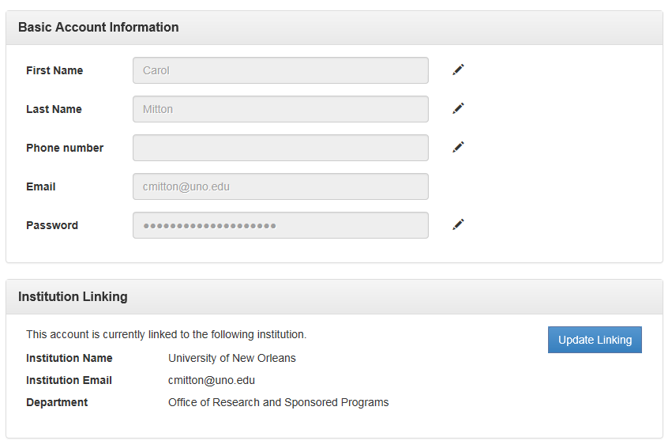
Enter the email address for the new institution.
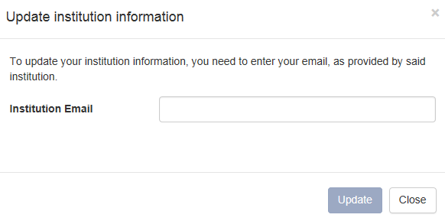

The system will automatically check for the institution’s name. If the institution is a current subscriber, the screen will update to the following:
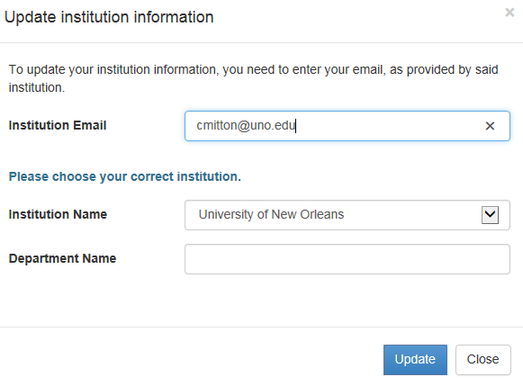
Enter the department name and click “Update”. The account will be created.

Search for Funding Opportunities

Search Options
The Grant Forward home page has a basic search option on the home page. Enter a keyword in the field provided and click Search to be given a list of potential opportunities.
The search results will be displayed, which will be discussed later in this document.
To include an exact phrase, use quotes, e.g., "Computer Science". (If quotes are not used, the result list will have opportunities that include the words but not necessarily grouped as entered.)
Another keyword search option in the keyword field involves using the plus sign ("+") and/or minus sign (“-“). The plus sign is used to designate words that must appear in the search results and the minus sign is used to designate words that should not appear in the search results. The signs can be used in combination with each other to search on a broad category but exclude one specific category. For example if +science -"computer science" is entered in the search field:
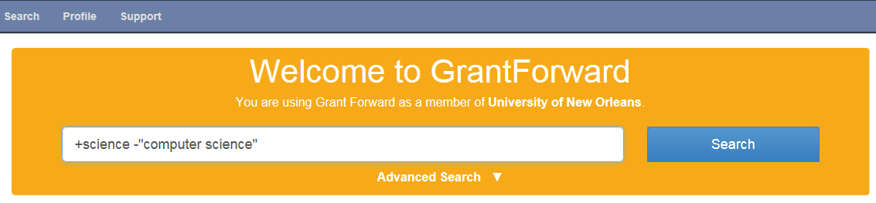
The result list will include all opportunities containing the word "science," but not containing the phrase "computer science."
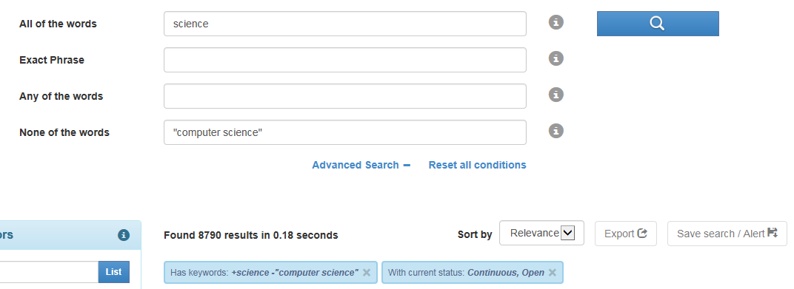
Another search option is to use the Advanced Search from the home page. Click “Advanced Search” to open additional fields.

Use any combination of the offered fields to perform the search.
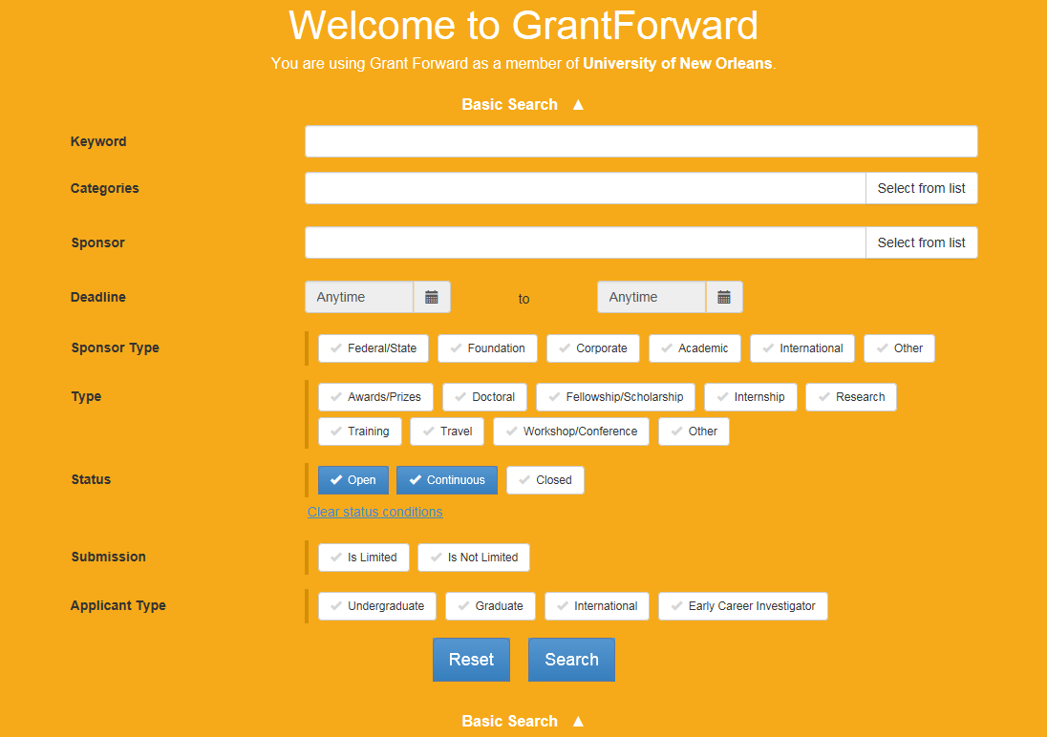
The keyword field is used the same way as the search field from the main page. The other parameters are discussed next.
Categories are selected from a system provided list; click “Select from list” to open the category list.

A pop-up selection box will appear. Click the desired broad category or categories, as many as desired. To further define the search parameters, click the subcategory arrow for the desired category.
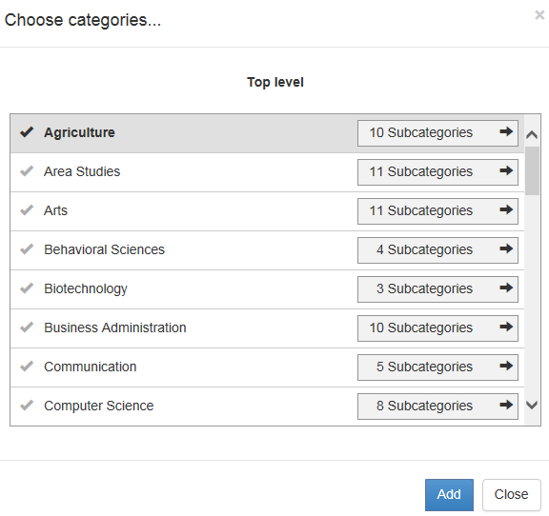
A new pop-up box will appear with the subcategories within the category selected. Make selections as desired. Further definition can be done by clicking the subcategory arrows.
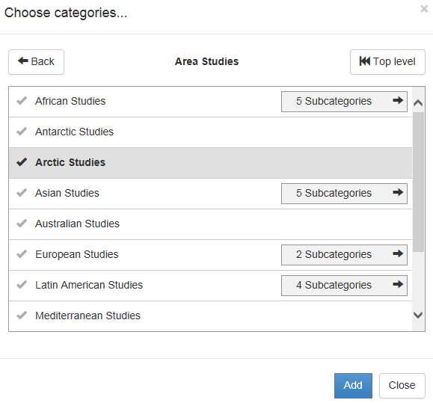

Select as many categories and subcategories as desired; the categories do not have to be related. Once the desired categories and subcategories are selected, click the “Add” button to load the values in the Categories field and return to the search page.
The selected values are added under the Categories field.
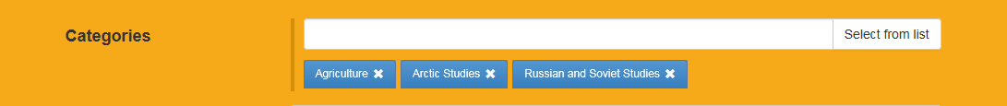
To remove a category, click the X by the name.
Next is the Sponsor parameter. A sponsor name can be entered in the field provided. Once the user starts typing in the field, the system will provide some auto-complete options; the user can choose from the list or continue typing. Another option is to click “Select from list”.
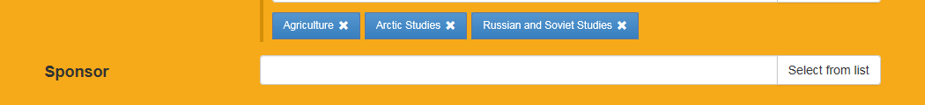

The list of sponsors is provided in a pop-up box.
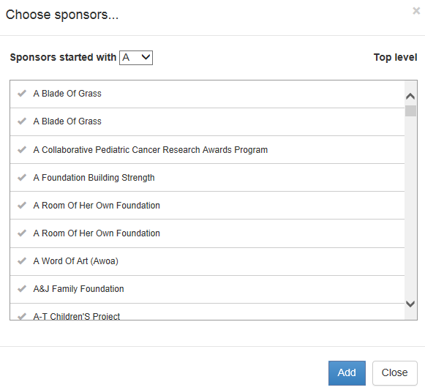
Select the appropriate sponsor or sponsors. Use the alphabet list on the top to jump to that letter and use the scroll bar on the right to go through the list for the selected letter. Select as many sponsors as desired.
Some sponsors may have further levels just like Categories. Click Subsponsors if further definition is desired.
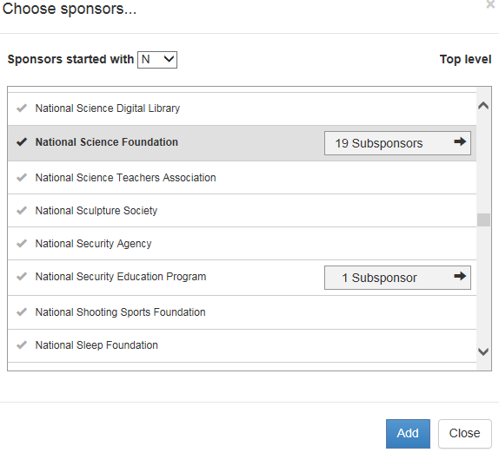
Once the value(s) is/are selected, click the “Add” button to load the value(s) on the search screen. Unless a particular sponsor is needed, this option should not be used for a general search for opportunities in a particular area.
The next Advanced Search option is Deadline. The default values are to select all deadline values, which include open, past and no deadlines. To select particular deadline dates, click the “Anytime” field to open a calendar option:

Scroll through the months until the appropriate month appears; click the desired date. Select a date for either of the date ranges. If a date is entered, “Anytime” is not an available option. The form would need to be reset in order to clear all of the search parameters or the date can be cleared on the search results screen.


Sponsor Type allows the user to select a category of sponsors. Click on the desired types; more than one can be selected. If no value is selected, the search results will include all.

The Type option allows the user to limit the opportunities to a particular type of funding. Select the desired types; more than one can be selected. If no value is selected, the search results will include all.
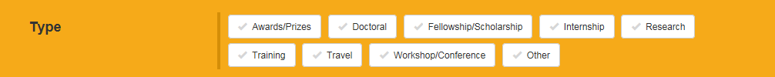
Status allows the user to select only the opportunities with a set deadline (“Open”), no set deadline (“Continuous”), or past deadline (“Closed”). Closed opportunities are included in the database because there may be a deadline announced in the future; therefore, these opportunities should not be ignored but rather kept in mind for the future. The default is to have “Open” and “Continuous” checked. To remove both checked values, click the Clear status conditions link under the statuses.
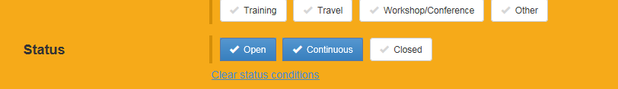
The next search criteria option is Submission. The user can select whether to include only opportunities with a limited submission (the university can only submit a certain number of proposals for the announcement) or not. Limited submissions must be coordinated through the Office of Research and Sponsored Programs. A value does not need to be selected.

Applicant Type is the final search criteria option. If desired, select the appropriate type in order to limit the list of funding opportunities.

To remove selections from the “Advanced Search” options, click the X next to the sponsor name, click the value selected for the other field(s), or if applicable, click the “Clear … conditions” link under the list of values.
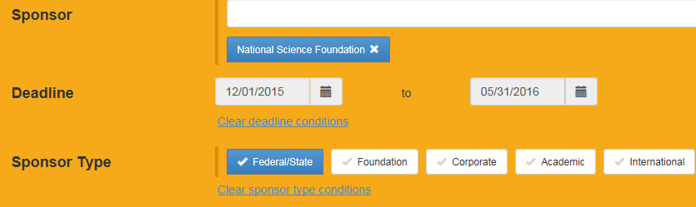
To perform the search, click the Search button on the bottom of the Advanced Search screen.
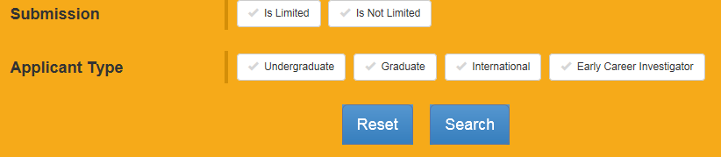
The search results will be displayed (to be discussed later in this document).
Remember, multiple values can be added to both Keywords and Categories fields on the same search to further refine the search results.

Search Results
Below is the search results screen. Basic information on each opportunity (deadline, agency, program title, and a portion of the program description) is provided on the main results screen; additional details on the opportunity can be obtained by clicking on the opportunity title.
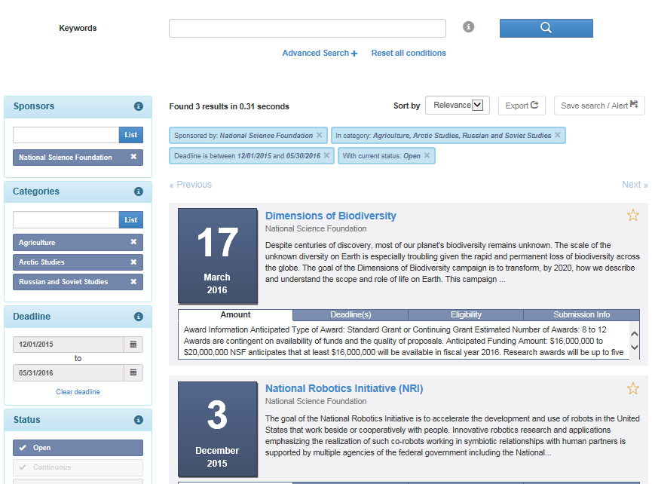

Below is the detail for a funding opportunity. The following information can be obtained from the page:
- Contact and application information
- Link to the sponsor’s website
- If applicable, list of others, with a Grant Forward profile, at the institution who matches the interests
The user is given the opportunity to export the information to a spreadsheet. The opportunity can be added to the user’s favorite list; this requires the user to be signed in. Adding an opportunity to the favorite’s lists allows the user to save the funding opportunity link for future use (which will be discussed later in this document). To add an opportunity to favorites, click the “Favorite” button.
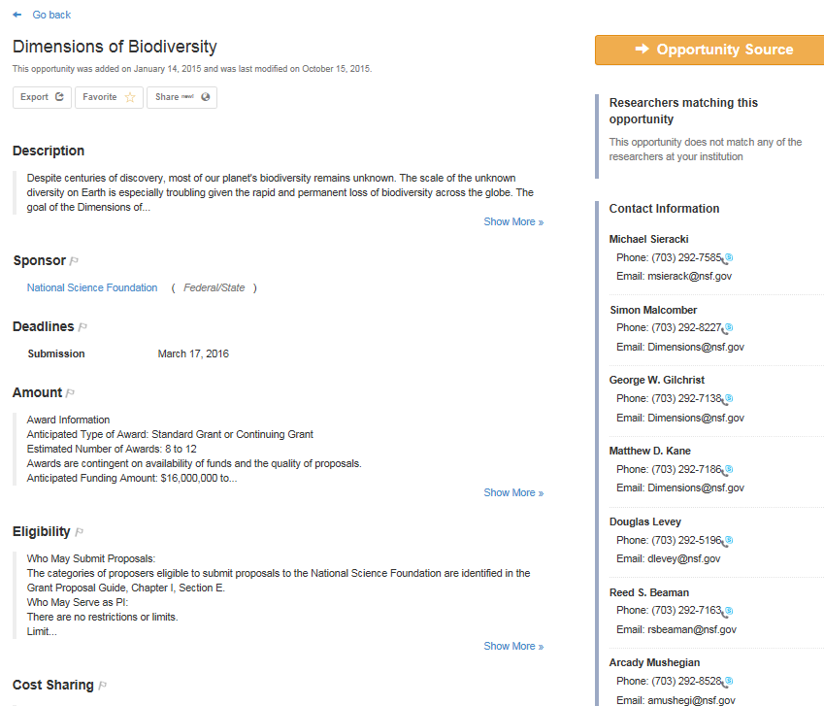
Click to share with someone (must be logged in).
Click to add to favorites list.
Click to send to a spreadsheet.
Click to see more information.
List of researchers with matching interests, if any.
Grant Forward allows the user to see additional basic information for the funding opportunity on the search result screen (this allows the user to decide whether to go to the detail page for the opportunity). To see basic information on the opportunity, click any of titles in ribbon bar under the short description for each opportunity.
Click on any of these titles to see additional information.
Some funding opportunities will include links to similar opportunities.
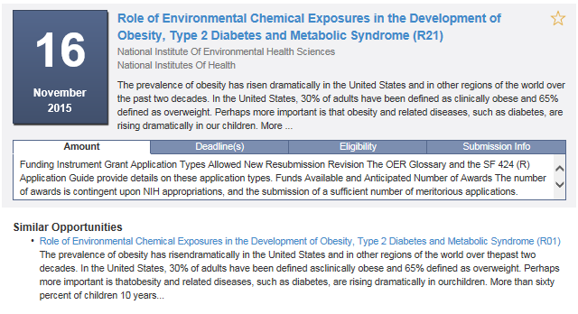

The search result screen allows the user to filter the results if desired. All search categories except for Keywords are available on the left side of the screen. Changes made in these fields will automatically adjust the search results. In addition, the user can select whether to include specific sponsor types or project type; if one of the type values is selected, only that value will be included in the search results.
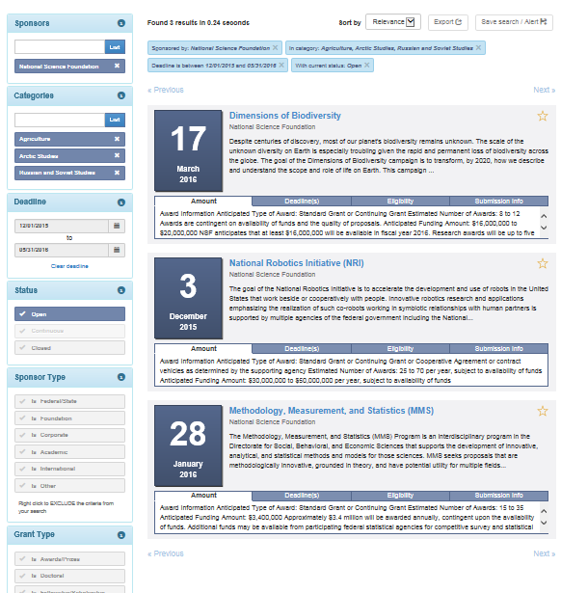
If all deadlines are desired (which will include opportunities with continuous deadlines), click the “Clear deadlines” link.
Click the value to select to include only that value in the search results.

The Keywords field is available at the top of the results screen; however, changes to keywords requires the user to run another search (click the magnify glass button). Additional options for the keywords field are available if “Advanced Search” is clicked.
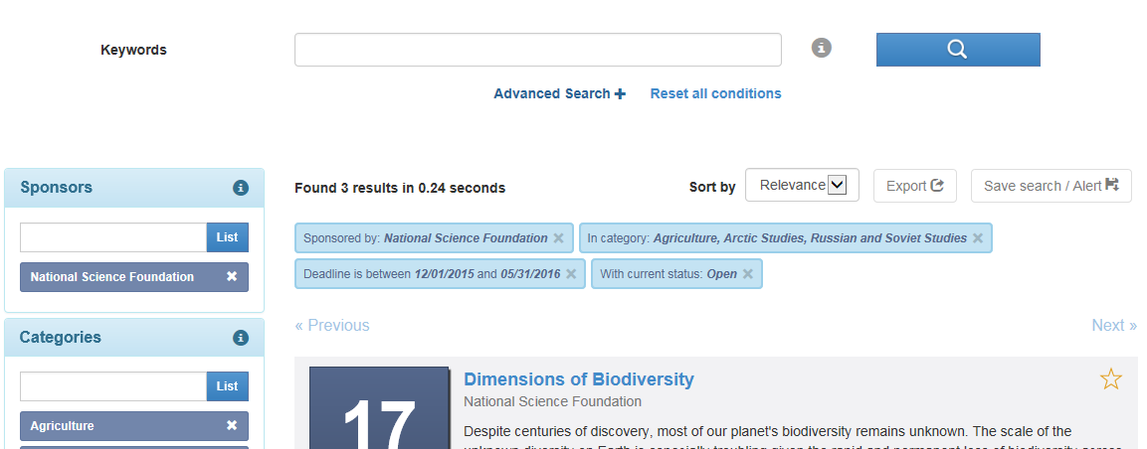
Click to open more keyword options.
Below are the advanced keyword options. Enter words in any of the fields. Hover the mouse over the circle with the question mark to get additional information. When finished entering values, click the magnify glass button to perform the search.
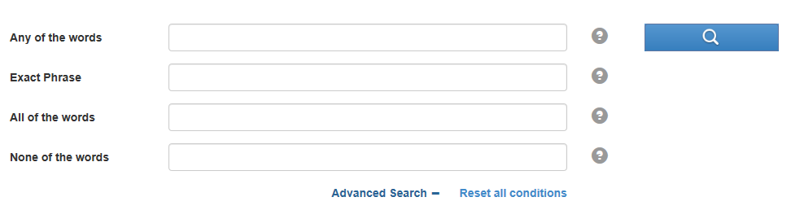

At the top of the result list, the number of opportunities is listed. There is an option to export this page of search results to a spreadsheet or text document. The search can be saved and an alert created based on the search parameters, if desired. The user can also change how the results are sorted; the sort values are relevance, deadline, newest, sponsor and title. The default sort value is relevance.
Exporting the results is only available if the user is logged in. To export the list, click “Export”:
A pop-up box will appear asking for details on what to export. Make the desired selections and click “Export”:
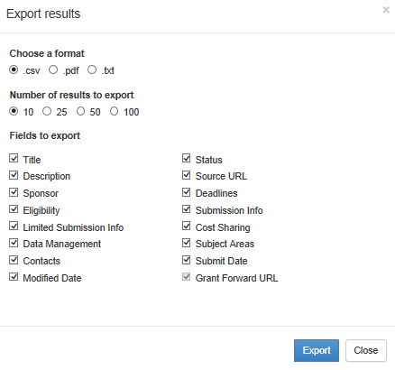
If the box was opened by mistake, click “Close”.
In order to use the save/alert feature, the user must be signed in. When a search is saved, the search terms, not the results, are saved; this allows the user to run the same search at some other point. To save, click “Save search/alert”:
A pop-up box will appear. Enter a descriptive name for the search (or update a previous saved search if you already have a search saved; the above pop-up box will include “update a previously saved search” as the first option) and select the appropriate value for the alert, if desired. The alert values are no alert, every day, every Monday, and every first day of the month. Once done, click save.
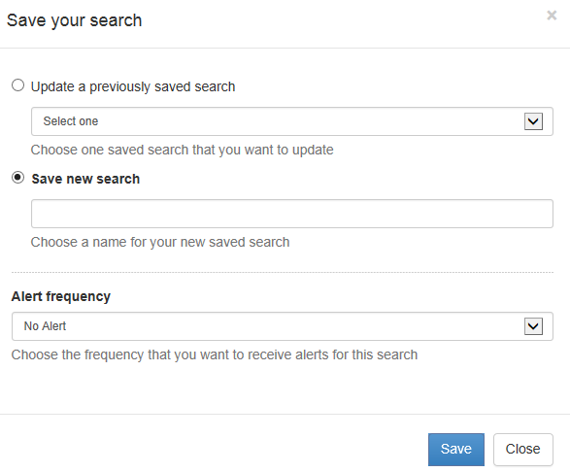
Running a saved search is discussed later in this section.
A user can have multiple saved searches and alerts can be established for any of the saved searches. Each alert can be setup with different or same frequency values. A particular day’s email alert will combine all results in one email. If there is more than one search, the email will group the result by the individual searches with a heading for each search (the searches are either numbered or have the title entered when the search was saved).
The alert email will contain links to the funding opportunities that match the criteria in the designated search; if there are no opportunities that match the search criteria, the email will state that. The links in the email are to the particular funding opportunity page in Grant Forward; therefore, the user must either be using a computer on the UNO network or log into Grant Forward to view the page.
Email alerts can be changed or deleted if the user desires. Changes are made through the Saved Searches page (under the Search menu option) which is discussed later in this document.
Another option on the search results is the ability to add a particular opportunity to a user’s favorite list; this requires the user to be signed in. Adding an opportunity to the favorite’s lists allows the user to save funding opportunity links for future use and to manage upcoming deadlines (which will be discussed later in this document). To add an opportunity to favorites, click on the star to the right of the opportunity.
Click star to add to favorites list.
When an opportunity is added to favorites, the star becomes filled:
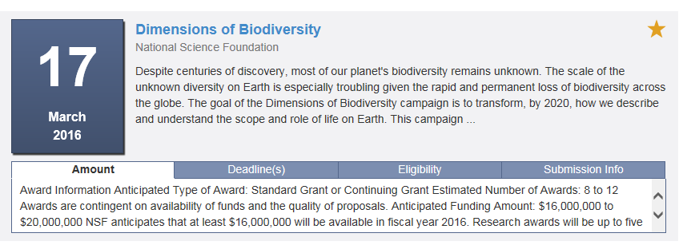

Saved Searches
Saved searches can be run at any time and changes to the saved search can be made. To view/change/run a saved search, click “Search”.
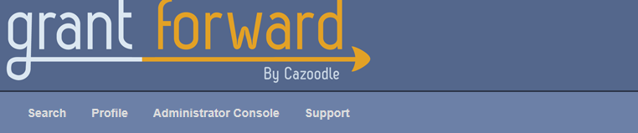
Then select “Saved Searches”.
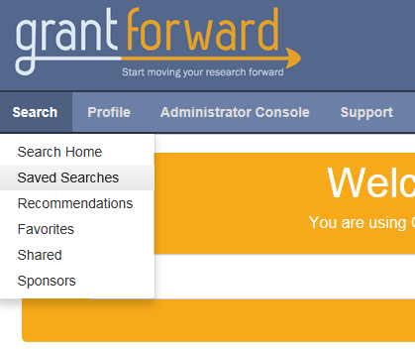
The user’s list of saved searches will be displayed. Each search will list the criteria for the search as well as whether an alert was set up for the particular search; the first one on the list below has an alert established but the second one does not.
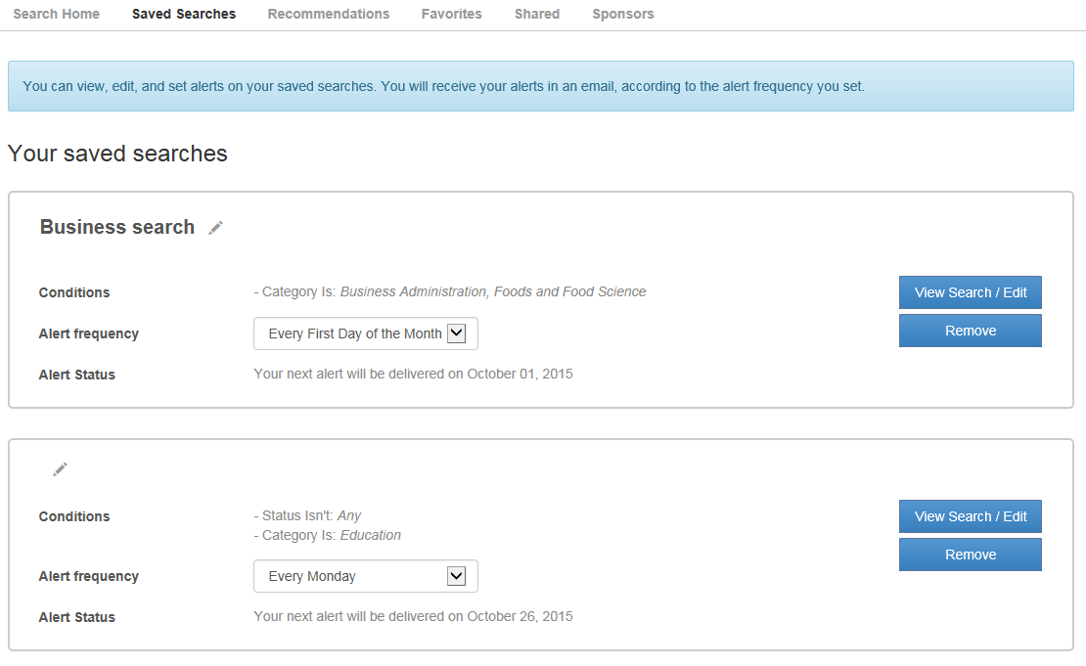
A title can be changed or added by clicking the pencil in the bar:
The field will be available for edit. After typing in a value, click anywhere on the screen to save the title.
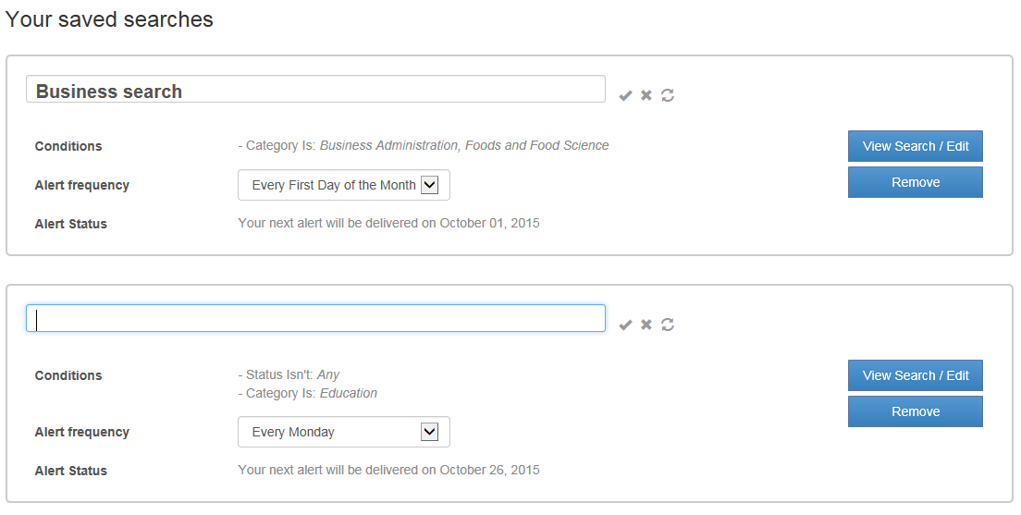
Changes to the search criteria can be made by clicking “View Search/Edit” for a particular search:
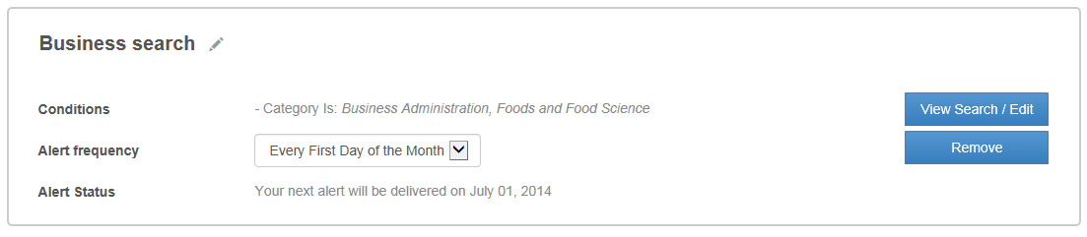
The search will be run and the results screen will be displayed. Changes can be made to any of the categories (see previous discussion in the Search Options and Search Results Sections). Once all changes are done, click “Save search/Alert” at the top of the page to save the changes.
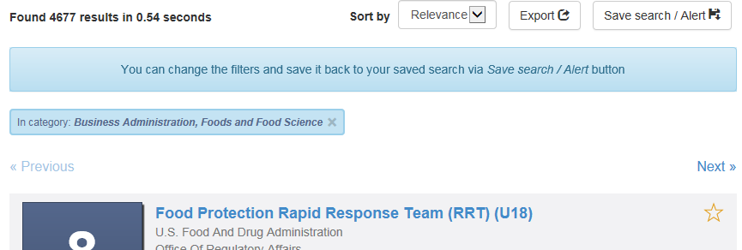
The pop-up for save a search will appear. The user can save the search under a new name or select the search from the list of previously saved searches. An alert can also be set.

Alert frequency can also be changed or added for any of the searches. For a search the user wants to change or add an alert, click the down arrow to select the appropriate frequency value:

The alert options are no alert, every day, every Monday, and every first day of the month. Once an alert is set, the screen will display when the next alert will be sent.
Searches can be removed from the list by clicking “Remove”:

Favorite List
When users click on the star for a particular funding opportunity, the funding opportunity will be shown on their favorite list. To view the list of favorite opportunities, click “Search”.

Then select “Favorites”.
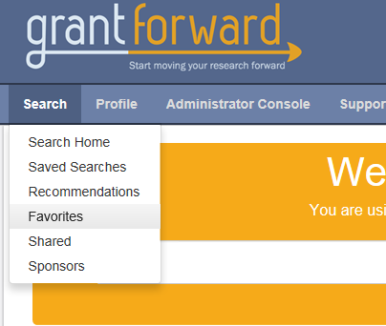

The user’s list of favorite opportunities will be displayed. The default is to list all favorites but the user can select any of the list options on the left of the screen:
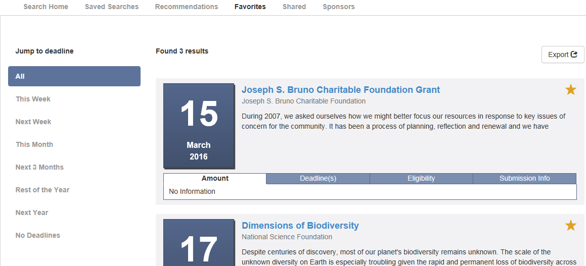
If a funding opportunity with an expired deadline is marked as a favorite, the opportunity will be displayed under “all” but not under any of the other categories. (Note: Opportunities with expired deadlines are good to keep on the favorite list just in case the sponsor updates the deadline. If the opportunity is kept as a favorite and an update is made, an email will be sent to the user assuming the user has the option checked to receive emails on updates to favorites which is set on the Notifications page under User Account.)
To view details on the opportunity, click the opportunity title or click any of titles in ribbon bar under the short description for each opportunity.
Click on any of these titles to see additional information.
To remove the opportunity from the Favorites list, click the opportunity title and then click the “Favorite” button on the opportunity page.
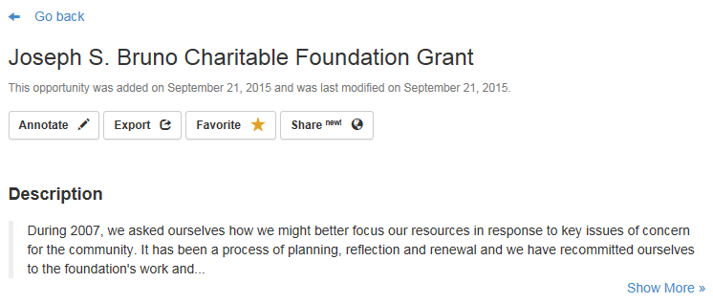
Another option to remove an opportunity from the list of favorites is to click the star next to the opportunity on the list of favorite.

Profiles
The profile option in Grant Forward is a tool used to identify potential funding opportunities based on the individual’s research interests. Research interests are identified through keywords, publication titles, URL for publication page, and/or CV. The interests are used to create an interest cloud which is used to identify potential funding opportunities. There are two settings to view the profile: 1) only the individual and others at the institution with administrative access to Grant Forward or 2) everyone at the institution. An administrator or the profile owner can delete a profile.

Create Own Profile
In order to create a profile, the user must log into Grant Forward (link in upper right-hand corner of the main Grant Forward Page). Once logged in, click “Profile”:
Click “Create Profiles”:
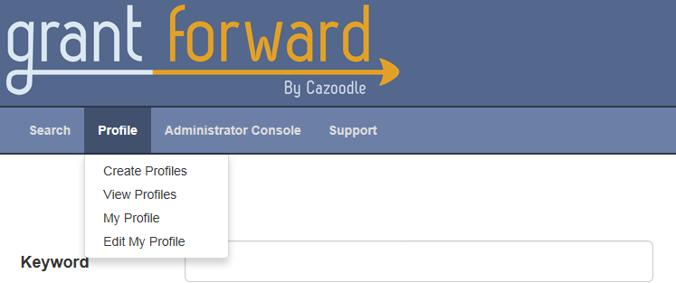
Click “Begin building” under Build your profile:
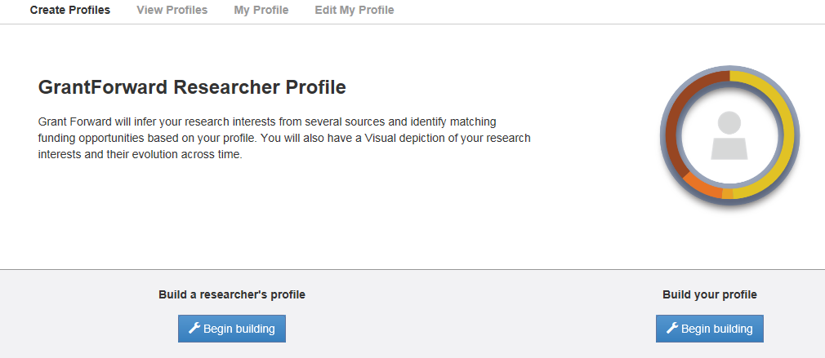
The profile is completed in steps. The first step involves entering basic information. Once the information is entered, click “Research Interests” on the bottom of the screen. The name field is required but the other fields are optional.
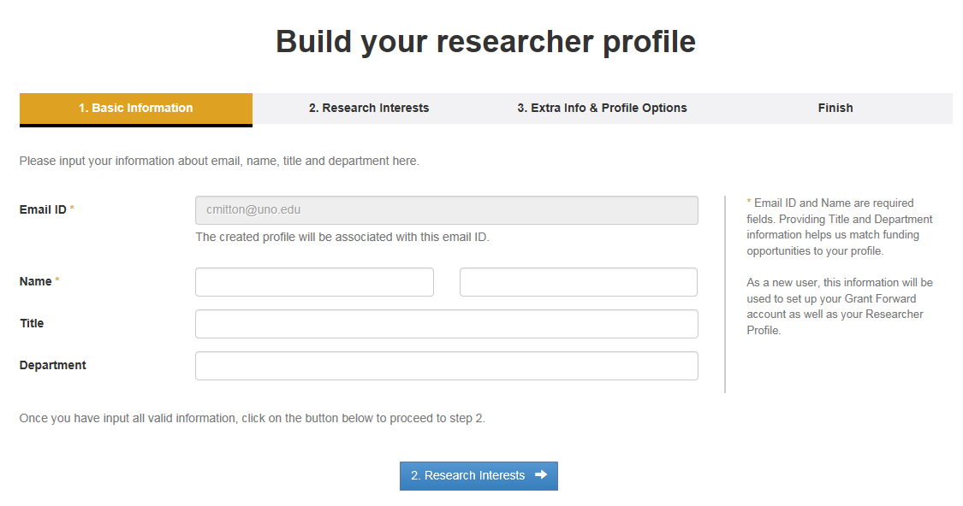
There are two options to enter researcher interests – Interest Source and Other Interests. At least one of these options must be used; values can be entered under both options though.
Interest Source has three options to enter interests: publication webpage, upload curriculum vitae, and manually input publications. Only one of the Interest Source options can be used. Grant Forward will review the link, document or titles and extract research interests. This process may include some terms the researcher does not want in the profile; the unwanted terms can be removed which is discussed in the Edit Profile section. A screenshot for each of these options follows the main Research Interests screen.
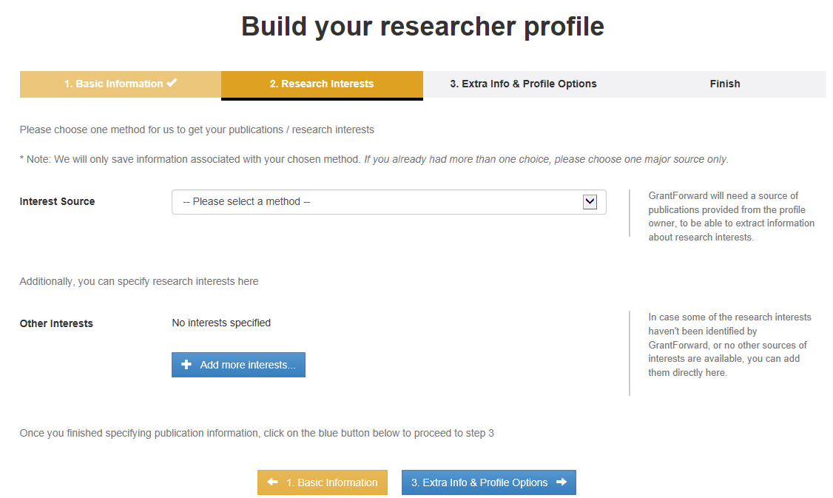
Only one publication page can be entered.
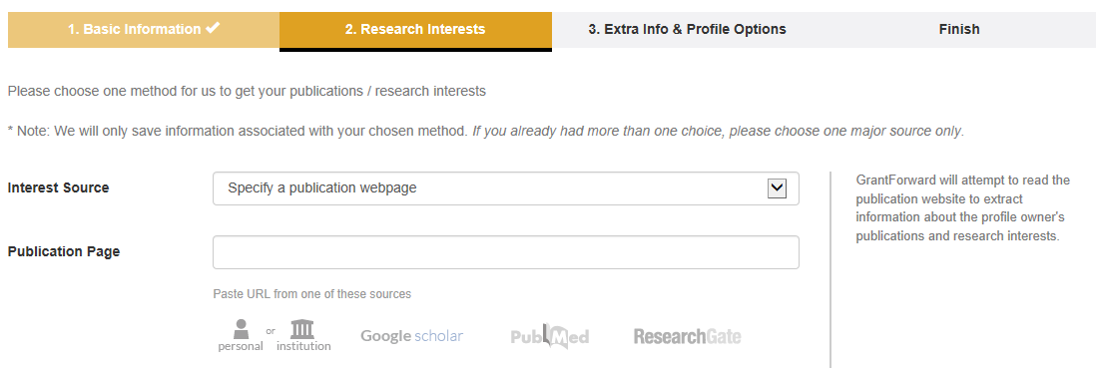
Upload a PDF version of the vitae; only one document can be uploaded.
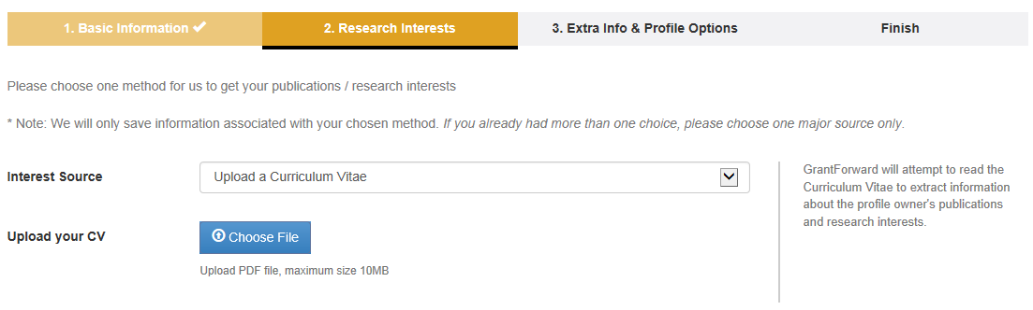
Enter as many publications as desired; use separate lines for each title. Separating the titles will result in a better list of research interests.
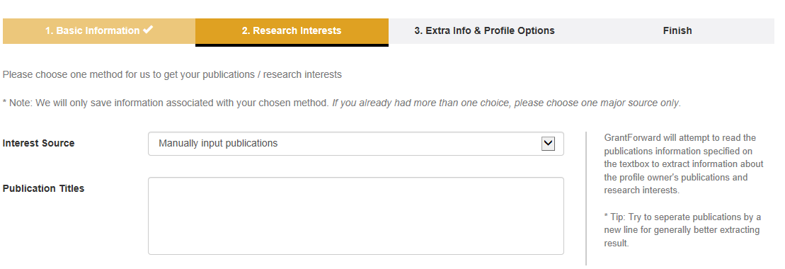
In addition to entering information under Interest Source or instead of using that option, specific research terms can be added under Other Interests. Click “Add more interests…”.
A field will be provided to enter an interest and to enter a rank for the term (low to high importance; the default value is in the middle). More interests can be added by clicking “Add more interests…”.
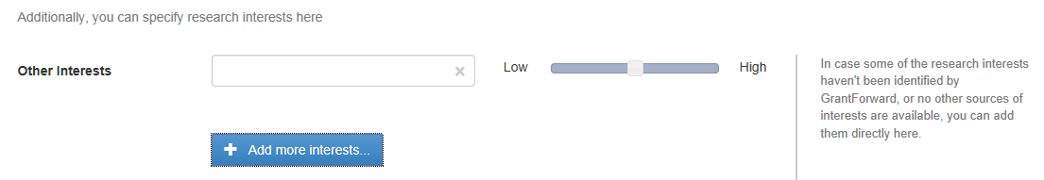
When done adding interests, click “Extra Info & Profile Options” which is the final step.
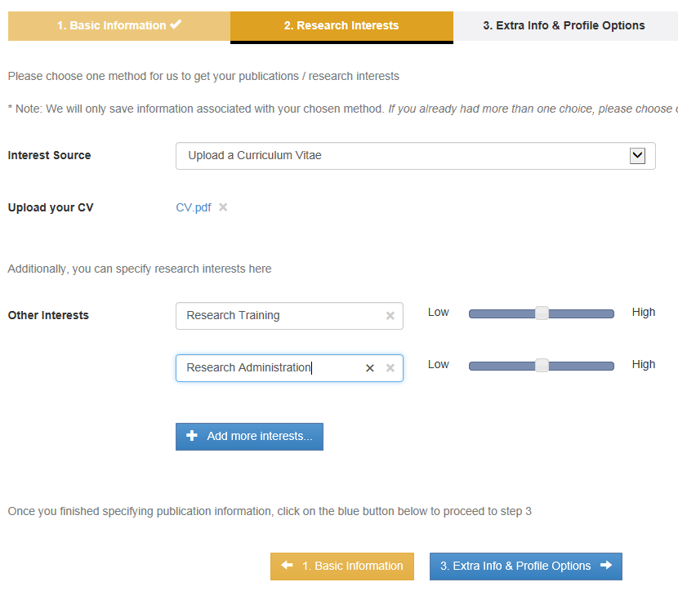
Values can be entered in any or all of the extra information fields.
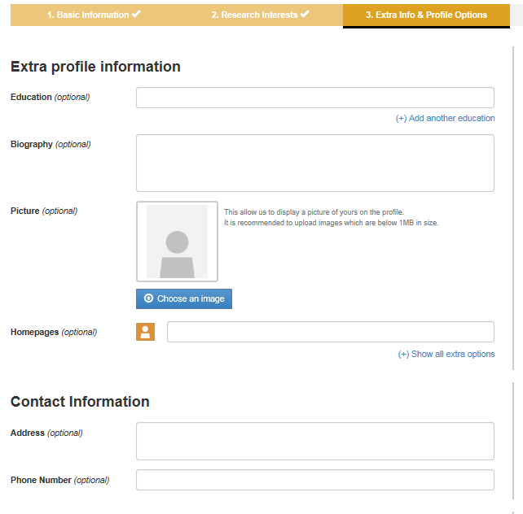
Lastly, options for what is included in the displayed profile and who has access to the profile can be set. The profile can either be public, everyone at UNO can view, or private, only the profile owner and individuals at the institution who are designated as administrators can view. The default is public but that can be changed by clicking “Public”. Choices can be made as to what will be displayed on the profile; the default is yes for all but that can be changed by clicking “Yes” for the ones to change. When done, click “Finish”.
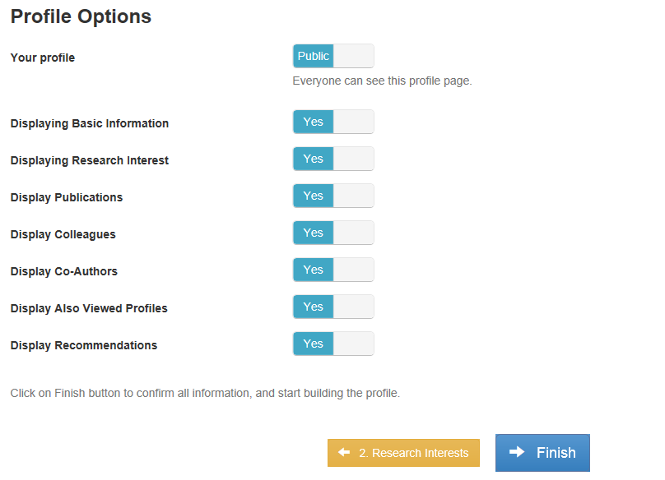
They system will examine the information provided and build the profile; this may take a few minutes depending on the information provided.
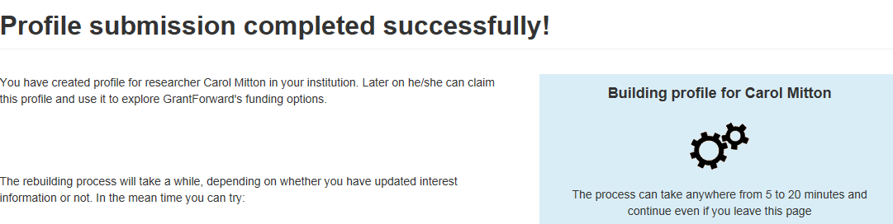
Once the profile is complete, a link to the profile will be given.
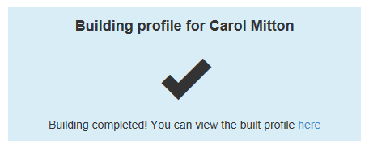
The information provided on the profile pages will be displayed as well as colleagues and co-authors if any.
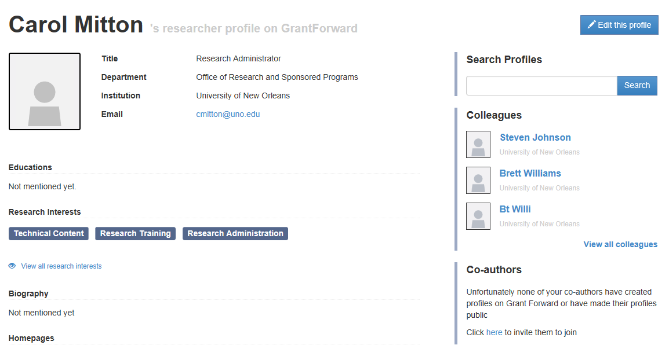
In addition a cloud of research interest is provided; the research interests can also be displayed as a list. There is also a scroll bar to see how the interests may have changed through the individuals list of publications. Grant Forward will provide a list of recommended funding opportunities based on the research interests.
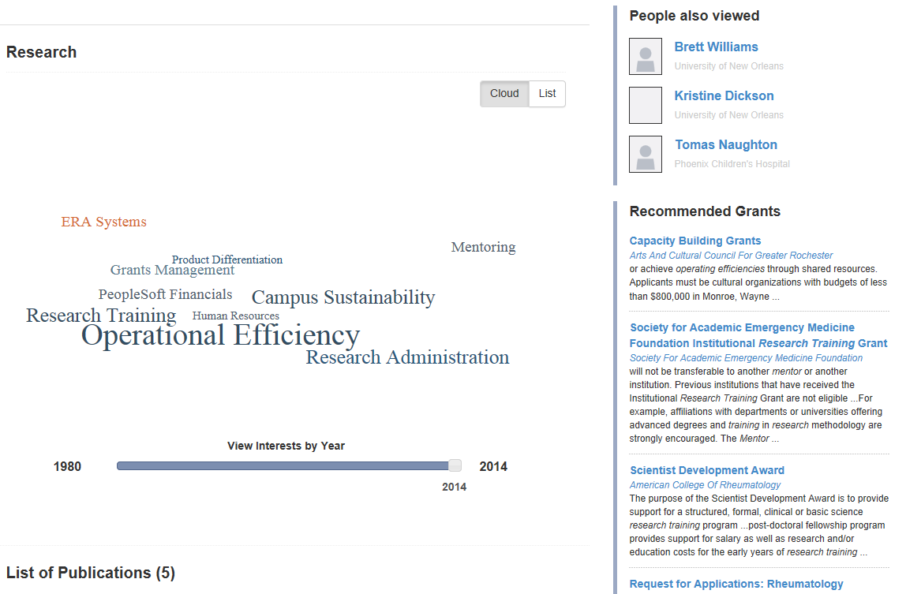

After the profile is created, the GrantForward home page will have a list recommended grants for the user and links to the user’s favorite grants and updates for the saved searches.
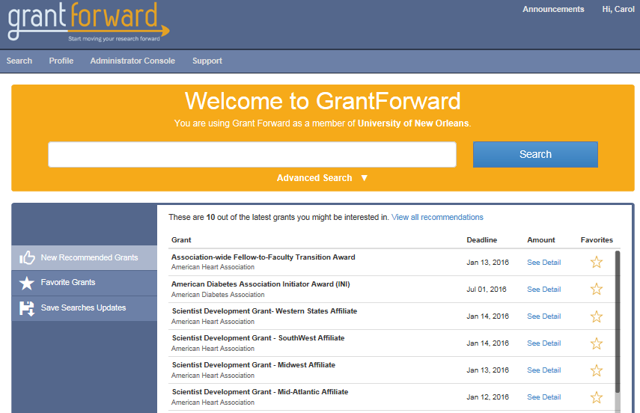
The next time the user logs in this information will be displayed.

Create a Profile for Someone Else
A user, who has an account in Grant Forward, can create a profile for someone else. Once logged in (link in upper right-hand corner of the main Grant Forward Page) , click “Profile”:

Click “Create Profile”:
Click “Begin building” under Build a researcher’s profile:
Just like with creating your own profile, the profile is completed in steps. The only difference is that the researcher’s email address needs to be entered; when creating a profile for yourself, the email address self-populated.
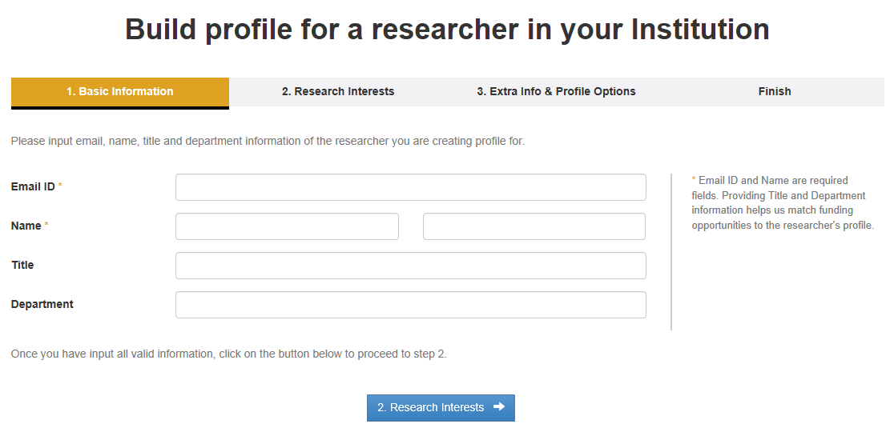

Claiming a Profile
When a profile is created by someone other than the researcher, the researcher will receive an email stating a profile was created and providing a link to the profile. The user needs to “claim” the profile. If the link is used, the log in screen will appear. If an account has already been created, enter the email ID and password and click “Log In”. If an account has not been created, click “Sign Up” in the upper right-hand corner. Account creation is discussed earlier in this document.
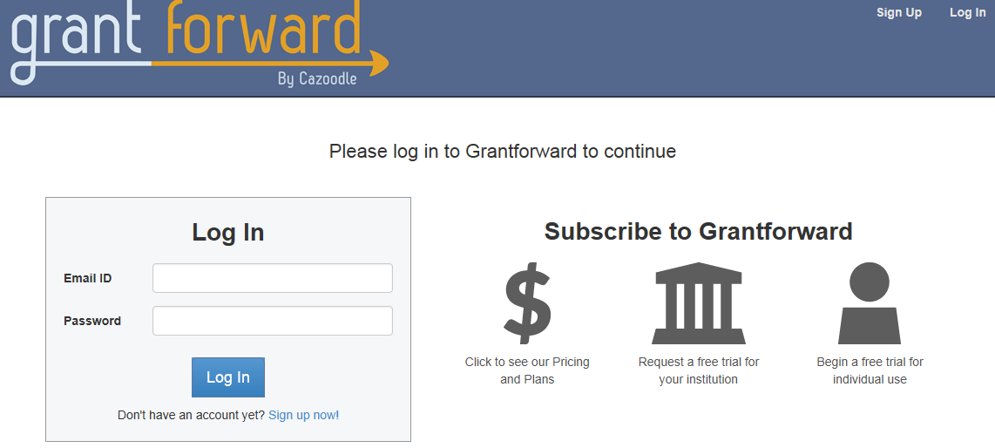
Once logged in, the profile edit page will appear. Go through each page and check the information entered, make changes as necessary. When done, click “Claim and save this profile”; this button appears on each of the pages.
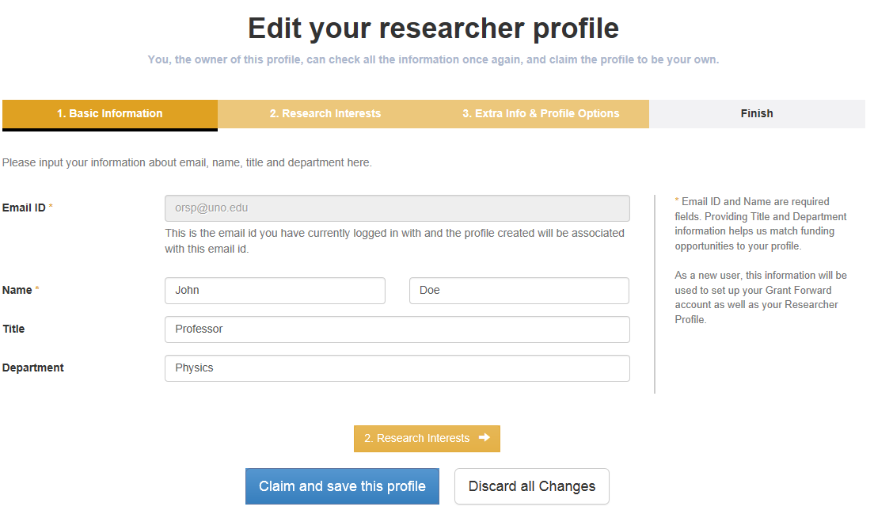
If the profile edit page does not appear when the individual logs in, click “Profile” from the main menu and then “Edit My Profile”.
Go through each page and check the information entered, make changes as necessary. When done, click “Claim and save this profile”; this button appears on each of the pages.

Editing A Profile
A profile can be edited by the profile owner or an individual at the institution designated as administrator in the system. Once logged in, click “Profile”:
To edit their own profile, click “Edit My Profile”:
Proceed through each page and make changes as necessary. Once done making changes, click “Save this profile” which is on the bottom of each page. Note, the user can either select “Discard all Changes” or “Delete Profile” from each page as well.
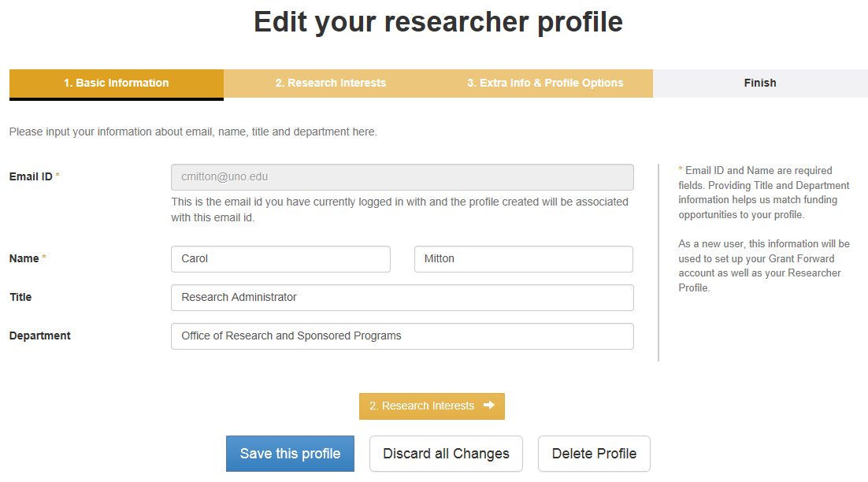
On the Research Interests page, keywords can be removed from the list by unchecking the box (just click on the box) next to the word. This is usually a necessary step since the system may have extracted irrelevant words from a publication site or curriculum vitae.
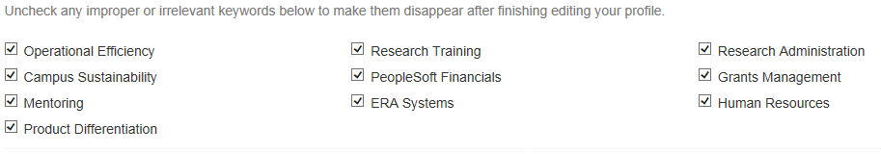
Once the “Save this profile” button is clicked, the profile will be rebuilt based on the changes.
The edit button is also available in the upper right-hand corner of the profile.
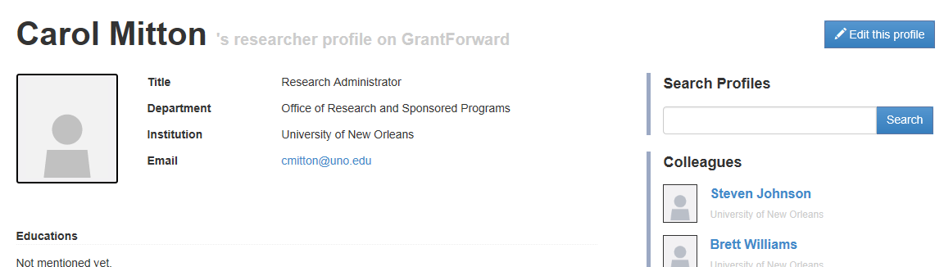

Institutional administrators can also edit someone else’s profile. To do that, select “View Profiles” from the Profile menu:
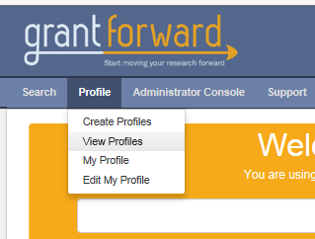
The profiles created for the institution are displayed. To find the particular profile, use the search box, alphabet (select the first letter of the individuals last name), or scroll options.
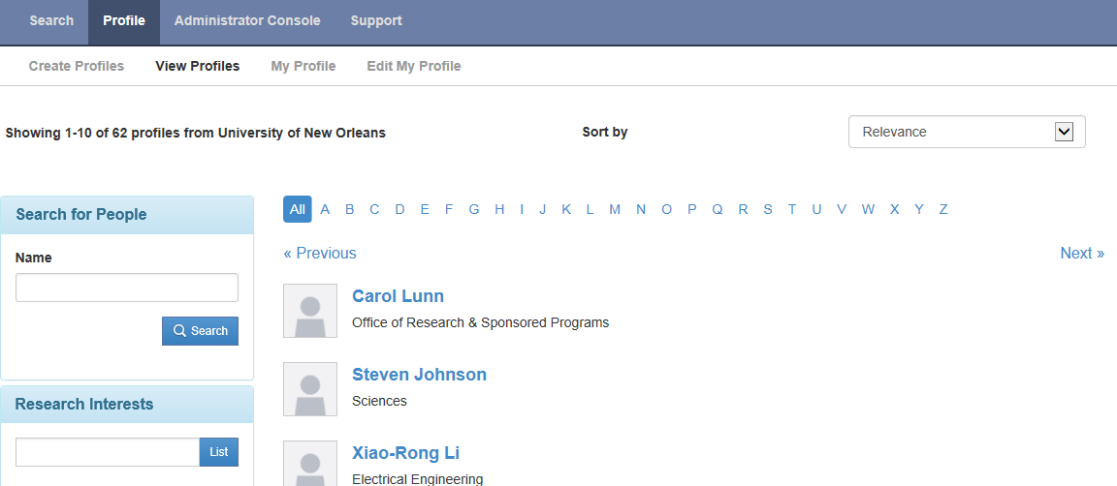
Once the individual is located, click the name to open the profile. Make changes as necessary just as previously discussed.

Delete a Profile
Just as with editing a profile, a profile can be deleted by the profile owner or an UNO designated administrator in the system. To delete a profile, open the individual’s profile page (see previous discussion) and then click “Delete Profile” on the bottom of any profile page:

Privacy Options
As explained under creating a profile, the user has the option of allowing anyone at the institution or only allowing themselves and the users with an administrator role in Grant Forward to view their profile. The default value is to allow everyone. The value can be changed when the profile is either created or edited. Step 3 of the profile create/edit page is where the privacy option can be changed. To change the value, click the value that is currently selected. In the example below, click “Public” to change it to private.
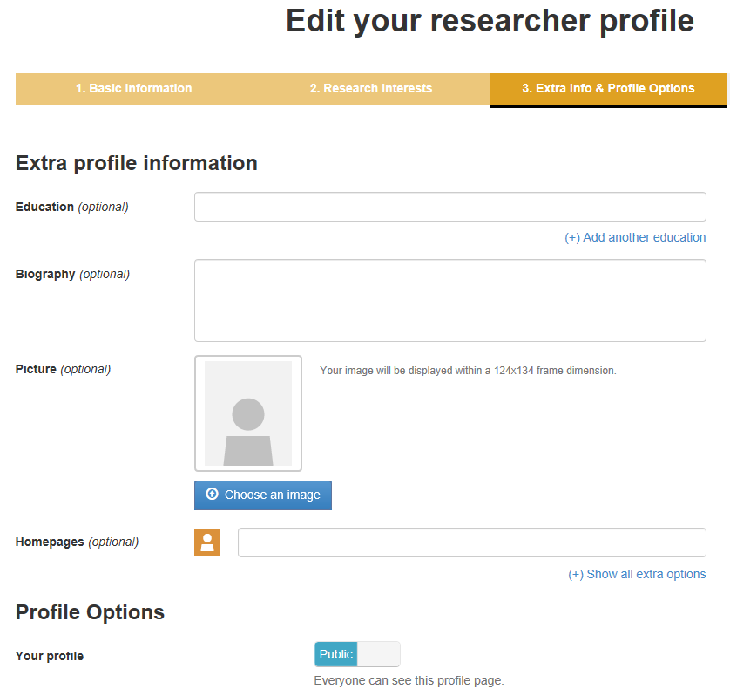

Recommendations
One of the features of Grant Forward is recommendations. Based on the information entered on the Profile page, Grant Forward will provide a list of potential funding opportunities. The list can be modified by using the same procedures as changing a list of opportunities created when performing a search.
To obtain the list of recommendations, choose “Recommendations” under the Search menu (a profile has to be created to use this option and the user has to be logged in):
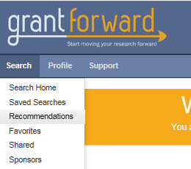
A link to the profile page is provided at the top of the page as well as the interest cloud. The recommendations are provided on the bottom of the screen. To the left of the list of funding opportunities are the same search options available under a regular search. An alert can be set based on the search parameters.
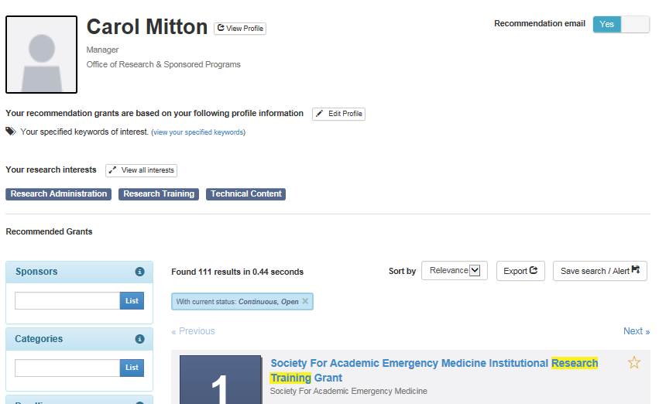
Use the options in this column to refine the list.
The save pop-up box will appear. Enter a descriptive name for the search (or update a previous saved search if you already have a search saved; the above pop-up box will include “update a previously saved search” as the first option) and select the appropriate value for the alert. The alert values are no alert, every day, every Monday, and every first day of the month. Once done, click save.
The list can also be exported to another file. Click the “Export” button:
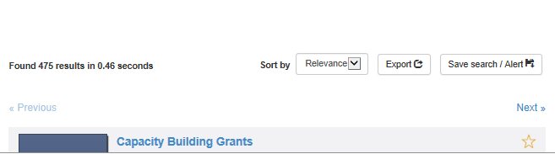
A pop-up box will appear asking for the formant and details on what to export. Make the desired selections and click “Export”:
If the box was opened by mistake, click “Close”.
Another option available on the Recommendations page is Edit/Update Profile (see previous discussion for more details).

User Account Page
The User Account page is used to manage the user’s profile and settings. To get to the Account page, click on “HI” (it will include the user’s name if a name is entered on the User Account page) in the upper right-hand corner of any of the Grant Forward pages and select “Account” from the list:
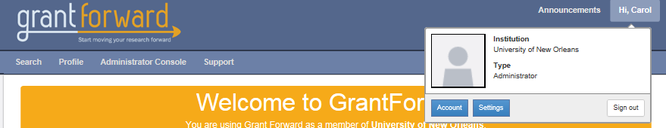
User Account has four menu options; each of which is discussed next.
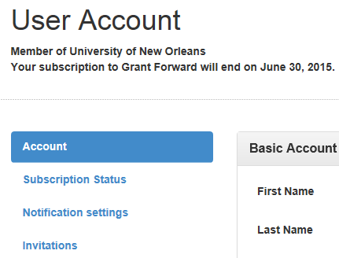

Account
This menu option is used to enter the user’s name and phone number if desired; the password and institution link can also be updated if necessary. If a name is entered on this page, the User Account title will change to the user’s name on the Account page. To make changes, click the pencil to the right of the field name.
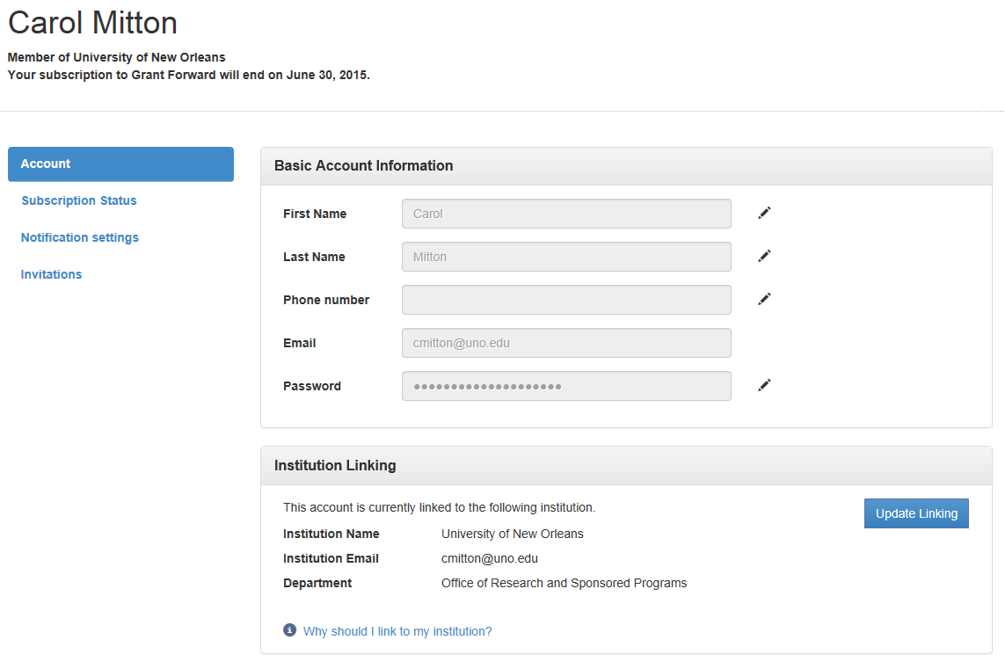
Make the necessary change and then click the check mark to save the change or the X to not change the value.
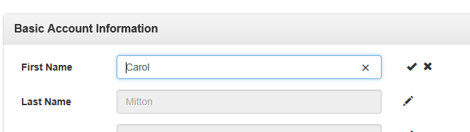

Subscription Status
This tab will display the end date for the institution’s subscription assuming the user’s account is linked to an institution.
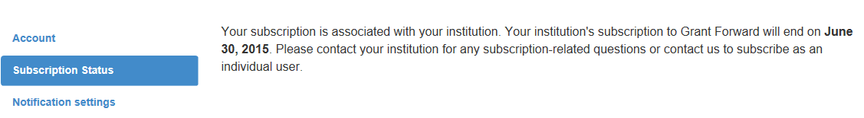

Notification Settings
On the Notification Settings page, the user can select whether to receive notifications concerning updates/changes to Grant Forward or changes to funding opportunities marked as a favorite. The user can also select who will be allowed to view their research interests as determined on the Profile page. The default is that everyone at UNO can view the interests; the other option available is that only the user and the individuals designated as Administrator in Grant Forward can view the interests.
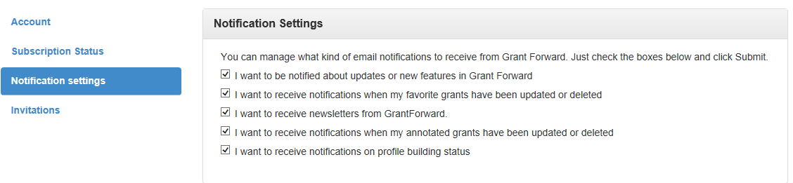

Invitations
The invitations tab is used to invite Co-Authors on publications identified on the user’s Profile to create a profile in Grant Forward. The default value is to have this feature disabled; click the “No” button to enable this feature. The user can also invite specific individuals to create a profile.
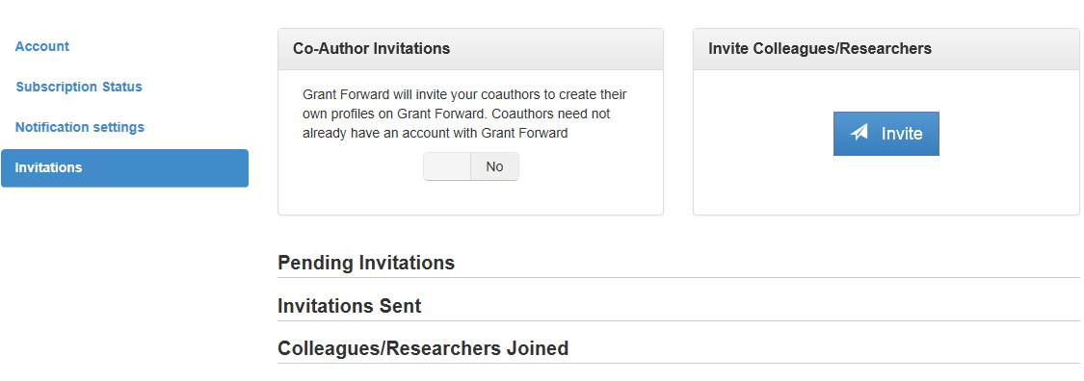

Sponsor Directory
Grant Forward includes a directory of sponsors in the database. To open the list of sponsors, click “Search”.
Then select “Sponsors”.
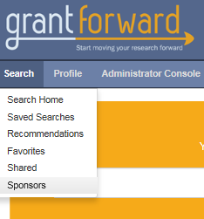
The list is alphabetized and can be scrolled through using the arrows and page numbers on the top of the screen. The user can also search for a particular sponsor or select only certain types of sponsors. To get more information on the sponsor, click the sponsor name.
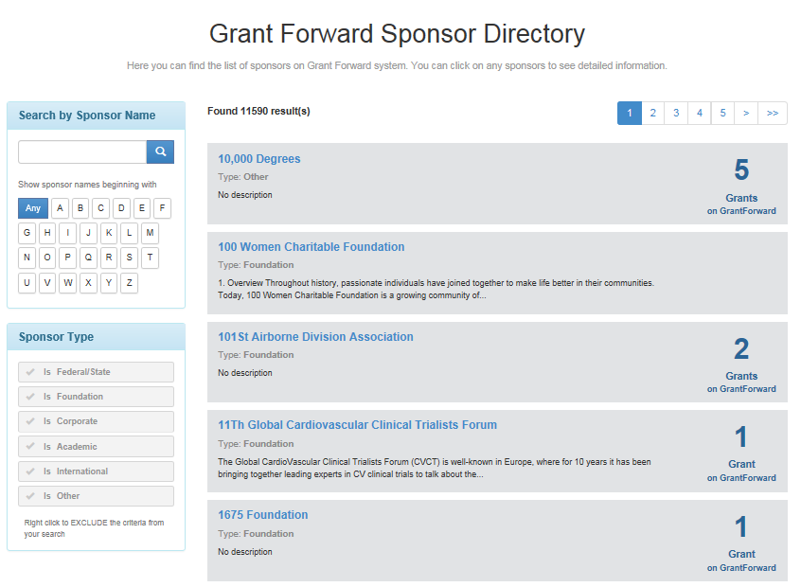
Below is the sponsor detail page for 3M Foundation. This sponsor does not have much information; other sponsors will have more information. The following shows the type of information that can be available, which includes a link to the sponsor’s website.
