Connecting to Wifi Using Windows 10 Operating System

- Click on the Windows Start button. Select the Settings options.
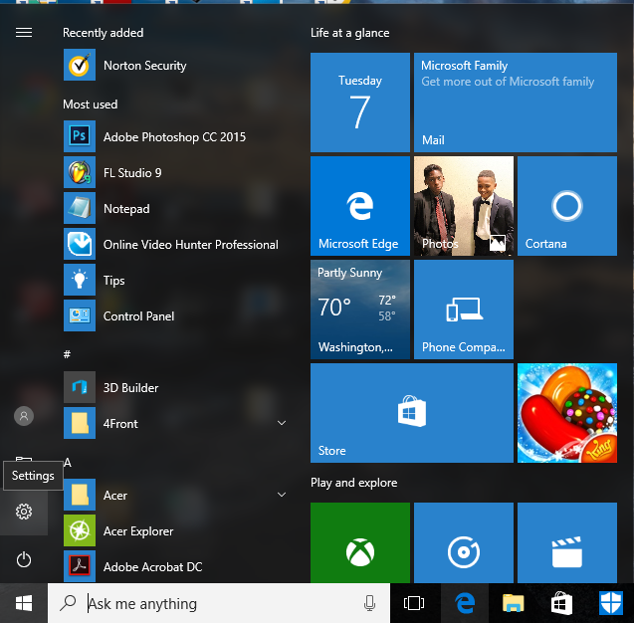
Start menu button

- On the Windows Settings page, Click on the Network & Internet Option
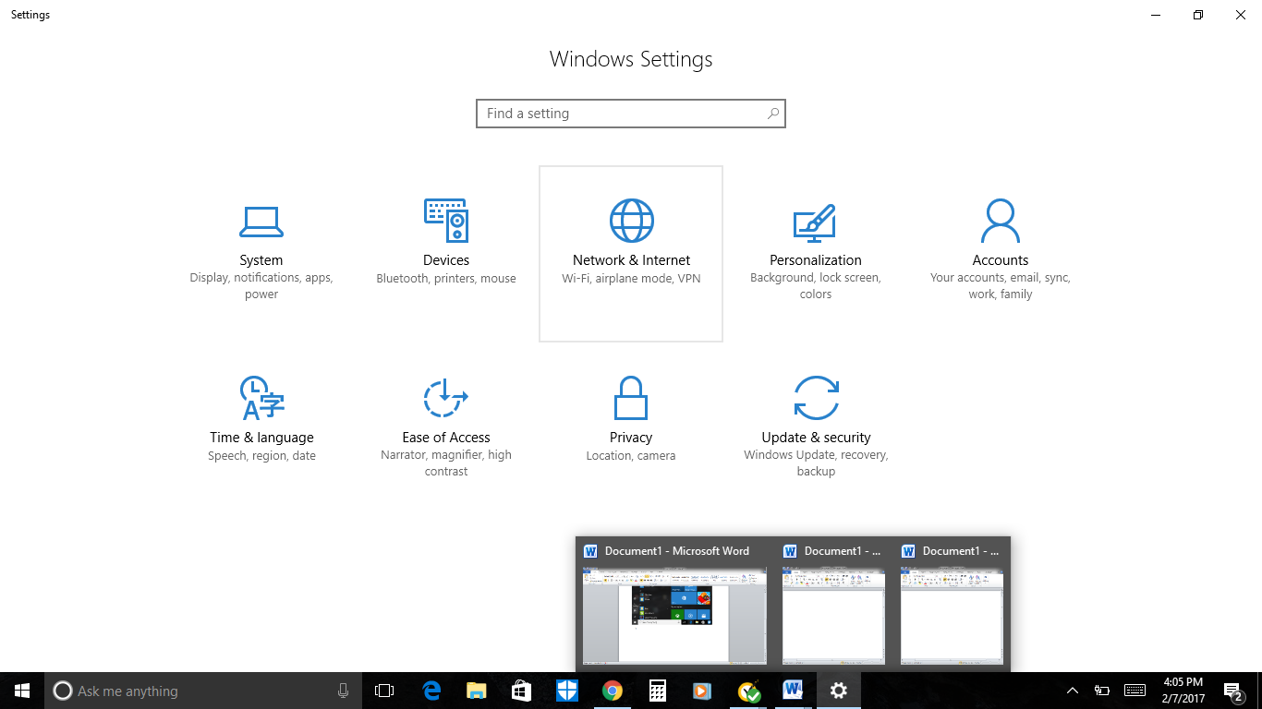

- Scroll down and select the Network & Sharing Center Option.
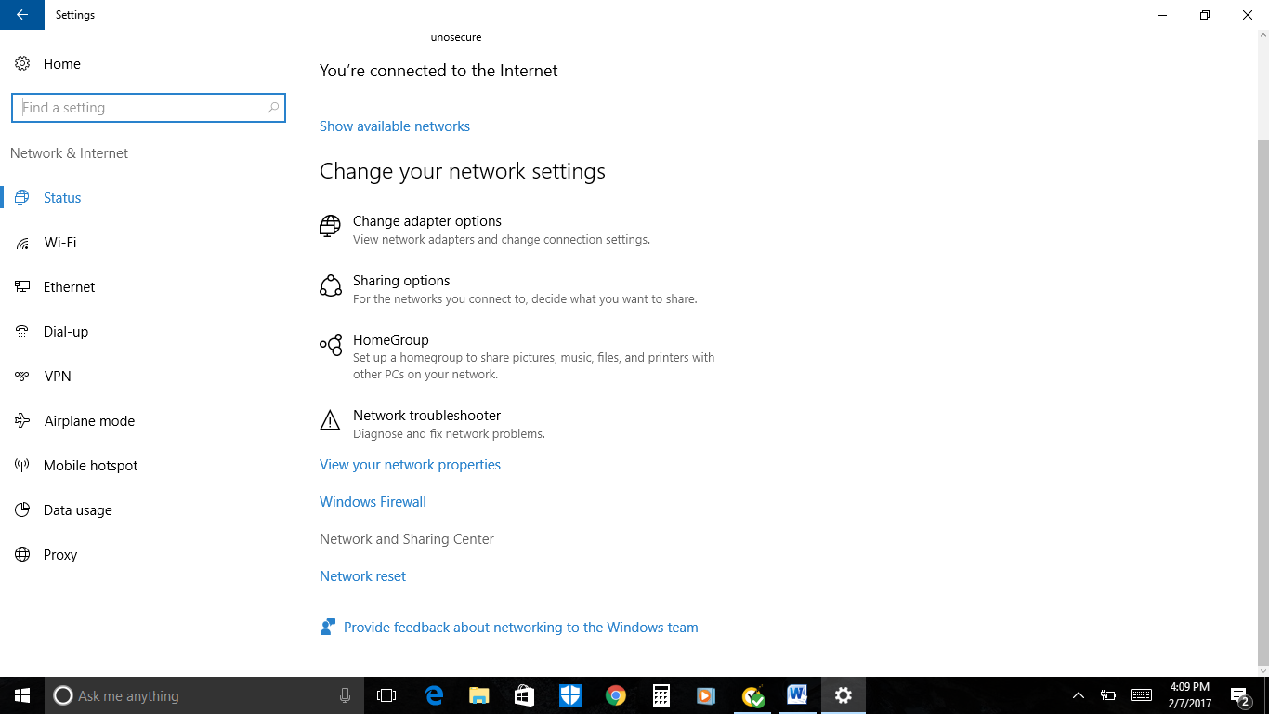

- Click on Set up a new connection or network.
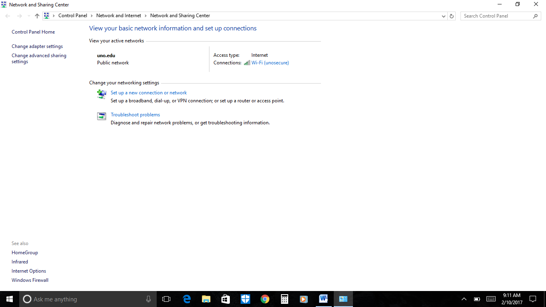
- Select the Manually Connect to a Wireless Network option and click the Next button.
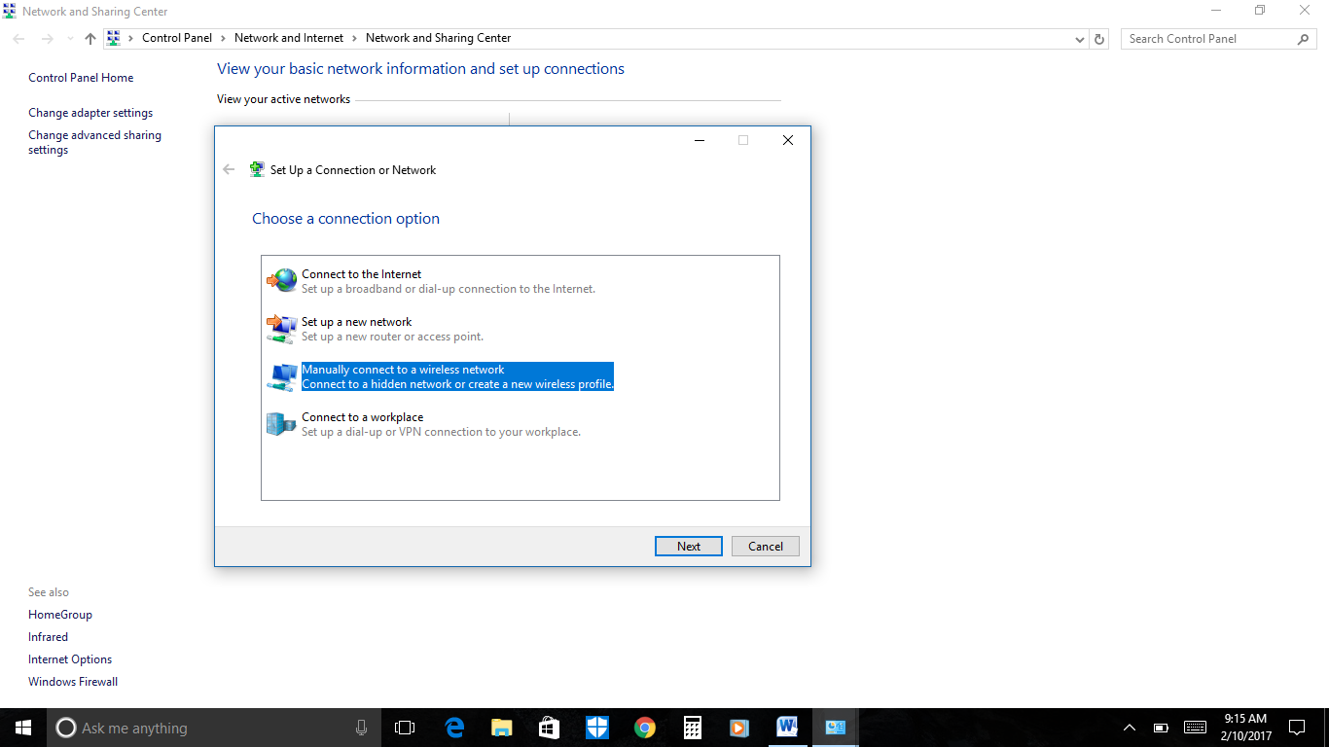
- Enter the following information, to add the ResNetSecure network to your PC. Click Next after entering the information listed below:
  - Network Name: resenetsecure
  - Network Type: WPA2- Enterprise
  - The Start the connection automatically box must be checked.
  - The Connect even if the network is not broadcasting box stays unchecked.

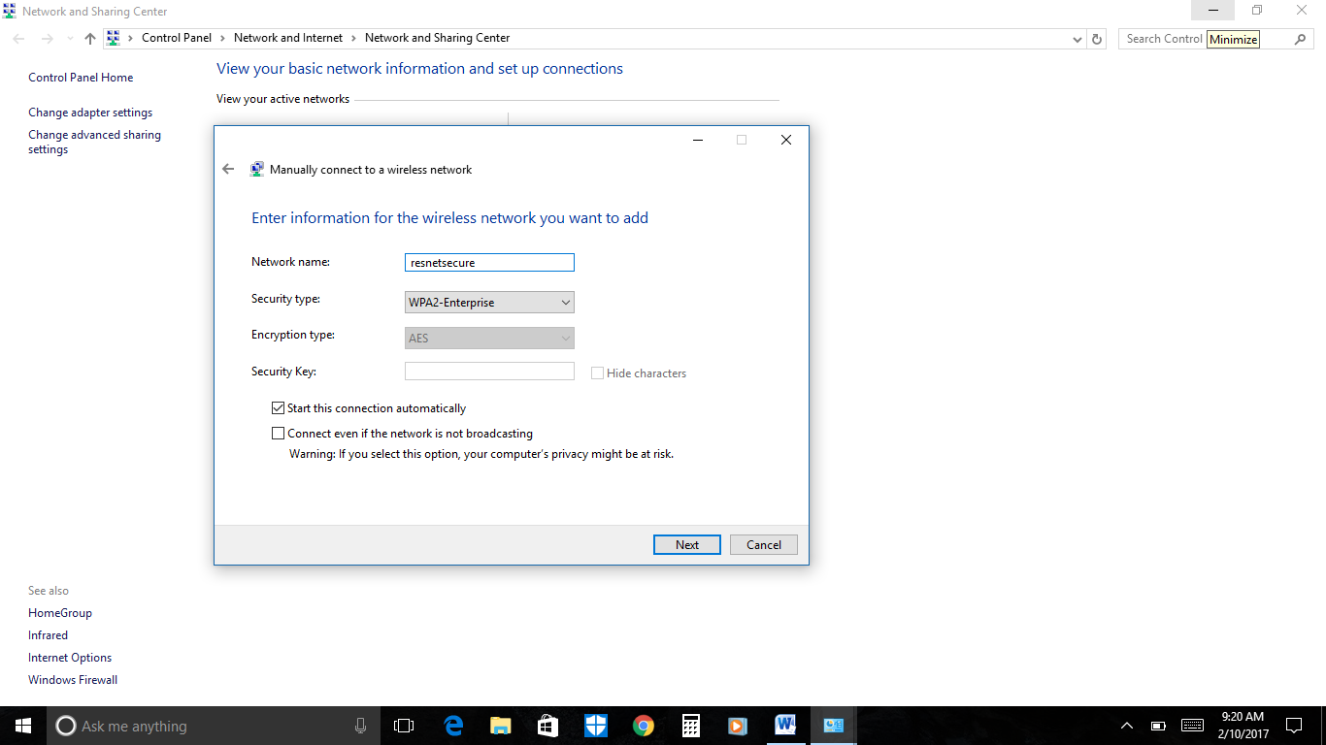

- The Resnetsecure network is added to your PC. Enjoy!

