Connecting to WiFi (UNOSECURE) with a Chromebook
- On your Home Screen, click the gear icon to open the Quick Settings Menu. Locate and select the Internet option
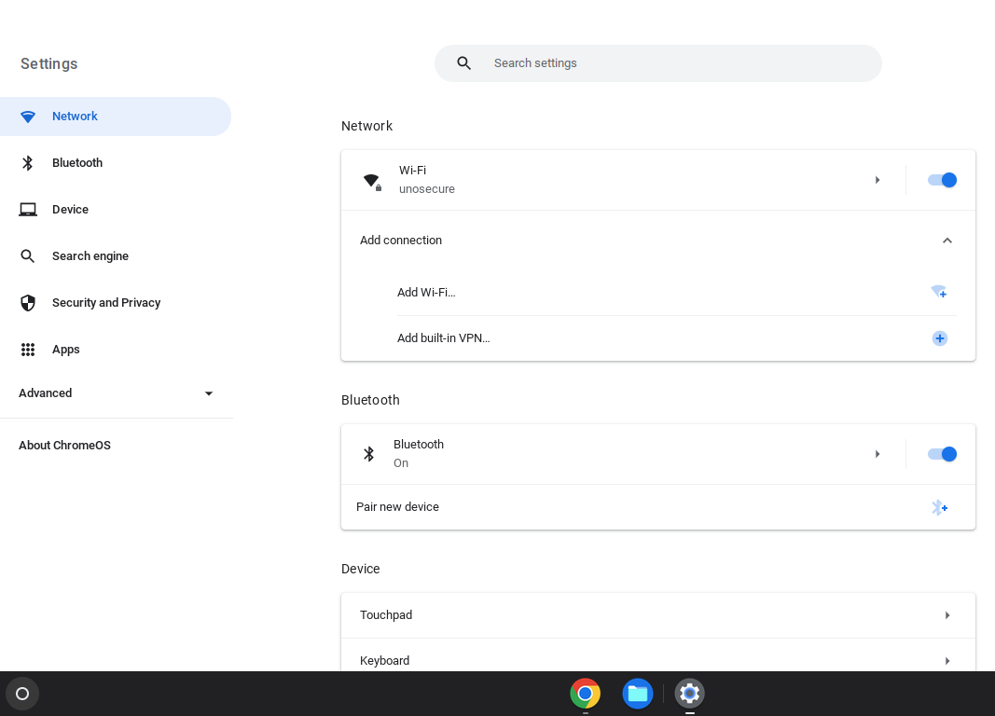

- Scroll down until you see the Security & Privacy Options. Turn “Use Secure DNS” off.
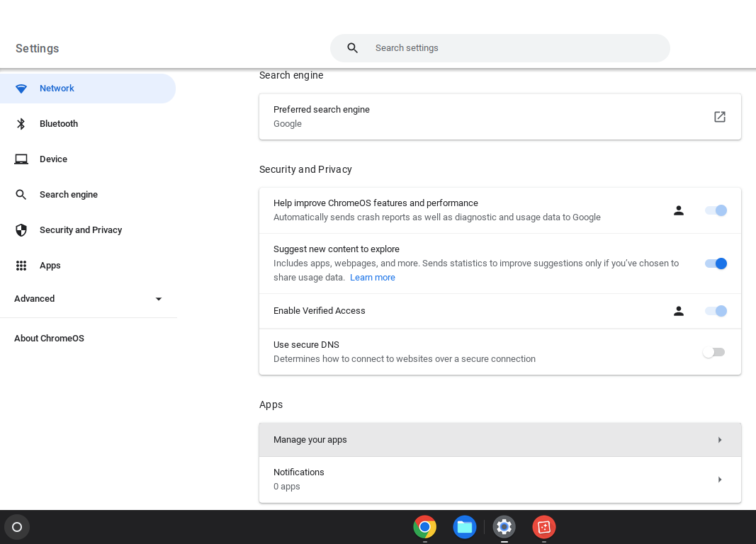

- Locate the UNOSECURE network in your available WiFi networks and select it

- If you are asked to select an EAP Method, choose PEAP. If you are asked for a Phase 2 Authentication type, choose MSCHAPV2. And if you are asked to choose a CA Certificate, choose either Trust On First Use or any other option with the word “Trust.” If you see options for Anonymous Identity, leave it blank.

- You should be prompted for your credentials (instead of Username or Email Address, you might be prompted for Identity—this just requires your UNO email address). Enter your UNO email address and password

- Connect. You should now be able to open websites and use other Internet-based functions

