Common Accessibility Issues in Word not Flagged by Accessibility Checker

Title
For accessibility, when title is flagged, the title is not the heading on the page. It is the title in the metadata of the document. To add a title to a Word document, go to File > Info. Position your mouse next to Title on the page and type in the title of the document.
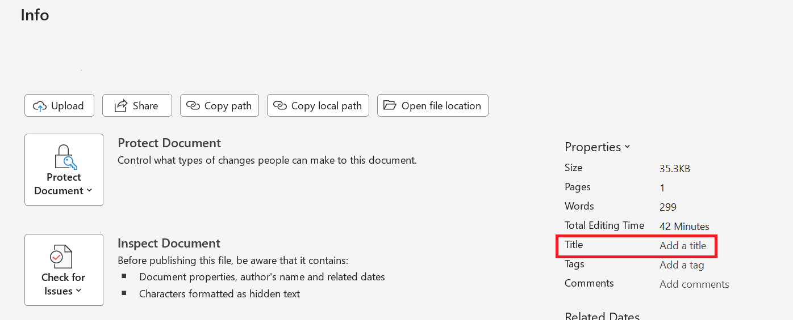

Headings (if document is shorter than 2-3 pages)
The Microsoft checker will not flag a document for missing headings if the document is very short. If you are using Yuja Panorama to scan documents, they must have headings. If no headings are present, the document must be corrected in the native application. Panorama will not facilitate adding headings. The title at the top of the page needs to be formatted as Heading 1, subheadings should be Heading 2. If there are any subsections within sections, those would be Heading 3. Including headings in this order is referred to as “properly nested headings” in Adobe Acrobat.
Add Headings in Word (Microsoft tutorial)

Descriptive links
Making links “descriptive” means that the link text describes where the link will take the reader. For example:
Use CTI Accessibility resources instead of https://www.uno.edu/cti/teaching-learning/accessibility or click here.
Add descriptive links in Word (Microsoft tutorial)

Accuracy of alternate text
Images need accurate alternate text that describes the image within the context of the information being provided. If the image is purely decorative and does not add additional meaning to the text, choose to “mark as decorative.” If the image is necessary for the reader to fully understand the message, the alternate text needs to describe the image well. Some images may require a caption or a link to an extended description.
How to write effective alt text (W3C resource page)

