
STK WESTERN RED CEDAR – 711R1 T&G
Where natural wood beauty and high fire resistance are required
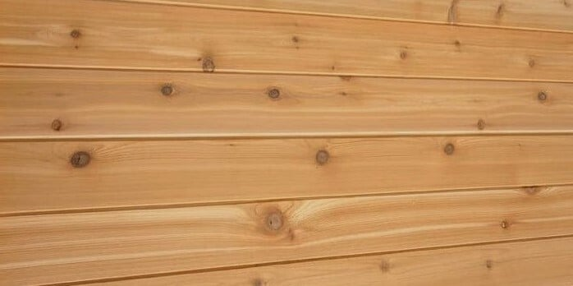

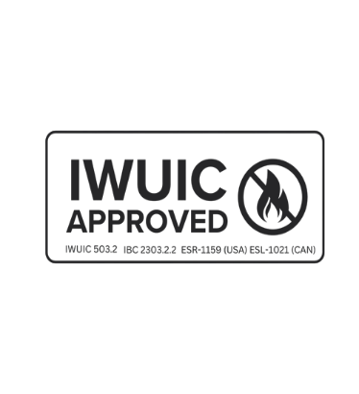

Size: 1x6 nominal, 11/16" thick x 5" width (coverage)
Profile: Tongue and Groove (T&G), 711R profile w/resawn face
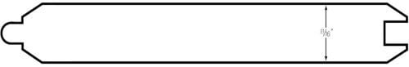
Treatment: Thermex-FR, FIRE RETARDANT TREATED WOOD
- WUI and IWUIC Compliant • Class A (E-84 Extended 20-Minute)
- Non-Toxic Materials • Paintable Stainable
- Limited Lifetime Warranty • Indoor / Outdoor use

Andrea Monti 619-464-9959
amonti@generalwoodcraftinc.com

