Our
Curriculum
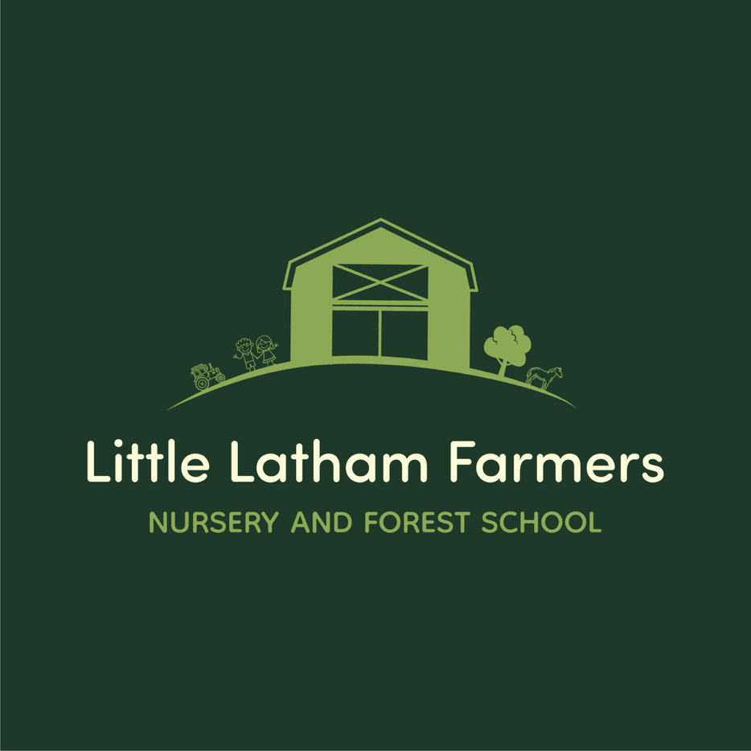

Our Curriculum
Our curriculum is designed around the needs of our young children and is organised into seven areas of Learning and Development.
These are:
- Communication and Language
- Personal, Social and Emotional Development
- Physical Development
- Literacy
- Mathematics
- Understanding the World
- Expressive Arts & Design

Here are the main components of each of the seven areas. Communication and Language experiences are about:
- Listening, attention and Understanding
- Speaking
Personal, Social and Emotional experiences are about:
- Self Regulation
- Managing Self
- Building Relationships
Physical Development experiences are about:
- Gross Motor Skills
- Fine Motor Skills
Literacy experiences are about:
- Comprehension
- Word Reading
- Writing
Mathematics experiences are about:
- Number
- Numerical Patterns
Understanding the World experiences are about:
- Past and Present
- People, Cultures and Communities
Expressive Arts & Design experiences are about:
- Creating with Materials
- Being Imaginative and Expressive

Our Planning System:
At Little Latham Farmers we us ‘In the Moment Planning’.
-What is in the Moment Planning?
In the moment planning is a strategy where a topic/theme is spontaneously planned by staff members based on the children’s interests and likes. In the moment planning takes children’s curiosity and turns it into an exciting and imaginative activity for the children to access. We have found as a nursery that ‘In the Moment Planning’ is one of the most beneficial and effective ways of introducing ‘child led’ learning as apposed to ‘adult led’. By following the children’s interests it increases their engagement with the activity. Increased engagement builds on children’s skills set and develops responses to different challenges. The needs and interest of a child change all the time and by following the ‘In the Moment Planning’ this allows them to be met at an appropriate standard.

Cultural Capital:
At Little Latham Farmers the children are provided with exciting and stimulating activities every day.
These include:
- finding books on a child’s favourite topic.
- creating role-play activities that further their interest in a particular idea.
- taking trips to the park and around the local community.
- or organising visits from community figures such as the police.
We use our knowledge from regular observations, the close work we do as key persons with both the child and their family and what we know of the children’s home lives to develop children’s experiences and learning whilst being with us at Little Latham Farmers.

Learning Through Play:
At Little Latham Farmers we believe in ‘Learning through Play’. Play is important for the early stages of brain development and playing with the children can help build relationships for later life. Play helps to develop important skills for learning, life and work (Cultural Capital). Play is how young children make sense of the world. We believe that play in early childhood can help to co-ordinate children’s mental and physical capabilities. Through play, children of all ages develop problem-solving skills, imagination and creativity, language and observation skills, and memory and
concentration. By teaching children to learn through play we are encouraging them to
become critical thinkers, resilient and curious investigators.

Forest School:
At Little Latham Farmers children are given access to the outdoor environment where it is made a fundamental part of their education. We take a Forest School approach to outdoor learning where the children are exposed to well planned, exciting and engrossing forest school activities that are led and delivered by our fully trained forest school teacher in the local woodland area and at our Forest School at our sister site. The children spend their days exploring the natural habitat, making dens, getting creative with natural objects, hunting for bugs under logs and leaves and drinking hot chocolate whilst listening to the calming sounds of our natural woodland area.
The outdoors creates a positive impact on the children’s learning and development and plays an important part in a child’s later adult life. Engaging in quality time outside not only allows the children to develop their physical development but it increases their well-being, health and happiness. All things that we think are an important part of our children’s Little Latham House journey.

Key Person System:
At Little Latham Farmers each child is assigned a Key Person from their first day with us. When moving rooms the child will be given a new Key Person where they will take over where the child left off from the other room. The key persons role is designed to support children's learning and development. The process of allocating a key person to each child can be based on a number of different factors, but whom the child gravitates towards the most is often a deciding factor. The key person will build positive relationships with both the child and their family. The key person will decide the best ways in which to support this learning and development based on the child's individual needs and current levels of development. As the key person builds a positive relationship with the child, they will learn more about their interests and how they learn best. They can use this information, alongside the child's individual needs, current levels of development, and possible next steps of learning, to plan how they will support the child's future learning and extend their development further.

Bassline Assessments:
At Little Latham Farmers a Bassline Assessment takes place before the child starts with us. This is where the Room Leader of the room the child is due to start and the parent of the child sit down together and discuss where the child is developmentally. They will discuss what the child can already do and where they need support. They will also discuss the next steps for the child when starting here at Little Latham Farmers.

Assessments:
At Little Latham Farmers we complete 6 monthly assessments which are tailored to the child. Their first assessment will be completed just after the child’s first parents evening and the next one will be completed after the second parents evening. Parents evenings are held April and November. In the assessment the Key Person will give a summary of the child at nursery, their likes and interests and how they are generally within the room which is everything that will have been discussed at parents evening. The assessment will also include more detailed information about how they are developing within each areas of the Early Years Foundation Stage.
Here are the areas of the EYFS you should expect to see filled out relating to the age of the child:

0 – 2 years: Prime Areas – PSED, PD & C&L
2 years+: All seven areas of the EYFS

Observations:
Every month parents will receive an Observation from their child’s Key Person. Observation is the practice of looking at and listening to children to find out how they are developing, what they like doing and what they are learning through their play and the experiences provided at Little Latham Farmers.

The 3 I’s
Little Ducklings (Babies):

Intent:
To create a safe space for the babies to form bonds in a new social situation and separate from main care giver.

Implementation:
By using a nurturing approach in a calm environment to allow the children to feel safe and secure.

Impact:
Allows the children to feel confident away from their main care giver and in preparation for their transition to Little Tractors room.

Little Tractors (Toddlers):
Intent:
Promoting independence and life skills that will accompany them in their transition through to the Little Lambs room.

Implementation:
We implement this by encouraging the children to sit down at the table during meal times/snack times. We also introduce potty training to the children and show them the importance of health and self care by teaching them to wash their face and hands. Children take part in decision making by having rolling snack that they can access throughout the day.

Impact:
The children are ready for their transition to the Little Lambs and have the independence skills to aid them in this.

Little Lambs (Pre Preschool)
Intent:
Promoting independence and life skills that will accompany them in their transition through to the Little Farmers room.

Implementation:
We implement this by encouraging children the children it sit at the table at mealtimes using a knife and fork to eat with and self serve. We also work towards all children been independently potty trained before they move across in to Little Farmers. Lastly we show them the importance of health and self care by encouraging do activities around oral health Children take part in decision making by having rolling snack and are encouraged to cut they food up themselves.

Impact:
The children are ready for their transition to the Little Farmers room and have the independence skills to aid them in this.

Little Farmers Room (Preschool):

Intent:
Encouraging the children to be confident individuals by thinking critically and making decisions to solve problems in preparation for their transition to school.

Implementation:
We implement this by encouraging the children to use their social skills to play with groups of children, solve conflict with peers independently, use their own ideas to work things out and use their confidence to complete challenges. We also provide school readiness sessions and have a school council team who are involved in organising events for parents and putting forward ideas.

Intent:
Gives the children the confidence to go onto the next part of their educational journey and be confident and resilient individuals.

