Beyond the Numbers: Using Data Visualization to Improve Decision-Making

Visualizing your data can help you move beyond the numbers.
Looking at numeric data alone often lacks one critical piece of information: context. Are 5.3 shipments a week a good thing? What does it mean that 8,732 items were closed? Without context, even accurate data can be difficult to interpret.
Graphs, charts, and dashboards provide context by giving information scale and meaning. A well-designed visualization connects the “What” to the “So What,” helping users understand not only what the data says, but why it matters.

Tableau EVM Dashboard Example
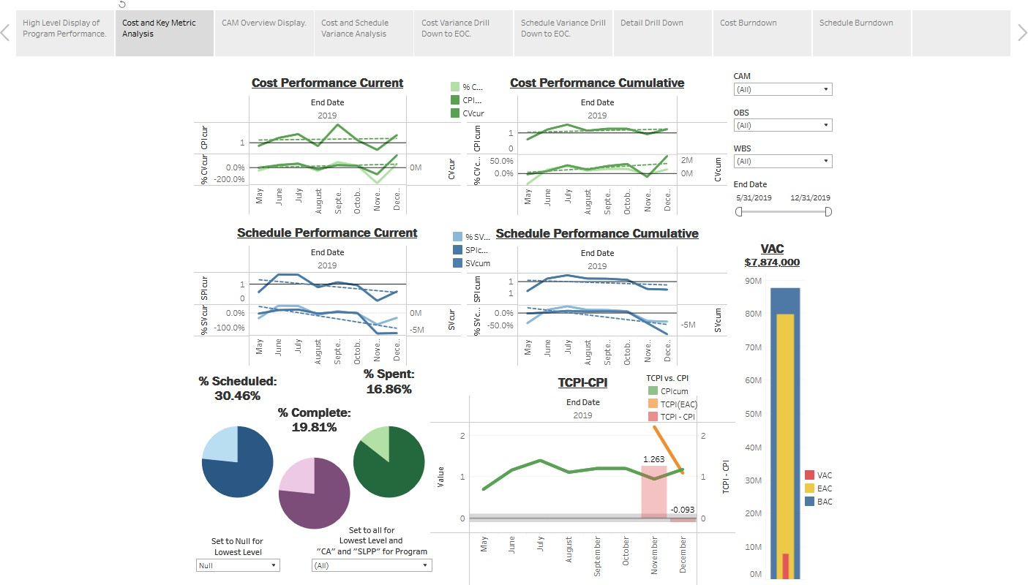

Caption: Program-level dashboards bring related performance measures together so trends, exceptions, and areas requiring attention can be identified more quickly.

Turning Data into Decisions
Even the most detail-oriented among us can have our understanding quickly enhanced by visualization. Good visualization enables leadership to make informed decisions, validates instinct with reason, and makes potential risks easier to identify. The data itself may show a trend, but a graph can amplify it, helping everyone quickly get on the same page.
Visualizations also make information more memorable. A chart showing that actual charges for “Project B” have been outpacing its budget for several months can make a far more immediate impression than the numbers alone. Conversely, visualizations can highlight strengths and provide clear evidence when performance is trending in the right direction.

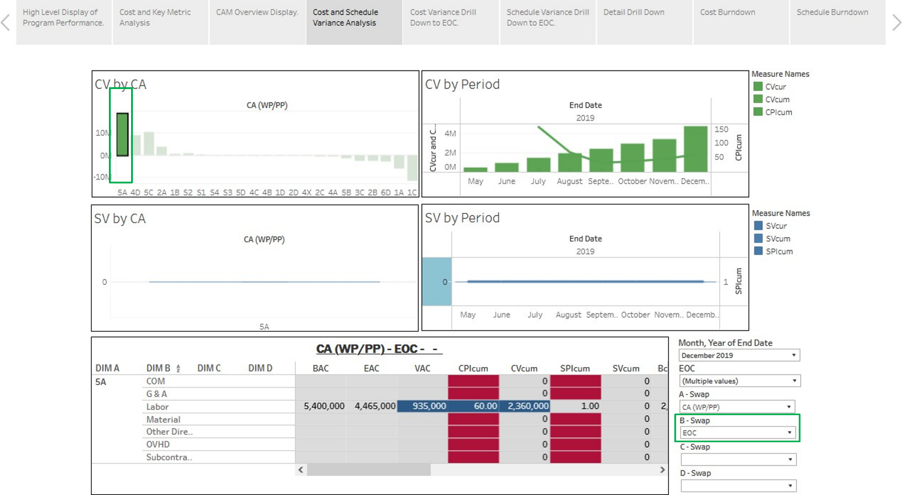
Cost & Schedule Variance Dashboard

Caption: Cost and schedule variance visualizations make the magnitude and direction of performance trends easier to recognize than reviewing the underlying numbers alone.

Delivering the Right Information to the Right People
Organizations often need to keep project cost tracking, scheduling, and other critical systems restricted while still providing employees with the information they need to perform their roles.
By connecting visualization tools to the underlying data sources, organizations can provide relevant information without giving every user direct access to source systems. Dashboards can also limit information to the most relevant data, helping avoid confusion from data saturation.
Role-based dashboards take this further. CAMs, PMs, executives, and customers may need different views of the same program information. Filters, timescale adjustments, and drill-down capabilities allow each audience to focus on the metrics most relevant to its responsibilities.

Data Modeling Graphic
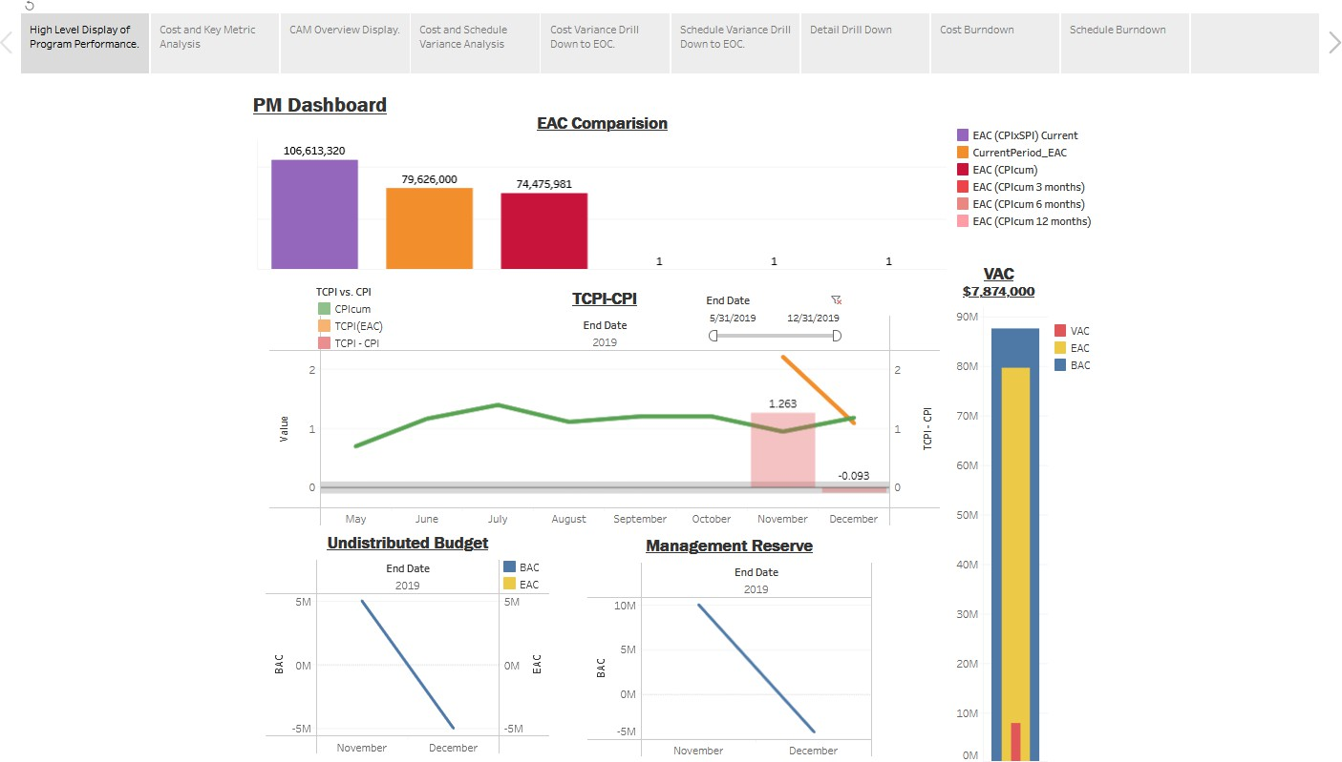

Caption: Role-based dashboards provide decision-makers with focused access to the performance information most relevant to their responsibilities.

Before You Visualize
Effective visualization starts with reliable data. Before developing a dashboard, organizations should understand their data, transform or normalize it where necessary, map relationships between sources, and then visualize it.

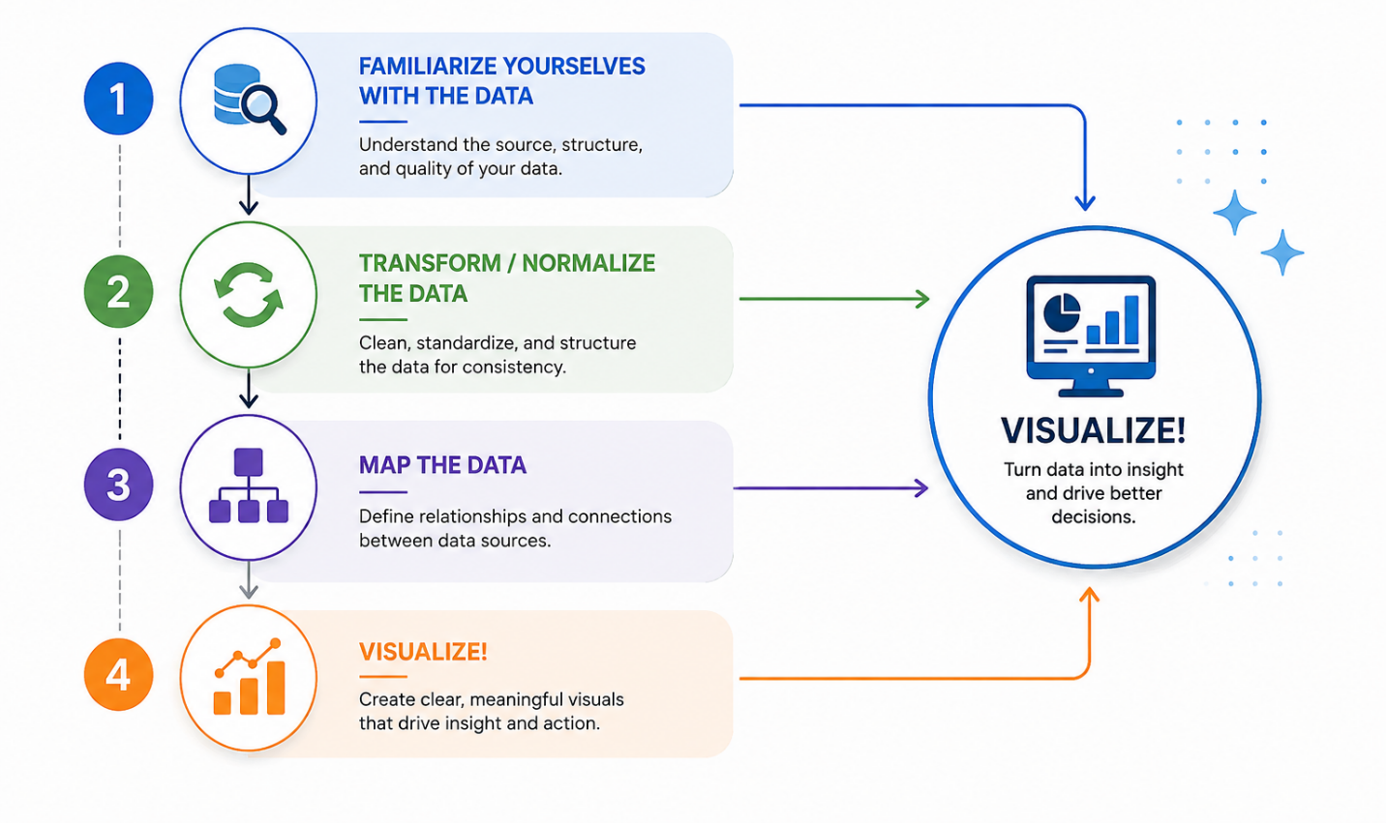
Preparing Data for Meaningful Insight

Caption: Effective data visualization starts before the chart—by understanding the data, preparing and normalizing it, and mapping relationships between sources.

Organizations considering data visualization should ask three important questions:
- What is the quality of our data? Is information being entered correctly and consistently?
- Where is our critical data stored? Is it on company servers, in the cloud, or across multiple systems?
- Do we need to combine data from disparate sources? Visualization tools can connect information from multiple systems using shared or linking data elements.
Data visualization is ultimately about more than creating attractive charts. It is about transforming information into meaningful insight that helps people recognize trends, identify risks, understand performance, and make better-informed decisions.
Intra Management Solutions helps organizations understand, connect, and visualize their program data. Drawing on our experience supporting clients with program management and EVM data, we help turn complex information into focused, actionable insight—empowering organizations to make more informed decisions.

