CDTnet Doctoral Candidate Application Form
Cardio-vascular Digital Twin Network (CDTnet)
Marie Sklodowska-Curie Actions Doctoral Network
Applications close: 30 September 2026, 23:59 CET
Recruitment date target: 28th February 2027 the latest

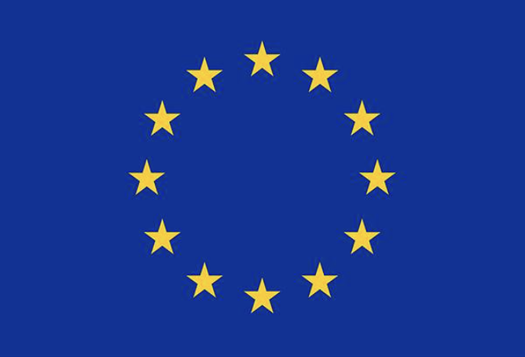

Thank you for your interest in CDTnet. This application form allows you to apply for up to five doctoral projects through a single recruitment process. Please complete all required sections and submit the form together with the supporting documents listed in Section 11.

1. Personal Details
Full Name:
Email:
Telephone:
Nationality:
Country of Residence:
LinkedIn (optional):
Personal Website/Portfolio (optional):

2. Eligibility
Academic Eligibility
☐ I do not hold a doctoral degree and will not have been awarded one before recruitment.
☐ I will be eligible to enroll in a doctoral program at the recruiting institution by the proposed recruitment date.
Degree qualifying me for doctoral study: ____________________
Expected/Actual graduation date: ____________________
MSCA Mobility Rule
Applicants must not have resided or carried out their main activity (work, studies, etc.) in the country of the recruiting institution for more than 12 months during the 36 months immediately before the recruitment deadline. Please add rows if necessary
Country | Main Activity | From (MM/YYYY) | To (MM/YYYY) | Total Months

English Language Proficiency
Please indicate your level of English and provide details of any formal qualifications, where applicable.
Qualification | Score/Grade | Date Awarded

3. Academic Qualifications
Complete degree information below. Please add rows if necessary
Degree | Awarding Institution | Year | Grade (indicate if expected) | Grade Scale

4. Research Experience
Describe research projects, internships, thesis work and relevant employment (max 500 words).

5. Technical Skills
Skill | Basic | Intermediate | Advanced
Python | ☐ | ☐ | ☐
MATLAB | ☐ | ☐ | ☐
R | ☐ | ☐ | ☐
Statistics | ☐ | ☐ | ☐
Machine Learning | ☐ | ☐ | ☐
Mathematical Modelling | ☐ | ☐ | ☐
Data Science | ☐ | ☐ | ☐
Medical Imaging | ☐ | ☐ | ☐
Signal Processing | ☐ | ☐ | ☐
Software Development | ☐ | ☐ | ☐

Please provide examples demonstrating your strongest technical skills (max. 300 words).

6. Research Outputs
List publications, posters, software, datasets and other outputs. Add rows if necessary.
Type | Title | DOI/URL

7. Project Preferences
Select up to five projects (F1-F15) in order of preference.
Preference | Project Code | Project title
1
2
3
4
5

8. Project Motivation
Explain the reason for the selection in section 7 (max 500 words). Please indicate how your education, skills and experience match the requirements of each project.

9. Motivation for CDTnet
Personal statement (max 500 words).

10. References
Provide details of two academic/professional referees.
 | Referee 1 | Referee 2
Name
Institution
Position
Email
Relationship to Applicant

11. Supporting Documents Checklist
CV ☐
Transcripts, translated in English ☐
Degree Certificate, translated in English ☐
English Evidence ☐
Publication List (optional, can also be included in CV) ☐

Remember that if you are applying to any position at King’s College London, you also need to submit a second application through their portal.

12. Declaration
I confirm the information supplied is accurate and complete.
Name____________________________________________________________
Signature ____________________________________________________________

