Local
Professional
Development Committee

Employee Handbook

Revised August 2012

Philosophy
The Warren County ESC Local Professional Development Committee (LPDC) believes that high-quality professional development is instrumental in building professional expertise and providing the highest level of services to students and families.

Purpose
The role of the LPDC is to provide an appropriate process for educators to create an Individual Professional Development Plan (IPDP) that will facilitate lifelong professional growth opportunities and effectively meet state certification and licensure requirements. It is the responsibility of each educator to create an IPDP by October 1st of each year, to follow guidelines for activity selection, and to provide documentation to verify that the activity was completed. Each certified staff member requiring an IPDP will be assigned an LPDC Mentor. If an employee has a question, has a concern, or needs additional guidance, the LPDC Mentor should be the first person s/he contacts.

Criteria for Coursework or Professional Development Activities
The LPDC uses SWOCA’s online KIOSK system to manage the creation of IPDPs, the approval of activities and documentation, and tracking of Continuing Education Units (CEUs) earned toward licensure renewal. The criteria for approval of activities are as follows:
- Per State guidance in the Resource Guide for Establishing & Maintaining Local Professional Development Committees, “The IPDP must be submitted and approved prior to beginning the coursework or activities for which the educator seeks approval.”
  - If a staff member has not submitted an IPDP by October 1st, any activities completed after that date without an approved plan in effect will NOT be approved for CEU credit. This could result in an employee not receiving CEU credits even if the activity is otherwise appropriate for his or her field and even if documentation of activity completion is available. Once an approved plan is in place, it would be possible for the staff member to resume earning CEUs. However, activities completed between October 1st and the IPDP approval date would remain out of compliance with the State guidance above.
  - Because many high-quality professional development activities occur at or near the beginning of the school year, the LPDC will allow the approval of activities without a plan prior to October 1st as long as the activities have been approved by the employee’s department supervisor and/or documentation can be provided to verify that the activities were relevant to the employee’s professional growth. However, activities completed prior to plan approval must still be logged in KIOSK once an approved plan exists.
  - The LPDC understands that extenuating circumstances may arise, so activities disallowed due to this rule can be appealed by following the appeals process later in this handbook (see pg. 7).
  - School social workers, school speech-language pathologists, school nurses, school audiologists, occupational therapists, physical therapists, occupation therapy assistants and physical therapy assistants are required to maintain licensure through their respective Ohio professional licensure board. To renew five-year professional ODE pupil services licenses in these areas, educators must maintain their other board license. By doing so, they meet all ODE renewal requirements and therefore do NOT need to work through the LPDC. However, these staff may still need to complete IPDPs if they have other licensures to keep current.
- CEUs used for the renewal of a license must have been earned during the life cycle of the license being renewed. For example, and activity completed on June 30, 2012 cannot be applied toward a license with a life cycle of July 1, 2012-June 30, 2017.
- For first-time users, KIOSK can be accessed as follows:
  - Go to www.swoca.net
  - Hover the mouse pointer over “Additional Resources” and select “KIOSK” when it displays
  - Below the two white boxes, click on the “register” link highlighted in red.
  - Follow the KIOSK registration prompts. The email address with which you need to register is your ESC email address.
- A detailed KIOSK user guide is available on the ESC’s website. This will assist each employee as s/he creates an IPDP, revises the IPDP (as necessary), and submits activities for LPDC approval. The user guide can be found as follows:
- Go to http://www.warren.k12.oh.us/
- Under “Personnel Services,” select “LPDC Info for ESC Staff.”
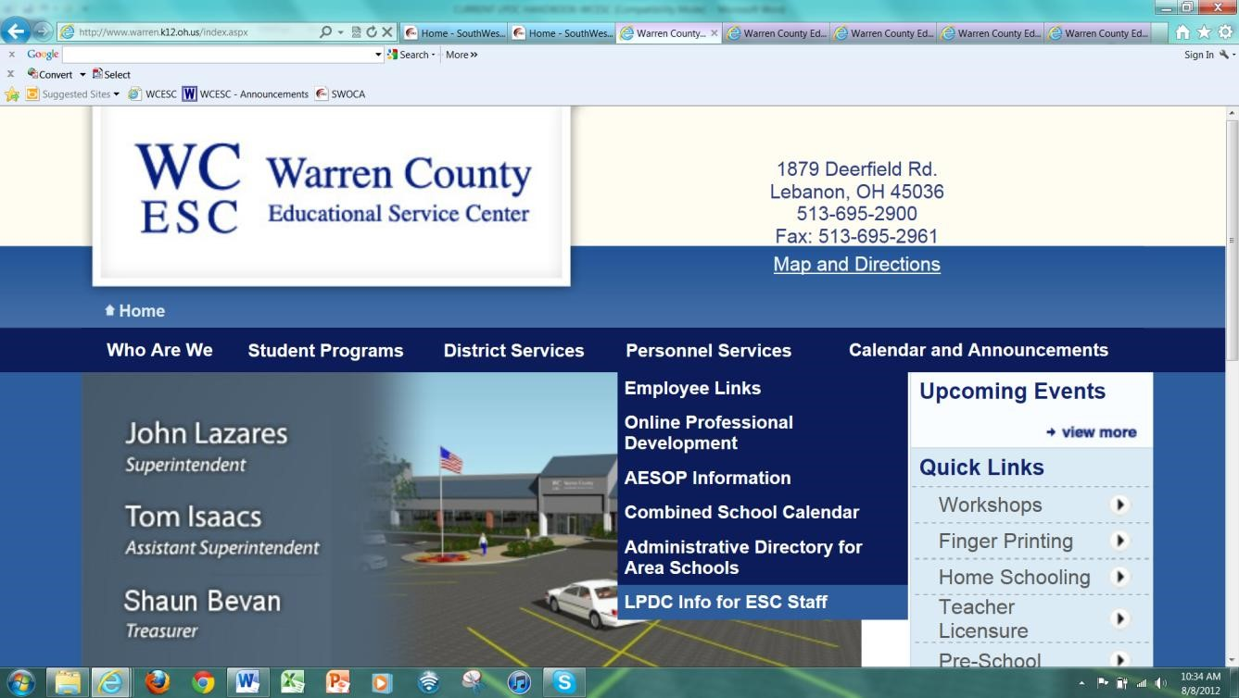
- On the right side of the screen, select “KIOSK User Guide.”
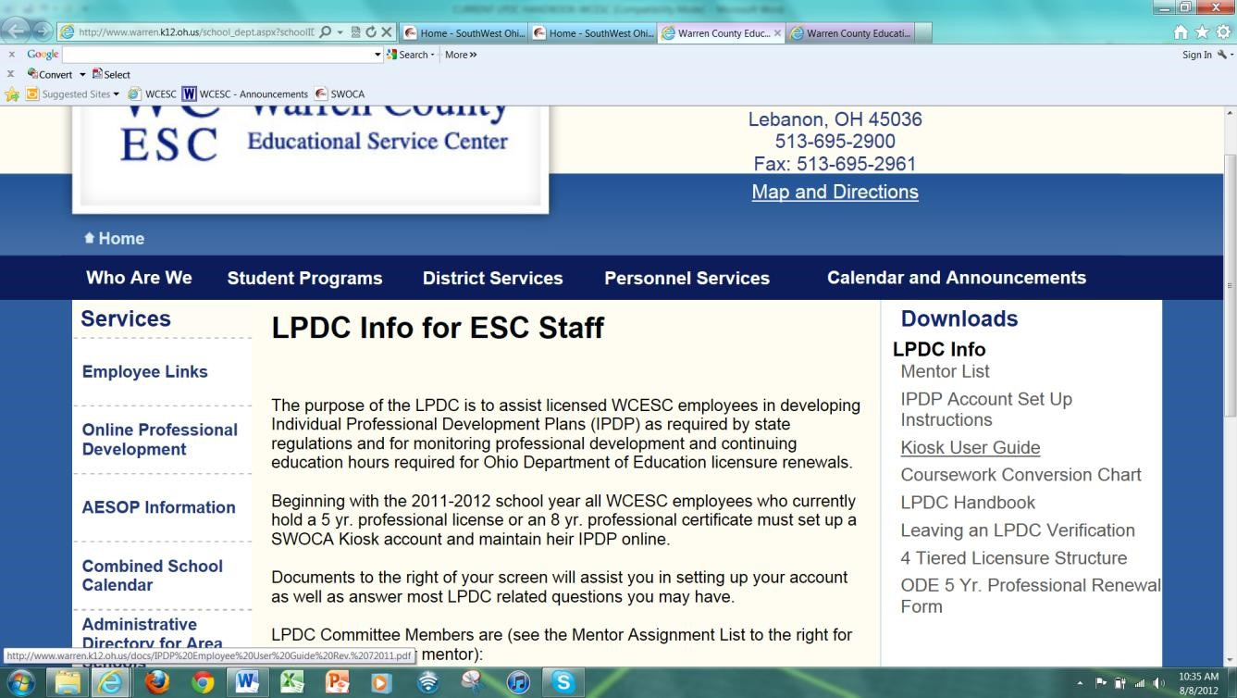
- One difference between this User Guide and the version completed by ESC employees involves denoting the TYPES of activities completed to meet IPDP goals. As a guide, the LPDC’s guidance is to mark any and all types of activities you may complete. While there is no punishment for later electing not to complete an activity type, activities not checked at this time cannot be approved without amending your plan before completing the activity.
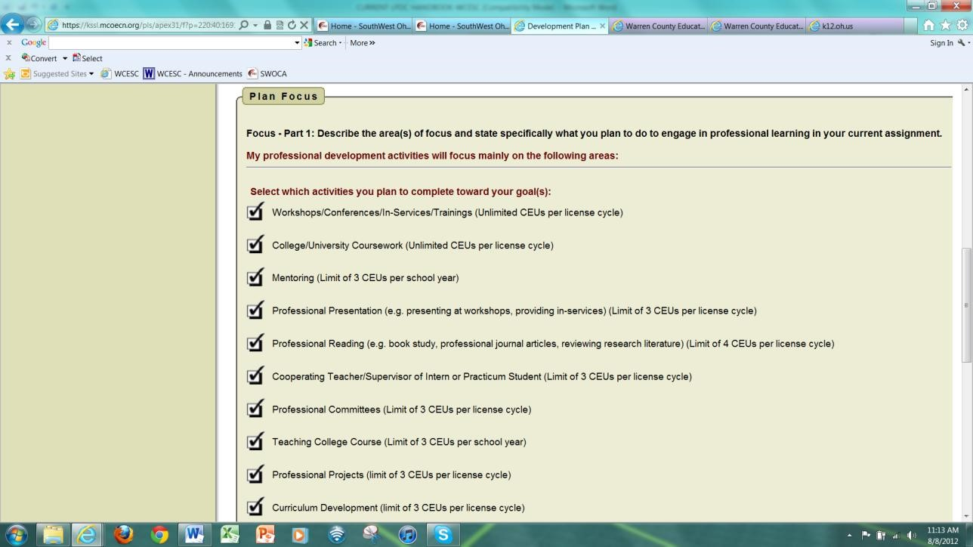
- When preparing to submit your plan, please be sure to select your LPDC Mentor as your “Approving Supervisor.”

- The following criteria describe broad characteristics of high-quality professional development activities (HQPDs):
  - HQPDs are above and beyond one’s typical job responsibilities. For example, attending department meetings is likely NOT HQPDs unless specific professional development activities are planned during that time.
  - HQPDs present opportunities for professionals to further their knowledge and to become increasingly advanced practitioners in their areas of licensure.
- In order for activities to be finally approved by the LPDC, the steps 15-18 in the KIOSK User Guide must be followed to create an activity corresponding to the HQPD completed. This must include attached documentation that the activity has been completed. In many cases, this will be a Certificate of Attendance including your name, the name of the training, the date(s) of completion, and the contact hours. Depending upon the activity type, however, it could alternatively be a course transcript, a reflection paper, or another form of verification as listed in the “Continuing Education Unit Options” chart within this handbook.
  - If no documentation is attached to your activity request, credit will not be granted.
  - It is the responsibility of the activity-submitting staff member to provide this documentation. LPDC members are not responsible for contacting other staff members or entities to recover certificates of attendance or other verification documents on behalf of employees.
  - The method by which staff attach documentation is as follows:
    - Use a scanner to convert your paper-based documentation to an electronic copy.
    - Save the electronic copy to your computer’s desktop or to another place where it can be easily found. It may be helpful to name the documentation to match the activity, but please keep the names relatively brief. If KIOSK will not allow you to upload your file, try reducing the length of the filename.
    - After clicking “Add New Attachment to this Activity,” select the “Browse” button. iv. Navigate to your desktop or to wherever the documentation was electronically saved, click on the certificate’s filename, and select “Open” or “Save.”
v. Upload the documentation to your activity request.
- LPDC does not require pre-approval for specific activities aligning to one’s approved IPDP. However, it is the responsibility of the employee and his/her department supervisor to ensure that attended activities align to the submitted and approved IPDP goals AND that the activity type has been approved for completion (from the screenshot above). For example, a book study cannot be submitted unless “Professional Reading” was marked when completing the IPDP. Using broad IPDP goals can assist in ensuring that more topics will be encompassed by one’s plan.

Composition of the Membership, Selection of Members, and Terms of Office
The goal of the LPDC is for its membership to reflect a sampling of the departments whose staff members are subject to IPDP creation and license renewal requirements. Pending the availability and interest of employees, however, this balance may or may not be achieved. As a guide, the LPDC will strive to include a minimum membership equating to 10% of total staff with IPDPs. This will ensure that Mentor: Mentee ratios approximate 1:10. If there are not enough Mentors to achieve this ratio, LPDC members will first consider any staff member who has expressed interest in becoming an LPDC member from unrepresented departments. The next consideration will be given to staff members who have expressed interest from already-represented departments. Finally, LPDC members will openly recruit new members at their discretion.

If you are interested in serving as an LPDC representative, please contact your LPDC Mentor. The following are requirements of LPDC membership:
- LPDC members must complete their IPDPs by October 1st each year (unless on Family Medical Leave or otherwise separated from their workstations for an extended period).
- LPDC members must have attached electronic documentation for all submitted activities during the previous year (if employed by the Warren County ESC during that time).
- LPDC members must be fluent in the use of KIOSK and must possess basic computer skills. These skills include sending and receiving email, scanning and saving documents, and navigating websites. Alternatively, prospective LPDC members must be willing to master these skills prior to October 1st.

LPDC Members serve terms of two years, after which ongoing LPDC membership can be voluntarily continued by the employee for additional one-year terms. Because members are electronically linked as Mentors to multiple staff members in KIOSK, any resignations from the LPDC cannot take effect until all submitted IPDPs and activities have been approved or resolved and until a new Mentor has been assigned to the affected Mentees.

The LPDC Chairperson will be selected at the end of the previous Chairperson’s term to serve during the following two academic years. The LPDC Chairperson must have served on LPDC for at least two years prior to being elected. The Chairperson shall be elected by a majority written vote of the LPDC. Anyone interested in serving as Chairperson may self-nominate. Co-chairs may also be selected per the LPDC’s judgment.

The duties of the LPDC Chairperson shall include:
- Presiding at all LPDC meetings;
- Establishing a meeting calendar, calling all meetings to order, and setting all agendas;
- Ensuring that the processes and procedures detailed in this document are followed;
- Serving as a liaison to other school districts’ LPDCs as appropriate;
- Serving as the appeals process facilitator; and
- Suggesting training needs of LPDC members (as appropriate).

Operating Procedures
The following procedures reflect the practices of the LPDC:
- As soon as a staff member’s contract begins for the school year, his/her IPDP can be completed through KIOSK. This should be submitted and approved prior to the completion of professional development activities, but it MUST be completed by October 1st. If it is not, professional development activities completed between October 1st and the IPDP approval date will not be accepted toward meeting licensure requirements.
- Because LPDC Mentors are able to review and approve submitted IPDPs and activities electronically, the LPDC does not formally meet on a regular basis. The LPDC does meet at or near the end of each school year to conduct final approvals of activity requests and to sign off on completed license renewal paperwork. Interested staff members can ask their LPDC Mentors at any time to determine dates and times of any upcoming LPDC meetings.
- The following responsibilities fall on LPDC members:
  - At least once per instructional week, check email to review any submitted IPDPs or activity CEU requests.
    - As appropriate, submit initial or final approval of acceptable IPDPs and aligning activities with documentation.
    - As appropriate, reject unacceptable or narrowly-focused IPDPs and non-aligning or undocumented activity CEU requests.
  - Respond to mentee inquiries in a timely fashion and/or ask another LPDC member as needed.
  - Remain professional in interactions and correspondences with Mentees and with fellow LPDC members.
  - Contact LPDC Mentees near the beginning of each school year to share applicable expectations for IPDP development. This should include a reference to the need to earn 18.0 CEUs during each 5-year license cycle, equating to 36 contact hours of professional development annually in the absence of college coursework.
- When reviewing an IPDP for approval, LPDC Mentors consider the following questions:
  - Does this IPDP include a Focus that reflects an individual’s desire to grow as a professional?
  - Do(es) the goal(s) in this IPDP support professional growth while remaining broad enough to capture multifaceted development opportunities?
  - Did the staff member include sufficient types of activities to meet his/her goals in accordance with approvable CEUs per license cycle?
- When reviewing a submitted activity CEU request, LPDC Mentors consider the following questions:
  - Does this activity fit within the scope of the staff member’s approved IPDP goals and focus?
  - Did this activity occur during the IPDP’s effective dates (which could include the time prior to October 1st if no IPDP was in place)?
- Both approval processes include two steps. The first approval is made by the LPDC Mentor (“Approving Supervisor” in KIOSK). The final approval is made by another member of the LPDC.
  - In the event that an IPDP is rejected, the LPDC Mentor will provide feedback regarding the corrections needed to warrant plan approval.
  - In the event that an activity CEU request is rejected, the staff member may appeal the decision as outlined within the appeals section of this handbook.
- Staff members submitting IPDPs and activities will receive an e-mail from KIOSK when a status change (approval or rejection/return for editing) occurs.
- All newly-submitted documentation will be retained electronically within the KIOSK system. STAFF
MEMBERS SHOULD ADDITIONALLY RETAIN ORIGINAL COPIES OF THEIR CERTIFICATES OF ATTENDANCE, as ultimate responsibility for proof of completed coursework falls on each employee requiring an IPDP.
- Appeals of LPDC decisions will be handled in accordance with the appeals section in this handbook.
- Staff member completion of professional development activities will be verified via attachment of a certificate of attendance or other relevant form of verification to each activity CEU request.
- All LPDC members will electronically register and provide signature verification to ODE on an annual basis. In order to renew a license, each educator must have the registered signature of an LPDC member on his/her renewal application.

Reflection and Revision
The LPDC welcomes feedback from certified staff members regarding the effectiveness and guidance provided by LPDC. Please consult your LPDC Mentor if you have questions or comments.

Forms
At present, the Warren County ESC uses forms through SWOCA’s KIOSK system. The only applicable forms not included in KIOSK relate to appeals (included in this handbook) and to educators leaving the LPDC (available on ODE’s website in the forms section). Additional information about professional development can be found on the Ohio Department of Education’s website under Professional Development.

Reciprocity When an educator’s employment by the Warren County ESC is discontinued, the LPDC will (upon request of the departing educator) provide verification of the approval of the educator’s IPDP and any coursework and professional development completed by the educator and accepted by the LPDC. This will be documented on the Verification Form for Educators Leaving the LPDC from ODE’s website. In this instance, the leaving educator should approach the new LPDC as soon as possible with the ongoing IPDP to complete the reciprocity transfer.

When an educator is hired by the Warren County ESC, the LPDC will honor coursework and other professional development activities the newly-hired educator had completed pursuant to the IPDP approved by his/her former LPDC (prior to employment with the ESC). As soon as possible after employment and before engaging in any additional coursework or professional development activities, the newly-hired educator must submit an
IPDP in accordance with the procedures of this handbook. As a final note on reciprocity, the LPDC’s acceptance of previously-approved coursework assumes that the previous LPDC approved the IPDP and activities for application toward the license for which future renewal is sought. If an employee is hired at the Warren County ESC under a new area of licensure or if the employee has multiple areas of licensure, the LPDC will need to verify that the activities were approved for application toward each license and that the activities occurred during the applicable license cycles.

License Renewal During the academic year after which an educator’s license is set to expire, the educator must obtain an application from the designated certification/licensure coordinator (Pam Tone). These forms are also available on the Educator Licensure section of ODE’s website. The completed application and fee must be returned to the certification/licensure coordinator by June 1st of the renewing year. Once the IPDP documentation has been approved by the LPDC, the approval will be sent to the certification/licensure coordinator. The information is then forwarded to the Ohio Department of Education.

Appeals Process
Given the roles and responsibilities of the LPDC, there are two potential actions that could prompt an educator’s desire to appeal:
- Rejection of a staff member’s submitted IPDP; and
- Rejection of a staff member’s submitted coursework or professional development activity.

In the event that an IPDP has been returned for revision, LPDC Mentors are expected to offer the reasons for the rejection as well as the steps through which approval could be given. If no such information is included in the rejection notice, the staff member should first contact the LPDC Mentor to ensure that the IPDP was not rejected in error. If steps are included and these steps are found to be unacceptable to the staff member, the appeals form in this handbook should be completed.
In the event that submitted coursework or a professional development activity has been rejected (i.e., CEU credit not granted), the appeals form in this handbook should be completed. Recall that, per State guidance in the Resource Guide for Establishing & Maintaining Local Professional Development Committees, “The IPDP must be submitted and approved prior to beginning the coursework or activities for which the educator seeks approval.” The Warren County ESC LPDC is willing to work with those employees meeting the conditions set forth on the appeals form on a case-by-case basis, but it should be understood that entering the appeals process does not guarantee a favorable outcome.

When submitting the appeals form, the staff member initiating the appeal should send it to at least two LPDC members. One of these should be the LPDC Chairperson. The completed and signed form may be attached to an email or can be sent or delivered to the ESC. In that case, it should be given to the Secretary of Certification to the attention of LPDC. The staff member initiating the appeal should additionally email the LPDC Chairperson to ensure timely receipt of the appeal.
Once submitted, an appeal will be handled in accordance with these guidelines:
- LPDC policy and procedures cannot supersede the Governing Board policy.
- The staff member initiating the appeal will be invited to meet with available members of the LPDC at a mutually-agreeable time. No fewer than 5 LPDC members must be present in the meeting. The meeting will be scheduled to occur within 15 business days of when the appeal is received, with the following notable exception:
a. If the appeal is made after June 1st and no mutually-agreeable contract day would allow at least 5 LPDC members to attend, the appeal will be heard when staff members are again available in August.
Appeal meetings will be held at the Warren County ESC unless otherwise requested and agreed upon.
- During the time of reconsideration, the staff member can discuss with the LPDC his or her reasons for appeal and can defend how the activity in question fits within the scope of his or her approved IPDP.
- Following an open discussion for which the staff member may remain present and may participate, s/he will be asked to leave the room so that a vote can be taken. All present and non-abstaining members of LPDC will submit a vote for or against acceptance of the activity in question. Votes will be written and passed to the Chairperson, who will tally the results. With simple majority making the decision, the staff member initiating the appeal may return to the room to learn the results.
  - If a resolution is reached because the LPDC agrees to grant credit to the staff member, this will be documented and made a matter of record for the educator and for the LPDC. The staff member must resubmit the activity with documentation in KIOSK, and that activity request will be approved.
  - If the resolution is that the activity will not be granted CEU credit, the staff member may request a third-party review.
- In the third-party review stage, another meeting will be scheduled following the structure above. However, this meeting will include the appealer, his/her LPDC Mentor, the LPDC Chairperson, and three decision-making professionals:
  - One ESC-employed, licensed educator selected by the LPDC;
  - One ESC-employed, licensed educator selected by the appealer; and
  - One ESC-employed, licensed educator agreed upon by the LPDC and the appealer.
In the interest of impartiality, third-party members must not be current LPDC members. After hearing discussion just as done in the first appeal stage, the appealer, the LPDC Mentor, and the LPDC Chairperson will leave the room. The third-party members will vote by simple written majority, with the agreed-upon third member notifying the appealer of the decision. The decision of the third-party panel shall be considered final. If credit for the activity is granted, the activity must be resubmitted through KIOSK with documentation and must be approved. If credit is not granted for the activity in question, no CEUs will be approved whether or not documentation of completion is provided.
WARREN COUNTY ESC LOCAL PROFESSIONAL DEVELOPMENT COMMITTEE
LPDC DECISION APPEAL FORM

Educator Name:

Ohio Educator License #(s):

Ohio Educator License Type(s):

Employee Work Station(s):

Nature of Appeal: My IPDP was rejected, but I do not wish to make the recommended changes and resubmit it. I feel it should be approved as-is.

I submitted an activity that was not approved by LPDC, and I had an approved IPDP when the activity was completed. I wish to explain how the rejected activity aligns with my licensure and with the scope of my IPDP’s goals and focus.

I submitted an activity that was not accepted by LPDC. I did not have an approved IPDP at the time my activity was completed for the following reason:
The activity was completed prior to October 1st.

I was on Family Medical Leave or Sabbatical for all or part of the period from August 1st-October 1st.

I experienced other extenuating circumstances that impacted my ability to complete my IPDP by the October 1st deadline but that did not impact my ability to complete the rejected activity.
I was unaware that an IPDP is required.

Although I was aware that an IPDP is required, I failed to complete it by the October 1st deadline. I completed the activity with the good faith intent of quickly completing my IPDP and attempting to rectify the situation.

In the space below, please type or write a detailed explanation of the reason(s) for your appeal in addition to your desired outcome of the appeals process. You may include as much or as little information as you feel the LPDC members would need to know to make an informed decision. Please keep in mind, however, that you should include enough information to overturn the existing IPDP or activity rejection. Your statement should include sufficient information to communicate all key points to the LPDC, and these points will be evaluated and considered by the LPDC when making a decision on the appeal. The appeals process is outlined on pages 7-8 of the LPDC Employee Handbook.

Please be sure to sign and date your statement before submitting it to at least two LPDC members for review.

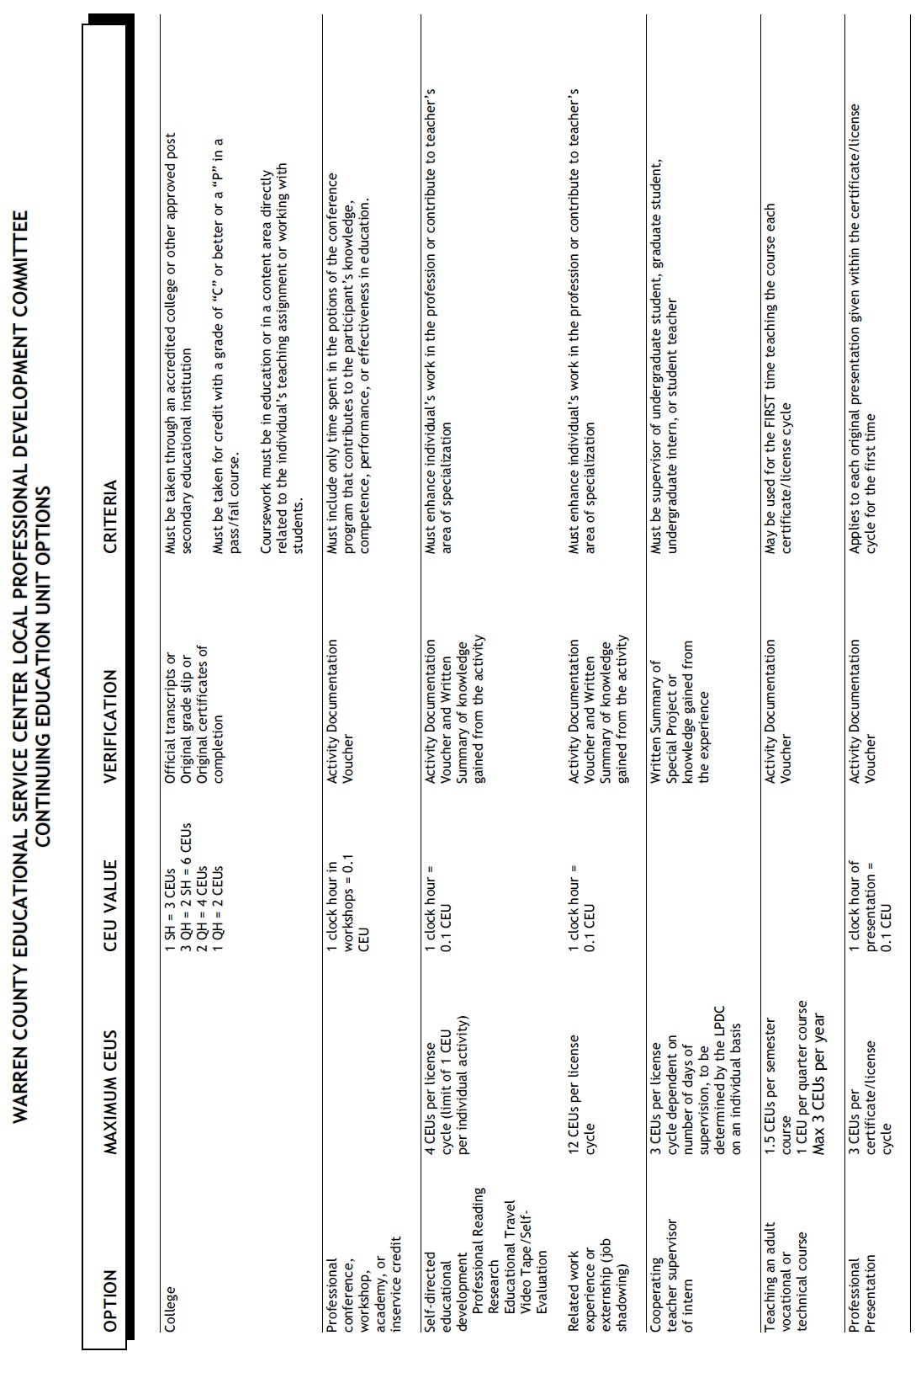
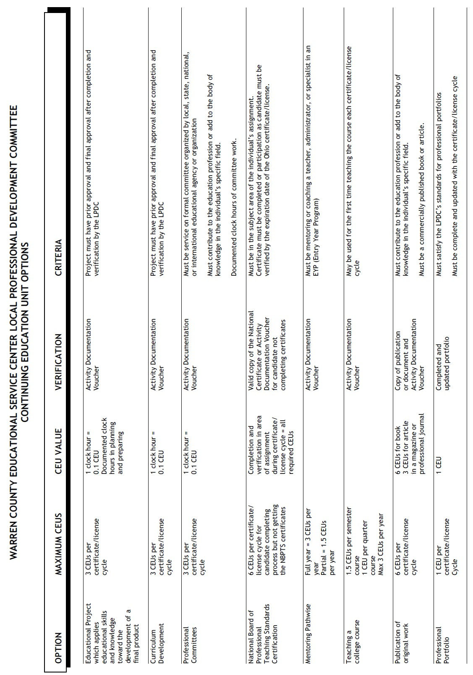

Continuing Education Unit Conversion Chart

CEUs | Semester Hours | Quarter Hours | Contact Hours
1 | ⅓ | ½ | 10
2 | ⅔ | 1 | 20
3 | 1 | 1 ½ | 30
4 | 1 ⅓ | 2 | 40
5 | 1 ⅔ | 2 ½ | 50
6 | 2 | 3 | 60
7 | 2 ⅓ | 3 ½ | 70
8 | 2 ⅔ | 4 | 80
9 | 3 | 4 ½ | 90
10 | 3 ⅓ | 5 | 100
11 | 3 ⅔ | 5 ½ | 110
12 | 4 | 6 | 120
13 | 4 ⅓ | 6 ½ | 130
14 | 4 ⅔ | 7 | 140
15 | 5 | 7 ½ | 150
16 | 5 ⅓ | 8 | 160
17 | 5 ⅔ | 8 ½ | 170
18 | 6 | 9 | 180

INDIVIDUAL PROFESSIONAL DEVELOPMENT PLAN: GOALS IDENTIFICATION GUIDE

To the Educator: This Goals’ Identification Guide is provided to assist you in identifying goals that may help you to maximize your professional potential capacity to serve your students, your district, and the community within which you work. It is a guide and is not intended to be all-inclusive. You are encouraged to develop goals that reflect those needs that will help you, your students, and your school district achieve excellence.

1. Content Knowledge
1.1 To learn how to apply techniques as effective content tools
1.2 To enhance professional knowledge (psychologists, speech therapists, treasurers, etc.)
1.3 To increase teaching area knowledge (elementary, art, English, mathematics, etc.)
1.4 To develop teaching/learning units which promote student knowledge growth in my discipline
1.5 To work with colleagues in ways that help to integrate my discipline within the school

2. Professional Ethics
2.1 To learn about and integrate educational theory/philosophy within my teaching strategies
2.2 To learn more about the community(ies) in which I serve
2.3 To learn and apply new ways of improving race relations among students/faculty/community
2.4 To gain knowledge of where and how to acquire information to exceed my job responsibilities
2.7 To maintain knowledge of current local/county/state/national educational policies and issues

3. Assessment and Evaluation Skills
3.1 To learn how to apply technologies as effective assessment tools
3.2 To learn how to apply assessment data to instruction
3.3 To learn how to construct effective evaluation instruments
3.4 To learn how to expand the number and types of assessment tools I use
3.5 To learn how to interpret test scores
3.6 To learn how to better teach test-taking skills
3.7 To learn more about proficiency, competency and/or standardized testing purposes and
creation

4. Instructional Methodology
4.1 To learn how to apply technologies as effective teaching and learning tools
4.2 To learn how to improve student reading skills
4.3 To learn how to foster students’ higher-order thinking skills
4.4 To learn how to facilitate student self-teaching and cooperative learning
4.5 To learn how to teach students to solve problems using existing knowledge and tools
4.6 To learn how to teach across many disciplines
4.7 To learn teaching methods that promote increased student achievement
4.8 To gain knowledge of how to adapt instruction to the individual needs of all students

5. Communications Skills
5.1 To learn how to apply technologies as effective communications tools
5.3 To enhance (oral) expressive language skills (of self, students, parents, peers, others)
5.4 To enhance written expression skills (of self, students, parents, peers, others)
5.5 To improve nonverbal communication skills
5.6 To learn ways to increase parental involvement in parent-teacher conferences

6. Interpersonal Skills
6.1 To learn how to apply technologies as effective interpersonal tools
6.2 To learn how to coach others to achieve and succeed
6.3 To learn how to coordinate or direct the efforts of others
6.4 To learn how to encourage the involvement of others
6.5 To learn how to facilitate groups (students, peers, others) to accomplish established goals
6.6 To learn how to motivate myself and others

7. Management and Administrative Skills
7.1 To learn how to apply technologies as effective management tools
7.2 To learn how to apply available resources to school improvement
7.3 To learn how to collect data to use in planning and for problem solving
7.4 To learn how to create conditions and environments that foster productive performance
7.5 To learn how to establish a vision that improves performance of myself and others
7.6 To learn planning and organizational skills that improve myself and others

8. Skills to Meet the Needs of Students with Special Needs
8.1 To learn how to apply technologies as effective intervention tools
8.2 To learn how to adapt instruction to all skill levels
8.3 To learn how to increase my awareness of strategies to address specific educational needs
8.4 To learn how to sensitize all students to the needs of individuals
8.5 To understand social/emotional needs of students and others

9. School District and/or Building Goals
9.1 To learn how to apply technologies as effective teaching and learning tools
9.2 To learn how to improve proficiency scores

