Join us for
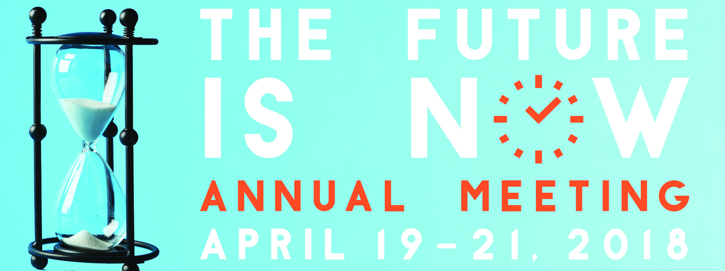
Featured Speakers
Dr. Cathy Jameson | Dr. Perry Brooks
Dr. Howard Farran | Dr. Rachel Wall
Dr. Michael Ditolla | Dr. Uche Odiatu
and | Mr. James Farly
Hotel Information
The Sheraton Hotel in Downtown OKC
405.815.6009
ODA Group Rate: $149/night
Book by March 16, 2018

35 CE hours available for the whole dental team!
Okda.org/annual-meeting
Registration opens in February!
#ODA2018

For all things Annual Meeting visit
www.okda.org
Join us for
Featuring Dr. Cathy Jameson
Opening Session: Creating a Healthy Work Environment
Friday, April 20, 2018, 8:00 a.m. – 9:00 a.m. (1 CE Hour)
Your practice cannot operate or reach its full potential without a dynamic, productive team. This engaging and informative presentation allows each participant to take a deep look at his/her role in the practice as well as examining the business and where it is going. Learn the skills you will need to take your practice from where it is now to that next level and how to develop a culture of superstars along the way. Enjoy this powerful session as you determine the key components to creating your own healthy work environment.
Dr. Farran’s One-Day Dental MBA
Friday, April 20, 2018, 9:30 a.m. – 12:30 p.m. (3 CE Hours)
In this seminar, Dr. Farran shares his proven techniques to increase your productivity and build your business. You will enjoy his fast-paced, straight-from-the-hip, politically incorrect, exhilarating style while you learn more in one lecture than you ever thought possible. Dr. Farran’s seminar focuses on the business of running a dental office – things that every business needs to do in this economic environment, what every business needs to make its products and services more efficient, and things that can realistically be managed and what functions your business should have.

