Bridge Care

- Do not worry about mild sensitivity to hot or cold foods. This sensitivity will dissipate gradually over a few weeks
- If the bridge is the first tooth to hit when you bite down, please call and make an appointment so we can adjust your bite
- Homecare for a bridge
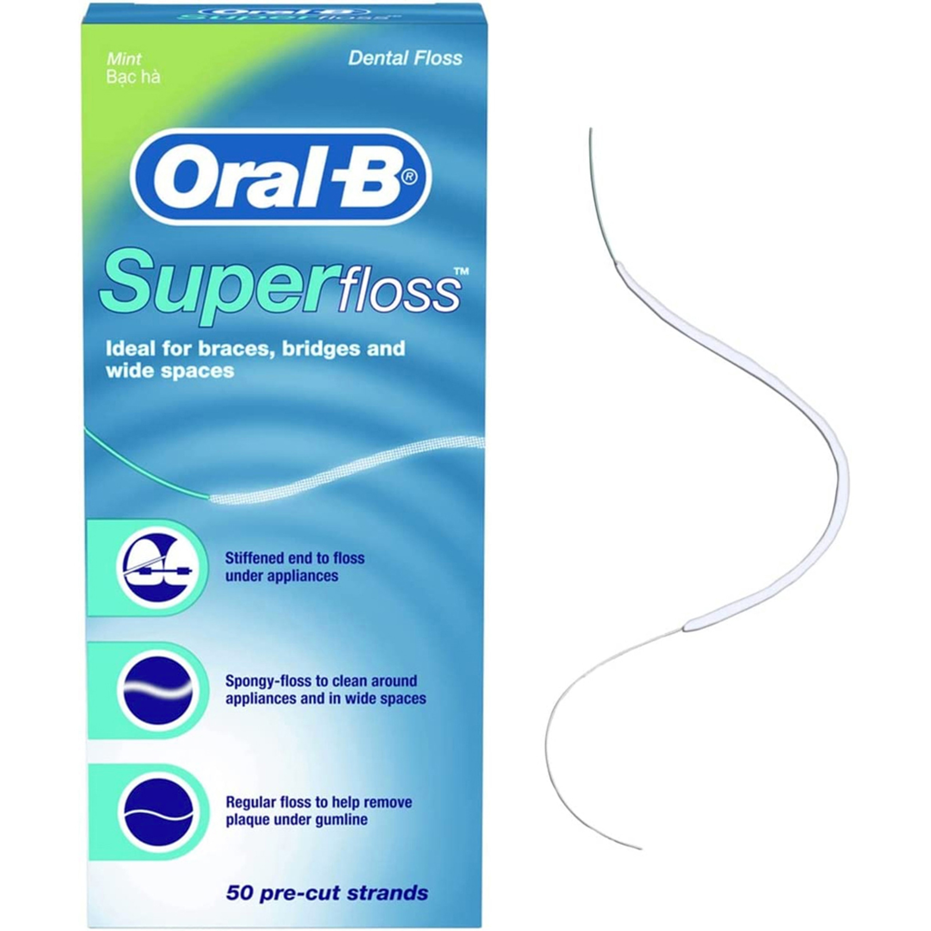
  - It is important to clean around and under the bridge. Without proper homecare the gums can get infected or you can develop cavities under the bridge
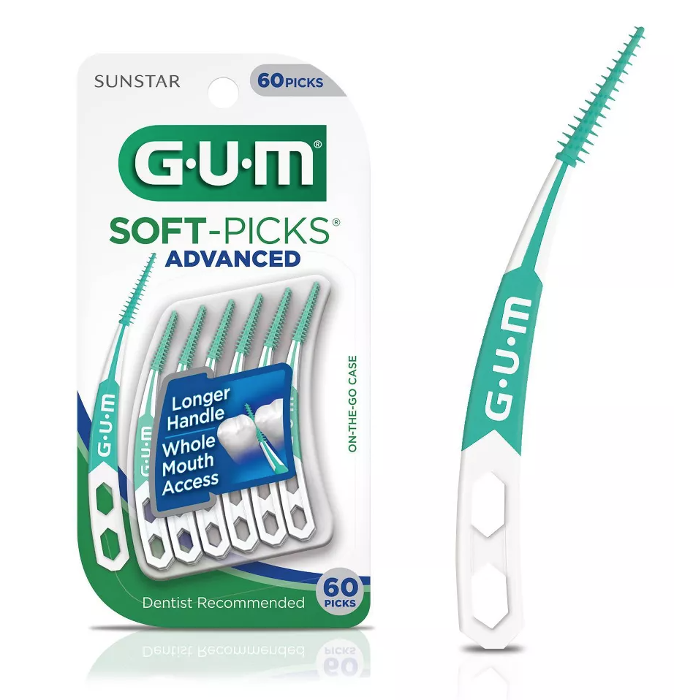
    - Floss under the bridge at least once a day using floss threaders or superfloss

    - Other ways to remove plaque from under the bridge include
      - Soft-picks
      - Waterpik- our waterpik recommendation is below

Cordless Waterpik Advanced Water Flosser- Model #WP-560

The waterpik is an adjunct to brushing and flossing. The waterpik sprays water along the gum line helping to remove the bacteria that causes gum disease. We recommend this product for people who have crowns/bridges/implants or who have periodontal disease. This product is portable and waterproof (recommended to use in the shower). It is important to also continue the use of string floss.
Demo video can be found on Youtube with search “How to Use the Waterpik Cordless Advanced Water Flosser WP-560”

Please call the office if you have any questions!

