This is a comprehensive list of the products we recommend for children under the
age of 18 at Branford Dental Care. Your Hygienist has circled the products that would
be best for your child.

Oral B Electric Toothbrush
The most important step to our oral hygiene routine is to brush twice a day for 2 minutes each time. At Branford Dental Care we recommend electric toothbrushes to all our patients. Electric toothbrushes do a lot of the work for us! They spin and vibrate to remove plaque and debris from under the gums and around the teeth while preventing us from scrubbing too hard and injuring the gums. Oral B makes electric toothbrushes for kids that you can find online or in the drug store.

Floss
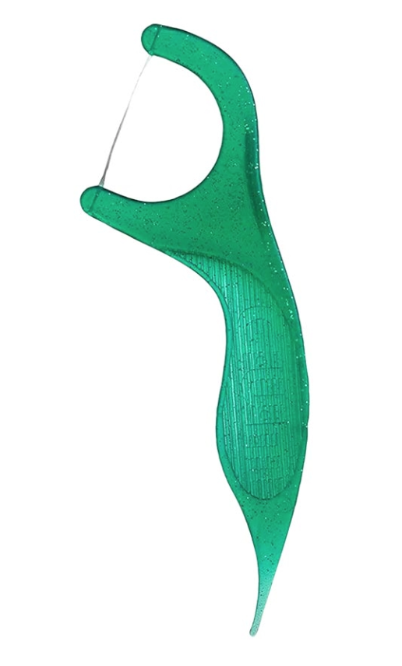
It is very important to floss every night prior to brushing our teeth. Your child should start flossing when they have teeth that contact each other. Flossing removes bacteria between the teeth and under the gums. There are many floss options including waxed or glide- the type you use is personal preference. You want to wrap each tooth in a C-shape and bring the floss up and down along each side of each tooth.

For children under 12 we recommend flossers with the handle.

Toothpaste
Most importantly, you want to make sure your toothpaste has fluoride in it. Fluoride strengthens the tooth structure to help prevent bacteria from penetrating the surface.

- For children age 0-6 years old - Kid’s Crest
  - 0-2 years old use grain-of-rice sized amount squished into bristles and do not swallow
  - 3-6 years old use pea-sized amount squished into bristles and do not swallow

- For children age 6 + years old- any brand of fluoride toothpaste
  - Use thin ribbon amount and do not swallow

- For frequent cavities- Our prescription paste Clinpro 5000
  - AGE 12 - 16 INSTRUCTIONS FOR USE: brush for 2 minutes, spit out paste, rinse mouth with water. Do not eat or drink for 30 min
  - AGE 17 + INSTRUCTIONS FOR USE: brush for 2 minutes, spit out paste, DO NOT rinse for 30 min after use. The longer it sits on your teeth the better it works for you.

Cordless Waterpik Advanced Water Flosser- Model #WP-580
The waterpik is an adjunct to brushing and flossing. The waterpik sprays water along the gum line helping to remove the bacteria that causes gum disease. We recommend this product for children who struggle with flossing or who have orthodontic appliances or braces. This product is portable and waterproof (recommended to use in the shower). It is important to also continue the use of string floss. Demo video can be found on Youtube with search “How to Use the Waterpik Cordless Advanced Water Flosser WP-580”

Your child should have your help while brushing and flossing until they can tie their own shoes!

