New UI Columns for Visibility

WS-1588
New Columns for Multi Inventory Adjustment
Two new columns have been added to the Multi Inventory adjustment screen, UOM which will show the item UOM being adjusted and Comments which is a free text box allowing users to enter comments
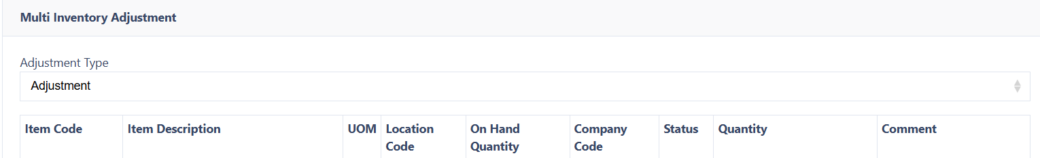

WS-1587
New Columns on Print Routing list
Two new columns have been added to the Print Routing list display to provide more visibility, Print Procedure and Station.


