Role Management Enhancements
Within any given role there is an additional tab for profiles.
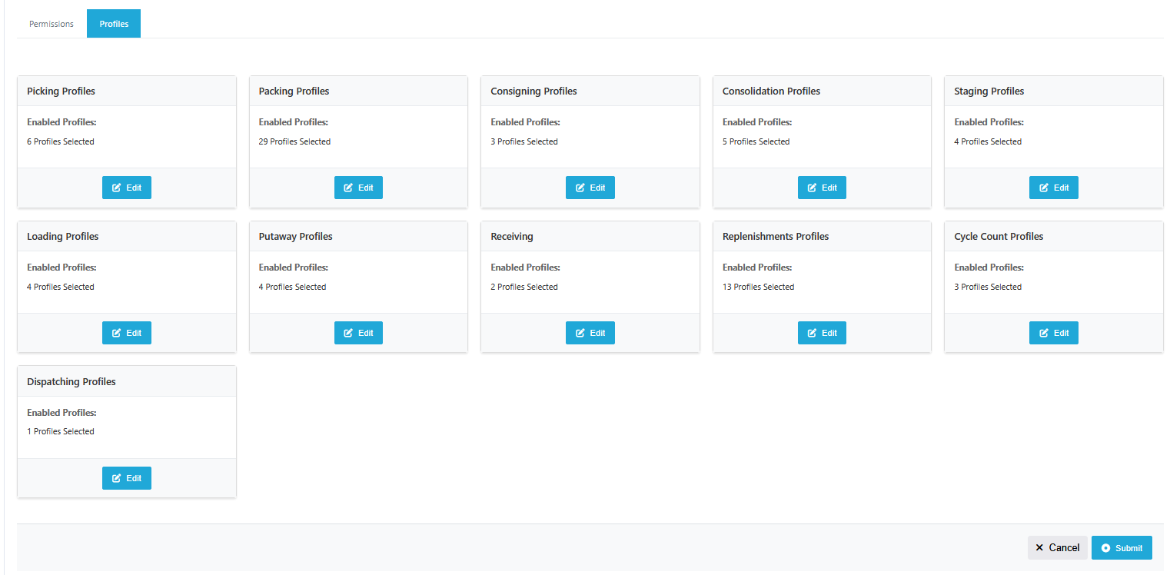
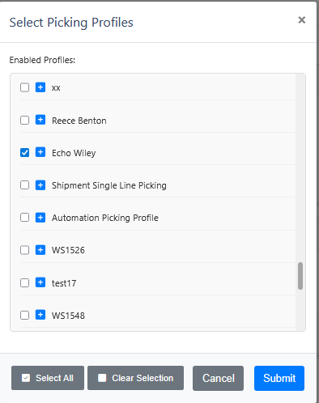
The profiles assigned to a role will now determine the options available in the Executions dropdown menu, ensuring users only see and access relevant profiles.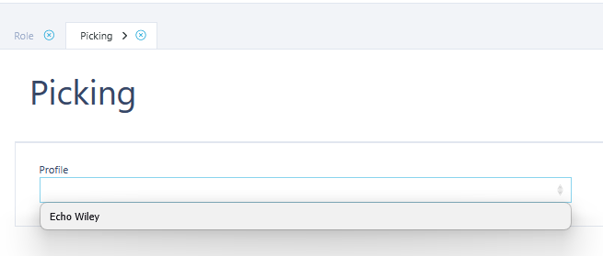

Notice: We have made changes to how users view profiles, this includes inside of receiving profiles which previously allowed for specific users to access that profile.
To reduce as much friction as possible for this deployment, it has been set that all roles will have access to all profiles.

