Reason code on Short Receipts
Inside the company menu a new checkbox for ‘Short Receipt Reason Code’ has been added.
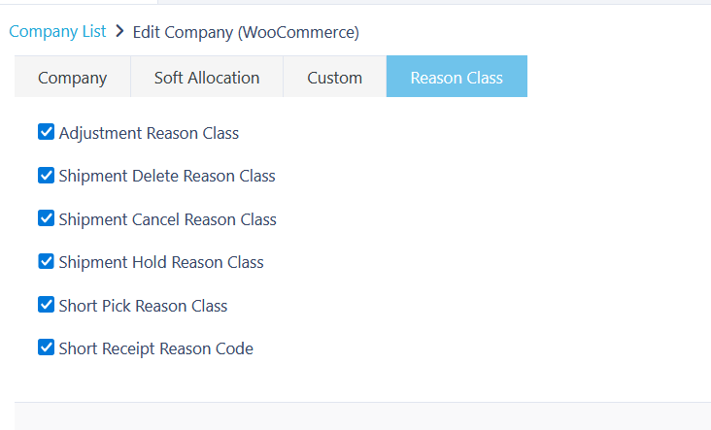

New reason class has been added called Short Receipt:
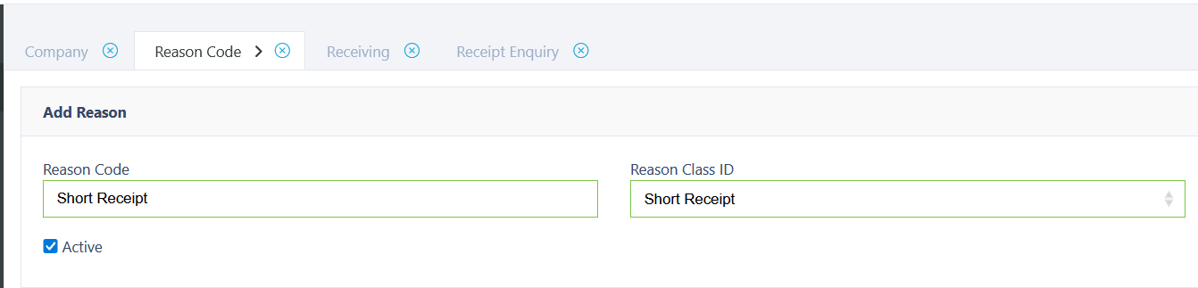

When short receipt reason code is enabled on the company, and the user receives less than the amount on the open quantity they will be presented an option to provide a reason code and comment for the short receiving.
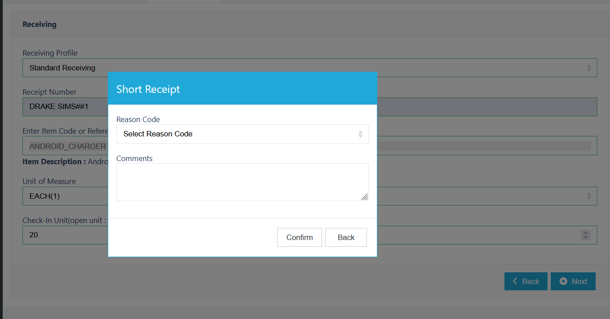

The reason code and comment will be stored and displayed against the receipt detail: 

