Container & Item Consigning Initiation Method release notes

We have added a new consignment initiation method of Shipment Container & Item
This initiation method allows users to initiate consigning by container and item
The user will select the Initiation Method on Consigning Profile
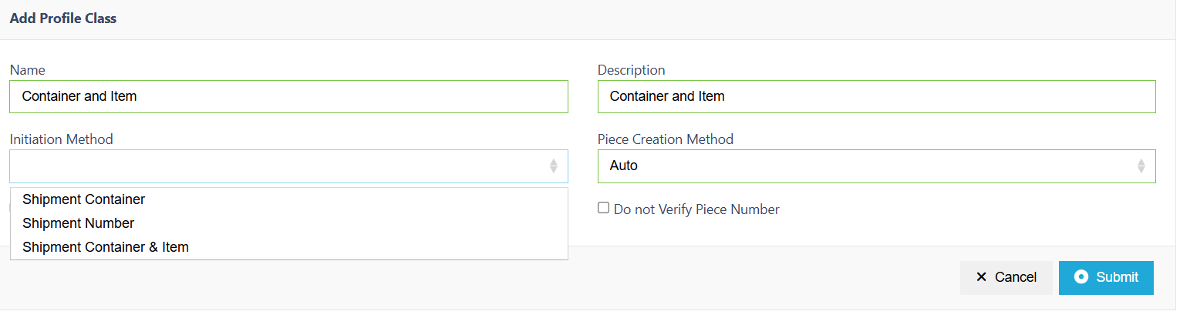
And will be prompted to enter container and an item on initiation
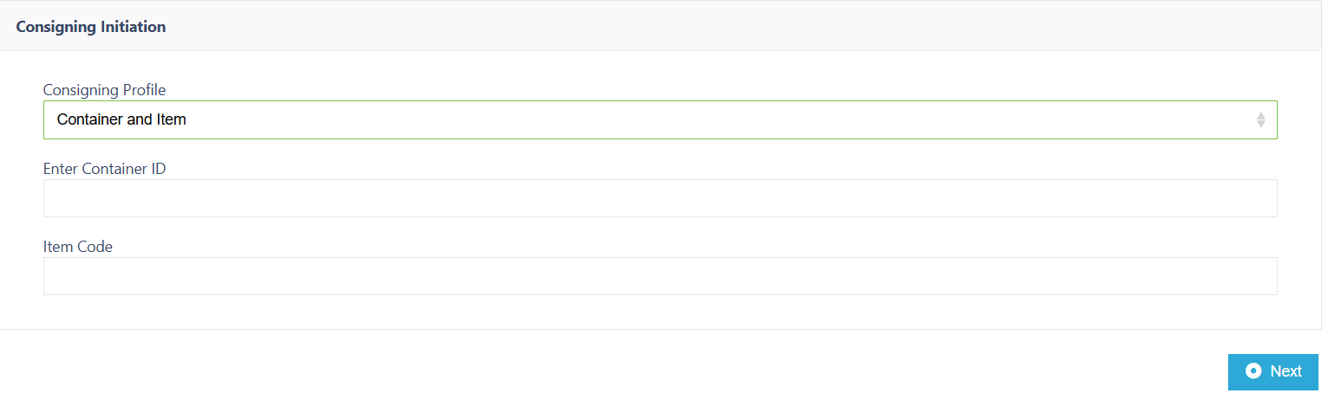
Any item within the container will initiate the job. An item not in container will generate no job error.

Picking Profile Option: Keep Assignment on Exit.
A new option has been added to the general tab inside of Shipment Picking Profiles, that when enabled will allow the user to retain their assignment to a job upon exiting the picking job prior to its completion. This feature will be especially useful when using cluster picking as users will be able to continue their progress from where they left off, without any concerns that another user will be assigned their job on exit.

