Replenishment Batch Demand
When running a replenishment plan using ‘Pool and Wave by Quantity and Batch Number’ it will now examine shipments that are in pool or wave for items that have been rejected, along with recording the batch number of the item that needs to be replenished. If the shipment detail batch number matches the batch number of inventory found in a bulk location, then it will create a replenishment job.
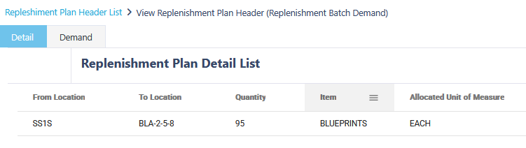
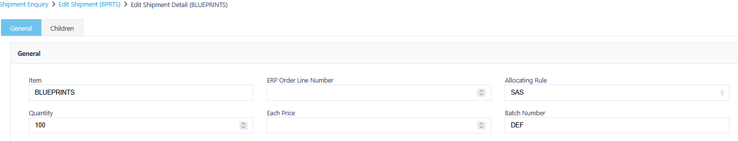
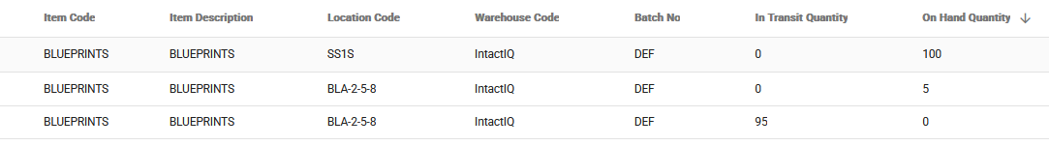

Picking exec: Show summary of job release notes
We have made some changes that will assist with the picking process by showing a job summary during picking execution.
A new option has been added to the picking profile for Job Summary on Execution
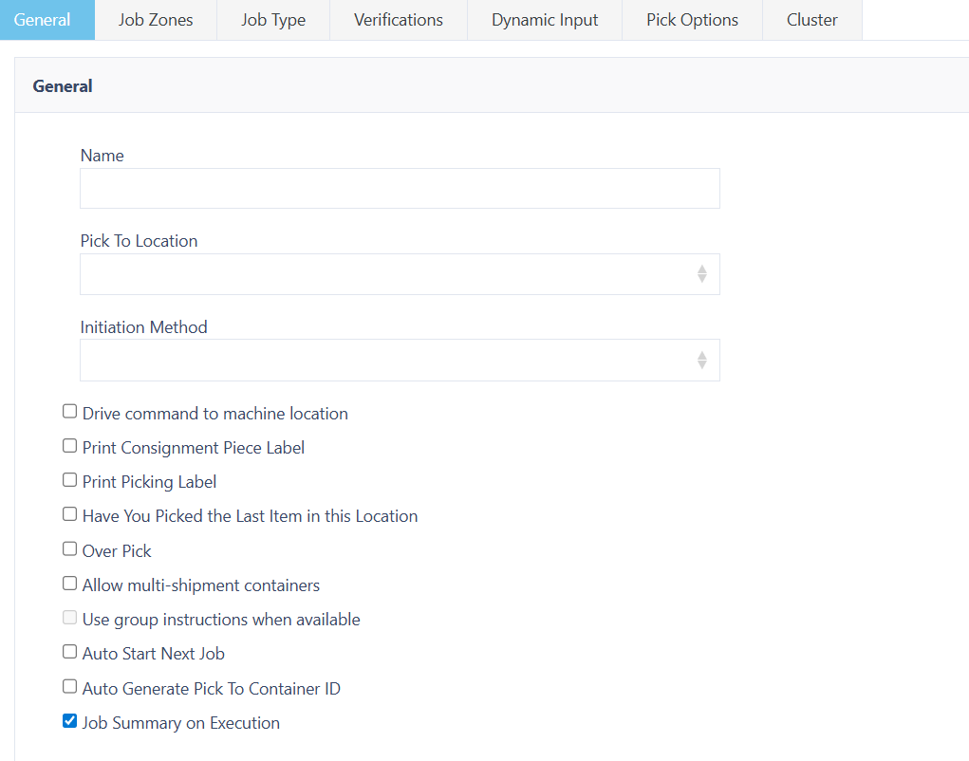
When enabled, after job initiation the user will see a new line called ‘Job Summary’.
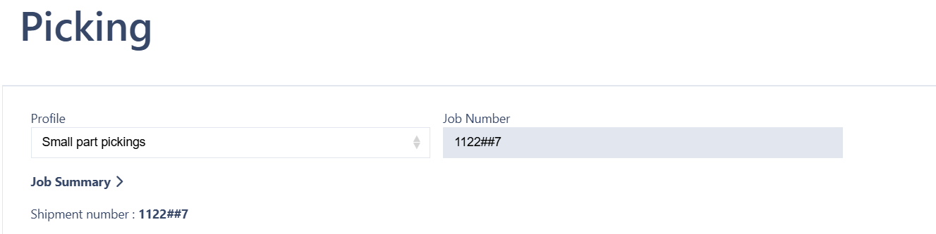
This will have an arrow icon to the right of the text which when interacted with will display the job summary all-in-one line. The following information will be included in the summary:
Jobs: This will represent the number of jobs remaining and display which job the user is on, for example if the user if on the first job it would be displayed as 1 of 5, and if they were on the third job it would be displayed as 3 of 5.
Instructions: Similar to jobs, will display the number of instructions assigned to the job.
Total Weight: This will display the total weight of all the jobs. 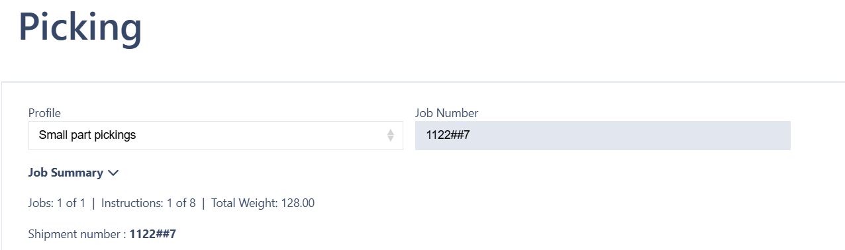

Wave Reject Shipment Planner Filter
A new Yes/No drop-down filter has been added to the shipment planner that will allow users to filter shipments based on whether they have a wave reject reason or not.


