Packing Change release notes

We’ve made some changes that will allow greater flexibility in the creation and execution of packing jobs.
Shipment Packing Job Creation
There is a new Shipment Packing Job Creation option where users can create Packing jobs in a similar fashion to picking and specify the packing job type and set criteria for the packing job creation.
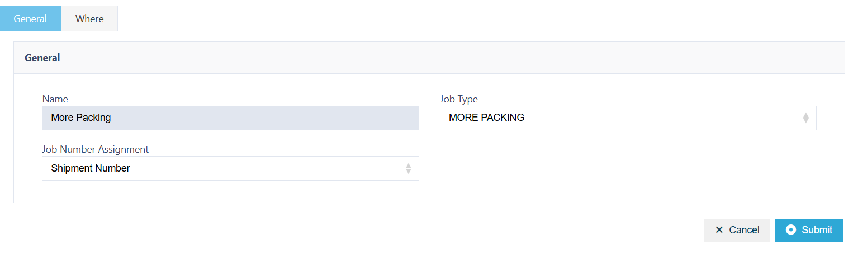
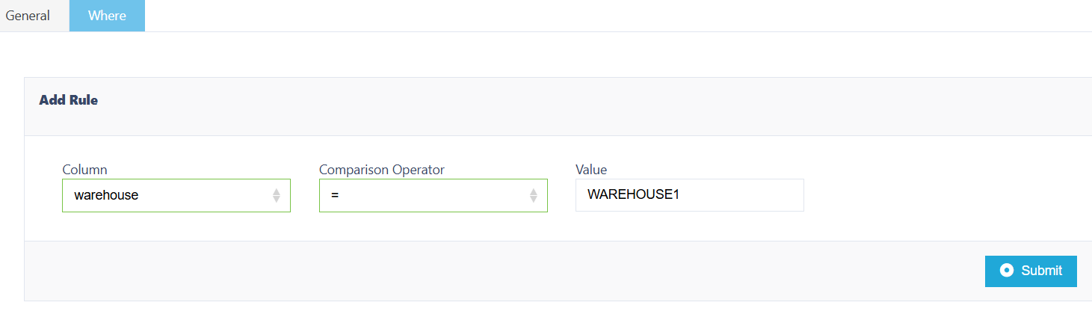
*all tenants will have Default Packing Job Creation of Packing initially
Shipment Packing Profile
On Shipment Packing Profile there will be an additional Job Type tab where users can select the Job Type the Packing profile will apply to.
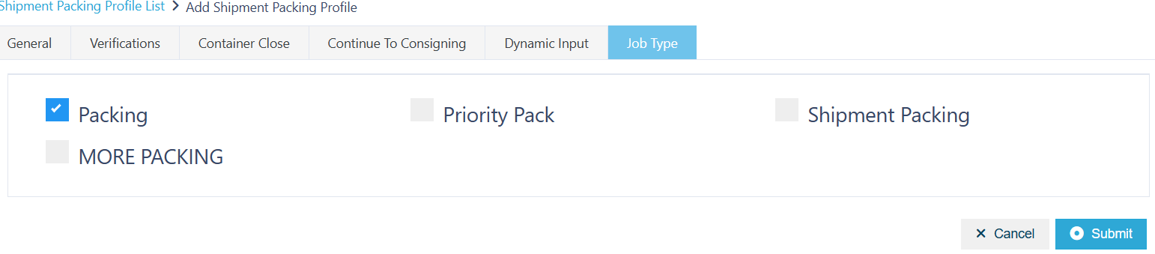
*all tenants will have Packing selected on Job Type initially for all Packing Profiles
There will also be 2 Custom Field selections available on the Verifications tab. If selected the fields will be a mandatory free form additional input during packing execution. The columns and input will appear on Shipment Detail Children List. If selected there is an additional option to add a label (optional).
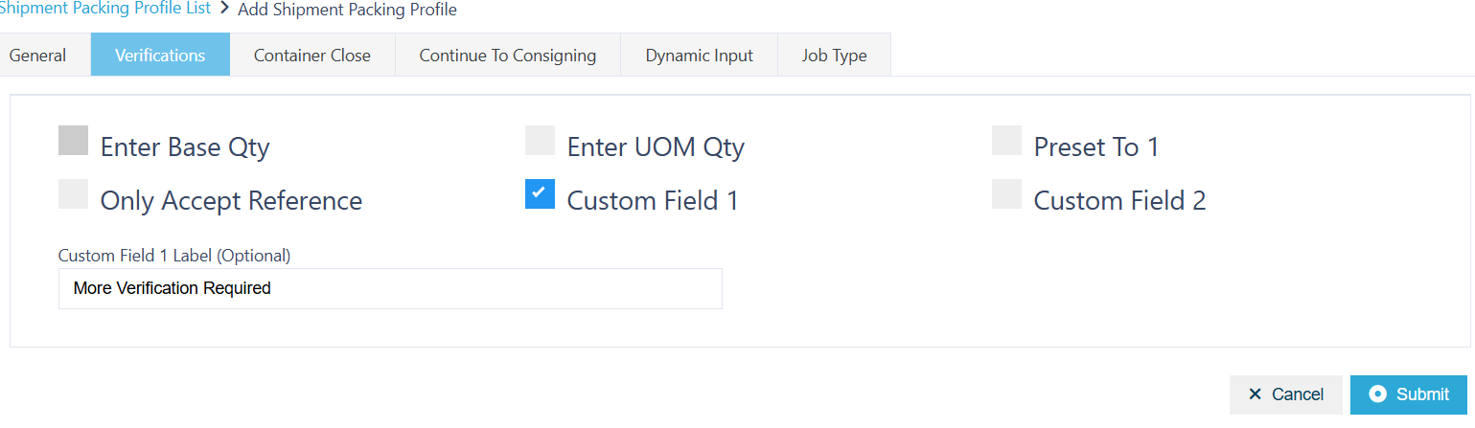
On packing execution
