Replenishment Batch Demand
When running a replenishment plan using ‘Pool and Wave by Quantity and Batch Number’ it will now examine shipments that are in pool or wave for items that have been rejected, along with recording the batch number of the item that needs to be replenished. If the shipment detail batch number matches the batch number of inventory found in a bulk location, then it will create a replenishment job.
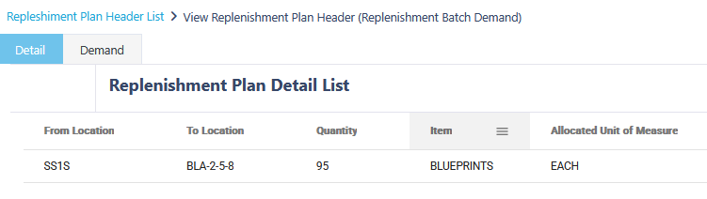
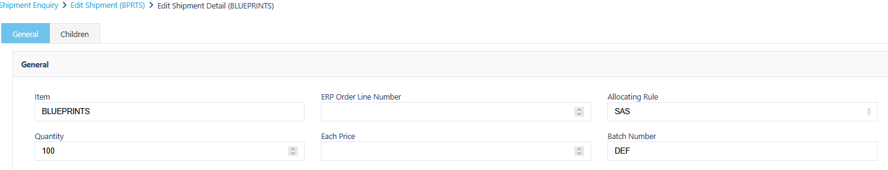
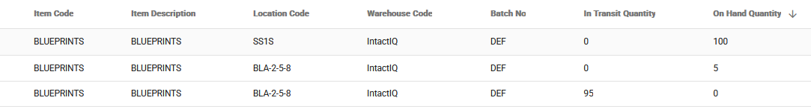

Adding Item to Shipment or Receipt Via Item Description.
It will now be possible to add items to Shipment or Receipt using the item description of the item. This can be done by typing part or all of the items description into the item field. The benefits of this being added is that it will allow for more accuracy when adding items to a shipment in cases where item codes are similar.

Receipt Enquiry Item - Batch Number Column
New column has been added to Receipt Enquiry – Item. This will display the associated batch number that is stored on the detail.
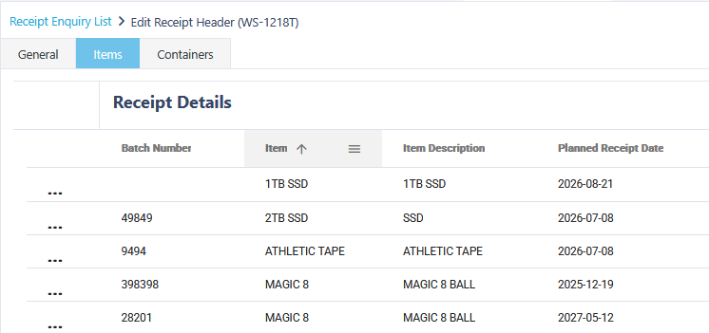

Additional Fields Added:
The following fields have been added to Canary7:
Shipment Detail
- Preferred Unit of Measure
Shipment Header
- Department Number
- Department Name
- Sort Code
- Destination Number
Shipment Load
- BOL (Bill of Lading)
- PRO (Progressive Number)
- Shipment ID

