Warehouse search release notes

We’ve made some changes that will make it easier to search by warehouse.

On shipment planner wave tab there is now a search option to select and search by either Warehouse or Waveflow Header or both. There is also an additional Warehouse column on the UI.
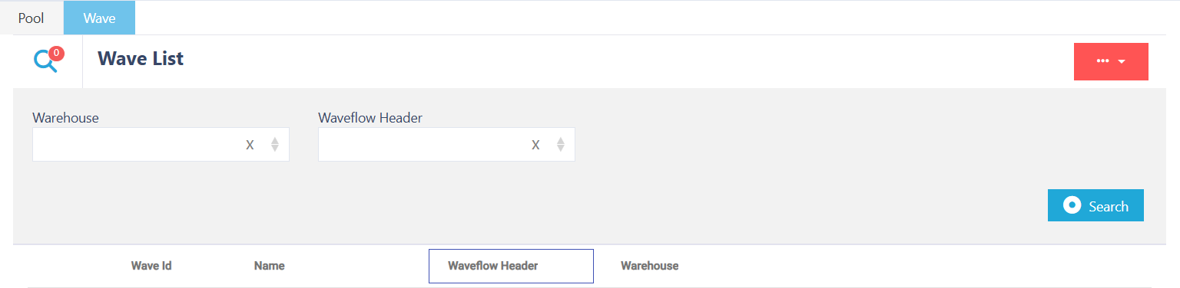

Warehouse search has also been added to Receipt Detail and Receipt Container search fields.
