Batch Number in Packing
When a shipment is ran through the wave with the wave step ‘Add Batch Number’, the batch number will now be displayed on packing below the item. The batch number can be seen in both the pack to and pack from containers.
This will be useful as it will allow greater accuracy when packing orders.
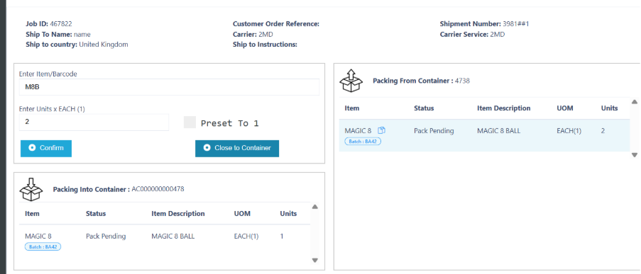

Split Part Allocated Shipments
When a shipment is part allocated and has the trailing/leading status of in-pool, users will be able to split the shipment. When the shipment is split, it will place the unallocated details into the new shipment and leave the details that are fully allocated in the original shipment.
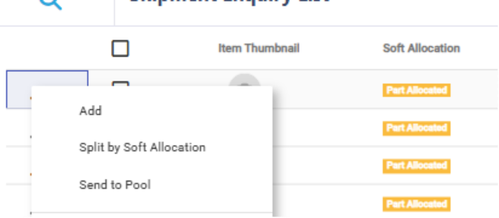

Changes to Shipment Hold:
When placing a shipment on hold, users will now be able to add hold comments that will be stored against the shipment header. The comments will be displayed on the hold comments column inside Shipping Enquiry. Along with this, we have added a new column called ‘Hold Reason Code’ which will display the reason code that was selected when holding a shipment
Use Case:
Users may use this to outline or highlight the specific reason why that the shipment was held for. For example, the shipment could have been incorrect or fraudulent.
Reminder: In order to add a reason code when holding a shipment, this needs to be enabled on the company.
