Soft Allocation Updated At Column
A new column has been added to Shipping Enquiry called ‘Soft Allocation Updated At’ which will display when soft allocation was last updated.
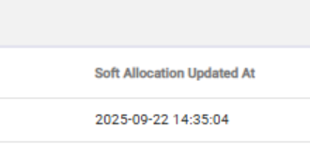

Job Zone : Location List Filter
A new filter has been added to the location menu which will allow users to filter and present locations based on their job zone. Like other filters, this can be used in conjunction with other filters to greater define your location search.
