Soft Allocation | Re-Run Allocation & Unallocate
The ability to unallocate inventory that has been Fully or Partially Allocated has been added to the shipment planner, and with this the ability to manually re-run soft allocation has also been added to shipment planner. These options will be visible within the three dots and will be useful with controlling prioritising which shipments to allocate inventory to.
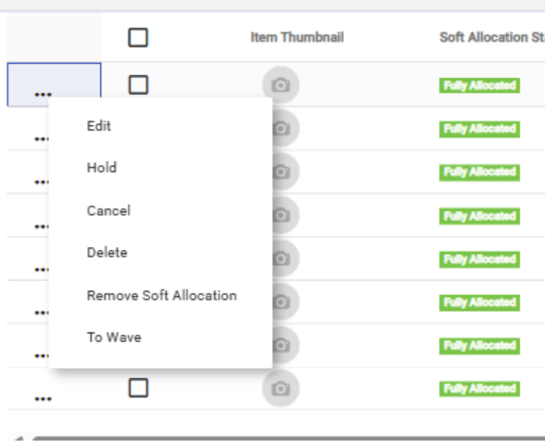
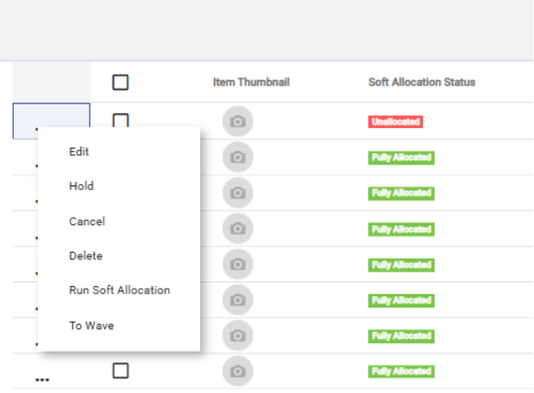

Open Shipments
The feature will introduce a menu option that displays a list of all
open shipments, along with their current statuses.

Users will be able to:
• View detailed information for each shipment.
• Select individual shipment tiles to access more specific details.
• View a list of associated jobs for each shipment.
• Navigate directly to picking jobs from the Open Shipments screen.
This enhancement will provide a more streamlined way to monitor and manage open
shipments, improving overall workflow efficiency.

Columns and Filters Added Across Canary7
New columns have been added to inventory enquiry and location list which will display whether an item or location is a permanent location.
A new column has been added to Inventory enquiry to display the job zone of the inventory location.
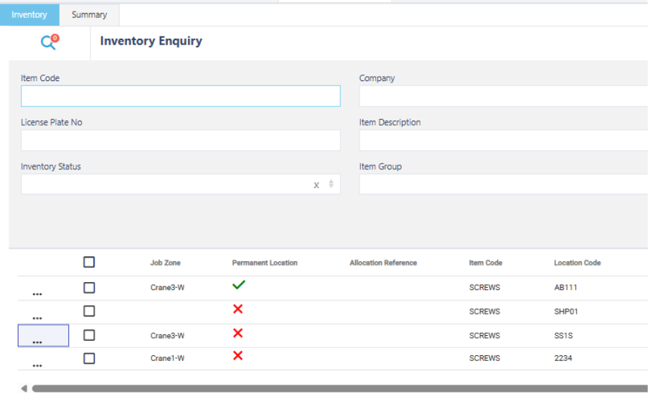
Several new columns have been added to Shipment Planner:
- Ship to Instruction: This will display the ship to instructions stored on the shipment header.
- Customer Code: Will display the customer code stored on the shipment header. Alongside this we have added a customer code filter into shipment planner.


