Columns and Filters Added Across Canary7
New columns have been added to inventory enquiry and location list which will display whether an item or location is a permanent location.
A new column has been added to Inventory enquiry to display the job zone of the inventory location.
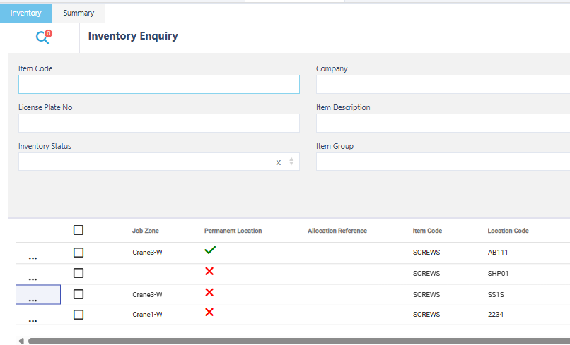
Several new columns have been added to Shipment Planner:
- Ship to Instruction: This will display the ship to instructions stored on the shipment header.
- Customer Code: Will display the customer code stored on the shipment header. Alongside this we have added a customer code filter into shipment planner.
