STUMP & ROOT CO. PRESENTS
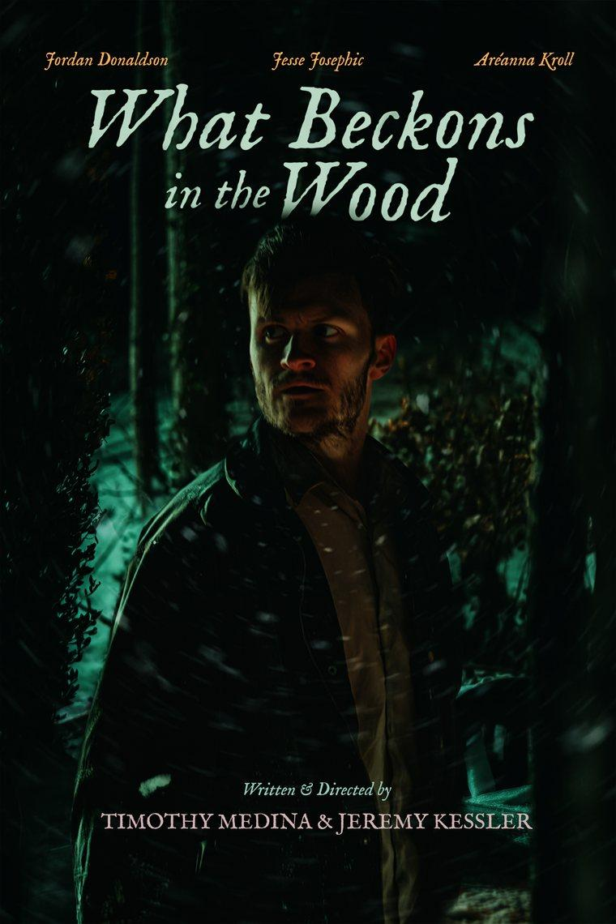
What Beckons in the Wood
Every bell has its echo.
A short film written and directed by
TIMOTHY MEDINA · JEREMY KESSLER
2026 · 10 MIN 33 SEC · HORROR · UNITED STATES · ENGLISH
PRESS KIT

The film
A hunted thief in the 1930s stumbles onto a table set alone in the winter woods, and the crowned creature waiting there offers to give him exactly what he deserves.

SYNOPSIS
1930s. Edgar runs through a dying forest with hounds and flashlights closing behind him, clutching stolen bills that scatter into the night air when he falls. What he recovers instead is a folded photograph of a woman, tucked fast into his breast pocket.
Then a voice says his name.
A table waits in the clearing, laid with a goblet, a plate of ruined bread, a bone-handled dagger, and a small bright bell. When Edgar rings it, a cloaked and crowned creature rises from the earth and invites him to sit, promising liberation and something of far greater worth than what he lost. All it asks is that he first surrender whatever binds him.
Edgar has spent his life taking what he wanted. Now something is finally offering, and the terms are simpler than he expects.
SPECIFICATIONS
Title | What Beckons in the Wood
Runtime | 10 minutes 33 seconds
Year of completion | 2026
Genre | Horror. Folk horror, dark fantasy, period
Country of origin | United States
Language | English
Aspect ratio | 2.37:1 (64:27)
Resolution | 5120 x 2160
Frame rate | 23.976 fps
Sound | Stereo 2.0
Camera | Sony FX3
Lenses | Blazar Mantis 1.33x anamorphic
Production company | Stump & Root Co.

Directors' statement
The thing that pulled us into this story was not the monster. It was the line Edgar says face down in the leaves right after he loses the money, when he insists that it was his, that he had it, that he deserved it. We have heard that sentence in a hundred different forms, and we have said versions of it ourselves, and the older we get the more we think pride is not loud most of the time. It is quiet, and it sounds like accounting.
So we built the creature around a table instead of a lair, because the most frightening thing we could think of was not being refused. It was being served. Bread, a cup, a bell, a hand on the forehead. All of it borrowed on purpose, and borrowed inverted, because a counterfeit only works if it looks close enough to the real thing to sit down at.
We shot it in the snow on borrowed land with a crew who mostly worked for the love of it, and we are aware that the ambition of the film outran the budget by a good distance. We would rather it reach and fall short than be safe and land clean.
The question at the center of it is the one Edgar asks at the very end, after he has already traded her away. Will she remember me. He gets everything he asked for, and by then he has nothing left that can hold it.
Timothy Medina and Jeremy Kessler

Production notes
What Beckons in the Wood was photographed on a Sony FX3 with Blazar Mantis 1.33x anamorphic lenses, which places the film at a native 2.37:1 with no cropping. It was shot on private land in Lancaster County, Pennsylvania, in winter, in snow.
The creature was realized with a real silicone mask, with eyes augmented with vfx by Timothy Medina and practical makeup for his hands by Chloie Kessler, built and applied on location in the cold.
The film was edited and colored by Caleb Tyson, scored by Cory Rosen, and finished with sound design by Josh Joyce. It was produced independently by Stump & Root Co., a creative studio in Strasburg, Pennsylvania.

Cast
Edgar | Jordan Donaldson
The Creature | Jesse Josephic
The Woman | Aréanna Kroll
The Narrator | Eric Lee

Crew
Written and directed by | Timothy Medina, Jeremy Kessler
Produced by | Timothy Medina, Jeremy Kessler
Director of photography | Kent Mast
Film editor | Caleb Tyson
Colorist | Caleb Tyson
Visual effects | Timothy Medina
Music by | Cory Rosen
Sound design | Josh Joyce
Audio recording | Ethan Scott
Grip | Caleb Tyson, Elijah VanHanxleden
Makeup | Chloie Kessler
Behind the scenes photography | Timothy Medina
Behind the scenes video | Collin Proctor
SPECIAL THANKS
Bolivar and Caroline Medina, for the use of their home and land.

Stills
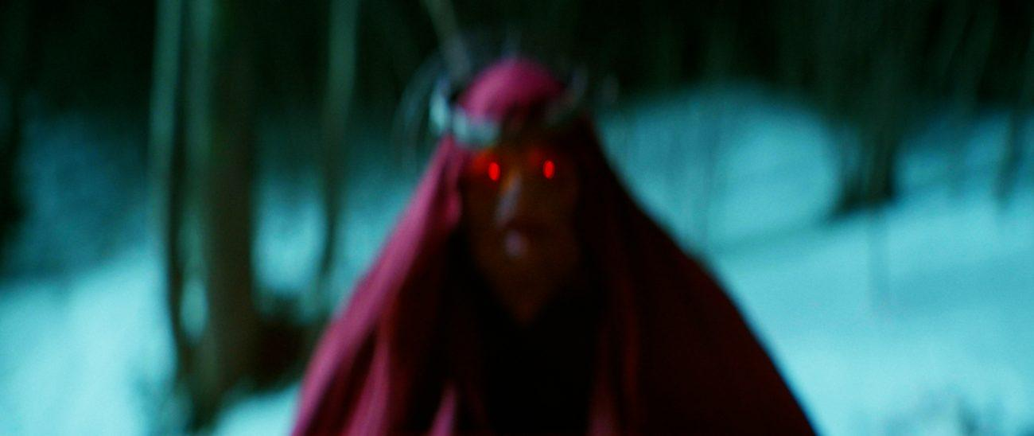
JESSE JOSEPHIC AS THE CREATURE
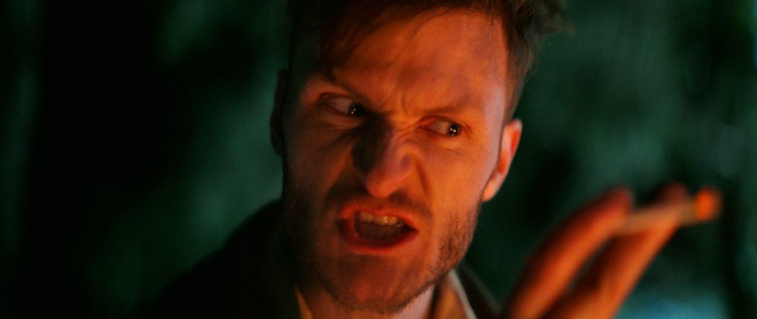
JORDAN DONALDSON AS EDGAR
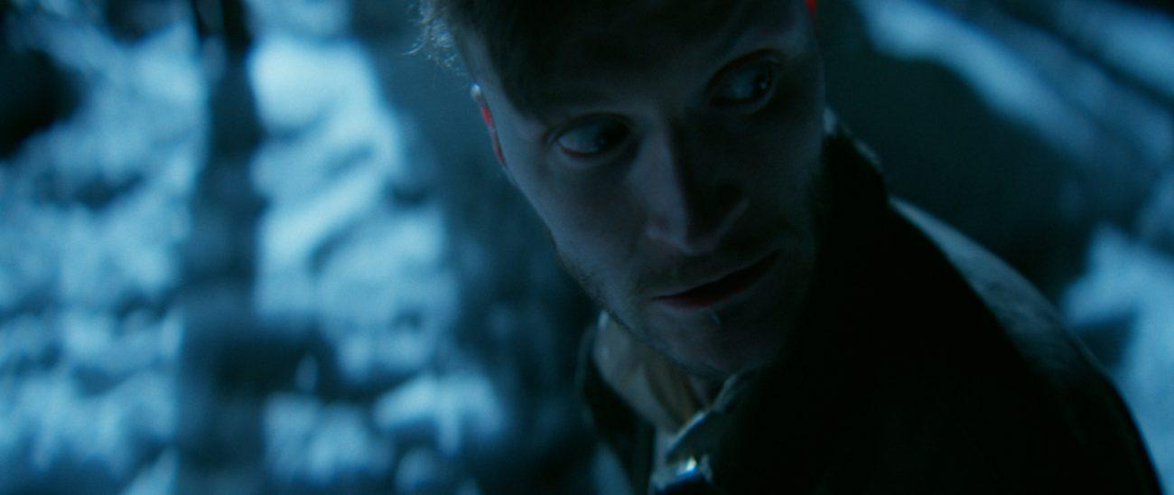
JORDAN DONALDSON AS EDGAR

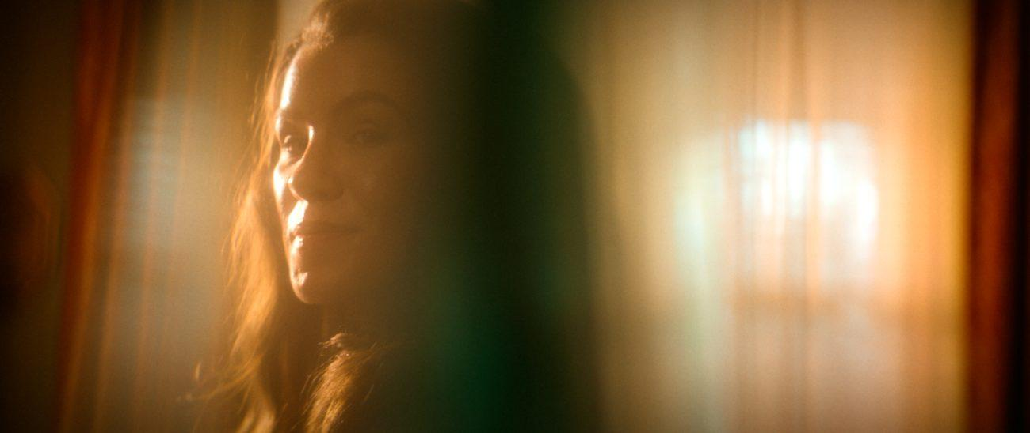
ARÉANNA KROLL AS THE WOMAN

THE BELL
High resolution stills and poster art available on request.
Stills courtesy of Stump & Root Co.

Contact
Timothy Medina | Director, Stump & Root Co.
Email | hello@stumpandroot.co
Website | stumpandroot.co
Film page | stumpandroot.co/what-beckons-in-the-wood
Screener | Available on request

(c) 2026 Stump & Root Co. All rights reserved.
The characters and events depicted in this film are fictitious. Any similarity to actual persons, living or dead, is purely coincidental.

