


▶ PLANTERLITE
Technical data sheet
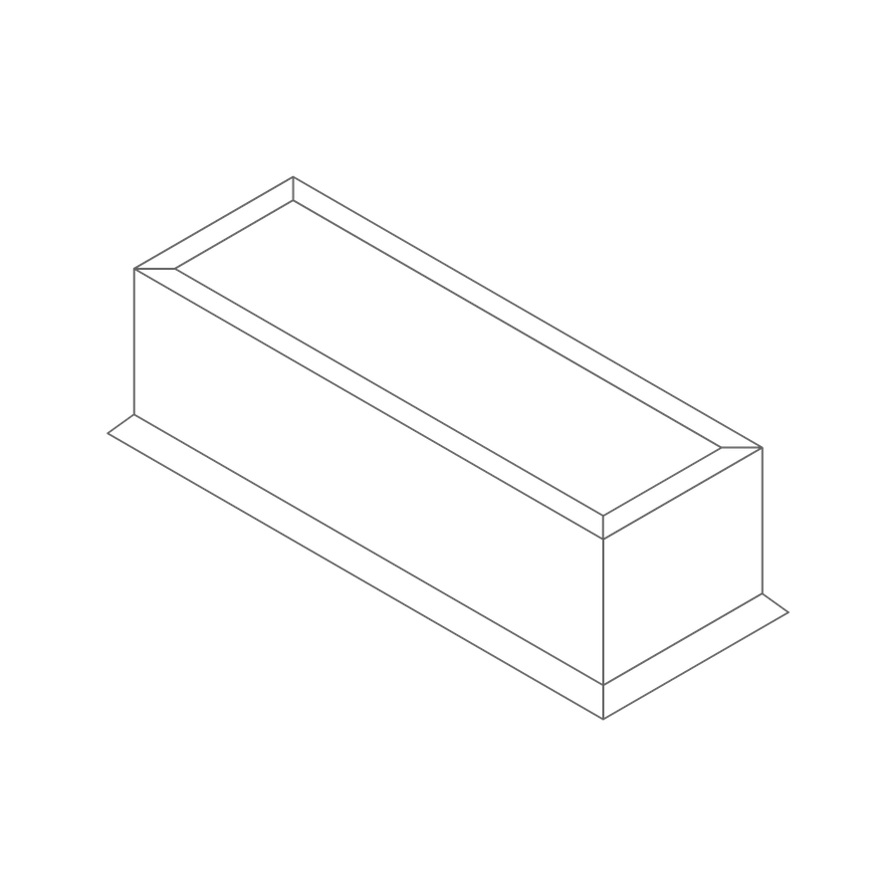

Reference:
DS-PL-0926

PLANTERLITE — PRODUCT RANGE
Range | Shape | Size range (mm) | Weight (kg) | Colourways / finish
Rustic Bowls | Bowl | Ø280–1100 × H210–720 | 2.5–50 | Rustic, Dark Grey, Sand
Rustic Bench | Bench trough | L1100 × D400 × H420 | 25 | Rustic, Dark Grey, Sand
Corten Troughs | Trough | L600–1200 × D280–600 × H280–600 | 8.5–35 | Corten (weathering-steel finish)
Corten Cylinders | Cylinder | Ø250–1000 × H250–1000 | 4.0–60 | Corten (weathering-steel finish)
Corten Boxes | Box | L240–500 × D240–500 × H240–500 | 4.0–18 | Corten (weathering-steel finish)
Chelsea Boxes | Box | L220–650 × D220–650 × H220–650 | 3.0–25 | Chelsea (natural finish)
Chelsea Troughs | Trough | L500–1000 × D160–450 × H170–450 | 4.5–25 | Chelsea (natural finish)
Chelsea Cylinders | Cylinder | Ø220–650 × H220–650 | 3.0–25 | Chelsea (natural finish)
Smooth Urban Troughs | Trough | L600–1000 × D280–450 × H280–450 | 8.5–30 | Black, Grey, White
Smooth Urban Boxes | Box | L240–500 × D240–500 × H240–500 | 4.0–18 | Black, Grey, White
Terracotta Lined Pot | Lined pot | Ø250–730 × H190–540 | 3.0–35 | Terracotta
Patterned Outdoor Planters | Planter | Ø250–500 × H250–500 | 3.0–13 | Flower / Tropical / Geometric / Fern – Dark Grey & White Grey
171 SKU variants across 19 ranges and multiple colourways. Sizes and weights shown are min–max across each range — full SKU codes, barcodes and pricing available on request.

TYPICAL SIZING (GENERAL GUIDE)  Indicative range for standard planters — individual lines vary, see Product Range table above. | COMPOSITION & AVAILABILITY  Composition: magnesium & sand composite, pasted over a fibreglass mesh for added stability and frost resistance (>95% biodegradable content).  Available finishes: over 100 finishes and size variations available on request.
  Dimension | Minimum | Maximum
  Width (W) | 250 mm | 500 mm
  Height (H) | 250 mm | 500 mm

ABOUT PLANTERLITE  Planterlite is an eco-friendly material that has demonstrated excellent resilience in many climates over the last decade.  Whilst it has similar qualities to Fibreclay, different manufacturing techniques and blends offer improved durability, UV resistance and colour stability (with no leaching).  Planterlite mostly consists of naturally occurring magnesium dredged from lakes and rivers. This is mixed with sand and coloured powder, before being pasted over a small fibreglass mesh for added stability and improved frost resistance.  Over 95% of the composite is biodegradable. The manufacture of Planterlite requires only a fraction of the energy used for other planter types, as it sets naturally without kiln firing or machine moulding.  KEY BENEFITS  Lightweight & roof-ready – up to 80% lighter than comparable concrete planters, ideal for rooftops, terraces and podiums.  Durable by design – magnesium-and-sand composite reinforced with a fibreglass mesh, giving excellent UV resistance, colour stability and frost resistance.  Low maintenance – easy to clean with no repainting, rust or corrosion.  Design flexibility – available in a wide range of contemporary shapes, sizes and colours.  Easy installation – lightweight construction simplifies handling, positioning and future relocation.  Built for commercial landscapes – suitable for residential, hospitality, commercial and public realm projects. | CLIMATE TESTING  - Climate Change Test (DIN EN 60068-2-38:2010): 240 hours. Samples remained structurally intact; minor surface pinholes observed after testing.  - Artificial Weathering Test (DIN EN ISO 4892-3:2016): 500 hours. No visual surface change after artificial weathering.  MAINTENANCE & CARE  Planterlite planters are designed for durable, low-maintenance performance in both indoor and outdoor environments.  Cleaning  - Clean regularly with warm water and a mild, pH-neutral detergent.  - Use a soft cloth or non-abrasive brush for stubborn marks.  - Rinse thoroughly and allow to dry.  - Avoid abrasive cleaners, harsh chemicals and wire brushes.  Outdoor care  - Keep drainage holes clear of soil and debris.  - Remove standing water and organic build-up regularly.  - Clean spills promptly to minimise staining.  - Avoid metal tools and aggressive de-icing products during winter.  Indoor care  - Dust and wipe surfaces regularly.  - Where planting directly into the planter, use a suitable liner or drip tray and avoid overwatering.  Natural weathering: minor variations, surface imperfections and changes in colour or texture are natural characteristics and may develop over time.  Moving: empty planters before moving. Use suitable lifting equipment where required and avoid dragging across finished surfaces.  With routine cleaning and good drainage, Planterlite requires minimal ongoing maintenance.

PRODUCT RANGE GALLERY
Every Planterlite shape, grouped by range. Sizes shown are the full min–max span across each shape — see the Product Range table for individual SKUs.
Rustic
Planterlite's core range, spanning six shapes in three colourways: Rustic, Dark Grey and Sand.
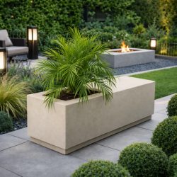  Bench trough  Rustic, Dark Grey and Sand finish — L1100 × W400 × H420mm, 25kg. | 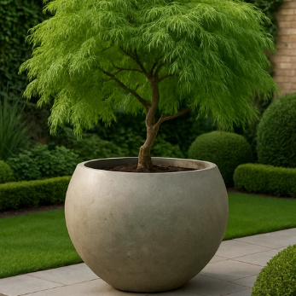  Rustic Bowl planter  Rustic, Dark Grey or Sand finish — 280–1100 × H210–720mm, 2.5–50kg

OTHER RANGES
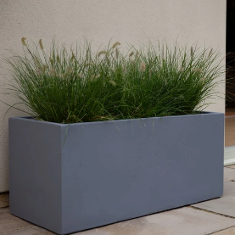  Smooth Urban  Trough — L600–1000 × D280–450 × H280–450mm, 8.5–30kg  Box — L240–500 × D240–500 × H240–500mm, 4.0–18kg  Colours: Black, Grey, White | 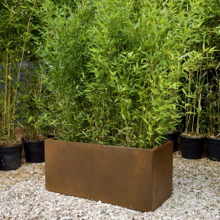  Corten  Trough — L600–1200 × D280–600 × H280–600mm, 8.5–35kg  Cylinder — Ø250–1000 × H250–1000mm, 4.0–60kg  Box — L240–500 × D240–500 × H240–500mm, 4.0–18kg  Finish: weathering-steel Corten (single signature finish)

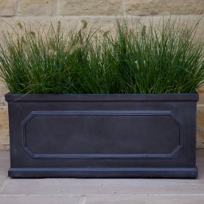  Chelsea  Box — L220–650 × D220–650 × H220–650mm, 3.0–25kg  Trough — L500–1000 × D160–450 × H170–450mm, 4.5–25kg  Cylinder — Ø220–650 × H220–650mm, 3.0–25kg  Finish: Chelsea natural (single signature finish) | 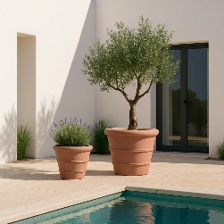  Terracotta Lined Pot  Lined pot — 250–730mm × H190–540mm, 3.0–35kg  Finish: Terracotta (single signature finish)
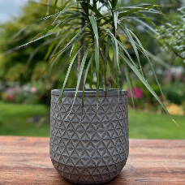
Patterned Outdoor Planters
Planter — Ø250–500 × H250–500mm, 3.0–13kg
Designs: Flower, Tropical, Geometric, Fern — in Dark Grey or White Grey

