HYDC Executive Alignment Assessment™
Closing the Acceleration Gap™
A strategic self-assessment for leadership teams navigating growth, AI disruption and organisational change.


AI may accelerate operations. Alignment accelerates growth.
Use this self-assessment before a prospect meeting, leadership discussion or strategy workshop to identify where pressure may be building beneath the surface.

1. Why This Matters Now
Most organisations are operating at 70mph externally and 40mph internally.
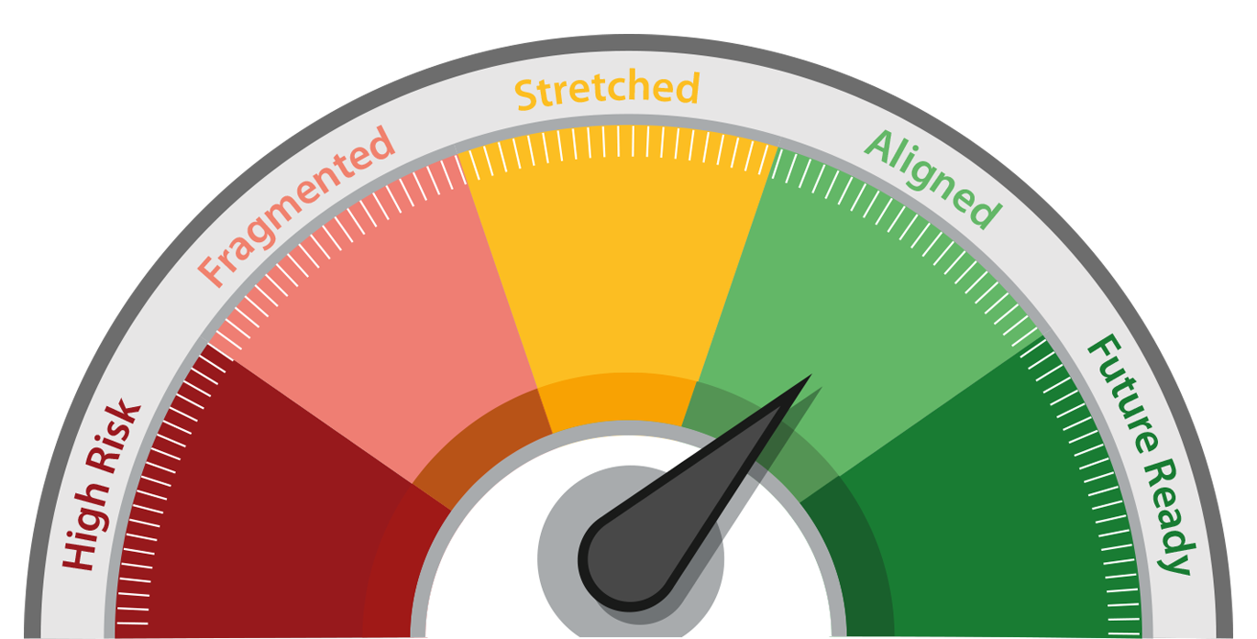

AI is accelerating customer expectations, innovation cycles, competitive movement, decision-making and organisational complexity. The risk is not simply moving too slowly – it is moving quickly without shared direction.
Many businesses remain constrained by unclear priorities, leadership misalignment, capability gaps, sliced execution and inconsistent positioning. This assessment helps reveal where human alignment is needed to convert acceleration into growth.
The challenge is no longer speed. The challenge is alignment.

2. The Alignment Barometer™
Dimension | 1 - Critical Misalignment | 3 – Functional but Vulnerable | 5 – Future-Ready Alignment
Market Clarity | Reactive, unclear future direction | Aware of shifts but action is fragmented | Foresight drives clear opportunity choices
Positioning Strength | Confused market perception | Clear internally, less sharp externally | Distinct, scalable market position
Leadership Alignment | Conflicting priorities and slow decisions | Broad agreement, inconsistent execution | Unified leadership and momentum
Team Capability | Overwhelm, resistance or unclear roles | Capable but stretched under pressure | Confident, adaptive and ready to change
Execution Flow | Silos and friction slow delivery | Delivery works, but momentum varies | Cross-functional execution is aligned and agile

Total score | Status | What it means | Recommended action
1-5 | High Risk | Significant strategic and organisational misalignment | Prioritise an Alignment Diagnostic Workshop
6-10 | Fragmented | Internal friction is slowing execution and confidence | Map pressure points and define a realignment plan
11-15 | Stretched | Growth is possible, but pressure is emerging | Strengthen leadership alignment and execution flow
16-20 | Aligned | Clear direction with manageable pressure points | Build future readiness through structured alignment
21-25 | Future Ready | Strategically aligned and adaptive | Maintain momentum through foresight and periodic reviews

How to score: For each statement, score 1-5.
1 = not true / critical pressure
3 = partly true / inconsistent
5 = consistently true / future-ready
Add the five-dimension scores to get your Barometer result.

- Market Clarity
Do we understand where the market is moving?
Statement | 1 | 2 | 3 | 4 | 5
We have a clear view of market shifts, macro trends and AI-led disruption.
We know which opportunities are most relevant to our next phase of growth.
Our decisions are informed by insight, not only by short-term pressure.
We understand how customer expectations are changing.
We can translate complexity into clear strategic direction.

Dimension Score /5:

Positioning Strength
Are we clearly differentiated?
Statement | 1 | 2 | 3 | 4 | 5
Our proposition is easy for prospects, customers and partners to understand.
Our leadership team can describe our value consistently.
Our positioning reflects where the market is going, not only where it has been.
Our brand, product and commercial narrative are working together.
Sales and marketing teams have a clear story to take to market.

Dimension Score /5:

- Leadership Alignment
Is leadership moving in the same direction?
Statement | 1 | 2 | 3 | 4 | 5
The leadership team is aligned around the same strategic priorities.
Decision-making is clear, timely and commercially confident.
Different departments understand how their work contributes to the strategy.
Change is communicated consistently across the organisation.
Leadership behaviour creates confidence rather than confusion.

Dimension Score /5:

Team Capability & Adaptability
Can the organization absorb change?
Statement | 1 | 2 | 3 | 4 | 5
Teams understand what is changing and why
it matters.
Managers are equipped to lead through uncertainty and pressure.
Roles, responsibilities and expectations
are clear.
People feel confident enough to adapt, contribute and take ownership.
Capability development is connected to
future business needs.

Dimension Score /5:

- Execution Flow
Can strategy move effectively across the business?
Statement | 1 | 2 | 3 | 4 | 5
Strategy translates into practical action across departments.
Teams collaborate without unnecessary silos or duplicated effort.
Momentum is maintained from leadership intent through to delivery.
Commercial, brand, product and people decisions are connected.
Progress can be measured and adjusted without losing strategic direction.

Dimension Score /5:

Score Summary
Dimension | Score /5
Market Clarity
Positioning Strength
Leadership Alignment
Team Capability & Adaptability
Execution Flow
TOTAL SCORE / 25

Your Barometer Results
Your score is not a measure of business success today. It is a measure of how prepared your organization is to sustain growth tomorrow.

Total Score | Status | Meaning | Recommended Action
1–5 | High Risk | Significant strategic and organisational misalignment | Prioritise an Alignment Diagnostic Workshop
6–10 | Fragmented | Internal friction is slowing execution and confidence | Map pressure points and define a realignment plan
11–15 | Stretched | Growth is possible, but pressure is emerging | Strengthen leadership alignment and execution flow
16–20 | Aligned | Clear direction with manageable pressure points | Build future readiness through structured alignment
21–25 | Future Ready | Strategically aligned and adaptive | Maintain momentum through foresight and periodic reviews

Prompt for prospects
If your market is moving at 70mph but your positioning, leadership and
teams are still operating at 40mph, HYDC helps close the Acceleration Gap.

What happens next?
This assessment is designed to stimulate discussion rather than provide definitive answers. Many organisations that appear successful externally still operate within the Stretched zone because leadership alignment, positioning and capability have not kept pace with market acceleration.
The most valuable insight often lies in understanding where different leaders score differently. That is where hidden friction, opportunity and future growth potential often reside.

Following review with HYDC, you will receive:
- Alignment Profile
- Executive observations
- Pressure point analysis
- Recommendations
- Suggested next steps

Reflection prompts
- Where is the greatest pressure showing up?
- Which dimension is most exposed by AI, market change or growth ambition?
- Where is internal capability lagging behind external speed?
- What needs to be realigned in the next 90 days?

Suggested call to action:
Share your score with HYDC to explore where clarity, positioning,
leadership alignment or team capability could unlock faster, more
confident growth.

