Family Wellbeing
We hope some of the resources in this booklet can help you and your family access support if you need it

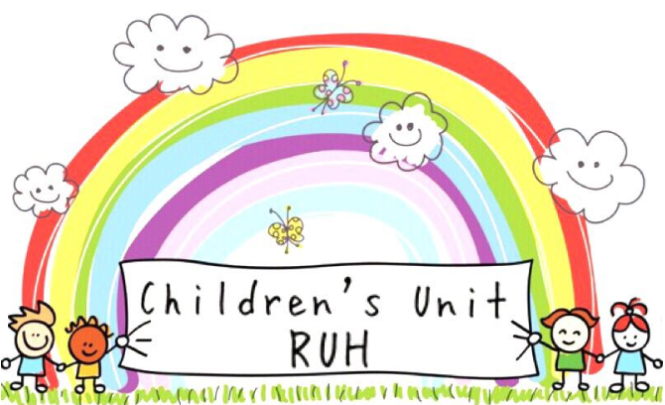


Help with Income
If you are struggling to manage your money or have debt problems get support from:

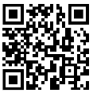
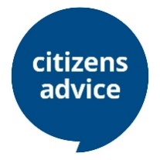
Citizens Advice
Benefit advice, legal advice & more
BANES www.cab-banes.org, 0344 848 7919
Wiltshire www.citizensadvicewiltshire.org.uk
0800 144 8848
National: www.citizensadvice.org.uk

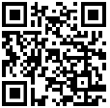
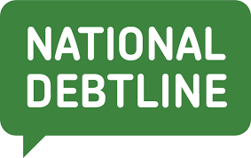
National Debt Line
Free independent debt advice over the phone and online.
0800 808 4000, www.nationaldebtline.org

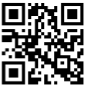
Turn to Us

Help to access welfare benefits, charitable grants and other financial help. Check you are getting everything you are entitled to with their benefits calculator www.turn2us.org.uk

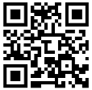
Debt Free Southwest

Free independent debt advice in the South West. 0800 138 3422 debtfreesouthwest.uk

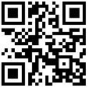

Money Helper
Guidance, debt advice and tools making money choices clearer.
0800 011 3797 MoneyHelper.org.uk

Access Essentials

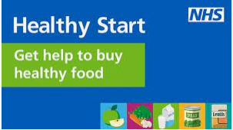
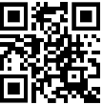
Healthy Start
If you’re pregnant or have a child under 4, the Healthy Start scheme can help you buy healthy foods like milk or fruit and get free vitamins: www.healthystart.nhs.uk

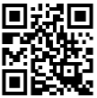

Shelter
Advice, support, legal services for people struggling with bad housing / homelessness 0344 515 1430, www.shelter.org.uk

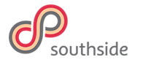
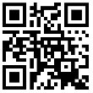
Southside
Southside supports families and individuals in Bath & NE Somerset, including domestic violence support, parenting support & much more. 01225 331243, south-side.org.uk

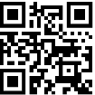

Refuge
Freephone, 24-hour National Domestic Abuse Helpline. 0808 2000 247, refuge.org.uk

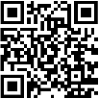

Sure Start Maternity Grant
A sure start maternity grant is £500.
Check eligibility and apply at up to 6 months of age www.gov.uk/sure-start-maternity-grant.

Healthcare Travel Cost Scheme
If you're referred to hospital (outpatients) you may be able to claim a refund of travel costs. Search NHS Healthcare Travel Costs Scheme
Support Wellbeing

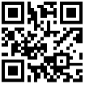
Mind
Mental health support for young people and adults

Wiltshire: www.wiltshiremind.co.uk
Bath: 01225 316199, bathmind.org.uk.
National: 0300 123 3393, www.mind.org.uk

Off the Record
Mental health & wellbeing support for young people 11-25
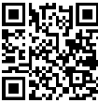

BANES: 01225 312 481,
www.offtherecord-banes.co.uk

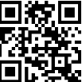
North Somerset: 0808 808 9120, otrnorthsomerset.org.uk

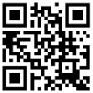

Kooth
Safe and anonymous online support and counselling for young people. www.kooth.com

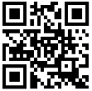
The Mix
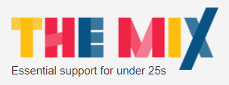
Advice and support from mental health to money, homelessness, work, break-ups, drugs and more. www.themix.org.uk

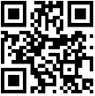
Happy Maps

Resources recommended by parents & professionals to help manage challenging behaviour, sleep problems, bullying, children’s mental health and more www.happymaps.co.uk

Community Wellbeing Hub
Accessing support can be difficult to do on your own. Call the community wellbeing hub to get friendly advice over the phone
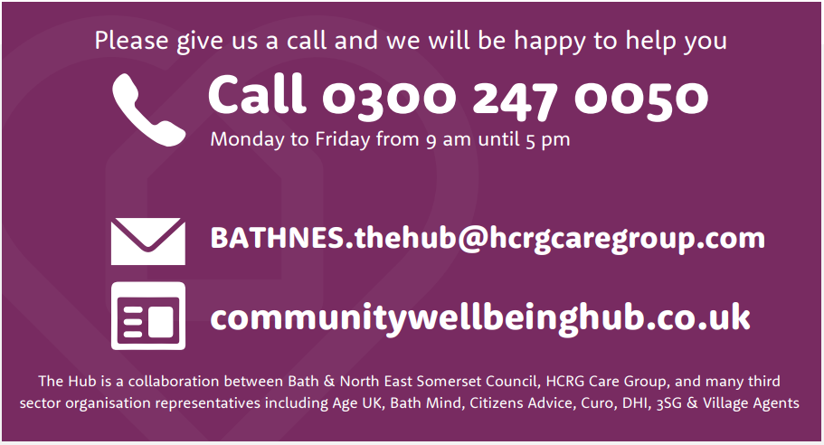
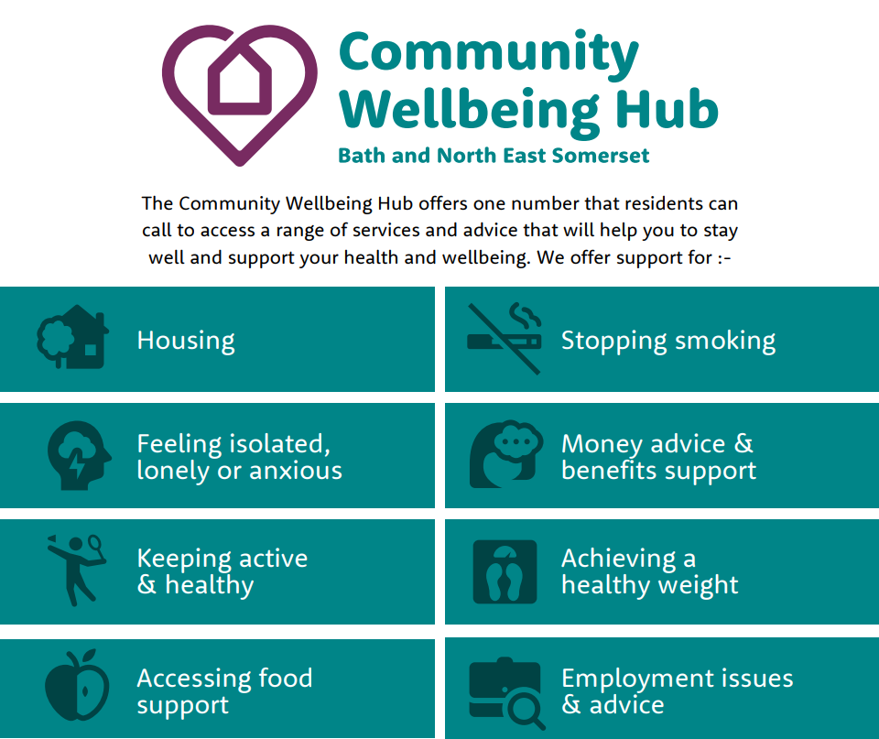

Children’s Centres
Children’s Centres are for parents and carers with children under five. They offer a range of activities and support services to help with all aspects of parenting, through regular groups available to everyone, as well as more specialised courses and programmes.

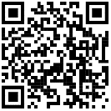
BANES:
Scan the QR code to access registration or
visit: beta.bathnes.gov.uk/childrens-centre-services

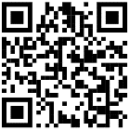
Wiltshire:
Scan the QR code to access registration or
visit: wiltshirechildrenscentres.org.uk

Or search your local council website to find your nearest
Children’s centre

Advice for when your child is unwell
For trustworthy advice on what to do if your child is unwell we recommend the following resources

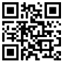
NHS Healthier Together Website
Excellent resources for child health and wellbeing
available in multiple languages
Visit https://what0-18.nhs.uk or scan here:

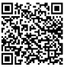
HANDiApp
Advice for common childhood conditions
Search for HANDiApp in your app store or
scan here to download for free:

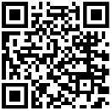
Medicines for Children
For practical and reliable advice about giving
medicines to your child
Visit https://www.medicinesforchildren.org.uk/
or scan here:

If you would like this information in an electronic format please use the QR code below:
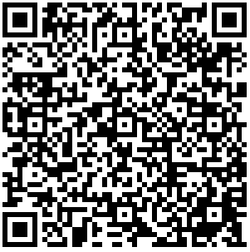

https://www.ruh.nhs.uk/patients/patient_information/PAE108_Wellbeing_support_for_families.pdf

Royal United Hospitals Bath NHS Foundation Trust
Combe Park, Bath, BA1 3NG
01225 428331 | www.ruh.nhs.uk

Please contact the Patient Advice and Liaison Service (PALS) if you require this leaflet in a different format, or would like to feedback your experience of the hospital. Email ruh-tr.pals@nhs.net or telephone 01225 82565Date of publication: February 2023 | Ref: PAE108
© Royal United Hospitals Bath NHS Foundation Trust

Notes:

