Title of Extended Abstract Using 18 Point Times New Roman Boldface Type and Initial Capitals

Author Name
Organization
City, State/Province, Country

1 Author instructions for 29th ICDERS Extended Abstracts
A complete extended abstract must be submitted in the length and format intended for final publication in the 29th ICDERS electronic proceedings. Specially, a submitted abstract should be at least 4 pages but must have a maximum of 6 pages, strictly. Please use this Word template to create your extended abstract file and convert the word file into Adobe Acrobat .pdf format. Authors must submit extended abstracts in Adobe Acrobat .pdf format only. Please embed all fonts (select this option when converting file to PDF) in your document. Microsoft Word is also an acceptable format with file size less than 5MB; all graphics must be embedded (do not link), either within the text or at the end of the paper. The extended abstract must be submitted to the scientific committee as a pdf file named after the first-author name (i.e. "firstauthorlastname-papernumber.pdf"). Templates margins and text area are set so printed abstracts fit best to the A4 ISO paper size and should not be changed. Font sizes should also not be changed. Please also do not change the position of the first line of the title. Note that headers and footers for the title page are different from those of pages 2 onward. Headers of the title page and footers of other pages must not be changed. Only the left footer of the title page and the headers of other pages must be changed according to the following rules: For the title page: left foot: indicate the correspondence details, center foot: leave empty, right foot: leave unchanged For other pages: left header: indicate the first author name (see example) center header: leave empty, right header: indicate the short title of your extended abstract LaTex typesetting is strongly encouraged. Do not enter any copyright statement on your abstract: a general copyright statement will be made by the editors in the ICDERS electronic proceedings.

2 Text Continued
Continue your text here.
Continue your text here.
Continue your text here.
Continue your text here.
Continue your text here.
Continue your text here.

3 An Example of a Simple Equation
The Eikonal ray equation:
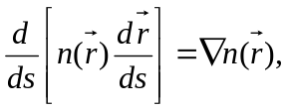
where 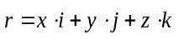 is the position vector of a point on the ray and ds is an element of the arc length along the ray. The details of the reconstruction are given in [5] and illustrated on Fig. 2.

4 Examples of Figures and Tables
Sample figure:
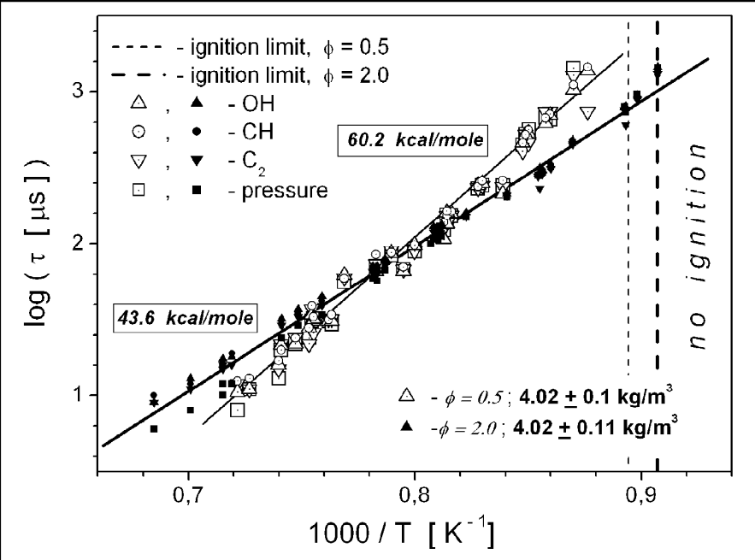
Figure 1: Ignition time vs. reciprocal temperature in lean and rich ethylene/air mixtures for mid post-shock density behind RSW [4].
Continue your text here.
Continue your text here.
Continue your text here.
Continue your text here.
Continue your text here.
Continue your text here.
Continue your text here.
Continue your text here.

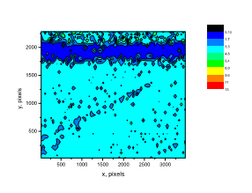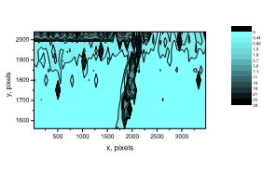
Figure 2: Contours of normalized density. Left: Density gradients isoline in transonic flow, obtained by digital laser speckle photography. Right: Magnified fragment of the flowfield.
Sample table:
Table 1: Characteristics of some prehistoric films for high speed diagnostics.
Type | Resolution, line/mm | Exposure for D = 1, 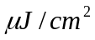 | Remarks
Agfa 8E75 | 5 000 | 10 | λ = 632.8nm
Agfa 8E56 | 5 000 | 15  25 | λ = 476nm  λ = 521nm
Agfa 10E56 | 2 800 | 1.4  1.9 | λ = 476nm  λ = 521nm
Agfa 10E75 | 2 800 | 2 | λ = 632.8nm
Agfa 14C70 | 1 500 | 0.3 | λ = 700nm
Agfa 14C75 | 1 500 | 0.3 | λ = 700nm
Kodak 649F | 2 000 | 70  500 | λ = 632.8nm  λ = 694.3nm
Kodak 125 | 1 250 | 2  5 | λ =441.6nm  λ = 514.5nm
Kodak 131 | 1 250 | 0.5-0.8 | λ = 632.8nm
Kodak 120-02 | 1 250 | 33 | λ = 694.3nm
Kodak TP 2415 | 320 | 0.15 | λ = 694.3nm

References
[1] Bazhenova TV, Soloukhin RI. (1958). Gas ignition behind shock waves. Proc. Combust. Inst. 7: 866.
[2] Oppenheim AK. (1966). Novel Insight into the detonation process. Acta Astronaut. 11: 391.
[3] Lee JHS. (1977). Initiation of gaseous detonation. Ann. Rev. Phys. Chem. 28: 75.
[4] Penyazkov OG, Ragotner, KA, Dean AJ, Varatharajan B. (2005). Autoignition of propane-air behind reflected shock waves. Proc. Combust. Inst. 30: 1941.
[5] Brossard J, Fomin N, Soloukhin R. (1979). Shock tube ignition and detonation studies by resonance (10.6 μn) absorption in propane. Acta Astronaut. 24: 861.
[6] Zel'dovich YaB , Barenblatt, GI, Librovich, VB, Makhviladzw GM. (1985). The mathematical theory of combustion and explosions. Plenum Publishing Corporation (ISBN 0-306-10974-3).

