WORKING TEMPLATE | GUIDANCE MARKED FOR DELETION


The Guided Carbon Reduction Plan
An editable PPN 006 aligned template with practical guidance, worked examples and preparation checklists
Created by Joanna Whitear at Evergreen Assessment, helping NHS and public sector suppliers create credible Carbon Reduction Plans, meet procurement requirements and turn commitments into practical action.
Template version 1.1 | Reviewed 4 October 2026

How to use this template
The publishable plan begins after the working guidance. Keep the formal headings and declarations, replace every yellow field, and remove every item carrying the red deletion label. The two substantive labels distinguish mandatory content from additions that improve credibility and usefulness.
■ REQUIRED
Content required by the current PPN 006 template or reporting standard. Complete it or provide a clear, acceptable explanation where the guidance permits this.
◆ MAKE YOUR PLAN BETTER
Content that is not expressly required but strengthens transparency, governance, comparability or delivery.
⚠ DELETE BEFORE PUBLISHING
Coaching notes, examples and prompts for the preparer. Remove them before board approval, signature or publication.

Scope of this template
Use this template for PPN 006: UK operations as a minimum, Scope 1 and Scope 2, and the five specified Scope 3 categories. Keep supporting calculations and evidence alongside the plan.
For NHS procurements from 1 April 2027, check the buyer’s reporting tier. The broader 2027 NHS CRP tier requires global reporting and all relevant Scope 3 categories, considering all 15. Where it applies, extend this template’s five-category tables and UK-only commitment.
Key sources: PPN 006 | Technical standard | NHS requirements from April 2027 | GHG Protocol Corporate Standard
This template is general guidance, not a guarantee that a particular tender response will pass. Always follow the tender documents where they impose additional or different requirements.

Before you start
⚠ DELETE BEFORE PUBLISHING
A Carbon Reduction Plan is the public summary. The calculations, evidence and decisions behind it are what make it credible. Complete this working checklist before drafting the formal plan.

Confirm what the plan is for
☐ Identify the tender, framework or customer requirement driving the plan.
☐ Check the submission deadline and any buyer specific instructions.
☐ Confirm the exact legal entity that will bid for or deliver the contract.
☐ Check the current PPN 006 guidance rather than relying on an older plan or a consultant summary.
☐ If you supply the NHS, confirm the required reporting tier. For the broader 2027 NHS CRP tier, extend the boundary, commitment and Scope 3 reporting before using this template.
☐ Confirm that the reporting period will be sufficiently recent for the intended tender.

Create a working folder
Use one shared location that another person can understand and update next year. Suggestion:
Folder | Contents
01 | Guidance and tender requirements
02 | Organisational boundary
03 | Source data
04 | Carbon calculations
05 | Assumptions and evidence
06 | Drafts and approvals
07 | Final published plans

Use filenames containing the reporting year, subject and version. Avoid “final”, “final revised” and “final final”.

Agree the reporting boundary
◆ MAKE YOUR PLAN BETTER ⚠ DELETE BEFORE PUBLISHING
Choose one consolidation approach and apply it consistently. For a straightforward single entity business, operational and financial control may produce the same result. The distinction matters more for groups, joint ventures, shared premises, franchises and complex leases.
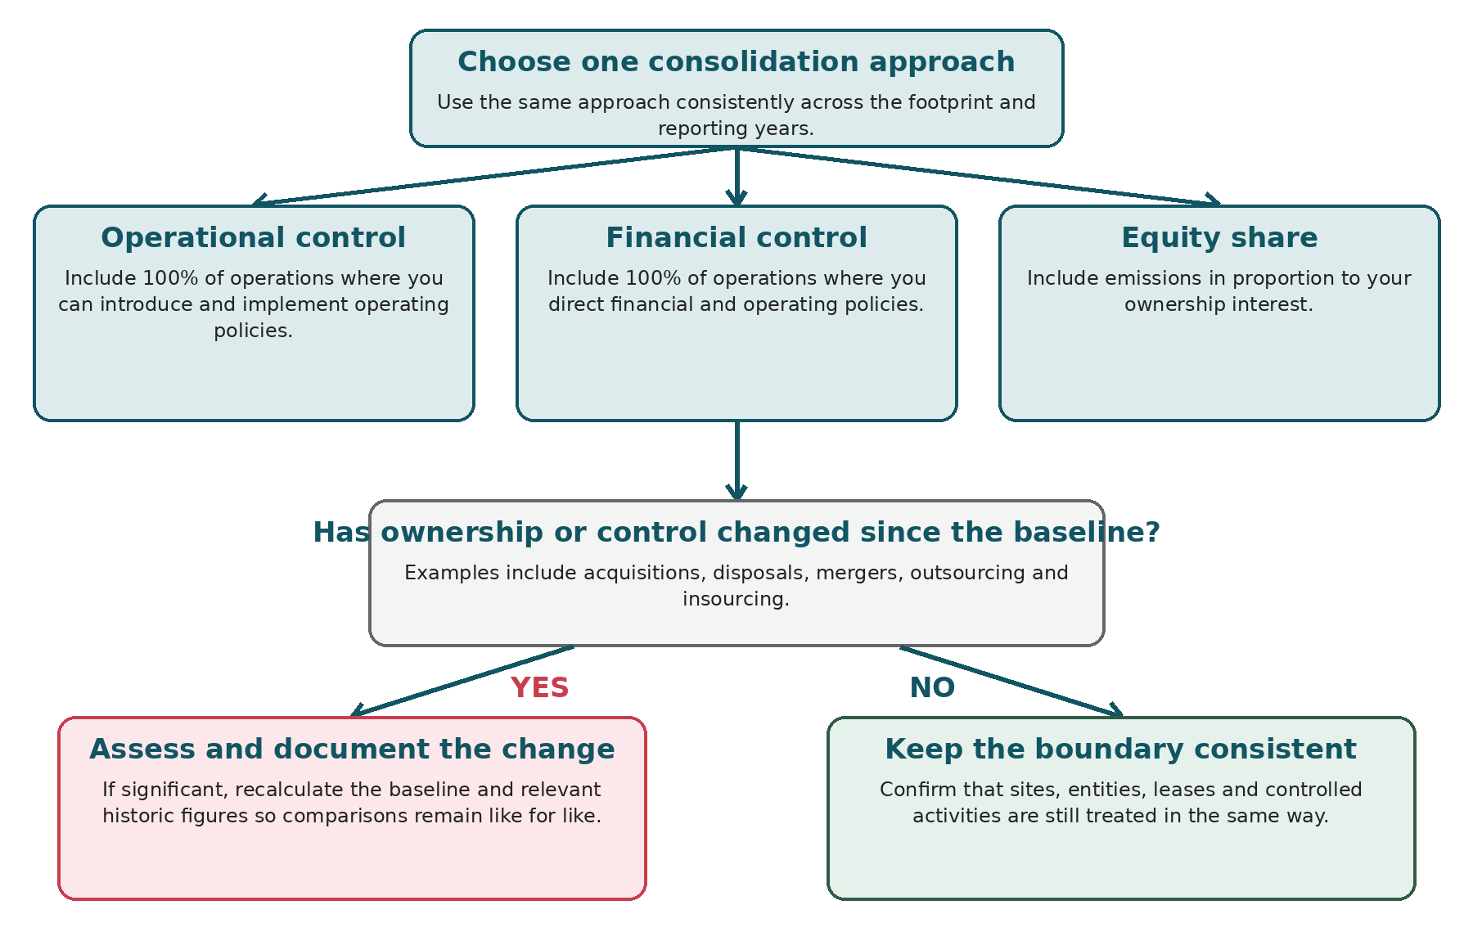
Figure 1 Organisational boundary decision tree

Definitions
Approach | Plain English definition
Operational control | Report 100% of emissions from operations where the organisation has authority to introduce and implement operating policies.
Financial control | Report 100% of emissions from operations where the organisation directs financial and operating policies, such as setting budgets and approving expenditure.
Equity share | Report emissions in proportion to the organisation’s percentage ownership interest.

Record why the chosen approach reflects how the organisation is structured and managed.


Boundary working record
Entity site or operation | Relationship | Control judgement | Included scope | Evidence or rationale
<Insert> | <Owned, leased, joint venture or other> | <Operational financial equity or outside control> | <Scope 1, 2 or relevant Scope 3> | <Lease group chart policy or explanation>
<Insert> | <Insert> | <Insert> | <Insert> | <Insert>
<Insert> | <Insert> | <Insert> | <Insert> | <Insert>

If the organisation has changed since the baseline
A significant acquisition, sale, merger, insourcing or outsourcing may require the baseline and relevant historic figures to be recalculated. This preserves a like-for-like comparison and prevents a transfer of emissions from being presented as a reduction. Record the original baseline, recalculated baseline, method, reason and approval. If reliable historic data are unavailable, explain the limitation and consider whether a new baseline is more appropriate.
Weak wording | Improved wording
Emissions fell by 30% because we sold one division. | During the year we disposed of Division A. Its emissions have been removed from the baseline and comparative years. On a like-for-like basis, emissions from continuing operations changed by <x>% due to <drivers>.

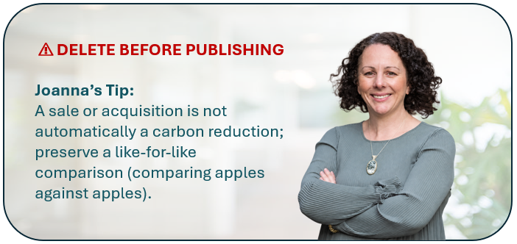

Need help with the boundary or calculations
⚠ DELETE BEFORE PUBLISHING
Not sure which entities to include, or how to handle missing data? I can help you work through the boundary and calculations, or review your draft before publication.
Ask Joanna a question or request a Carbon Reduction Plan review

Data collection checklist
◆ MAKE YOUR PLAN BETTER ⚠ DELETE BEFORE PUBLISHING
Nominate one coordinator, agree a reporting period, identify data owners and retain original records. Use reasonable estimates when primary data are genuinely unavailable, but document the method and improvement action.
Data area | Collect | Possible evidence | Ready
Boundary and organisation | Legal entities, sites, leases, vehicles, headcount or FTE, operating changes | Company records, leases, organisation chart | ☐
Scope 1 fuels | Gas, oil, LPG or other fuels used in controlled buildings or equipment | Invoices, meter readings, landlord data | ☐
Scope 1 vehicles | Fuel or mileage for owned or controlled vehicles | Fuel cards, telematics, mileage logs | ☐
Scope 1 refrigerants | Plant list and refrigerant top ups or leaks | F gas log, maintenance records | ☐
Scope 2 energy | Purchased electricity, heat, steam or cooling | Invoices, meters, landlord statements | ☐
Scope 3 Category 4 | Inbound freight and purchased transport services | Supplier data, courier records, freight spend | ☐
Scope 3 Category 5 | Waste quantity, type and treatment route | Waste transfer notes, contractor reports | ☐
Scope 3 Category 6 | Business mileage, rail, air, hotels and taxis | Expenses, travel portal, mileage claims | ☐
Scope 3 Category 7 | Commute distance, mode, attendance and homeworking | Staff survey, HR attendance data | ☐
Scope 3 Category 9 | Outbound transport not paid for by the reporting company | Carrier or distributor data | ☐
Intensity denominator | Revenue, output, care hours, units or FTE where useful | Finance or operational system | ☐
Approvals | Reviewer, board meeting, signatory and publication owner | Governance timetable | ☐

Data owner tracker
Data item | Owner | Requested | Received | Evidence saved | Follow up
<Insert> | <Name role> | <Date> | <Date> | ☐ | <Action date>
<Insert> | <Name role> | <Date> | <Date> | ☐ | <Action date>
<Insert> | <Name role> | <Date> | <Date> | ☐ | <Action date>

Peer review exercise
◆ MAKE YOUR PLAN BETTER ⚠ DELETE BEFORE PUBLISHING
Review three recent plans from comparable organisations. The purpose is to identify useful questions and common weaknesses, not to copy figures, exclusions or wording.
Assessment point | Peer 1 | Peer 2 | Peer 3
Organisation and plan link | <Insert> | <Insert> | <Insert>
Publication and reporting dates | <Insert> | <Insert> | <Insert>
Clear reporting entity and boundary | Yes No Unclear | Yes No Unclear | Yes No Unclear
All five required Scope 3 categories addressed | Yes No Unclear | Yes No Unclear | Yes No Unclear
Data limitations explained | Yes No | Yes No | Yes No
Absolute target and trajectory shown | Yes No | Yes No | Yes No
Actions have owners dates and evidence | Yes No | Yes No | Yes No
What is worth adapting | <Insert> | <Insert> | <Insert>
What should be avoided | <Insert> | <Insert> | <Insert>

<Insert organisation logo>

Carbon Reduction Plan
<Company or bidding entity name>
■ REQUIRED
Document information
Registered address | <Insert registered address>
Company number | <Insert company number or local equivalent>
Reporting entity | <Insert exact legal entity covered by this plan>
Consolidation approach | <Operational control financial control or equity share>
Reporting period | <Start date> to <end date>
Baseline period | <Start date> to <end date>
Total reporting year emissions | <Insert total> tCO2e
Publication date | <Insert>
Version | <Insert>
Next review due | <Insert date within six months of financial year end>

⚠ DELETE BEFORE PUBLISHING
Replace all yellow text. Confirm that the reporting entity is the bidding supplier. If a parent company plan is used, check the additional PPN 006 conditions rather than assuming group coverage is sufficient.


Version control
◆ MAKE YOUR PLAN BETTER
Version | Date | Prepared by | Reviewed by | Approved by | Change summary
0.1 | <Date> | <Name> | <Name> |  | First working draft
1.0 | <Date> | <Name> | <Name> | <Board or equivalent> | Approved for publication

About the organisation and this plan
◆ MAKE YOUR PLAN BETTER
<In two or three short paragraphs describe what the organisation does where it operates the legal entity covered and why this plan has been prepared. State the reporting boundary and any important changes since the baseline.>
⚠ DELETE BEFORE PUBLISHING
Keep this factual. Do not fill the opening with generic climate language. A reader should understand the business model, scale, boundary and purpose before reaching the emissions tables.
Weak wording | Improved wording
We are committed to sustainability and protecting the planet. | <Company> provides <services or products> from <locations>. This plan covers <legal entity and operations> using the <control approach>. During the reporting year <material organisational change or “there were no material boundary changes”>.

Commitment to achieving net zero
■ REQUIRED
<Company name> is committed to achieving Net Zero greenhouse gas emissions for its UK operations by <year no later than 2050>.
⚠ DELETE BEFORE PUBLISHING
Use an approved year. Do not use “carbon neutral” as a substitute for Net Zero, and do not imply that offsets replace the need for deep emissions reductions.
Weak wording | Improved wording
We hope to become greener and reduce carbon where possible. | <Company> is committed to achieving Net Zero greenhouse gas emissions for its UK operations by 2050 at the latest. Progress will be reviewed annually against the absolute emissions trajectory in this plan.

Baseline emissions footprint
■ REQUIRED
Baseline emissions provide the reference point against which future emissions and reductions are measured.
Baseline period: <start date> to <end date>
Additional baseline details: <Explain why this period was selected the organisational boundary any missing historic categories structural changes recalculations estimates and limitations.>
⚠ DELETE BEFORE PUBLISHING
Use the earliest relevant period for which sufficiently reliable data are available. If this is the first inventory, say so. If a significant acquisition, disposal, restructuring, boundary change or error affects comparability, explain whether the baseline has been recalculated or replaced.
Weak wording | Improved wording
2024 was chosen because it is the most recent year. | The 2024 calendar year is our baseline because it is the earliest complete 12 month period for which Scope 1, Scope 2 and the five required Scope 3 categories could be estimated. Employee commuting uses a staff survey covering 72% of employees, with non respondents extrapolated by work location.

Baseline emissions | tCO2e | Data status | Main evidence or limitation
Scope 1 | <Insert> | <Actual estimated zero unavailable> | <Insert>
Scope 2 | <Insert> | <Insert> | <Insert>
Scope 3 Category 4 | <Insert> | <Insert> | <Insert>
Scope 3 Category 5 | <Insert> | <Insert> | <Insert>
Scope 3 Category 6 | <Insert> | <Insert> | <Insert>
Scope 3 Category 7 | <Insert> | <Insert> | <Insert>
Scope 3 Category 9 | <Insert> | <Insert> | <Insert>
Other Scope 3 categories included | <Insert> | <Insert> | <Insert>
Total emissions | <Insert>

Understanding data status
◆ MAKE YOUR PLAN BETTER
Term | Meaning | How to report it
Zero or nil | The activity is in scope but the measured or evidenced activity value is zero. | State the source of confirmation. Do not use zero simply because no data were supplied.
Unavailable | The activity may occur, but reliable primary data are not held. | Use a reasonable estimate or proxy where practicable, explain the method, and set an improvement action.
Immaterial | A screening calculation indicates that the source is small in the context of the inventory. | Record the screening basis. A required category should still be addressed; “immaterial” is not a blanket permission to omit it.
Excluded | The source is outside the chosen boundary or reporting set, or has been deliberately omitted for a stated reason. | Explain the boundary and rationale. Do not silently exclude a required source.
Not applicable | The relevant activity does not occur in the organisation. | Report nil and explain why the category does not apply.

Weak wording | Improved wording
Business travel: 0 tCO2e. No information was available. | Business travel data were not held centrally. We reviewed the expense ledger and identified <items>. Rail and hotel data are actual; taxi travel is estimated from spend. A dedicated expense code will be introduced by <date>.

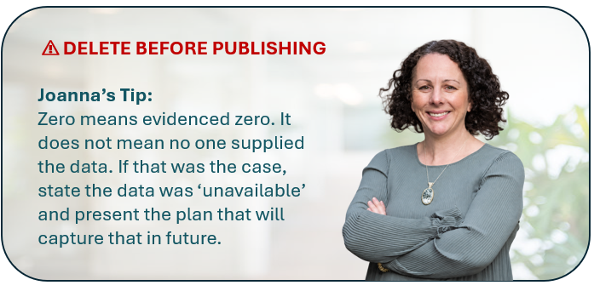

Calculation methodology
◆ MAKE YOUR PLAN BETTER
<State the reporting standards used consolidation approach emission factor set location or market based Scope 2 approach rounding treatment use of estimates and whether the inventory has been assured.>
Weak wording | Improved wording
We used standard carbon factors and best available data. | The inventory follows the GHG Protocol Corporate Standard and the PPN 006 technical standard using operational control. Calculations use the UK Government <year> conversion factors. Scope 2 is reported on a location based basis. Figures are calculated using unrounded values and rounded only for presentation. The inventory has not been independently assured.

Required Scope 3 categories
■ REQUIRED
PPN 006 requires the defined subset below to be addressed alongside all Scope 1 and Scope 2 emissions. Use the category boundary, not the everyday meaning of words such as delivery or travel.
Category | What it covers | Useful evidence | Common mistake
4 Upstream transportation and distribution | Transport and distribution of purchased goods between tier 1 suppliers and your operations; purchased transport services; relevant transport between your sites in vehicles or facilities not owned or controlled by you. | Freight invoices, courier reports, supplier data, separately identifiable transport spend. | Leaving it blank because freight is embedded in the price; confusing goods spend with transport emissions.
5 Waste generated in operations | Third party disposal and treatment of waste generated by your operations. | Weights, bin size and collections, waste transfer notes, contractor reports, treatment route. | Reporting recycling percentages without calculating treatment emissions; assuming zero where landlord data are absent.
6 Business travel | Employee travel for business in vehicles not owned or operated by the company, including mileage claims, rail, air, taxis and hotels where relevant. | Expense ledger, mileage claims, travel platform, card statements. | Using only mileage reimbursements and missing rail, hotel or company card bookings.
7 Employee commuting | Travel between employees’ homes and workplaces. Homeworking may also be reported where useful and should be treated consistently with attendance assumptions. | Staff survey, postcodes handled appropriately, attendance days, mode, distance and occupancy. | Assuming everyone drives five days a week; deducting avoided commutes without evidence.
9 Downstream transportation and distribution | Transport and distribution of sold products between your operations and the end customer where it is not paid for by your company. | Distributor or carrier data, customer delivery arrangements. | Using Category 9 for outbound transport purchased by your company; reporting zero without explaining a service based model.

Scope 3 completion record
Category | Applies | Method | Result tCO2e | Explanation or evidence
4 Upstream transport | Yes No | <Actual estimate or not applicable> | <Insert> | <Insert>
5 Waste | Yes No | <Insert> | <Insert> | <Insert>
6 Business travel | Yes No | <Insert> | <Insert> | <Insert>
7 Commuting | Yes No | <Insert> | <Insert> | <Insert>
9 Downstream transport | Yes No | <Insert> | <Insert> | <Insert>

Calculation source register
◆ MAKE YOUR PLAN BETTER ⚠ DELETE BEFORE PUBLISHING
Keep the detailed calculation workbook outside the published plan. This register provides the audit trail from the published total back to activity data, evidence and factors.
ID | Emission source | Scope or category | Activity data and unit | Evidence file or system | Factor source and year | Result tCO2e
C01 | <Insert> | <Insert> | <Value unit> | <Filename link or system> | <DESNZ year tab factor> | <Insert>
C02 | <Insert> | <Insert> | <Value unit> | <Insert> | <Insert> | <Insert>
C03 | <Insert> | <Insert> | <Value unit> | <Insert> | <Insert> | <Insert>
C04 | <Insert> | <Insert> | <Value unit> | <Insert> | <Insert> | <Insert>

Assumptions exclusions and improvement register
ID | Assumption exclusion or proxy | Reason and evidence | Potential effect or uncertainty | Owner | Improvement and due date | Status
A01 | <Insert> | <Insert> | <High medium low or range> | <Name role> | <Action date> | Open
A02 | <Insert> | <Insert> | <Insert> | <Insert> | <Insert> | Open
A03 | <Insert> | <Insert> | <Insert> | <Insert> | <Insert> | Open


Current emissions reporting
■ REQUIRED
Reporting period: <start date> to <end date>
Current reporting year emissions | tCO2e | Change from recalculated baseline | Data status
Scope 1 | <Insert> | <Insert tCO2e and %> | <Insert>
Scope 2 | <Insert> | <Insert> | <Insert>
Scope 3 Category 4 | <Insert> | <Insert> | <Insert>
Scope 3 Category 5 | <Insert> | <Insert> | <Insert>
Scope 3 Category 6 | <Insert> | <Insert> | <Insert>
Scope 3 Category 7 | <Insert> | <Insert> | <Insert>
Scope 3 Category 9 | <Insert> | <Insert> | <Insert>
Other Scope 3 categories included | <Insert> | <Insert> | <Insert>
Total emissions | <Insert> | <Insert>

<Explain the current year methodology major assumptions limitations boundary changes and factor set. State whether figures have been independently assured.>
Weak wording | Improved wording
Emissions fell by 12%, showing that our carbon programme is working. | Total emissions fell by 12%. Approximately 7 percentage points relate to the disposal of Site A and the recalculated baseline; 3 points reflect lower production; and 2 points are attributed to verified reductions from the fleet replacement programme. Improved commuting data increased Category 7 by <x> tCO2e and is reported separately from operational performance.



Year on year variance analysis
◆ MAKE YOUR PLAN BETTER
Separate genuine reductions from changes in organisational structure, activity, data quality and calculation methods. A larger footprint can reflect better information rather than worse performance.
Emission source | Baseline tCO2e | Previous year | Current year | Change % | Primary driver | Explanation and evidence
Scope 1 | <Insert> | <Insert> | <Insert> | <Insert> | <Acquisition disposal activity factor data or reduction> | <Insert>
Scope 2 | <Insert> | <Insert> | <Insert> | <Insert> | <Insert> | <Insert>
Scope 3 Category 4 | <Insert> | <Insert> | <Insert> | <Insert> | <Insert> | <Insert>
Scope 3 Category 5 | <Insert> | <Insert> | <Insert> | <Insert> | <Insert> | <Insert>
Scope 3 Category 6 | <Insert> | <Insert> | <Insert> | <Insert> | <Insert> | <Insert>
Scope 3 Category 7 | <Insert> | <Insert> | <Insert> | <Insert> | <Insert> | <Insert>
Scope 3 Category 9 | <Insert> | <Insert> | <Insert> | <Insert> | <Insert> | <Insert>
Total | <Insert> | <Insert> | <Insert> | <Insert> | <Insert> | <Insert>

Emissions reduction targets
■ REQUIRED
<State the approved absolute emissions reduction target over the next five years including baseline value target value target year and percentage reduction.>
Measure | Baseline year and value | Current year and value | Interim target | Five year target | Net zero year
Absolute emissions tCO2e | <Insert> | <Insert> | <Year value %> | <Year value %> | <Insert no later than 2050>
Optional intensity metric | <Insert> | <Insert> | <Insert> | <Insert> | Not a substitute for absolute Net Zero

⚠ DELETE BEFORE PUBLISHING
Targets should be approved, quantified and traceable to the baseline. Avoid setting a percentage without stating the tCO2e starting point and target value.
Weak wording | Improved wording
We aim to reduce emissions significantly by 2030. | Against our recalculated 2024 baseline of 240 tCO2e, we will reduce absolute emissions by 30% to no more than 168 tCO2e by 2030. Progress will be reviewed annually, with changes caused by acquisitions, disposals, methods or factors reported separately.

Absolute emissions trajectory
◆ MAKE YOUR PLAN BETTER
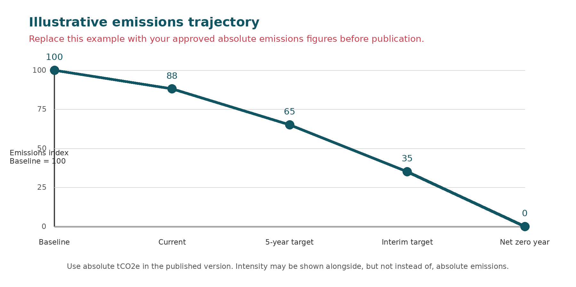
Milestone | Year | Target tCO2e | Reduction from baseline | Basis and approval
Baseline | <Insert> | <Insert> | 0% | <Insert>
Current reporting year | <Insert> | <Insert> | <Insert> | Actual or estimated
First interim milestone | <Insert> | <Insert> | <Insert> | <Insert>
Five year target | <Insert> | <Insert> | <Insert> | <Insert>
Net Zero | <Insert> | <Residual emissions and removals approach> | <Insert> | <Insert>

Intensity metrics
◆ MAKE YOUR PLAN BETTER
An intensity metric can help explain growth or service change, but it must sit alongside absolute emissions. Choose a denominator that is stable, meaningful and supported by reliable operational data.
Metric | Why it is useful | Baseline numerator and denominator | Current result | Interpretation
tCO2e per £m revenue | Useful where revenue is a stable indicator of activity. | <Insert> | <Insert> | <Explain price or mix effects>
tCO2e per unit service hour or output | Useful where delivery volume is measurable and comparable. | <Insert> | <Insert> | <Explain changes in service mix>
tCO2e per FTE | Useful for office based operations but may not reflect output. | <Insert> | <Insert> | <Explain workforce or attendance changes>



Carbon reduction projects
■ REQUIRED

Completed carbon reduction initiatives
<Describe measures completed or implemented since the baseline and the environmental management measures that will remain in effect when performing the contract. Quantify savings only where the method can be evidenced.>

Future carbon reduction initiatives
<Summarise approved or planned initiatives that support the target. Use the action plan below to identify ownership timing cost expected saving evidence and status.>
⚠ DELETE BEFORE PUBLISHING
Do not convert aspirations into completed achievements. Distinguish proposed, approved, underway and complete. If a saving has not been calculated, say “not yet quantified” rather than inventing a number.
Weak wording | Improved wording
We will encourage sustainable travel and reduce waste. | By March 2027, the Operations Director will introduce a travel hierarchy and monthly mileage reporting. The baseline is <x> miles. The expected saving is <x> tCO2e, calculated using <method>. Progress will be evidenced through mileage reports and reviewed quarterly.

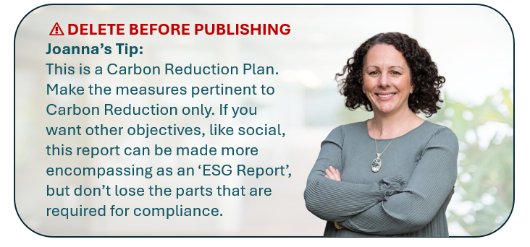

Reduction action plan
◆ MAKE YOUR PLAN BETTER
Action and emission source | Owner | Start and due date | Cost or budget | Expected saving and calculation basis | Evidence and status
<Specific action and Scope or category> | <Name role> | <Dates> | <£ or resource requirement> | <tCO2e year plus method or not yet quantified> | <Proposed approved underway complete plus evidence>
<Insert> | <Insert> | <Insert> | <Insert> | <Insert> | <Insert>
<Insert> | <Insert> | <Insert> | <Insert> | <Insert> | <Insert>
<Insert> | <Insert> | <Insert> | <Insert> | <Insert> | <Insert>
<Insert> | <Insert> | <Insert> | <Insert> | <Insert> | <Insert>



Action portfolio check
- The largest emission sources have proportionate actions.
- Every action has a named role, due date and evidence of completion.
- Savings are quantified only where a documented method exists.
- Actions required during contract delivery are clearly identified.
- Capital, operational and behavioural actions are distinguished.
- Dependencies, approvals and budget constraints are visible.

Declaration and sign off
■ REQUIRED
This Carbon Reduction Plan has been completed in accordance with PPN 006 and associated guidance and reporting standard for Carbon Reduction Plans.
Emissions have been reported and recorded in accordance with the published reporting standard for Carbon Reduction Plans and the GHG Protocol Corporate Standard and use the appropriate government emission conversion factors for greenhouse gas company reporting.
Scope 1 and Scope 2 emissions have been reported in accordance with SECR requirements where required, and the required subset of Scope 3 emissions has been reported in accordance with the published reporting standard for Carbon Reduction Plans and the Corporate Value Chain Scope 3 Standard.
This Carbon Reduction Plan has been reviewed and signed off by the board of directors or equivalent management body.
Approval field | Details
Signed on behalf of the supplier | <Insert name of exact bidding supplier>
Name | <Insert>
Job title | <Insert>
Date signed | <Insert>
Date of board or equivalent approval | <Insert>

⚠ DELETE BEFORE PUBLISHING
Do not alter the declaration casually. Confirm the plan has actually received the stated approval before publishing it. A physical signature is not required, but the director or equivalent name, title and date should be clear.


Annual update checklist
◆ MAKE YOUR PLAN BETTER ⚠ DELETE BEFORE PUBLISHING
- Confirm the reporting entity, control approach and organisational boundary.
- Record acquisitions, disposals, new sites, closed sites, leases, outsourcing and insourcing.
- Decide whether the baseline or historic figures require recalculation.
- Use a complete 12-month reporting period and the appropriate government factor set.
- Collect fresh data for Scope 1, Scope 2 and all five required Scope 3 categories.
- Update the calculation and assumptions registers and close completed data improvements.
- Explain changes caused by activity, structure, factors, methods, data quality and genuine reductions separately.
- Review absolute and intensity performance against approved targets.
- Update action owners, dates, costs, expected savings, evidence and status.
- Obtain board or equivalent approval and director or equivalent sign off.
- Publish the new plan prominently and retain earlier versions.
- Set the next review date within six months of the next financial year end.

Publication board approval and accessibility checklist
■ REQUIRED ◆ MAKE YOUR PLAN BETTER ⚠ DELETE BEFORE PUBLISHING
- The latest plan is published on the bidding supplier’s UK website in a prominent and clearly signposted location.
- The reporting period is current enough for the intended procurement.
- The board or equivalent management body has reviewed and approved the exact published version.
- The named signatory is a director, equivalent senior leader or designated member where applicable.
- The publication date, signature date and approval date are complete and consistent.
- Previous plans remain available so progress can be followed over time.
- Headings use Word heading styles and tables have meaningful header rows.
- Charts and meaningful images have alternative text or an adjacent text explanation.
- Colour is not the only way information is communicated.
- The final PDF has searchable text, readable type and logical reading order.
- All red guidance, yellow placeholders, comments and tracked changes have been removed.
- Every hyperlink works and the filename clearly identifies the organisation and reporting year.

Would this survive tender scrutiny
■ REQUIRED ◆ MAKE YOUR PLAN BETTER ⚠ DELETE BEFORE PUBLISHING
Scrutiny test | Pass | Needs action | Evidence or location
The exact bidding entity is named and the plan covers it. | ☐ | ☐ | <Insert>
The commitment is Net Zero by 2050 at the latest for UK operations. | ☐ | ☐ | <Insert>
The reporting period and publication date meet the tender requirements. | ☐ | ☐ | <Insert>
All Scope 1 and Scope 2 sources are addressed. | ☐ | ☐ | <Insert>
All five required Scope 3 categories are quantified or acceptably explained. | ☐ | ☐ | <Insert>
The figures reconcile with the calculation workbook and supporting evidence. | ☐ | ☐ | <Insert>
Zeros, unavailable data, estimates, exclusions and limitations are used correctly. | ☐ | ☐ | <Insert>
Baseline and current figures are comparable after structural changes. | ☐ | ☐ | <Insert>
Targets state absolute tCO2e values, years and percentages. | ☐ | ☐ | <Insert>
Reduction actions relate to significant sources and can be applied during the contract. | ☐ | ☐ | <Insert>
Claims of savings and progress are supported by evidence. | ☐ | ☐ | <Insert>
The declaration is complete and the exact version has been approved and signed. | ☐ | ☐ | <Insert>
The plan is prominent, accessible and publicly available on the supplier website. | ☐ | ☐ | <Insert>

Overall result: <Ready for approval Needs correction Specialist review recommended>

Official sources used in this template
⚠ DELETE BEFORE PUBLISHING
- PPN 006 Taking account of Carbon Reduction Plans
- PPN 006 technical standard for completion of Carbon Reduction Plans
- UK Government greenhouse gas conversion factors
- GHG Protocol Corporate Standard
- NHS Carbon Reduction Plan requirements from April 2027
Check these sources for updates each time you use the template. Remove this working sources section before publishing your plan.

⚠ DELETE BEFORE PUBLISHING


Would you like a second pair of eyes?
You have done the groundwork. Before you publish or submit your plan, I can review whether the document is complete, credible and ready to withstand procurement scrutiny.

A review can cover
- The reporting entity and organisational boundary
- Scope 1, Scope 2 and the five required Scope 3 categories
- Calculation logic, factors, assumptions and exclusions
- Baseline recalculations and year-on-year explanations
- Targets, trajectory and reduction actions
- The declaration, approval and publication requirements
- Clarity, accessibility and tender readiness
I will tell you what is already strong, what is missing and what should be corrected before the plan goes in front of a buyer or your board.
Request a Carbon Reduction Plan review evergreenassessment.co.uk/contact
Remove this invitation page before publishing your organisation’s Carbon Reduction Plan.

