How to do the Disability Discovery survey

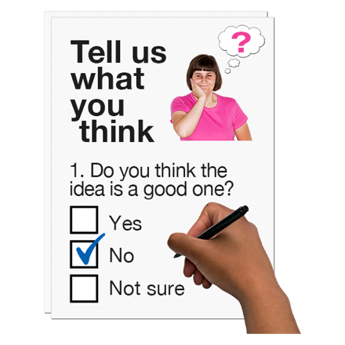 | This survey is called Disability Discovery and is part of the Disability Dialogue project.
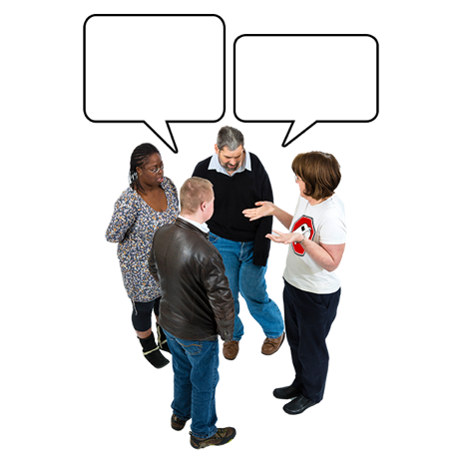 | The Disability Dialogue is a group of people who come together to talk about things they care about and want to make better.
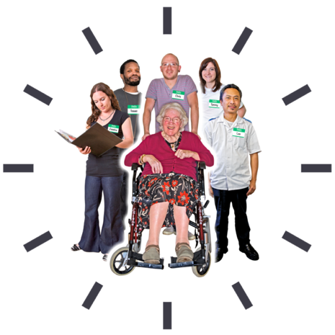 | The Disability Dialogue is made of  - People with disability  - Their family members  - Service providers  - Other people who care about people with disability
 | This information will tell you about the Disability Discovery survey and how to do it.

About the survey

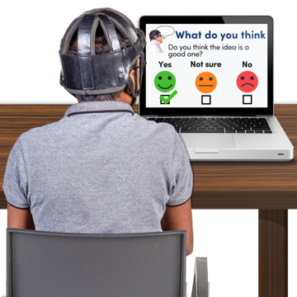 | This survey will be done online.
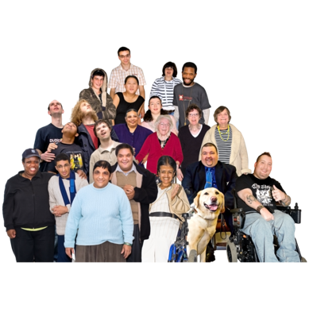 | This survey is for  - People with disability  - Their family members  - People who support people with disability
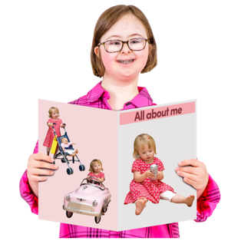 | This survey will ask you questions about yourself and about supports you use in your life.
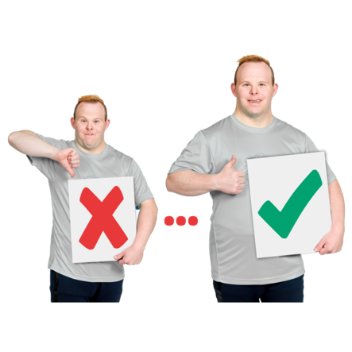 | This survey will help people learn about how we can make support better for people with disability.
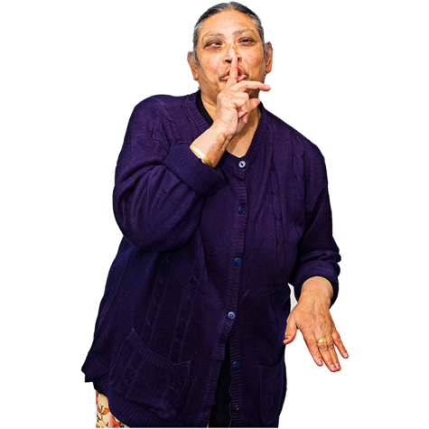 | We will not share information about you such as your name and address with anyone.
 | The information we do collect will be shared with researchers from universities.  They will use the information to write a report.
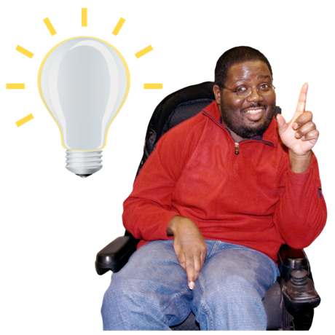 | The report will help us learn what supports people with disability need to make their life better.
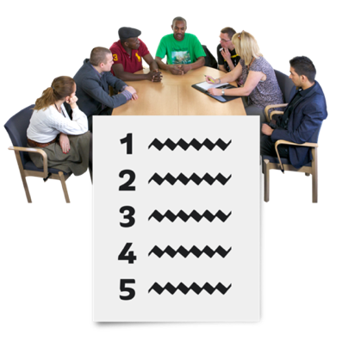 | We will share the report at a public meeting.

What you will need

 | You will need something that can take a picture.
 | You will be asked to email photos only if you want to.
 | You will need this link to fill out the survey: https://forms.gle/TxhnmxdzcnfVKqA49
 | You will need to think about what supports you use that make your life better.
 | You will also need to think about supports that you wish you had to make life better.

How to do the survey

 | Start by answering a few questions about yourself.
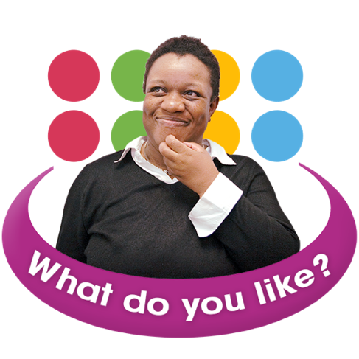 | Then you will be asked to share an example of one type of support that you really like.  This support makes your life better in some way.
 | You should include:  - A few words about why you like this support  - How you found the support  - How you pay for the support
 | You can also take a picture of the support if you want to and send it to info@disabilitydialogue.com.au.
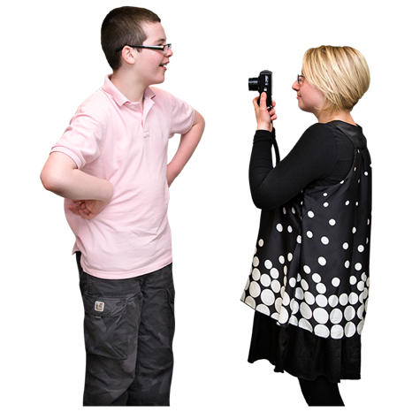 | If you are taking a picture of a person please make sure they are okay with their picture being taken.
 | The next question is about what support you wish you had.

 | Think of a support you wish you had to make your life better.
 | Then you will be asked to tell why you wish you had this support and how it would make a big difference in your life.
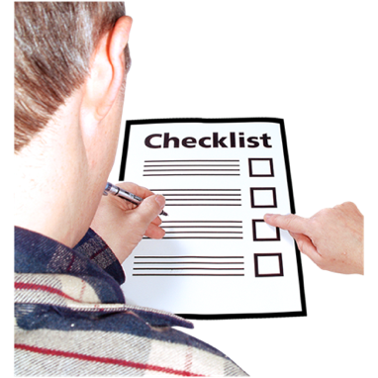 | You should include:  - A few words about why you wish you had it  - Why you don’t have this support
 | You can also take a picture of where the support should be if you want to.  You can send it to info@disabilitydialogue.com.au.
 | Then you will be asked if you know the term foundational supports.  It is okay if you do not know.
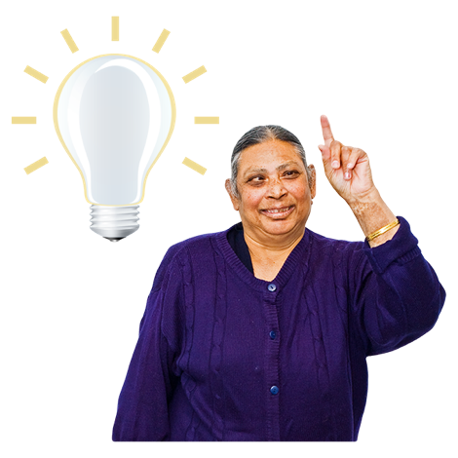 | Foundational supports is a new idea from the NDIS.
 | We want to know:  - If you know what foundational supports means  - If you want to know more  - What other kinds of supports you think are important for people with disability
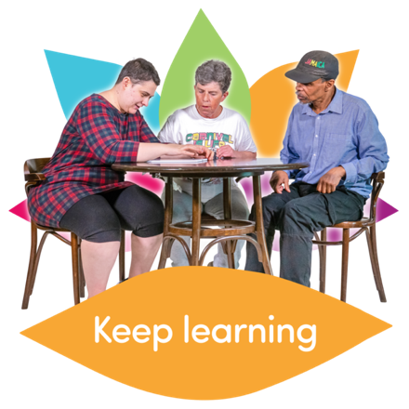 | When you are done with the survey you will be asked if you want to learn more about the Disability Dialogue.
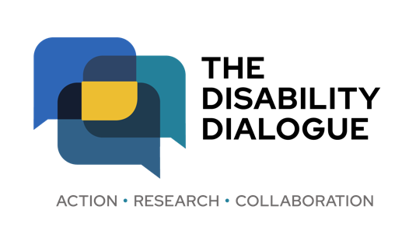 | If you have any questions please send them to  info@disabilitydialogue.com.au.

